
Assignment Cover Sheet

Student Name: | Sara Spiers
Student Number: | 1486
Course: | Diploma in Wedding Planning (Level 4)
Assignment NO: | 13

Marking Criteria:
We expect the learners to write minimum one well expressed point in three lines against each allocated mark. This means one needs to write 15 lines with 5 well expressed points to get high grades for a 5 marks question.
For high grades use examples and illustrations where appropriate.
Please insert your completed assignment ( in word format) here:

1.
(i) What is the importance of transportation for a wedding ceremony?

Transportation is very important for a wedding ceremony in order to make sure that the wedding party and guests are able to get there. Without it, the wedding simply wouldn’t happen. Firstly, the wedding guests need to be transported (depending on the location and their preference of travelling with a group or making their own way). Secondly, the groom and his best man and groomsmen need to arrive on their own, and lastly, the bridal party including the bride, the father of the bride and the bridesmaids and maid of honour need to arrive separately after everyone else.

The arrival of the bride is also key in setting the ambience of the event so it is vital that the transportation is booked far enough in advance, and it is the couple’s preference of what type of vehicle they want to set that ambience.

(ii) List the important factors that should be considered when choosing wedding vehicles?
When choosing a vehicle, the couple needs to consider which style they want which, in most cases will reflect the type of ceremony they are having. This can be formal or informal. They also need to consider the distance they need to travel as this will affect the type of vehicle they can choose. For example, some vintage cars have a mileage limit in their hire conditions. The vehicle also needs to be reliable to get the wedding party there on time. This can sometimes be an issue with vintage cars as they are more likely to break down. They also need to consider the cost as their budget will limit them in their choice, but ultimately, it is the couple’s own preference which is the most important thing to consider.

(iii) Inspecting the vehicle is important before finally booking it. Why?

It is vital to inspect a vehicle firstly to ensure that it is in good condition, not just aesthetically but also mechanically. As with any car, any damage or faults must be highlighted at this stage to ensure that you as the hirer are not liable for it when it comes to returning the vehicle. Also, checking these things also gives piece of mind that the car is reliable, particularly when inspecting elements under the bonnet.

It is also imperative that the documentation is inspected to ensure the car is legal, taxed, insured and has a valid MOT as without this, a legal fine can be imposed on you. Other smaller but important items to inspect include the cleanliness of the car to avoid any potential damage to the wedding attire and also inspect its comfort, even if the car will only be used for a matter of minutes.

(iv). List some important questions that should be asked from the vehicle company manager when booking the vehicle.

Can you provide proof of car being used for wedding recently?
Who will be driving and are they fully insured and licensed to drive it?
What hire packages are on offer and at what cost?
Are there guest cars that match the bridal car?
Do costs include VAT?
Will the staff assist with the bride in getting into and out of the car?
What uniform will the staff wear?
How many people will fit in the car?
Is the car air conditioned or heated?
What is the full hire period?
Will there be any additional charges (fuel, breakdown, damage cover [internal and external], insurance?)
Will the car have to be refueled before handing back?
Can the cars be decorated or is this something your company provides?
Should there be any breakdown or issue, will a back-up vehicle be provided?
When is payment due?
Will there be a deposit required?
Will there be a cancellation fee?
Will you provide a contract detailing everything that is included in the cost and all contingency measures which have been verbally agreed?
What contingency plans are in place if a car is delayed in picking up the party on the day?

2.
Give some creative ideas about the modes of transport that could be used for the wedding ceremony. Present your ideas in a report supported by evidence in the form of images or illustrations.

Old style London Buses or School Bus
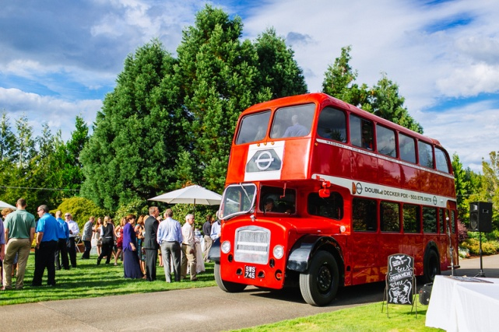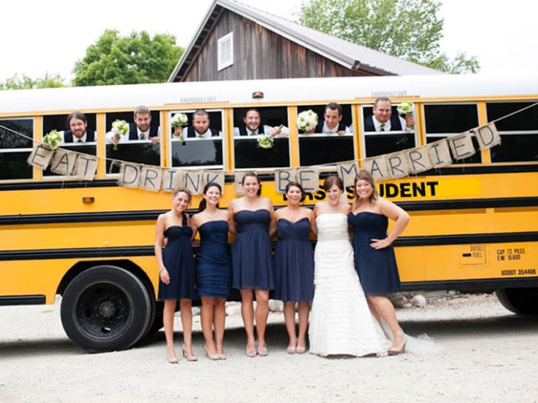
This mode of transport is great for taking wedding guests, large bridal parties, or the groom’s entourage. These buses are becoming increasingly popular due to how much they stand out and become a memorable part of the wedding. Travelling by bus or coach is usually standard for most wedding guests but a private London Bus or old style school bus provides something a little bit different for guests.

Bike
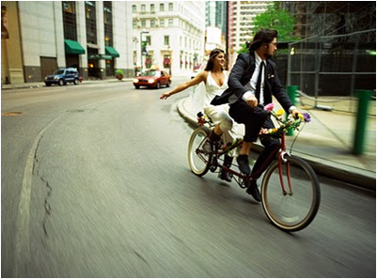
Bikes are an easy way of getting around. Couples can use individual bikes or a couple’s bike if they are not traditional and choose to arrive together. Alternatively, this can be a great way of the couple leaving the ceremony. This mode of transport, however, isn’t suitable if the bride has a long or wide gown as it can be a hazard.

Helicopter
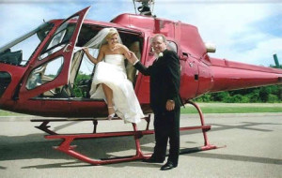
Helicopter is very much a modern but very expensive way to travel. It is certainly a grand entrance and very memorable, however, it is limited on the number of passengers it can take. It would only be suitable for the bride and her father, or the groom and one groomsman or best man.

Segway
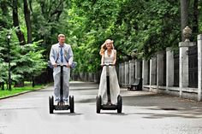
Segways have increased in popularity over the last few years. A lot of venues with acres of ground around them often have these as an activity for guests. This type of transport is more for show and is for short distances only. It would suit the outdoor and adventurous types of couples, and is perfect for unusual wedding photographs. Again, this is not suitable for brides with larger gowns as it can pose a safety risk.

Campervan
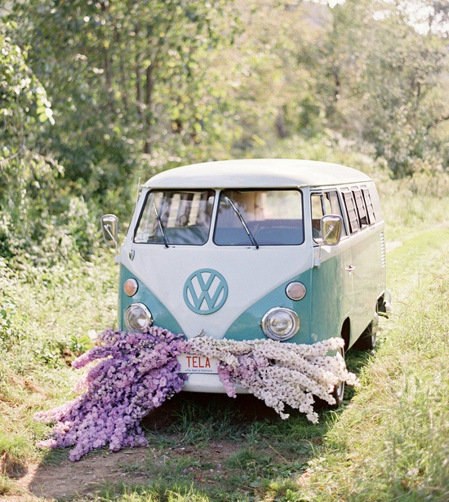
Although campervans are usually older styles of vehicles, they are seen as ‘vintage’ and are quite popular particularly with beach or outdoor weddings. This type of transport is again suited to the more adventurous types and can tie in with a camping honeymoon.

Student Statement:

By submitting this assignment, I confirm that this is my own work.

Student Signature | Sara Spiers | Date | 20/07/2016

For Tutor / Assessor Use Only
Total Marks
Marks Obtained
Percentage / Grade

