
Assignment Cover Sheet

Student Name: | Rebekka Annika Schendel
Student Number: | 1391
Course: | Dress Designing Essentials
Assignment NO: | Unit 7

Marking Criteria:
We expect the learners to write minimum one well expressed point in three lines against each allocated mark. This means one needs to write 15 lines with 5 well expressed points to get high grades for a 5 marks question.
For high grades use examples and illustrations where appropriate.
Q:1: Give short answers to the following questions:

a) Which type of materials should be chosen for the dress of a thin person? And when choosing a stripy print which type of stipes would you recommend for the dress of a thin person?
I think the best chosen type of materials for the dress of a thin person is a loos fitting one, but also shiny materials or stiff materials which stands somewhat out from the figure.
When I would choose a stripy print for a dress of a thin person, I would recommend types of stipes with horizontal movements. Patterned fabrics with curved lines and broken lines are also good materials which fit well for a dress of a thin person.

b) How would you design a dress for a person with large waist and hips? Which designing techniques would you apply?
A dress for a person with large waist and hips would I design in this way; A dark skirt (or the bottom of the dress) for example with the color oxford blue or midnight blue with diagonal lines or maybe with vertical lines, with a shirt (or the top of the dress) which has rhythm through progression – from dark blue to light blue. The shirt is provided with shoulder pads or puffed sleeves and a white neck cloth (or V-neck). The material should not be too stiff but also not too tight.
Here is an example in the color from dark brown to white:
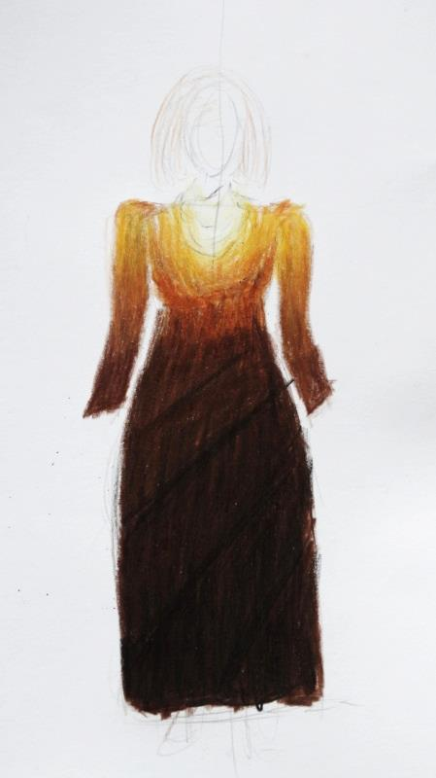

c) ‘A person with stout figure must never try wearing a dress which is too tight for him/her.’ Discuss
A person with stout figure must not try wearing a dress which is too tight for him/her, because it emphasis the figure. But I would not say never, because if a person with a stout figure tries a garment on which is too tight, than it can be that the person becomes the desire to lose some weight and to change their life style. The result would be that the person is not so stout anymore, is happier, healthier and have better results in the daily work. But of course not every person can do something to lose some weight for example because a sickness. For them it is better to never try on a dress which is too tight for him/her.

d) How would you design a dress for a person with round shoulders so this problem is least noticeable?
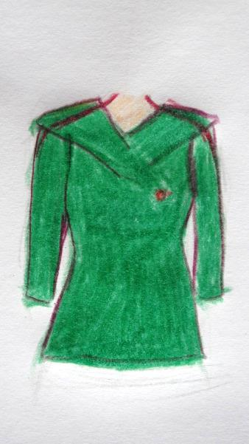
I would design a dress for a person with round shoulders so that the problem is least noticeable in this way:
This line shows how the shoulders are
and this line shows how it looks with a right
design.
The design has set-in sleeves, it can have
shoulder pads, and has a special collar
which hits the round shoulders.

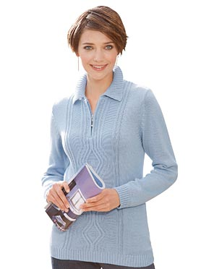

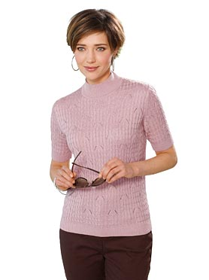
Activity
Here are two examples one fits not so well and the other one fits better. This has a collar which fits not good for this person, but this collar fits much better! It would fit also a waterfall collar.

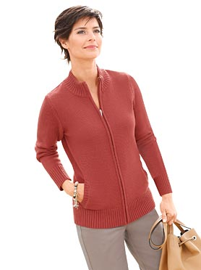

On this image is the collar also not so good. A roll collar would fit very well and it would look better without a zip. When this person would where a dress it should be made with a soft material and a waterfall collar would fit her also well.

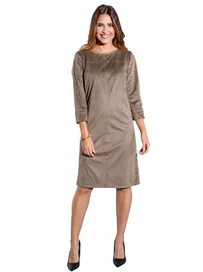
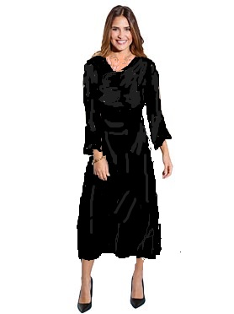
The dress one on the right hand is not a garment which fits well to this person. One the left hand is an example how it would look better. A darker color, a soft fabric which is not so stiff like on the bad example, a V- collar or waterfall collar would make the design much better, also if it is on the waist more tight.

Picture references:
Activity: they are all from the website www.witt-weiden.at

Student Statement:

By submitting this assignment, I confirm that this is my own work.

Student Signature | Rebekka Annika Schendel | Date | 10.10.2016

For Tutor / Assessor Use Only
Total Marks
Marks Obtained
Percentage / Grade

