
Assignment Cover Sheet

Student Name: | Carly Clarke
Student Number: | 1162
Course: | Diploma in Beauty Therapy & Salon Management
Assignment NO: | 7

Student Statement:

By submitting this assignment, I confirm that this is my own work.

Student Signature | c.clarke | Date | 10/09/2015

For Tutor / Assessor Use Only
Total Marks
Marks Obtained
Percentage / Grade

1

Mrs Carly Clarke
Student Number: 1162
Assessment: 7
Beauty Therapy & Salon Management
Address:
8 Hilton Road
Martlesham Heath
Ipswich
Suffolk
IP5 3RL

Assessment 7

Q.1. Multiple Choice Questions:

- Which of the following face shapes is said to be perfect?
C) Oval

- In order to give an effect of length to a round shaped face, apply a shader over the;
B) Angles of the jaw and temple areas

- How will you do corrective make up for close set eyes?
A) Light colours to the inner and dark to the outer portion of the eyelids

- While doing corrective make up for a short thin nose, apply
B) Highlighter to the sides of the nose

- How would you do the corrective make up for the double chin;
A) By applying a shader to the centre of the chin and blending it to the jaw

- How would you do the corrective make up for a thick neck;
B) By applying shader to both sides of the neck

- Strip lashes are applied;
A) By leaving some space on both corners of the eye

- While applying evening make up, always keep in mind the lighting in which the client will been seen, because;
B) Colours of the make up seem different in different lights

- For photographic maake up keep foundation as;
A) As strong as possibble

2

Carly Clarke
Student Number: 1162
Assessment: 7

Q.2. Subjective Questions

- Mrs Jones is preparing for her daughters wedding and comes for a pre-wedding make up practice. Her eyebrows are thick and her eyes are quite small. What can you recommend?

Firstly I woulld gather some information on the day to find out what kind of lighting and duration of the day we were expecting. The make up needs to be glamourous but if the event will be iin the day it needs to be on the more subtle side so she does not look too overdone. As her eyes are quite small i would recommend using a lighter colour on her upper eyelid which will create a more eye opening effect. White eyeliner is also a good option for making the eyes look wider and I would advise a highlighter below the eyebrows.

- How is the corrective make up done for wide set and close set eyes?

WIDE SET EYES:
To correcct wide set eyes darker colours should be used on the inner corners of the eyelids. To baalance this lighter colours are then placed on the outer areas of the eyelids.

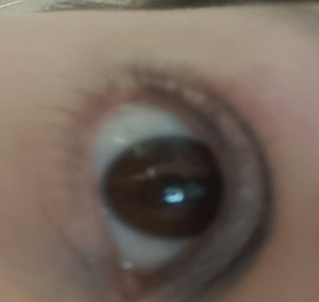 (Darker on inside lighter on outside)

CLOSE SET EYES:
Shaping eyebrows can help create space between the eyes. Lighter colours should be placed on the innerpart of the eyelid and darker on the outer corners of the eyelids. This should make the eyes look and seem futher apart.

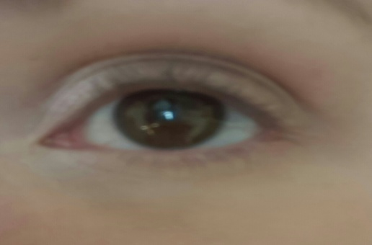

(Lighter on the inside darker on the outside)

3

Carly Clarke
Student Number: 1162
Assessment: 7

- How would you contour a client with a round shaped face?

For a round face you want to use make up to try and create and illusion of length to face. A blusher should be applyed to the cheeks and then blended up onto the temples. A shader being used on the jaw and temples areas should create the illusion of length by slimming the sides of the face. A highlighter should be blended down the centre of the nose.

- Why is the position of the client important while doing her make up:

The position of the client is important because daylight/ natural light will show off and make imperfections very obvious. This is why day make up should be kept to a minimum and appear natural. a foundattion that matches your own skin tone/ shade is best as it will look natural and even out your skin tone.
When doing night time make up artificial lights can make colours appear different and they will usually lose their brilliance.

- How would you do the corrective make up for the following problems:

THICK NECK;
For a thick neck you want it to have the illusion of being slimmer so you need to shade both sides of the neck creating that slimmer look.

THIN NECK;
In contrast to a thick neck you would want to apply highlighter to both sides of the neck givingn it the illusion on thickness as highlighter makes an are more prominant.

WIDE NECK;
A wide neck is simalr to a thick neck, you want to shade the out side to create a slimmingg illusion.

WIDE JAW;
To correct a wide jaw a shader should be applied just below the cheek bones and along the jaw line. this needs to be blended into the neck area.

4
Carly Clarke
Student Number: 1162
Assessment: 7

DOUBLE CHIN;
To correct the double chin a shader down the middle of the chin is best. This needs to be blended well beneath the chin and on the jaw bone.

- In makeup application what must you remember when applying the following cosmetics?

FOUNDATION;
As with all make appliccation the skin will have been cleasned aand moisturised. Before any application the foundation needs to be tested to ensure it matches the clients skin tone. This should be tested on the jawline. It needs to be bllended from thte middle of the face outwards.

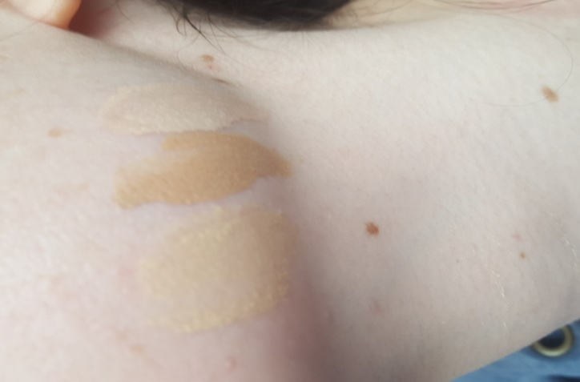 (3 different colours. Should be blended on the jaw line to get the match)

CONCEALER;
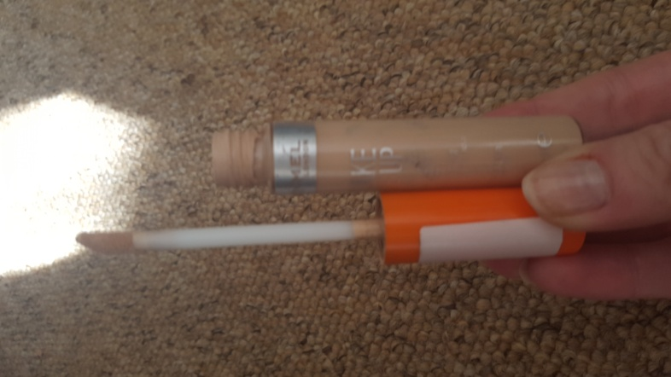
A brush should be used to apply concealer. Concealer will hide any imperfections and dark circles under the eyes. A corrective concealer should only be used in certain places that need it.

5

Carly Clarke
Student Number: 1162
Assessment: 7

FACE POWDER;
Face powder wil be used to set the foundation in place. It should be applied with cotton wool at the top of the face moving gradually downwards on the face.

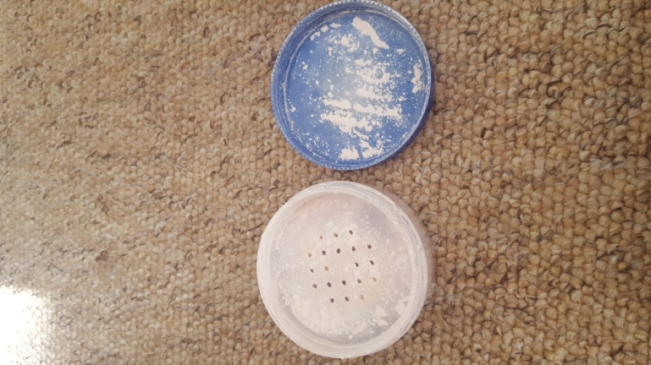

BLUSHER;
A blusher will help in contouring the face but will also add a glow and bit of colour when used on the apples of the cheeks.

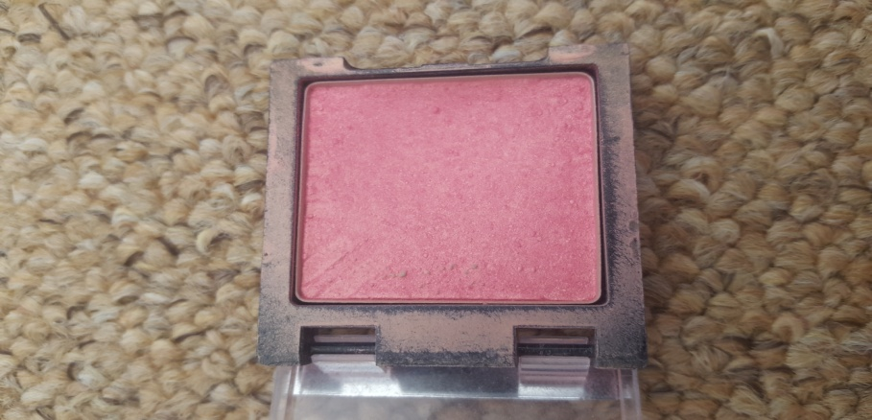

6

Carly Clarke
Student Number: 1162
Assessment: 7

LIP LINER;
A lip liner is good at adding more fullness and shape to the lip area. Lip liner lies the outside of thte lips or is used to add new shape. It should be a close matchh to the natural lip or the lipstick that is being used.

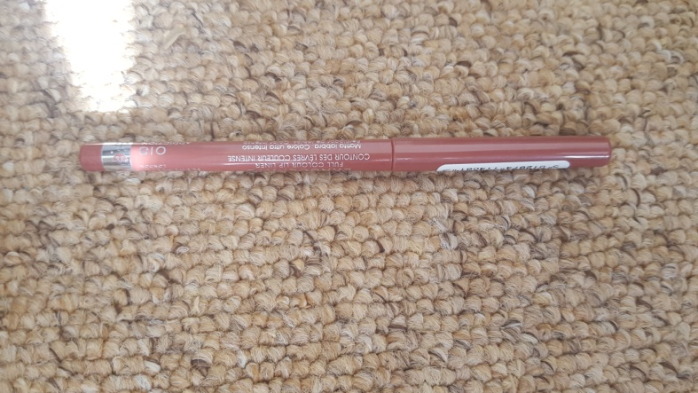

EYESHADOWS;
Eyeshadows can be used to correct different eye shapes. By blending darker and lighter eyeshadows you can create the illusion of bigger/ smaller and wider or closer eyes dependingg on their shape. llighter colours will highlight certain areas while darker will hide areas. e.g wide eyes need darker colours on the iner corners and lighter on the outer corners of teh lid.

MASCARA;
Mascara iis used tto accentuate the eyelashes. It should not be used to thicken them as this can cause a clumpy effect. Itt should always be applied with the client looking downwards using strokess going upwards in the direction of growth.

- While applying photographic make up which points must be remembered?

- Under hot lighting makeup may melt of the face. The skin needs tto be keptas cool aspossible.
- oily mskeup will slide off the face and also emphasis the porees on the skin so it should be avoided.
- Matte makeup will be the best as the cameras will pick up any type of shine.
- shading and highlighting should be used for contouring.
- Makeup will need to be aapplied more strongly because of thestronger lights used in photography.

7

Mrs Carly Clarke
Student Number: 1162
Assessment: 7

Q.3 Whatt isthe difference between day and evening make up?

Daylight can show up impections easily, they are very obvious on the skin. you want the effect of your makeup to be quite natural so it is bbest to try keep all makeup to a minimum so it wont looks so harsh or hevy on the skin. Your foundation should be the same coloour as your own skin to even out the tone and look natural.
Using a translucent powder is used to set the foundation annd strong oloursshould be aadvoided.
For evening makeup you need to take certain lighting into consideration as artificail lighting can make the makeup appear different and darker shades on the skin can look duller. Bright colours ccn be used as they will show up better. Highlighting will help push back any shadows on the face, these should be light and bright. you could use a heavy foundation for night time such as a moouse for ssligghtly heavier coverage.

