
Assignment Cover Sheet

Student Name: | TAMSANQA LEEROY NDHLOVU
Student Number: | 3093
Course: | SUPPLY CHAIN MANAGMNT
Assignment NO:

Marking Criteria:
We expect the learners to write minimum one well expressed point in three lines against each allocated mark. This means one needs to write 15 lines with 5 well expressed points to get high grades for a 5 marks question.
For high grades use examples and illustrations where appropriate.
Please insert your completed assignment ( in word format) 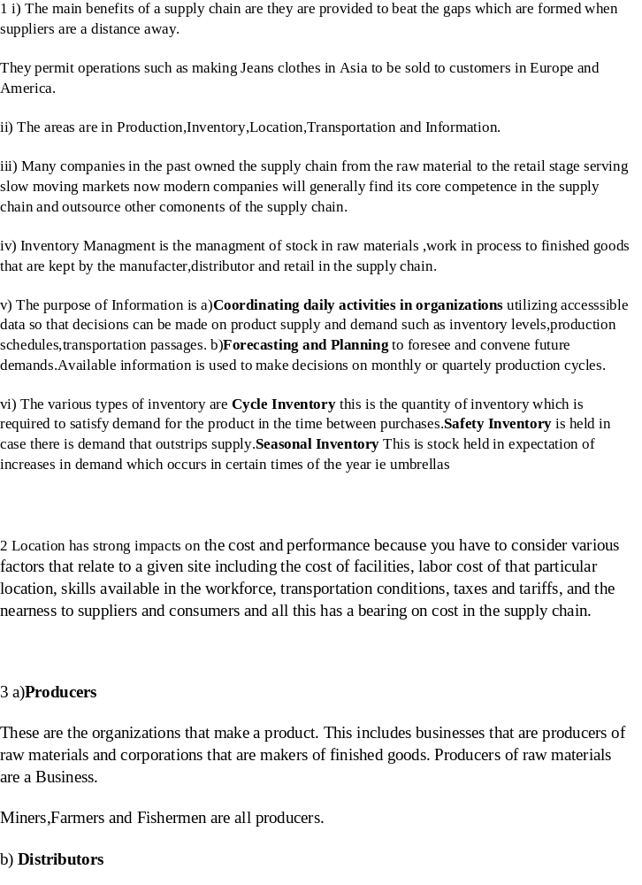re:

Distributors are businesses that take inventory in mass from producers and supply a bundle of associated product lines to consumers. Distributors are termed as wholesalers.
They usually sell in large quantities to their Customers.
Distributors are businesses that take inventory in mass from producers and supply a bundle of associated product lines to consumers. Distributors are termed as wholesalers.
c)Retailers
Retailers stock inventory and sell in lesser quantities to the common public. This business also closely tracks the demands and preferences of the consumers that it sells to. It advertises to its consumers and often utilizes some blend of price, service, convenience and product selection, as the primary draw to attract consumers for the products it sells.

The Supply Chain of milk
Milk moves through a farm, tanker collection,dairy, bottling plant, distributor, and supermarket before we purchase it.
PE Dairies is a dairy,bottling plant and distributor in the logistics chain.
PE Dairies specific activities in Logistics are Customer Service ,Demand Forecasting,Order processing,Transportation,Inventory (warehousing and storage)
The main problems PE Dairies face is in Demand Forecasting because there is variation in daily demand,and having Inventory that can support a spike in demand.

Student Statement:

By submitting this assignment, I confirm that this is my own work.

Student Signature | TAMSANQA LEEROY NDHLOVU | Date | 24/11/2016

For Tutor / Assessor Use Only
Total Marks
Marks Obtained
Percentage / Grade

