

Assignment Cover Sheet

^{Student Name:} | ^{Hiyam Daou}
^{Student Number:} | ²³²⁰
^{Course:} | ^{Diploma in Diet & Nutrition}
^{Assignment NO:} | test 4 digestion and detoxification

Q. 1 Multiple choice question:

Please note the correct answers are in red.

The first stage in the process of digestion is known as:

- Absorption phase
- Cephalic phase
- Chewing phase

Each mouth full of food takes about:

- 12 second to reach the stomach once swallowed
- 10 seconds to reach to stomach
- 6 seconds to reach to stomach

the walls of the stomach are made up of:

- 5 different layers of muscles
- 4 different layers of muscles
- 3 different layers of muscles

the stomach produces the enzyme pepsin which breaks down:

- fats
- proteins
- carbohydrates
digestion and absorption of fats proteins and carbohydrates occur in;

- stomach
- small intestine
- oesophagus

the gall bladder provides bile salts that help to make;

- proteins easier to absorb
- fats easier to absorb
- water easier absorb

the process of fat digestion and absorption can take up to:

- 5 hours
- 8 hours
- 10 hours

which of the following hormones is called stress hormone?

- Thyroid hormone
- Cortisol hormone
- Cholesterol hormone

The major detoxification organ in the body is;

- Liver
- Heart
- stomach

if a person loses weight too quickly his or her liver secretes extra cholesterol which may lead to:

- diabetes
- heart burn
- gallstone

Q. No. 2 Short Question:

- What is the function of hydrochloric acid in the stomach?

Hydrocholoric acid is to sterilize the food you eat and to prevent harmful bacteria from entering the GI tract. HCL also triggers the release of enzymes such as pepsin which are essential for the digestion of proteins.

- What is the importance of the hormone ghreline in the stomach?
The ghreline is the hunger hormone also known as lenomorelin produced by specialized cells that line the stomach and the pancreas.
Ghreline is one of the main hormones to stimulate hunger. Ghrline levels increase before meals and decrease after meals, a mechanism that has its roots in the hypothalamus is removed, feeling increase leading to weight gain and serve obesity.
Ghrelin plays an important role in hunger and therefore weight gain. Also called the growth hormone secretagogue is also important for a process called neurotrophy which refers to the brain’s ability to adapt to new environments and learn new processes.
Ghreline enters the hippocampus of the brain from the blood and alters the connections between nerves and cells to enhance learning and memory.

- How does eating moderately slowly and regularly help maintaining the healthy digestive system?

Don’t overeat eat moderate portion avoid putting too much stress on the digestive system try not to eat rush.
Exercise regularly cardiovascular exercise help to strengthen the muscles of the abdomen and reduces sluggishness by stimulating the intestinal muscles to push digestive contents through your system.
Reduce manage stress levels stress effects the nerves of the digestive system and can upset the intricate balance of digestion. In some people stress slows the process of digestion, causing bloating pain and constipation while others may need to frequently empty their stomach. Stress can worsen some condition such as ulcers or irritable bowel syndrome.
Eat a healthy diet
Eat moderately slowly and regularly
Exercise regularly
Reduce manage stress levels
Quit smoking
Stay hydrated
Eat on schedule
Limit food high in fat
Get insoluble and soluble fiber
Eat high fiber diet

- How does stress effect our digestive system?

Digestion is controlled by the enteric nerves system a system composed of hundreds of millions of nerves that communicate with the central nervous system.
The impact of stress on the stomach goes far beyond indigestion. The entire system is extremely sensitive to our mood stress is a major player in digestive problems, like irritable bowel syndrome indigestion and heartburn.
A two- way street
Gut feeling a strong connection between the brain and the digestive system. The stomach and intestines actually have more nerve cells than the entire spinal cord some call it the digestive system a mini brain. A highway of nerves runs directly from the real brain to the digestive system 95 percent of the body’s serotonin a hormone that help control mood found in the digestive system not the brain.

severely stressed we put our digestive system in dangers. The hormone CRH
( corticotropine hormone) is the body alarm bells. In stressful situations the brain pumps out CRH to fight or flight. Stress can cause stomach aches nausea and diarrhea. In long term stress can aggravate chronic diseases such as irritable bowel syndrome and heartburn.
CRH also turns off appetite with some people and its contrary some people turn on their appetites.
Cortisol and adrenal function
Cortisol is a life sustaining adrenal hormone essential to the maintenance of homeostasis .called stress hormone, cortisol influences regulates or modulates many of the changes that occur in the body in response to stress including ,but not limited to blood sugar glucose level fat protein and carbohydrates metabolism to maintain blood glucose, immune response, anti-inflammatory actions, blood pressure, heart and blood vessel tone and contraction, central nervous system activation.
Cortisol is produce from cholesterol in two adrenal glands located on top of each kidney.its reponses to the event and circumstances such as waking up in the morning ,exercising and acute roles in the body’s effort and maintain homestasis.
Cortisol plays an important role in human nutrition.it regulate energy by selecting the right fat or proteins when chronically elevated cortisol can effects on weight immune function and chronic disease risk. Cortisol its involvement in the fight or flight responses and temporary increase in energy production.
Whole body effects of elevated cortisol blood sugar imbalances and diabetes,
Under stress conditions cortisol provides the body with glucose by tapping into protein storess via gluconeogenesis in the liver leading to increase blood sugar level.
Cause weight gain and obesity, immune system suppression cortisol function reduce inflamtion in the body which is good but over time these efforts to reduce inflammation also suppress the immune system, gastrointestinal problems cortisol activates the sympathetic nervous system on in a cortisol flooded stressed out body when food is consumed.digestion and absorption are compromised, indigestion develops and mucosal lining becomes irritable and inflamed. This can lead to ulcers irritable bowel syndrome and colitis mucosal inflammation leads to increased production of cortisol.

Stress can make colon contract.
Chronic stress keeps cortisol level high and disrupts the body’s natural 24 -hour cortisol
that rises and falls throughout the day.
Not only that but elevated cortisol:
Raises blood sugar
Suppresses immune function and healing
Promotes leaky gut syndrome
Cause hormone imbalance
Increase depression and anxiety
Altered digestive motility

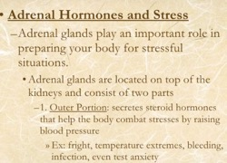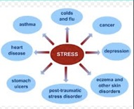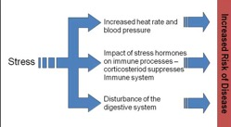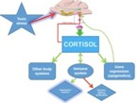

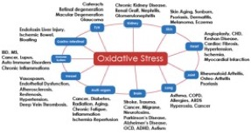

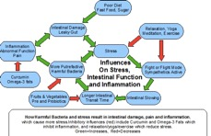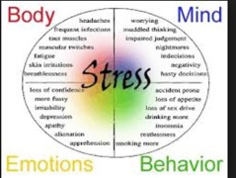

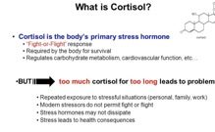

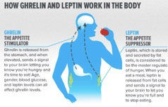

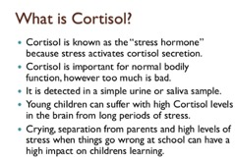

- Name three sources of toxicity?
Cigarette smoke, excess alcohol, sugar, drugs, excess caffeine, artificial sweeteners, food additives, and pesticides found on processed and non -organic foods all create toxicity.

Meet the neurotoxins Manganese, Fluoride, Chlorpyrifos,DDT/DDE, Tetrachloro Ethylene (PERC) Polybrominated Diphenyl Ethers (PBDEs) Arsenic Leads Mercury, Toluene,Ethanol,Polycholorinated Biphenyls (PCBs)

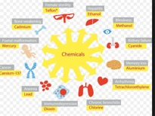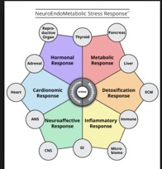

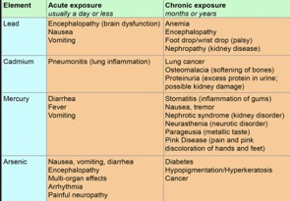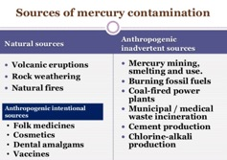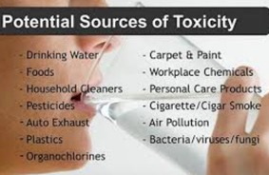

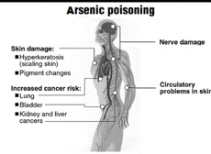

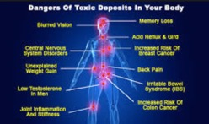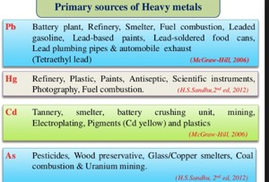

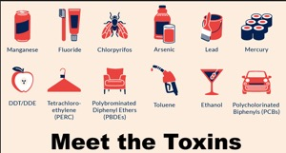

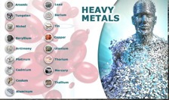

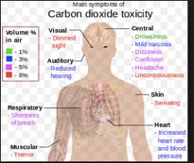

- What are the symptoms of indigestion?

Bloating, belching and gas, nausea and vomiting an acidic taste in your mouth, fullness during or after a meal, growing stomach, burning in your stomach or upper belly, belly pain.
The symptom might be worse when you’re stressed. If you swallow too much air when you eat, that can make belching and bloating worse.
People often have indigestion along with heartburn a burning feeling deep in the chest which happens when stomach acids rise into the esophagus.
Eating too much too fast or when you’re stressed high-fat food can also add to the problem. Drinking too much alcohol Smoking stress and fatigue.

- How can indigestion prevented?

Do not chew with your mouth open talk while chewing or eat quickly
Chew food completely and eat slowly
Drink fluids after meals rather than during
Avoid late-night eating
Avoid spicy greasy foods
Quit smoking
Avoid alcoholic beverage
Avoid caffeine
Wait at least one hour after eating to exercise.
Eat plenty of fiber every day.
Lack of digestive enzymes.
Exercise regularly and avoid stress.

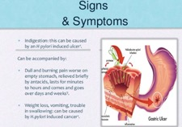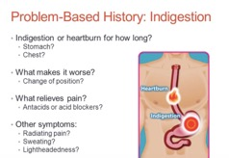

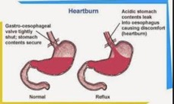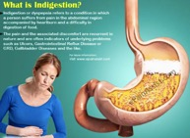
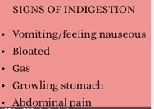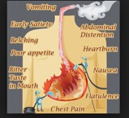

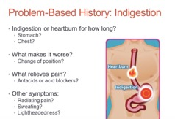

- Describe the effects of prolonged stress on the body?

Chronic stress disrupts nearly every system in your body. It can raise blood pressure suppress the immune system, increase the risk of heart attack and stroke, contribute to infertility and speed up the aging process. Long-term stress can even rewire the brain, leaving you more vulnerable to anxiety and depression.
Chronic stress can have a serious impact on our physical as well as psychological health due to sustained high levels of chemicals released in the fight or flight response.
The long-term activation of stress-response system and subsequent overexposure to cortisol and other stress hormones can disrupt almost all your body’s processes. This puts you at increased risk of numerous health problems including:
Anxiety, depression, digestion problems, heart disease, sleep problems, weight gain, memory and concentration impairment.
Stress management strategies include:
Eating a healthy diet and getting regular exercise and plenty of sleep.
Practicing relaxation techniques such as yoga,
Practicing deep breathing getting massage or learning to meditate.

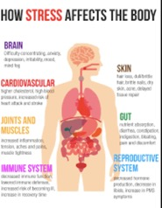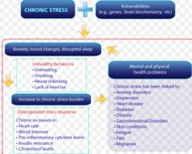
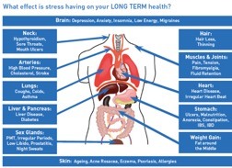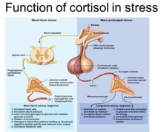

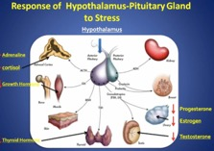

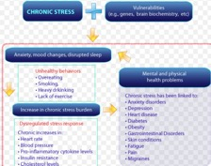

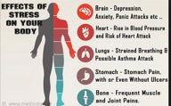

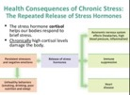

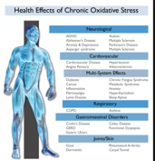

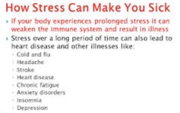

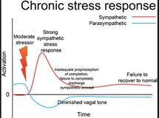

ix. What are gallstones?
Gallstones are pieces of solid material that form in the gallbladder. These stones develop because cholesterol in bile sometimes from hard particles.
Gallstones are small stones usually made of cholesterol that form in gallbladder.
The gallbladder is a small pouch-like organ found underneath the liver. Its main purpose is to store and concentrate bile.
Bile is a liquid produced by the liver to help digest fats. It’s passed from the liver into the gallbladder through a series of channels known as bile ducts.
The bile is stored in the gallbladder and over time it becomes more concentrated which makes it better at digesting fats. The gallbladder releases bile into the digestive system when it’s needed.
What cause gallstones?
Gallstones are thought to develop because of an imbalance in the chemical make-up of bile inside the gallbladder. In most cases the level of cholesterol in bile become too high and excess cholesterol forms into stones.
The gall bladder provides bile salts to help make fats easier to absorb.
Gallstones form in the gallbladder a small organ located under the liver. The gallbladder aids the digestive process by storing bile and secreting it into the small intestine when food enters, bile is a fluid produce by liver and made up of several substances including cholesterol bilirubin and bile salts. Gallstones are pieces of solid material that form in the gallbladder these stones develop because cholesterol and pigments in bile sometimes form hard particles.

Several factors may come together to create gallstones including: genetics body weight, obesity estrogen ethnic gender age cholesterol diabetes rapid weight loss decreased motility movement of the gallbladder diet gallstones can form when there is an imbalance in the substances that make up bile.

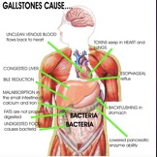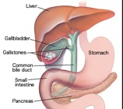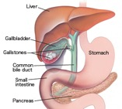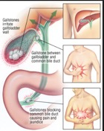

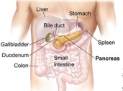
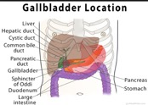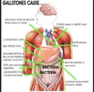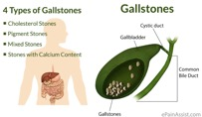

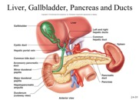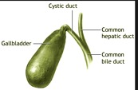

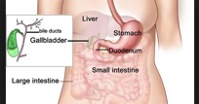

Case study

Julian a 35 years old woman is greatly concerned with her recent weight gain, though she does not look overweight. She actually has quite thin arms and legs but she has bloated abdomen. She has a stressful life because of some problems in her life. Her DAL dietary and life style record shows that she is getting a regular exercise and is mostly eating whole foods.

What could be the reason of her bloated stomach?

- Menopause
- Continuous stress
- Weight gain

Julian needs to follow a

- Weight loss programme
- Stress management
- Fitness training programme

She should be advised to increase foods containing vitamin B5 in her diet because.

- It is good for the skin
- Vitamin B5 directly feeds the adrenal glands
- Vitamin B5 directly feeds the thyroid gland

