
Assignment Cover Sheet

Student Name: | Olena Datchenko
Student Number: | 2843
Course: | The Business Environment
Assignment NO: | 1

Marking Criteria:
We expect the learners to write minimum one well expressed point in three lines against each allocated mark. This means one needs to write 15 lines with 5 well expressed points to get high grades for a 5 marks question.
For high grades use examples and illustrations where appropriate.
Q.1:

- The EXIM Policy is Export and Import Policy, also known as Foreign Trade Policy. EXIM policy announced every 5 years by country’s Ministry of Commerce & Industry. The Ministry releasing annual Hand Book of Procedures to for exporters and importers to follow, which also provides clarity and support to traders operations. Initial intent of EXIM policy is to increase export and decrease import.

- The types of non –economic environment in the following cases:
- Demand for new closes increases during festive season.
This is Social Environment – which depends on social factors like traditions, values and beliefs. The social factor developed over decades and varies between different countries with different traditions, life styles and culture.
- Computer has outdated typewriter.
This is a Technological Environment – in our modern world technologies changes very fast. Therefore in order to survive in the market IT products related companies have to regularly review and analyze the market demands, its competitors and perform scientific researches for innovations.

- Sugar factories are being set up where sugarcane is grown abundantly.
This is Natural Environment – the geographical and ecological factors influencing businesses. It is always good practice to place factory near to its source: sugar factories close to sugarcane grown place, cement factory close to the raw materials quarry. This will not only provide direct accessibility to manufacturing process but decrease the operational costs (by lowering the transportation costs and other logistics costs) this all will impact on final product price and enable competitive price in the market.

- Availability of skilled labor in a particular region.
This is Demographic environment – when the company decides to open a business in any other regions or countries, it is very important that the region have skilled labors. The lack of skilled labors locally may put increase in company expenses by bringing international experts to this region. In other hand, some companies like Mark & Spencer for example, very rarely having products made in UK, most of the production done in India, Pakistan & Africa where they able to access skilled labors with the lower salaries compare to the same skilled labor salary in UK.

- How does demographic environment of business influence the business activities?
From the Marketing perspectives, any organization deciding to sell their products or services at any regions / countries, should take a closer look at the targeted region demographic environment to understand who most likely will buy the product, how it shall be marketed, accordingly adapt product as per targeted region needs. Otherwise, company’s products/services will not be selling very well or at all, as a result company will waster money. For example, McDonalds, by entering Muslim countries, has to modify its menu in this region. They do not sell pork meat burgers in those countries, and all other type of meat must be produced as “Halal”.

- Describe the importance of business environment for a business firm.
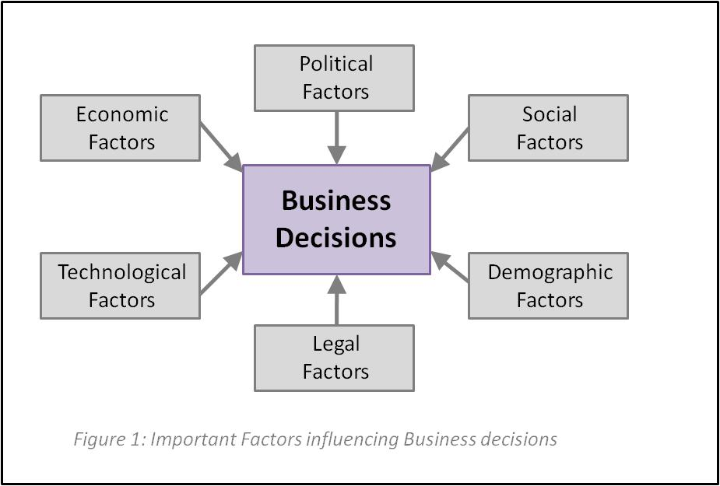

The figure 1 above, displaying the macro-environments (external factors) that dramatically influencing business decisions. Any businesses, before taking a decision to expand, reallocate or introduce their business, must identify the location. Each location must be analyzed for external environment which are affecting business, either they should or should not take a decision to come to this market, identify the strength and the weaknesses. If the company neglecting the importance of study business environment in targeted areas, they may result in business threats from government Laws in this area, threats from heavy competition. Continuously monitoring business environment and anticipate its changes will help a company to prepare for upcoming changes and grow in its market successfully.

- It is very important that any business activities of the company do not affect the interests of the society. Social Responsibilities towards each group:
Owners / Shareholders:  - They are the one who invest money in the business, therefore they must be provided with fair ROI; | Employees:  - Ensure fair treatment of employees;  - Provide good working conditions: health, safety, housing, salaries, bonuses and end of service benefits;
Consumers:  - Ensure quality of supplied products / services;  - Ensure reasonable prices for offered products / services;  - Avoid misleading and dishonest advertising;  - Ensure proper handling of customers complaints; | Government:  - Abide Government Laws and Regulations;  - Pay taxes;  - Avoid corruptions;
Community:
- Contribute towards Community general welfare;
- Preserve & promote Community values;
- Generate employment opportunity;
- Take active role in protecting environment;

Q.2: Legal Environment depends on the country’s legal systems and differs from country to country. It is mandatory to obey the Laws of the country. The Laws may affect every aspect of the business including the product packaging requirements & advertisement. Starting up business shall pay high attention to Legal factors before signing any contracts, agreements and register business – as fail to follow the legal laws will result in company’s heavy charges and penalties.

Case Study:
1.
A) Limited liability company: (LLC) is a mix of Corporation and Partnership or Sole Proprietorship. The functions of Limited Liability Company similar to Corporation, but taxation are similar to Partnership structure. LLC members do not held liability personally for the company’s debts, unlike William Simpson’s Sole Trade company case – where all debts will be handled by the Sole owner.

B) Partnership: is type of the structure where two or more individuals share profits & liabilities. However, the percentage of shared profits and responsibilities may be different. For example, in UAE all the companies placing business outside free zone must have local sponsor who will have 52% of company’s ownership by default, and share the profits accordingly.

2. The advantages of being a sole trader:
- Keep all the profits to yourself;
- Sole decision making;
- Low start up costs;
- Can easily close the company if required;

3. The reasons why a third of sole traders cease trading within their first year of trading: Usually during the first year of company’s operations the business does not give very high returns in addition profits will be deducted with ROI to setup a business. William open shop as a Sole Trader and invest £ 7,000 from his own pocket. By hiring assistant he added expenses to his business, as he must pay salary to the assistant. As a result, all the profit deducts expenses, costs, including assistant salary, and left over profit of William get deducted with taxes, costs, and ROI.

Student Statement:

By submitting this assignment, I confirm that this is my own work.

Student Signature | Olena Datchenko | Date

For Tutor / Assessor Use Only
Total Marks
Marks Obtained
Percentage / Grade

