
Assignment Cover Sheet

Student Name: | Reema Ahmed
Student Number: | 1794
Course: | Diploma in Forensic Accounting
Assignment NO: | Assessment #3

- Short Questions
  - As an investigative officer, it is essential to first understand what causes both high and low level thieves to commit the theft before beginning to differentiate them. One commonality is the weakness of internal controls. Theft of both small and large sums is greatly associated with the ability for such perpetrators to bypass and/or override the weakened internal controls.

Consequently, since both high and low level thieves commit this theft, it becomes necessary in finding differentiating factors between the two types; two factors being namely, the level of occurrence and their character traits. High-level managers tend to steal less than low-level employees. However, even though there are a lower number of incidents partaken by high-level managers, quantifiably, they are larger in sum. In contrast, the incidents of fraud are more numerous at lower levels greatly due to the vast amount of employees employed at that level.

Information collected from Certified Fraud Examiners provide a concise overview on the common traits an individual has leading them to commit small versus large sum thefts. The data collected has been summarized in the table below and such profiling would constitute as a method of differentiating between high and low level thieves:
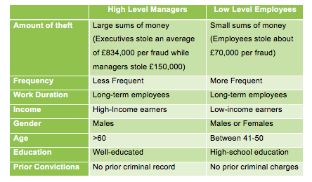

  - Any individual is not visually a criminal. What makes an individual a criminal are certain traits in addition to certain activities that have been carried out which has labeled him or her as a criminal. According to the Association of Certified Fraud Examiners, there are nine traits that outline a typical white-collar criminal:

    - Is at least 30 years of age, or older
    - Is more likely to be male (55%) than female (45%)
    - Maintains appearance of having a stable family
    - Above-average education
    - Less likely to have a criminal record
    - Psychologically healthy
    - Holds a position of trust within the organization
    - Has detailed knowledge of accounting systems and their loopholes
    - Has prior accounting experience

  - Calculating criminals are generally known as predators. On average, they usually start their criminal activities at a later stage then other types of criminals mainly due to their external locus of control – the belief that events are caused by uncontrollable factors. This highlights the existence of a lack of self-esteem and self-confidence which motivates them to commit crime to overcome that, in essence, for a sense of belonging; wanting to fit in with others. Their actions and perception of success is greatly influenced by the opinion of others instead of their own. Even though calculating criminals are highly intelligent and well educated; they tend to be repeat offenders. They are risk-takers and tend to lack empathy or anxiety.

  - The main difference between situation dependent criminals and power brokers is the methods and motives in which the crime is committed. Situation-dependent criminals are driven by their situation and intend no harm to the general public. They tend to convince themselves that their actions are not wrong and get caught up in the moment. Power Brokers on the other hand, are individuals who exert financial power. They exploit their positions in the organizations in order to commit financial crimes that are generated by a dangerous combination of predatory traits. Power brokers influence organizations decision makers to obtain illegal benefits and make more money regardless of its expense. As evident, motives behind the two are very different – a situation dependent criminal’s action is situation driven and is aligned with the fraud triangle whereas the power broker is in a position of power and is exploiting it.

  - According to the Fraud Triangle, there are three conditions that must be present in order for a fraud to be considered as conducted:

    - Incentive or pressure: Motivation or incentive to commit the fraud; these can be both personal or workplace pressure (debt, addiction, promotions)
    - Opportunity: Ability to defraud the organization, usually through weak internal controls or lack thereof.
    - Rationalization: Stage where the fraudster justifies the crime in ways in which it seems as if the crime was acceptable; moral compass situation.

  - Gwynn Nettler’s perception about employees lying, cheating and stealing encompasses three variables: personal, organizational and external.
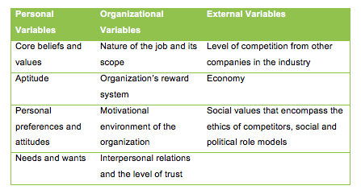
Employees tend to lie, cheat or steal due to various reasons. The level of motivation behind committing these actions depends highly on an individuals need. For example, lower income individuals are more likely to commit crime in comparison to middle or upper class individuals as they are exposed to greater stress and pressure.

In addition, some employees hold low opinion of themselves and have experienced failure in their lives, which makes them more likely to cheat and deceive. Also, employees are also prone to lying, cheating and stealing due to the need for success as they may be prominently failing. The motivation to deceive increases with the struggle and determination to survive. Sometimes, the pay does not support one’s lifestyle nearly enough or sometimes, employees experience trouble climbing the promotion ladder. At the end of the day, if the environment around these employees facilitates crime to be committed, it will be.

  - White-collar crime is easily masked by the appearance of being normal and stable. Due to this, trust of their superiors is gained easily and enables them to commit fraud. Corporate culture sustained is another determinant of white-collar crime; as mentioned in our reading, loyalty gets transformed into collusion and team playing becomes conspiracy. Keeping this in mind, some of the main reasons for white-collar crimes are listed below:

    - Frustration or dissatisfaction with the job or with aspects of the job
    - An employee’s need to take revenge for being abused by the employer
    - The employee is having financial difficulties and fees compelled to steal
    - The organization never punished or prosecuted anyone for stealing
    - Stealing/cheating is a mechanism to fill absence of love, trust or affection
    - Employee thinks that stealing will go unnoticed due to size of organization

- Before we can continue discussing how the profile of a white-collar or blue-collar criminal is different from other typical street criminals, it is essential to understand the difference between these three types of criminals and their driving factors. Though there exist plenty external motivating factors that drive people to commit fraud, there are four generalizations in particular that can be used to understand what type of individual is more prone to committing fraud.

The four generalizations are as follows: some people are always dishonest, most people are honest sometimes, some people are honest most times and some people are always honest. All in all, these individuals are driven by personal, organizational and external variables.

As previously discussed, white-collar criminals are professionals who conduct non-violent crimes for financial gain. White-collar crime involves lying, cheating or stealing by employees and is therefore, carried out in the course of the job. Blue-collar criminals are similar to white-collar criminals; however, they are those from a lower socioeconomic class. Both white-collar and blue-collar criminals differ from the typical criminal according to Hall and Singleton’s profiling. The table below summarizes the profile of the three types of criminal mentioned above:
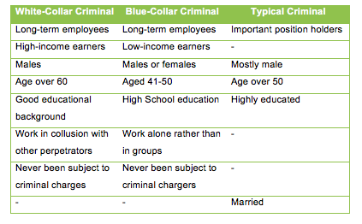
- Organizations need to be able to deal with fraud in whatever form it may occur. They should have practices that are rational, fair, efficient, easily enforced and applied uniformly so that employees at all levels can respectful and compliant. However, in order to really detect and prevent fraud, the control mechanisms of an organization need to be strengthened.

Fraud is most common in organizations that have no controls, trust, ethical values, profits and prospects because of the blind trust instilled in employees and the lack of accountability. The inability for management to segregate duties and weak controls constitutes as motivation for employees as the lack of such segregation is a driving factor to commit fraud. Instead of punishing wealthy executives or fraudsters, we celebrate them and in essence, reward them for being highly intelligent. For example, the fraud of Charles Ponzi – he committed a fraud that cost millions of dollars and hurt a multitude of honest individuals. They were robbed of their security – be it their savings, their asset backed investments, etc. However, as a society, we in some ways celebrated his intelligence as we refer to any fraud scheme following the same pattern, a “Ponzi” scheme. We are continuously reminded of what he once did. Where’s the ethical value in that? Moreover, as Feinberg and Tarrant once said: “If you are of above average intelligence – and if you have mastered the use of high intelligence to solve problems and achieve goals -… you are at risk of [perpetrating a fraud] because of the strength of your cognitive equipment”. This goes to say that no matter how much an organization implements fraud deterrence mechanism and internal controls, there will never be foolproof ways of stopping fraudsters. If the fraudsters have the opportunity and the motivation to commit crime, they will be able to find the loopholes. Long gone are the days of individuals being entirely honest. People hold tendencies to be dishonest and to cheat.

One of the reasons for white-collar crime was because the internal controls put in place by organization were so weak that it was easy to steal. Another reason being that the organization never punished or prosecuted anyone for stealing. This is why it is essential for employees to be monitored periodically and punishment from lack of compliance should be highly enforced. Organizations however can create awareness among their employees in hope of getting the message across. They can do this by:

    - Training and education regarding ethics and the code of conduct
    - Thorough background checks
    - Regular audits and forensic investigations
    - Strong internal control system

Case Study
- If the trader actually committed the crime, it would be a white-collar crime. As discussed, a white-collar crime involves lying, cheating or stealing by employees and is carried out in the course of the job.

- The first thing the forensic expert should do is, with the help of the trader, find copies of the photographs that he used and further identify their sources. If the forensic expert is able to trace the photographs back to their source, it can be deemed highly likely that these photographs were only used to reflect a higher standard of fittings than those he intended to sell. The trader mentions how he never sold or fitted any kitchens during the period of investigation. This claim can also be deemed truthful when analyzing the results of the costing exercise carried out by the tax inspector. The exercise concluded that a far higher profit would have been generated if, assuming four kitchens had been sold and fitted during the period, then what had been declared. Therefore, upon presenting the photographs and the associated books and magazines that they were obtained from to the inspector, along with an explanation of how the trader’s website was created with deception, the findings should be accepted. Moreover, the trader should face no significant adjustment in the initial trading results under investigation.
Student Statement:

By submitting this assignment, I confirm that this is my own work.

Student Signature | Reema Ahmed | Date | June 28, 2016

For Tutor / Assessor Use Only
Total Marks
Marks Obtained
Percentage / Grade

