
Assignment Cover Sheet

Student Name: | Coral Munro
Student Number: | 2565
Course: | Certificate in Fashion Design Level 1
Assignment NO: | 2

Marking Criteria:
We expect the learners to write minimum one well expressed point in three lines against each allocated mark. This means one needs to write 15 lines with 5 well expressed points to get high grades for a 5 marks question.
For high grades use examples and illustrations where appropriate.
Please insert your completed assignment ( in word format) here:

1. What is the relationship between the principles and elements in a design?

The Elements of design are a big component that is taken into account when creating a design. Coming from the art elements the elements of design consist of line, shape, form, colour and texture. A design can be defined by the arrangement of these elements.

The Lines in a design refer the edge or the outline of a garment and the style lines that divide the space within a garment. Defining a shape or a silhouette line can convey a certain mood or character. Lines can create visual illusions, such as weight and width and also can make a figure look thinner or thicker. Shape is a two dimensional area confined by a line it describes the outer lines or contour of an object. When a waistline is added, the dress is divided into two new shapes, a bodice and a skirt. The sleeve becomes another shape. These parts create new spaces for smaller details, such as collars and pockets. The pattern of the fabric can create even smaller shapes.
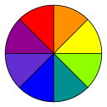
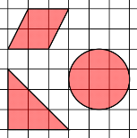
Form may be described as any three-dimensional object. Form can be defined by light and dark. It can be defined by the presence of shadows or highlights. Texture is the surface quality of an object. It could be rough and jagged or soft and smooth. Texture also refers to the illusion of roughness or smoothness in a picture. Colour comes from light and darkness. Colours play a large role in the elements of design, the colour wheel is used as a tool when designing and creating. Colour creates a mood within the piece, each colour says something different, and different colour combinations can change the look aswell.
In relation the Principles of design are guidelines for how you should use the elements of design. Elements are therefore the raw materials that must be combined successfully. The elements and principles of design are flexible and should be interpreted within the context of current fashion trends. In order to arrange the elements of design correctly the following principles have been put into place; these include balance, emphasis, harmony, proportion and rhythm. They are used for creating, discussing & evaluating garment designs on and off the individual. In order to arrange the elements of design well, application of principles is essential. These are not abstract art terms but specific guides that help to create attractive and individual garments.

2. Describe at least three ways for creating rhythm in dress designing.

Rhythm in a garment can be created by several different ways; repetition, gradation, transition, opposition or radial arrangement of various parts of design and fabric design. These can be accomplished by the construction of the following combination of lines, shapes, colours, and textures.
Rhythm through Repetition
Repetition links closely to patterns, a pattern is created when symbols or shapes and repeated. Rhythm can be achieved by repetition; this could mean regular repeats in shapes, buttons, tucks, pleats, laces, edgings, colour, textures, fabric designs and more. Or it could be having the same shaped edges, for example they could be squared, rounded, or scalloped. Repetition of colours is a good way to create rhythm, especially if the colours are placed in an interesting way. Any personality or character can be created by the use of different types of repetition. Lines which have sharp points and are jagged, when repeated gives an exciting rhythm which is more suitable for a dramatic evening wear.
Rhythm through Gradation/ Progression
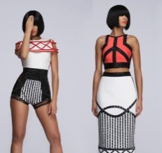
Another way for rhythm to be created in a design is by progression or by gradation. Gradation is a gradual increase or decrease of similar design elements. For example colours going from light to dark or textures from fine to coarse. Shapes may range from small to large, and lines could range from thin to thick. The gradual changes provide continuity while giving a feeling of movement. The degree of change can be small and this will result in the desired flowing smooth effect. A systematic sequence of increasing or decreasing the sizes of motifs, buttons, trims, flowers, ruffles, intensity, fabric design can create an interesting pattern or look for a design.
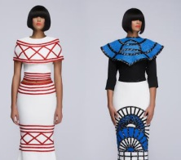
Rhythm by Continuous line Movement & Transition
This type of rhythm makes the eye move in a continuous line and is achieved by flowing lines of trims, bands of colour, or fabric designs and more. This movement unifies the garment design bringing about harmony. Rhythm is broken when lines, trimmings, or fabric designs are not matched at the seams or at other construction points. Fabric designs with widely placed motifs may lack rhythm whereas with smaller motifs the look can flow nicer. Linking in with the continuous movements of line, transition is a fluid rhythm created when a curved line leads the eye over an angle. The curved lines of transition cause the eye to change direction gradually rather than abruptly. Transitional lines and shapes sweep and glide over the figure in a smooth rhythm leading the eye gracefully and easily from one area to another. There is no abruptness like that of jagged lines. It is found in dropped shoulder designs, puff sleeves and cap sleeves. Transition can also be achieved by using scarves, shawls, ruffles and gathers in an outfit

3) What are the principles of design? How do they help a designer analyse the effectiveness of a design?

The Principles are concepts used to organize or arrange the structural elements of design. In order to arrange the elements of design correctly following the principles which include; balance, emphasis, harmony, proportion and rhythm are essential. The principles of design are useful in creating different forms of expression in an artistic manner, which are visually pleasing and attractive to the eye. The principles can determine how successful your design can be.

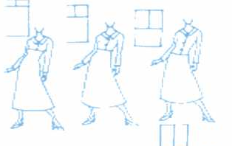
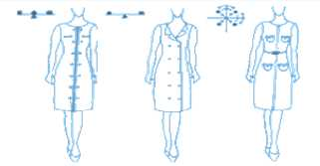
Balance is the pose, equilibrium, stability and security of the garment. The average human body is visually symmetrical, when important details or decorations are designed for a dress, they should be placed in a way that is equally pleasing to the eye. In visual images, balance is formal when both sides are symmetrical in terms of arrangement. Balance is informal when sides are not exactly symmetrical, but the resulting image is still balanced. There are three main types of balance, horizontal balance, vertical balance, radial balance. Emphasis is concentrating on one area of a design that acts as the centre of attention. Making this area more eye catching than any other part. All areas may be interesting, but some areas should be a lesser strength of interest. This means that some areas require toning down slightly in order to emphasize other. Harmony is also called unity in design or in other terms, harmony is pleasing visual unity. It is the relationship among all parts within the whole look. This is created when all parts of the design are related and complement each other in a regular and orderly manner. Functional aspects of harmony imply that a garment is comfortable, moves easily and breathes with body, performs any specialized duties effectively and fits well. Proportion is simply the pleasing interrelationship of the size of all parts of the garment. Generally, unequal proportion is more interesting than equal. When we see an outfit in the mirror, on someone else, or in a pattern catalogue, our eye automatically compares the smaller part of the outfit with the larger one. This comparison is called proportion. Rhythm is the feeling of organised movement. Rhythm results from a regular or a gradual change, giving the feeling of continuity throughout the design. Rhythm can be created in a garment with repetition, gradation, transition, opposition and several other ways. This is achieved most effectively in garment construction by the following combination of lines, shapes, colours, textures, space and also by changing the hue, value and intensity of colour.

Project
Look through costume books for pictures of an historic dress. Using these inspirations, design a
garment using the line, shapes, and details from the historic garment in a new combination
for our lifestyle.
My inspiration
My Design
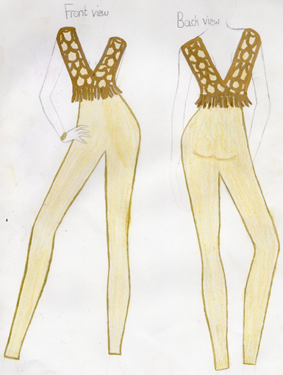
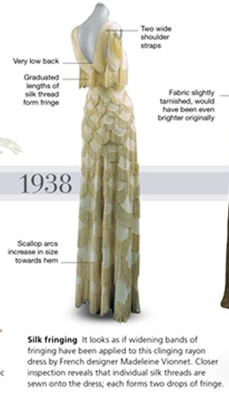
I found a dress from 1938 that I liked and wanted to take inspiration from.
To make the design more wearable in the modern day I changed it from a dress into a jumpsuit, creating versatility in the garment. It could be worn formally in the evening or dressed down in the day with some flat shoes and could even look profession when worn with a blazer.
I kept the upper shape, outer lines and style of the garment the same as a low back is very popular in today’s fashion.
Keeping from the original dress the fringing around the waist area adds a unique twist to an ordinary jumpsuit.
In my opinion the scallop pattern over the whole garment made the look more dated, so I incorporated the pattern into the top section of the jumpsuit still keeping the “flapper” style.
I kept the gold colour the same as it’s very wearable throughout each season and is still popular every year. I did make the gold colour on top slightly more intense to emphasis the scallop pattern and draw interest to the top of the jumpsuit. By keeping the same light gold colour from the trouser part of the jumpsuit to the underneath of the pattern at the top, I achieved harmony throughout the design.
In conclusion,
What was the same-
The Lines- I kept the same outline of the edge of the top section of the design with the low back line.
The Shapes- I kept the same shapes from the original designs scallop pattern also the top half of the designs shape I kept the same.
The Details- I kept the fringing detail around the waist area exactly the same and added the same scallop pattern to the top of the jumpsuit.
What I changed-
To make the design more fashionable to the modern day I changed it into a jumpsuit, also instead of having the scallop pattern all over I toned it down by putting it only in the top section.

Student Statement:

By submitting this assignment, I confirm that this is my own work.

Student Signature | Coral Munro | Date | 07/01/17

For Tutor / Assessor Use Only
Total Marks
Marks Obtained
Percentage / Grade

