
Assignment Cover Sheet

Student Name: | FLORENCIA CALCAGNI
Student Number: | 3557
Course: | DIPLOMA IN BUSINESS ADMINISTRATION
Assignment NO: | 3

Marking Criteria:
We expect the learners to write minimum one well expressed point in three lines against each allocated mark. This means one needs to write 15 lines with 5 well expressed points to get high grades for a 5 marks question.
For high grades use examples and illustrations where appropriate.
Florencia Calcagni
Student # 3557
Assignment # 3
Page 1

Human Resource Management

Assessment 3 Total Marks: 30

1. Short questions: (15)
I. What does human resource department do?
The Human Resources department:
1. Provides incentives to its workers so that they would be motivated to work harder and provide better results. A HR department must make sure that it satisfies and keeps every employee happy.
2. Recruits new employees and places them over various departments or organizations around the country.
3. plans the manpower or the human resources required for certain branches or throughout the organization.
Florencia Calcagni
Student # 3557
Assignment # 3
Page 2

4. Works at the retention of employees by taking steps to transfer from one job to another or one location to another, and also works at job rotation.
5. Conducts appraisals of the employees from time to time, reviews their performances and makes changes to improve the working cycle therein.
6. Helps the employees improve in their fields or the fields of their choice, and aids in the improvement of their specialized field by training them for the job. This is by utilizing their talents and by delegating work that would give every employee a chance to shine and show their abilities.
7. Analyses and calculates the people required for a job and the profile that would fit a certain employee within their organization. It creates teams that would fit well together and work in harmony.
8. Creates and handles the terms of the contracts of the employees. It bargains with them about the salaries, and terms of the contract.
9. Handles the grievances of the employees that are work related, and helps to solve them so they could work with a better frame of mind. It is responsible for the security and welfare of the people in their organization.
10. Remunerates the employees and their families for any losses incurred whether physical or financial by accidents at the work place.
The main function of Human Resources Management department in every organization is to plan, hire, distribute manpower effectively in all departments, and improve the working standard. It provides work amenities for the employees like canteens, medical, educational, safety, transportation, entertainment, and relaxation facilities. Finally, the HR department is solely responsible of solving grievances, signing contracts and creating a positive work environment by creating policies and rules that would benefit the organisation.

Florencia Calcagni
Student # 3557
Assignment # 3
Page 3
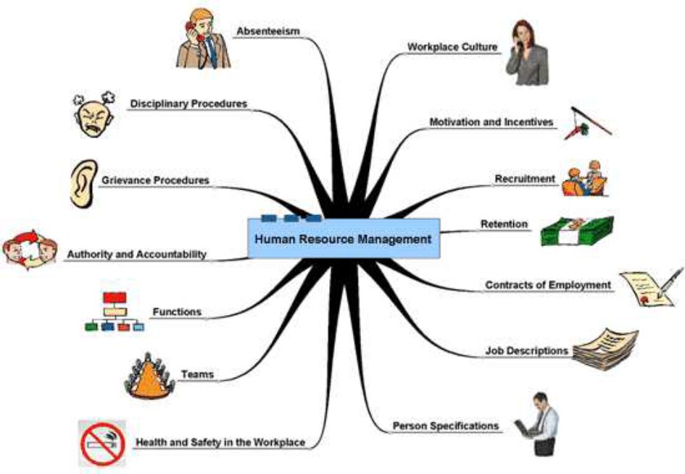

II. Outline the objectives of Human Resource management in an organization.
The objectives of the Human Resources Management are as follows:
1. Unlike other departments, this department focuses more on the results than on profit. Although it does help in profit maximization, it does so in the indirect route of working on the employees, who in turn work on the objectives. In such a way, one of the objectives of HRM is to help the organization realize its objectives.
2. Along with the company, HRM also makes sure that every individual of the company is treated with respect, regardless of their post. It tries to keep the employees happy by recognizing their needs and fulfilling them.
3. This department is there to ensure that every employee is putting in their very best within the work assigned to them. It tries to ensure that the talents of the organization are not going to waste, and that every employee is being utilized to their maximum capabilities.
4. Along with the goals of the company, HRM also ensures that employees can check off any personal goals that they have for themselves within the organization.
5. HRM also conducts interviews and placements camps from time to time in order to recruit new talents for their organization that would benefit them in the long run.

Florencia Calcagni
Student # 3557
Assignment # 3
Page 4

6. It aims at developing and maintaining the quality of work and the work life of the employees of the organization.
7. Since HRM is a human resources department, it deals with the people working in the organization. It has a social responsibility to the society as well as the employees of the organization and it works to ensure that the employees are treated ethically and given proper treatment by their co-workers, subordinates, and employers.
8. It works for training the employees who are newly recruited, and also the employees that have been shifted to other departments. It also helps enhance and improve the skills and knowledge of its workers so that they can perform better in their work field.
9. It also works at developing, among the workers, a sense of family, or belonging, so that every member of the organization works as a team, and recognizes and appreciates the effort of others.
It works at improving the morale of the workers with efficiency and delivering the promises that have been made.
III. Outline the ethics of HRM as relating to the organization and the individual employee.
The key responsibility of HR Professionals is to add value to the organizations they serve and contribute effectively to the ethical success of those organizations.
HR Professionals accept their ethical responsibility, which is rooted in their individual decisions and actions. HR Professionals advocate for the profession by engaging in activities that enhance its credibility and value.
- HR professionals must strive to meet the highest standards of competence and commit to strengthen our competencies on a continuous basis.
- HR professionals are expected to exhibit individual leadership as a role model for maintaining the highest standards of ethical conduct.
- Human Resource professionals are ethically responsible for promoting and fostering fairness and justice for all employees and their organization.
- HR professionals must maintain a high level of trust for stakeholders. They must protect the interests of all stakeholders as well as their professional
Florencia Calcagni
Student # 3557
Assignment # 3
Page 5

integrity. HR Professionals should not engage in activities that create actual, apparent, or potential conflict of interests.
- HR professionals consider and protect the rights of individuals, especially in the acquisition and dissemination of information while ensuring truthful communications and facilitating informed decision making.
IV. What are the benefits of clear recruitment process?
Some of the benefits of a clear recruitment process are:
- Job descriptions meet business requirements.
- Candidates are assessed against consistent selection criteria at every stage.
- The recruitment process is lawful.
- The candidate can be confident is a genuine job offer. It gives credibility to the company.
- The process can be followed by all stakeholders, giving them confidence of the outcome.
- Reduction of risk of bias or discrimination.
- Proving the company is reputable and following good practices. Thus, appealing more people to become an employee of the organisation.
V. How many opportunities of staff development can you think of? Here are some ideas.
- Refresher training.
- Providing materials for self-study.

- E-learning
- Workshops
- Seminars
- Reflective supervision sessions
- Coaching
- Consultation
- Case study method
- Communities of practice
Florencia Calcagni
Student # 3557
Assignment # 3
Page 6

- Lesson study
- Mentoring
- Technical assistance

2. Is there a need for human resource management specialists and if so what should their role be? How is this role evolving? (7)
I believe there is an explicit need of the Human Resource Specialists. They are a supportive and cooperative role within the HR department.
The person in this position should provide the best potential customer service, with a specific knowledge in budget management, civil service, and administration activities.
The main responsibility of this position is to provide information to certify and substitute employees regarding regulations and policies, providing general support, addressing a broad variety of issues, maintaining files, databases, records of actions of personnel, evaluations and tenure.
Among the many duties and responsibilities, the HR Specialist should:
- Assist in supervising recruitment, processing applications, verifying employment, separation, contract, laws, agreements.
- Interpret various written materials such as transcripts, employment records, references, employment regulations, and education codes.
- Communicate with other departments, employees, applicants, administrators, and staff providing information and assistance regarding recruitment, transfers, employment, personnel records and legislation.
- Assist in scheduling meetings and employee programs/events in compliance with department needs.
- Conduct employee orientation programs.
- Ensure accurate information reflects in payroll database.
- Preparing invoices and payment related to payroll reporting.
- Maintain confidentiality concerning personnel actions, termination, resignation, etc.
Florencia Calcagni
Student # 3557
Assignment # 3
Page 7

- Provide recommendations to the manager on training programs, trouble areas, etc.
- Provide assistance and research support to HR and Finance teams on benefit policies, programs, and procedures.
This role is leading organisations to organisation development, strategic utilisation of employees, talent management and development. It contributes to the organisation by constantly assessing the effectiveness of the HR function.
These specialists are far more common in large companies than small ones, and their role may be defined by the specialty they are assigned or decide to exploit.
They can be: Employment & Recruitment, Labour & Employee Relations, Training & Development, Job Analysis, or Benefits & Compensations specialists.

The role has evolved and transformed itself to align with forward-thinking practices and executive leadership. Today’s organisations cannot afford to have an HR specialist that fails to contribute to lead modern thinking and enhance company profitability.
Successful organisations have managed to readapt the role by becoming more resilient and quicker to change direction and be more customer-centered.

Case Study
Tony works in Big Star a city hotel. He is full time employee and has been working there for the last three years. But he is not happy with his job. He says that his pay is poor and he has to work on the weekends. (8)
1. What does his statement suggest about the motivation of this hotel worker?
His statement suggests that despite of the sacrifices he might do and the good performance he might have, his salary is not as good as he would have expected. He has been disappointed by his company and he is not happy anymore.
It is important for a manager to recognise a discouraged employee like Tony, to know what to do to help him return to his former level of production.

Florencia Calcagni
Student # 3557
Assignment # 3
Page 8

Once the reason/s have been identified, management can effectively help him to manage this situation and recover the trust in his company.
2. Identify and explain two possible ways of how Tony’s his motivation could be improved?
We can help a discouraged employee by encouraging them to talk and express themselves. Talking motivates people, it gives them a safety valve for their frustrations, it helps them build their confidence too. Employees should feel they can communicate openly and freely with their superiors, so that they can be frank and honest about their feelings.
Once the problem/s have been identified, management should help Tony work them through. Part of the challenge of being a manager is to help all employees reach their full potential.
One of the reasons he complains is because he has to work on weekends. To improve on this aspect, we should try to look for an option in which he can be off every two weekends so that this is not unfair for him or any of his colleagues either. We should arrange coverage and plan the resources accordingly so that we can make Tony feel respected without affecting operations/production.
With a simple modification we can regain the employee’s confidence and also make him feel better and more encouraged to be back at his former level of performance.
Regarding the salary, this is a harder aspect to revise since the payment should be the same for all those in the same position to avoid inequality. This will also be related to the possibilities the company has to afford such an increment. To provide a suitable option for both parties, we can set up a system of incentives by offering vouchers with discounts/benefits in other retail companies. We should test first the group preferences, and then plan accordingly. Good options are cinema vouchers, meal vouchers, supermarket vouchers. These are all services any employee always use. Even though we are not paying higher to them, we help them save on a monthly basis.
The parameters for vouchers eligibility should also be set so that only those having good performances can access to them. Not only will we encourage Tony to perform
Florencia Calcagni
Student # 3557
Assignment # 3
Page 9

better, but also his colleagues. This will bring an uprising improvement in the department production as well.

Student Statement:

By submitting this assignment, I confirm that this is my own work.

Student Signature | FLORENCIA CALCAGNI | Date | 06/02/2017

For Tutor / Assessor Use Only
Total Marks
Marks Obtained
Percentage / Grade

