DAVID JOEL
3536
ASSIGNMENT #3
PAGE 1

1.(I) What are the different the types of decisions in an organisation?
According to Bozarth and Handfield (2013), strategies are mechanisms by which businesses coordinates their decisions. So, from strategies, comes a strategic plan.
As Frendhall and Hill (2001) puts it most successful companies has a strategic plan that is followed by all of its operating units.
A strategic plan as defined by the American Production and Inventory Control Society (APICS) Dictionary 15th Edition (2017), “is the plan for how to marshal and determine actions to support the missions, goals, and objectives of an organization. Generally, includes an organization’s explicit missions, goals, and objectives and specific actions needed to achieve those goals and objectives.” Moving on from the definition, there are three levels of strategy or there are three types of planning decisions that can be made in a company.
They are strategic planning, tactical planning and functional planning or operational decisions.
As Bozarth and Handfield (2013) explains, strategic planning takes place at the highest levels of the firm. It addresses needs that might not arise for years into the future.
The strategic decisions include mission statement of the company- a statement that gives the overall aims of the organisation.
The corporate strategy-this shows how an expanded corporation will achieve its missions.(Waters2002)
The business strategy-this points out how each business within a large corporation will work towards the corporate strategy. (Waters 2002)
The functional strategy- this will explain the strategic direction of each functions or departments in the business. (Waters 2002)
The second level of decision is called the tactical planning. APICS Dictionary, 15th edition, (2017) defined tactical planning as the “process of developing a set of tactical plans (for example production plan, sales plan, marketing plan).” It when on further to say that there are “two approaches that links tactical plans to strategic plans. The two approaches are production planning and sales and operations planning”.Tactical planning also involves production levels planning, capacity levels planning, staffing levels planning and funding levels.

The third level of decisions or planning is called the operational plans. APICS Dictionary 15th edition, (2017) defines operational plans as the “set of short-range plans and schedules detailing specific actions. Operational plans are more detailed than strategic and tactical plans and cover a shorter time horizon.”

Bozarth and Handfield (2013) used an illustration to explain the levels of strategy in a business. As shown in figure 1 below.

David Joel
3536
Assignment #3
Page2

Figure 1: Different Levels of Planning (Source: Bozarth and Handfield, 2013)

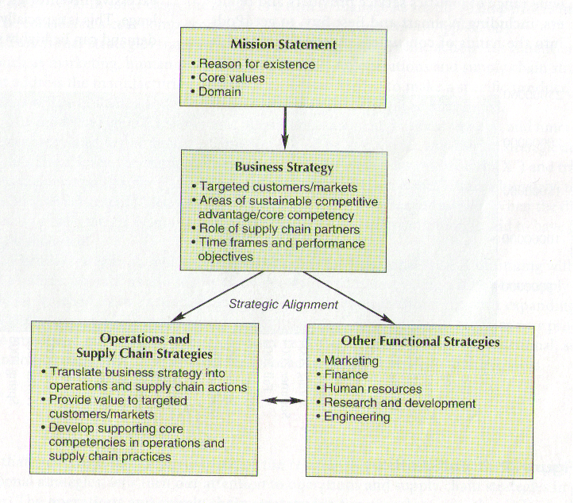

DAVID JOEL
3536
ASSIGNMENT #3
PAGE 3

1.(ii) What are tactical decisions about?

As defined by APICS Dictionary 15th edition, (2017) tactical plans or decisions are a “set of functional plans, these plans or decisions for example, includes production plans, sales plans and marketing plans”.
Tactical plans coordinate activities across functions or business units that specify production levels, funding levels, capacity levels, staffing levels for achieving the intermediate goals and objectives to support the organizations strategic plans.
Tactical planning decisions are made on the managerial levels. The decisions made at this level includes decisions on workforce levels, inventory levels, subcontracting and logistics decisions.
Tactical plans are concerned with executing the strategies the strategies over the medium term, they look at more detail, involve fewer resources and some risk. (Waters, 2002)
As explained by Bozarth and Handfield (2013), tactical planning covers shorter periods, like days or even hours. They went further to explain how Sales and operations planning will use the company’s tactical capacity resources to meet expected customer demand.

Figure 2: shows the tactical planning position in an organisation decision making process.

Tactical Planning Decision in an organisation (Source: Bozarth and Handfield, 2013)
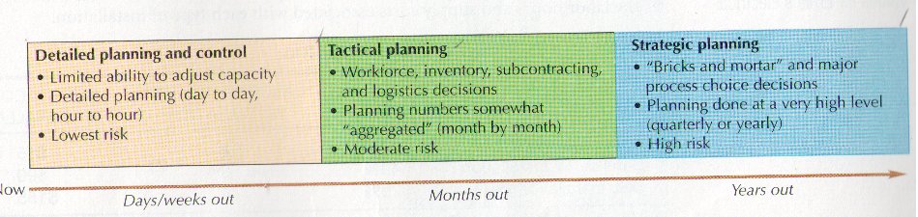

DAVID JOEL
3536
ASSIGNMENT #3
PAGE 3

1(iii) What is logistics strategy about?

Logistics strategy has been defined as the “plan for the logistics elements of a business- this includes warehousing, information systems, and transportation- that is aligned with the overall business strategy” APICS dictionary 15th edition, (2017).
Bozarth and Handfield (2013) explains that a logistics strategy ensures that an organizations logistics choices, that is, transportation, warehousing, information systems and even form of ownership – is in agreement with the business overall strategy. The logistics strategy should also support the performance dimensions that meets the need of the customers.
Waters(2002) explains that the logistics strategy forms a bridge between the more abstract, higher strategies and the detailed operations of the supply chain. Whilst the corporate and business strategies explains general aims, the logistics strategy concerns the actual movement of materials needed to implement mission statement.
Copacino (1997) has designed a logistics strategy pyramid to explain how logistics strategies interacts with the overall strategic decision of the organization. He explained how the logistics strategy pyramid allows issues that affects an organizations logistics that is, in areas of order management, inventory, transportation, warehousing, materials handling, and packaging to be analysed on four levels or four viewpoints in accordance with the strategic decisions on an organization.
The four levels are: Strategic, structural, functional and implementation.
In line with the strategic decisions of the organisation, the logistics strategy question will be as Copacino (1997) puts it “what are the basic and distinctive service needs of our customers in relation to the value proposition” of the company? “What must logistics do to meet those needs” Can the company’s logistics capabilities meet those needs? In order to deliver an enhanced, innovative customer service.
Also, in the structural level the next questions to ask that fits in with the strategic decision of the company are, should the company serve the market directly or use distributors or other intermediaries to reach customers, where to source materials, locate facilities, and mode of transportation and materials handling in order to reduce cost.
Furthermore, on the functional level, the logistics strategy is to deliver an efficient and effective operational practices that meets the requirements of the company’s strategic goals and objectives. This means as Copacino (1997) explains to achieve functional excellence in all departments of the company.
Lastly, how to implement the logistics strategy through information technology, following company’s policy and procedures, effective and efficient use of equipment and facilities.

Figure 3: Shows the Logistics Strategy Pyramid (Source: Copacino, 1997)

DAVID JOEL
3536
ASSIGNMENT #3
PAGE 4

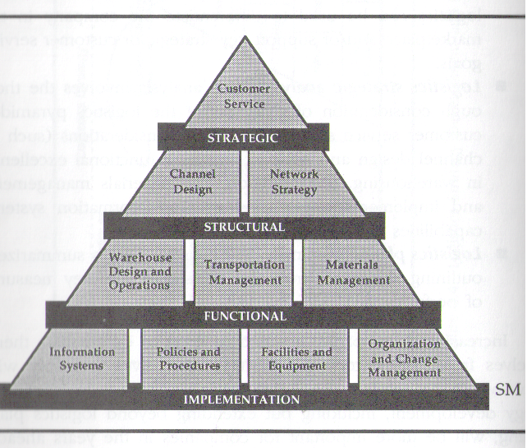

DAVID JOEL
3536
ASSIGNMENT #3
PAGE 5
1(iv) What is the value-added strategy about?

In order understand what value added strategy means, this paper shall look at the definition of differentiation strategy. Differentiation strategy has been defined as a “business strategy that focusses on setting a product or service apart from the competition-focussing on making the product or service unique.” APICS Dictionary 15th edition, (2017).
From this definition, value -added strategy is the ability to offer service or products that differentiates the company form its competitors thus providing competitive advantage for its customers.
Bowersox, et al (2002) suggests that when a firm becomes “committed to value-added solutions, it rapidly becomes involved in customised or tailored logistics aimed at providing unique or specific activities to enable specific customers to achieve their objectives thus encouraging the success of the customer’s business”.
As Christopher (1998) suggests “adding value through differentiation is a powerful means of achieving defensible advantage in the market, He equally suggests that equally powerful as a means of adding value is service”. So, service in this context means delivery service, after-sales service, financial packages and technical supports(Christoppher,1998)
Furthermore, a value-added strategy is about seeking service excellence through seeking greater responsiveness and reliability from suppliers, providing reduced lead time to customers, just in time delivery for customers’ other services that allows them to do a better job of serving their customers. (Christopher, 1998).i
In the same vein, Copacino (1997) suggests that value added strategy is about structuring a logistics system that serves customers as they want to be served-providing on-time deliveries or ready information on order status.
The ability to satisfy the consistent provision of time and place utility to the satisfaction of the customer is another aspect of value-added strategy.
As summarised by Christopher “the customer in today’s marketplace is more demanding, not just of product quality, but also of service.”

Figure 4 A customer service pyramid as part of a Value-added Strategy
Source: Adapted from (Copacino,1997)

DAVID JOEL
3536
ASSIGNMENT #3
PAGE 6

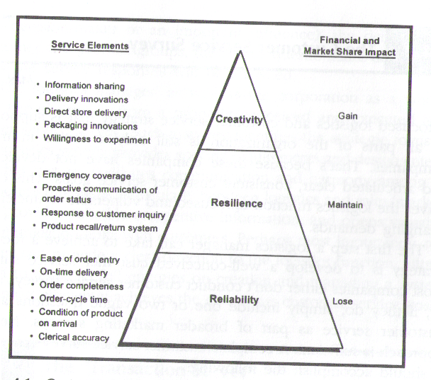

As shown in figure 4 above, Copacino, (1997) divides customer service into three segments, reliability, resilience and creativity.
Reliability involves(Copacino,1997) maintaining short order cycle times, delivering on time consistently, processing paperwork accurately and making damage free shipments.
Resilience is the ability to offer (Copacino,1997) an effective rush-order shipment capability, provide proactive communication of changes in order status and to maintain effective shipment-tracking capabilities and to respond to customers’ inquiries.
Creativity or innovation is the ability to develop (Copacino,1997) value added programmes for the customers, this includes services like dropping shipments to store locations, customised pallets building, innovations that reduces handling costs, and services tailored to individual customers’ needs.

1(V) What are the three factors to be considered when designing a logistics strategy?

There are three factors to be considered when designing a logistics strategy (Waters 2003). They are higher strategies, the business environment and the organisations distinctive competence.
(A)The higher strategies set the organisations goals and conditions for the company’s logistics decisions. Whilst the mission statements set the overall aims, the corporate

DAVID JOEL
3536
ASSIGNMENT #3
PAGE 7

and business strategies show how these aims will be achieved. In turn, the logistics strategy must the higher strategies. For example, if the focus of the business strategy is on customer service, the logistics strategy must show how this will be achieved.

https://momsocheat.files.wordpress.com/2013/05/foundemantal-of-logistic-management-ch2-logistics-strategy.pdf ( accessed 31/01/17)

(B)The business environment involves all the factors that affects an organisation, but which it cannot control (Waters 2003).
These are the customers-their expectations, attitudes and demographics.
Market conditions-size, location and stability. https://momsocheat.files.wordpress.com/2013/05/foundemantal-of-logistic-management-ch2-logistics-strategy.pdf (accessed 31/01/17)
Technology-current availability, likely developments and the rate of innovation.
Economic conditions-gross domestic product, growth rate and inflation. https://momsocheat.files.wordpress.com/2013/05/foundemantal-of-logistic-management-ch2-logistics-strategy.pdf. (accessed 31/01/17)
Legal restraints, competitors, shareholders, interest groups, social conditions, and political conditions. https://momsocheat.files.wordpress.com/2013/05/foundemantal-of-logistic-management-ch2-logistics-strategy.pdf (accessed 31/01/17)
Competitors-number, ease of entry to the market and strengths. https://momsocheat.files.wordpress.com/2013/05/foundemantal-of-logistic-management-ch2-logistics-strategy.pdf (accessed 31/01/17)

Shareholders- their target return on investments, objectives, and profit required. https://momsocheat.files.wordpress.com/2013/05/foundemantal-of-logistic-management-ch2-logistics-strategy.pdf (accessed 31/01/17).
Interest group-their objectives, strengths, amount of support. https://momsocheat.files.wordpress.com/2013/05/foundemantal-of-logistic-management-ch2-logistics-strategy.pdf (accessed 31/01/17)
Social conditions- customers lifestyles and changing demands. https://momsocheat.files.wordpress.com/2013/05/foundemantal-of-logistic-management-ch2-logistics-strategy.pdf (accessed 31/01/17)
Political conditions-stability, amount of governmental control and external relations. https://momsocheat.files.wordpress.com/2013/05/foundemantal-of-logistic-management-ch2-logistics-strategy.pdf (accessed 31/01/17)

(C) The distinctive competence, (Waters 2003) sets the organisation apart from competitors, and is defined by the factors that are under the control of the organisation, such as:
customer relations, -their demands, loyalty, relationships
employees’ skills, -loyalty and expertise

DAVID JOEL
3536
ASSIGNMENT #3
PAGE 8
finances, -cash flow, capital and debt

products, -reputation, quality and innovations.
facilities, -capacity, age, reliability
technology used, -current, plans, special types.
Suppliers-service, flexibility, partnerships
and resources available.

Figure 5 shows the factors in the design of a Logistics Strategy
SOURCE: https://momsocheat.files.wordpress.com/2013/05/foundemantal-of-logistic-management-ch2-logistics-strategy.pdf (accessed 31/01/17)

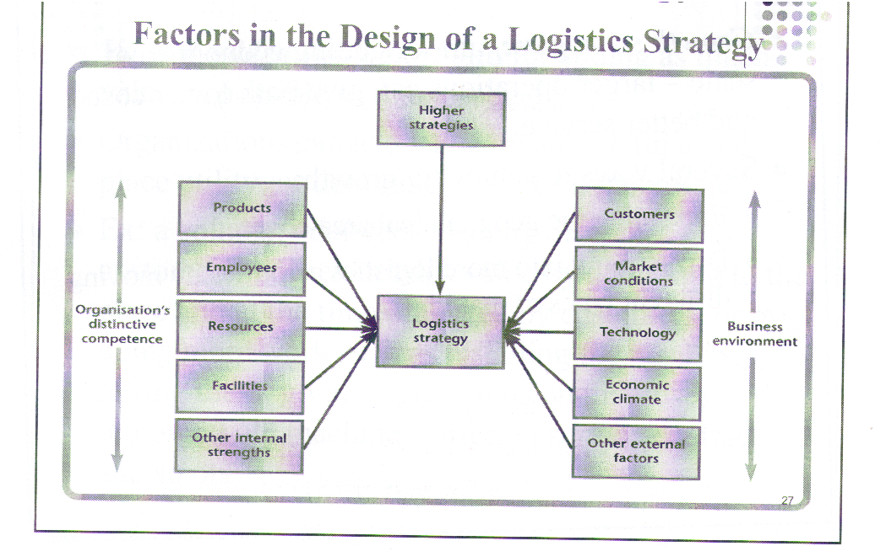

DAVID JOEL
3536
ASSIGNMENT #3
PAGE 9

1.(vi) How do logistics play a strategic role in an organisation?

According to Bowersox et al, (2002) in the context of supply chain management, logistics exist to move and position inventory to achieve desired time, place, and possession benefits at the lowest total cost. Looking at logistics from that perspective, a logistics strategy ensures that organisations decision choices (Handfield et al, 2006)- transportation, warehousing, information systems and even form of ownership- are consistent with the company’s overall business strategy.
Similarly, Waters (2003) states that some decisions in logistics have a strategic importance.
For instance, he says that the design of the supply chain of a company has a logistics tone. The sourcing policies of a company is also affected by its logistical inclinations. A company’s relationship with its customer is also determined by the logistics strategy
of the business. Also, a company’s alliance with its suppliers, methods of procurement, modes of transportation of inventories or goods, location of facilities, size of operations and the level of automation are all determined by the logistics capability of the company.
Bowersox et al, (2002) provides a visual representation of the interrelated nature of the five areas of logistics work to emphasise the strategic importance of logistics in an organisation. This they called integrated logistics. The five areas are order processing, inventory management, transportation, warehousing, materials handling and packaging and facility network. Consequently, decisions in these areas has a strategic implication for any organisations in the conduct of its mission statements.

Figure 6 shows the strategic relationship of an integrated logistics
SOURCE: Adapted from Bowersox et al, (2002)

DAVID JOEL
3536
ASSIGNMENT #3
PAGE 10

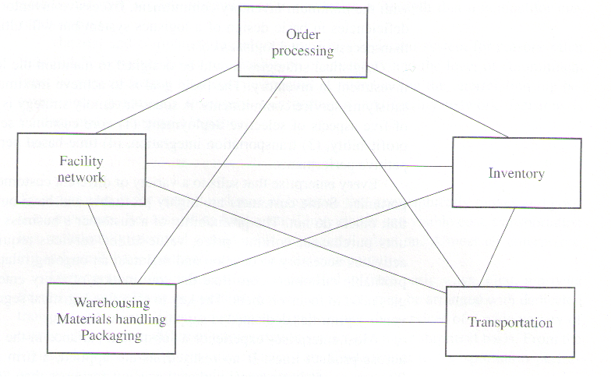

DAVID JOEL
3536
ASSIGNMENT #3
PAGE 11

1.(vii) Outline the main area that a logistics strategy emphasises.

According to Waters (2003) cost, customer service, timing, quality, product flexibility, volume flexibility, technology, and location are some of the areas that the logistics strategy plan of an organisation will most likely emphasize.
Cost – most businesses long for low costs, but some support a positive strategy of shrinking their logistics costs. This has the effect of increased profit for the business and a lower price for the customers. http://dlia.ir/Scientific/e_book/Social_Sciences/Industries_Land_use_Labor/HD_28_70_Management_Industrial_Management_/002491.pdf accessed 31/01/17.
Customer service-logistics directs stock levels, delivery times, speed of response, and other rates of customer services. By concentrating the logistics strategy on customer service, organisations can get a long term competitive advantage.
http://dlia.ir/Scientific/e_book/Social_Sciences/Industries_Land_use_Labor/HD_28_70_Management_Industrial_Management_/002491.pdf 31/01/17
Timing- customers preferably want their items as soon as possible, so a standard logistics strategy guarantees faster deliveries. Timing can also indicate a quick supply of new products, delivering at the time determined by the customer. http://dlia.ir/Scientific/e_book/Social_Sciences/Industries_Land_use_Labor/HD_28_70_Management_Industrial_Management_/002491.pdf accessed 31/01/17
Quality-customers expect higher quality in all items a common logistics strategy satisfies high quality service, even though it can be difficult to say define what high quality logistics means. http://dlia.ir/Scientific/e_book/Social_Sciences/Industries_Land_use_Labor/HD_28_70_Management_Industrial_Management_/002491.pdf accessed 31/01/17.
Product flexibility- this is the potential of an organisation to adapt products to individual specification. http://dlia.ir/Scientific/e_book/Social_Sciences/Industries_Land_use_Labor/HD_28_70_Management_Industrial_Management_/002491.pdf accessed 31/01/17
Volume flexibility-different levels of business can cause extreme problems’ for logistics, as can be observed during rush – hour periods in major cities. Volume flexibilities enables an organisation to react quickly to fluctuating levels of demand. http://dlia.ir/Scientific/e_book/Social_Sciences/Industries_Land_use_Labor/HD_28_70_Management_Industrial_Management_/002491.pdf. Accessed on 31/01/17
Technology-logistics employs a wide range of technologies for communications, tracking loads, sorting parcels, identifying products, recording stock movements, some organisations have adopted a strategy of developing and using up to date technologies. http://dlia.ir/Scientific/e_book/Social_Sciences/Industries_Land_use_Labor/HD_28_70_Management_Industrial_Management_/002491.pdf accessed 31/01 17
Location- one logistics strategy is to provide a service in the best possible location as customers will want their items to be delivered closer to them. http://dlia.ir/Scientific/e_book/Social_Sciences/Industries_Land_use_Labor/HD_28_70_Management_Industrial_Management_/002491.pdf

DAVID JOEL
3536
ASSIGNMENT #3
PAGE 12
1(viii) What is lean strategy?

A philosophy of production that emphasizes the minimal use of all the resources-people, space, stock, equipment and time- used in the various activities of the enterprise. APICS Dictionary, 15th edition (2017).
It includes identifying and eliminating non-value- adding activities in design, production, in supply chain management and also in dealing with customers. APICS Dictionary, 15th edition (2017).
Lean producers employ teams of multi-skilled workers at all levels of the organisation, and use highly flexible, increasingly automated machines to manufacture volumes of products in potentially huge varieties. APICS, 15TH Edition (2017).
Lean production contains a set of principles and practices to reduce cost through the relentless removal of waste and also through the minimisation of all manufacturing and support processes. APICS Dictionary, 15th Edition (2017).
Just-in-time (JIT) a philosophy of manufacturing based on planned elimination of all waste and on continuous improvement of productivity is used synonymously with lean (Bozarth and Handfield, 2002).
Waste has been defined as any activity that does not add value to the good or service in the eyes of the consumer. APICS, 15th Edition (2017).
Bozarth and Handfield have listed eight commonly recognised sources of waste. Citing Taiichi Ohno, a Toyota engineer, as the originator of the idea of lean strategy.
- Overproduction. Inflexible or unreliable processes may cause organisations to produce goods before they are required.
- Waiting. Inefficient layouts or an inability to match with output levels may cause waiting. (Bozarth and Handfield, 2002).
- Unnecessary transportation. Transporting goods always increases costs and the risk of damage, but it does not necessarily provide value to the final customer. (Bozarth and Handfield, 2002).
- Inappropriate process. Companies sometimes use overtly complex processes when simpler, more efficient ones will do. (Bozarth and Handfield, 2002).
- Unnecessary inventory. Uncertainty with regard to quality levels, delivery lead times, can lead to unnecessary inventory. (Bozarth and Handfield, 2002).
- Defects. Not only do defects create uncertainty in the process, they rob production capacity by creating products or services that require rework or must be scrapped. (Bozarth and Handfield, 2002).
- Unnecessary/excess motion. Poorly designed processes can lead to unnecessary motion. (Bozarth and Handfield, 2002).
- Underutilisation of employees. This is the newest form of waste added to the list, and it recognises that too often companies do not fully utilize the skills and decision-making capabilities of their employees. (Bozarth and Handfield, 2002).

DAVID JOEL
3536
ASSIGNMENT #3
PAGE 13

Waters (2002) explained that the concept of lean production was successful that it developed into a “lean enterprise” which focussed on five principle values.
Value – designing a product that has value from a customer’s viewpoint
Value stream- designing the best process to make the product
Value flow – managing the flow of materials through the supply chain
Pull- only making products when there is buyer demand
Aim of perfection- looking for continuous improvements to get closer to the aim of perfect operations.
According to Waters (2002), the mapping of different value streams has taken up a significant amount of work time from the Lean Enterprise Research centre. The frequently used value stream mapping tools is shown in figure 7 below and also the model of their value stream management method is shown in figure 8 below.

Figure 7
Frequently used value stream mapping tools
SOURCE: Adapted from Waters (2002)

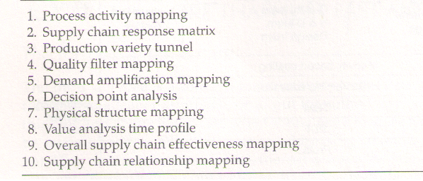

DAVID JOEL
3536
ASSIGNMENT #3
PAGE 14

Figure 8
Shows the outline steps of the LEAP programme (value stream management method)
SOURCE: Adapted from Waters (2002)

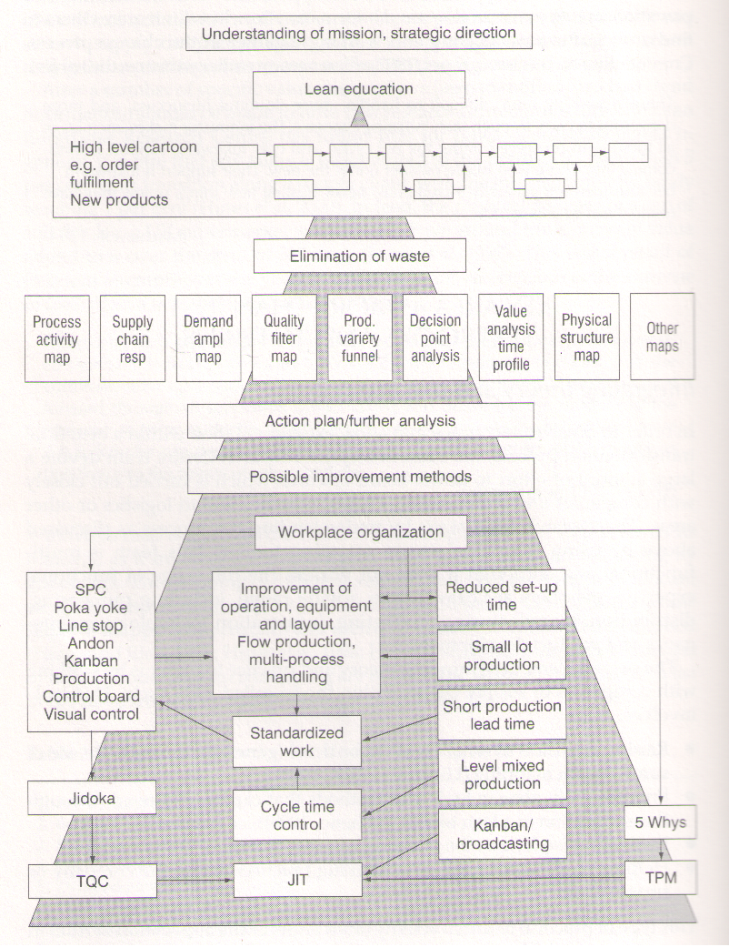

DAVID JOEL
3536
ASSIGNMENT #3
PAGE 15

1.(ix) What is the main purpose of logistics audit in organisations?

The main purpose of a logistics audit in an organisation is to “collect relevant information about existing practices and performance of logistics. It gives a systematic review of current operations, describing the procedures, costs, resources, utilisation, performance, products, and all relevant other details.” Waters (2002)
According to Waters (2002) there are two essential parts to a logistics audit. Firstly, getting information about the business environment and secondly, the business distinctive competence.
The first part which is the business environment examines the external audit. This identifies the location in which the logistics operates. It reviews the followings:
- The nature of the customers
- Types of demands
- Accepted service levels
- Locations
- Competitors and their operations
- Benchmarks and comparisons
- Services available
- Trends in the industry
- Economic conditions
- Geographical and political constraints.
The second part of the logistics audit examines the internal environment of the business. It investigates the way things are conducted within the organisation and highlights areas for improvements. It reviews the followings:
- The structure of the supply chain of the organisation
- The location of its warehouses and size
- Stock holdings
- Methods of materials handling
- Achieved service levels
- Lead times
- Transport arrangements
- Order processing
- Damages
- Productivity
The above procedures according to Waters (2002) corresponds to a SWOT analysis which catalogues an organisation’s strengths, weaknesses, opportunities and threats.
Using the SWOT analysis methodology, the logistics audit can get a clear idea of the current operations of the organisation.
- Strengths -what the organisation does well, qualities that it should build on, this looks at the organisations internal operations and shows its distinctive competence.
David Joel
3536
Assignment #3
Page 16

- Weaknesses -problems the organisation is facing, and the areas that needs improvements. This again looks at the internal operations of the business and its distinctive competence.
- Opportunities-openings that can help the organisation, this is from the external business environment
- Threats- hazards that can damage the organisation, this also is external to the organisation.

From the information gathered through the logistics audit, the organisation can assess its current performance and check the aims of its logistics as it is set out in its mission statements.

David Joel
3536
Assignment #3
Page 17

2. Outline the steps involved in developing a logistics strategy.

Waters (2002) has suggested eight steps for designing a logistics strategy.
- Execute a logistics audit.
As mentioned above, there are two parts to a logistics audit. The external audit gives an analysis of the business environment and then shows the factors that can lead to success in this environment.

- The second part of the logistics audit is the internal audit which analyses higher strategies from a logistics viewpoint, showing the conditions and overall aims for logistics, its strategic focus and also includes a logistics mission.
- Design the general features of the supply chain that can best deliver the desired services. This will involve the design of the network, location of facilities, capacity, and the technology to be used in the business.
- Set definite goals to show what each logistics activities must achieve. The internal audit will look into how well the current logistics have achieved this objective and suggest areas that needs improvement.
- Design the best organisational structure, controls and systems to support the logistics network.
- Benchmark logistics. This involves examining the performance of leading organisations, defining what measures to follow, comparing actual performances with the planned, optimal and with the competitors’ performances.
- Enforce the strategy, setting the conditions for the lower levels of logistics decision making.
- Follow up on actual performance, endlessly looking for corrections, keeping the strategies up to date, giving feedbacks on performances.

Copaccino (1997) recommended four elements to be included for the logistics strategy development and planning.
- Critical inputs- understanding company’s strategy, customer service requirements, view of competitor’s approaches, insight into external factors as mentioned above on page one.
- Visioning sessions- meetings with managers from the functional areas of the company in order to find out how logistics can be used to differentiate the company in the market place and how to support key strategic or customer service goals.
- Logistics strategic analysis-this involves a thorough analysis of all levels of the logistics pyramids as discussed earlier on page three.
- Logistics planning -finally the logistics plan is summarised, outlining objectives, programmes, milestones, and key measures of performance.

David Joel
3536
Assignment #3
Page 18

Figure 9 shows Copacinos (1997) logistics strategy development and planning process

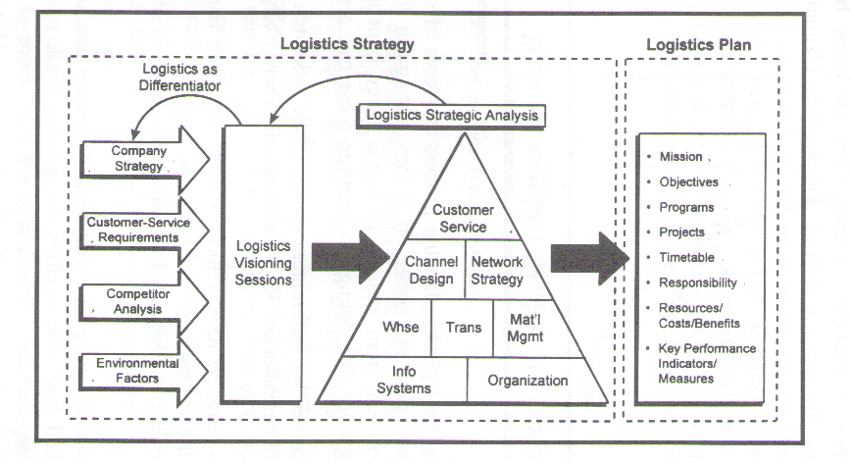

SOURCE: Adapted from Copacino (1997).

David Joel
3536
Assignment #3
Page 19

2. Case Study.
How does Charlotte currently organise her business?
Charlotte currently organises her business around cost leadership and product differentiation.
Cost leadership- because she makes the same or comparable products more cheaply.
Charlotte has diversified the business from a dairy farm and traditional crops. To a herbs manufacturing and processing business.
From her herbs, she is making new range of herb products,
- Making products for cooking (sauces, dressings and marinades)
- Making perfumes (posies, potpourri and sachets of dried herbs)
- Making healthy stuff (herb mixtures traditionally said to have beneficial effects)
Product differentiation- because she is selling unusual souvenir and unusual herbs. - these are products that customers cannot get from other suppliers.
- She runs her own unique holiday home
- Her visitors centre
- Shows her herb growing processes to tourist
- Shows how she prepares her own herbs
- Operates a herb kitchen
- Taste various samples of foods on her farm.
- Turned the farm into a tourist attraction.
Charlotte organises a business under a customer focussed approach.
She reacts to customer needs and she also keeps a close check on demands and she reacts quickly to changes. She is also able to tailor logistics demands from individual customers. it can be said that she puts a high emphasis on customer satisfaction by the varieties of herb products that are available for customers to choose from.
Charlotte is also organising her business by adding value to the herbs products that she is processing.
Charlotte is also following an agile strategy in her business organisation.
She is also organising her business through a diversification and specialised sales of herbs produce.
She is also following a time-based strategy.
Charlotte is expanding her business through a growth strategy of expansion.
Charlotte is also organising her business through direct-deliveries by taking orders through the business website.

What do you think are her aims and priorities?
The expansion and growth of the business is her main aims and priorities with the end result of generating additional income or profit. Her aims and priorities can be summarised as:
- Low costs- to run the business
- Customer service- in order to achieve long-term competitive advantage.

David Joel
3536
Assignment #3
Page20

- Timing- making the products available to the customers at the right time and in the right place.
- Quality – her products satisfies her customers, that is why she is able to expand and retain her customers.
- Product flexibility – she has introduced varieties of herbs.
- Volume flexibility- she is able to satisfy the orders that the customer has placed.
- Technology- she is using the mail-orders and the internet to promote her business.
She is using the product, place, promotion and price principle in her business.

What would be the effect of the expansion on logistics?
- Cost- It will cost her more to expand the business, this will involve more order processing, more inventories, more transport cost to move the goods, warehousing cost, materials handling cost and packaging. On the other she will have more share of the market and more income generation

What problems will Charlotte face?
As logistics is the movement and storage of materials as they move through the supply chain, the expansion of Charlottes business will have effect in the following areas of logistics:
- In the area of procurement or purchasing, goods or inventory will have to be processed from the new location, the raw materials will have to be transported from the local farm to the new processing facilities.
- Here emphasises the transport of the materials from the local farm to the industrial plant where the herbs will be processed. Transport cost is the issue here.
- Receiving-is the ability to make sure that materials delivered to the customers agrees with the order that was requested, receipts are acknowledged, vehicles carrying the raw materials are unloaded, inspected and damages to goods are sorted.
- Warehousing or stores- since the business now caters for direct sales through the internet, the business will need a warehouse to store the inventories and to distribute them to customers when they are needed
- Stock control- the inventory in the warehouse has to be monitored to meet the demands of the customers
- Order picking- this involves sorting and picking orders for customers.
- Materials handling-this involves moving materials from one part of the plant to another for packaging and distribution
- Outward transport- this involves transporting customer orders

David Joel
3536
Assignment #3
Page21

- Physical distribution management-this is the actual distribution of the materials to the customers.
- Location- this is finding the best location nearer to the raw materials and the customers.
- Communication-this involves communicating with all the participants in the supply chain.
- Direct cost-the cost of operating the new facilities
- Indirect cost- taxes and government regulations

What options does she have to overcome them?

- Examine the overall aims- Charlotte should look at the strategic plans of her organisation to identify her aims and goals in terms of customer service, costs, timing and deliveries of the materials to the customers.
- Do a logistics audit- Charlotte should do a logistics audit of the present logistics system and identify areas that needs improvement.
- Location decisions- Charlotte should look at the details of the facilities needed, find the best location and sizes for the facilities.
- Implement and monitor the solutions- Charlotte should implement and monitor the new facilities to ensure the performance of the facilities meets her aims.
- Identify the features needed in the new location.

