
Assignment Cover Sheet

Student Name: | Raymond Wilson
Student Number: | 2362
Course: | Diploma in Logistics and Supply Chain Management
Assignment No: | 7
Marking Criteria:
We expect the learners to write minimum one well expressed point in three lines against each allocated mark. This means one needs to write 15 lines with 5 well expressed points to get high grades for a 5 marks question.
For high grades use examples and illustrations where appropriate.
Assessment #7 Market Distribution in Supply Chain Total Marks: 30

- Give short answers for the following questions: (15)

i. What is distribution in a supply chain? What are the channels of distribution? And
how do they work?
A distribution channel is simply a chain of companies or intermediaries which goods or services pass through until it reaches the end consumer. It normally includes wholesalers, retailers, distributors and nowadays even the internet itself. Channels are split into direct and indirect forms, with a "direct" channel allowing the consumer to buy the goods/services from the manufacturer, and an "indirect" channel allowing the consumer to buy the goods/services from a wholesaler or retailer.
This distribution channel therefore is the route by which all goods and services must travel to arrive at an intended consumer. On the other hand, it is also used to describe the pathway that payments make from the end consumer to the original seller.
While a distribution channel can sometimes seem endless, there are three main types of channels, all of which include a combination of a producer, wholesaler, retailer and end consumer. These are;
- The first channel is the longest in that it includes all four, from producer to the end consumer. This channel operates in what is known as the three-tier system, meaning the producer is required by law to first sell its product to a wholesaler, who then sells to a retailer. The retailer, in turn, sells the product to the end consumer.
- The second channel is one where the producer sells directly to a retailer, who then sells the producer's product to the end consumer. This means the second channel contains only one intermediary.
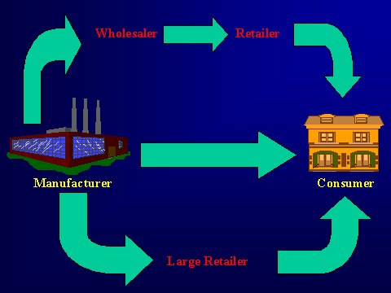
- The third channel type is a direct to consumer model where the producer sells its product directly to the end consumer. A perfect modern day example of this is Amazon, using its own platform to sell Kindles to its customers, which is the shortest distribution channel possible.

ii. Who are the channel participants in a distribution process?

Manufacturers (producers) only create the goods but it is the intermediaries who supply these goods to the people and companies who are in need of them. To reach end consumers effectively, businesses need a seamless set-up. The network includes manufacturers, retailers, wholesalers, agents and brokers commonly known as channel participants.
These listed participants will play a vital role in success and failure of any business. They actually bridge the gap between suppliers and end consumers thus framing the outline for a company in end users mindset. In the world of selling, several types of participants make up a distribution channel. Some of these might overlap each other because of the simple reason that retailers belong to several supply chains, each group focused on making and marketing different products. The participants are as follows;

Producers/Manufacturers:

Producers are entities that creates animal, botanical, or other agricultural products through natural processes, usually by stimulating them with labor, nutrients, and other means. Manufacturers make goods through a process that involves raw materials, components, or assemblies, usually on a large scale with different operations divided among different workers.

Wholesalers:
Wholesalers are intermediaries or middlemen who purchase products from manufacturers and resell them to the retailers. They take the same types of financial risks as retailers, since they buy the products, keep them in inventory until they are resold to retailers, and they often arrange for shipment to those retailers. Wholesalers can gather products from around a country or region, or they can buy foreign product lines by becoming importers.

Retailers:
Retailers are the gate keepers to the marketplace for all other associates of the sales distribution process. The unique feature that sets a retailer apart from other members of its distribution channel is that the retailer is the person who ultimately sells the goods to its end consumers.
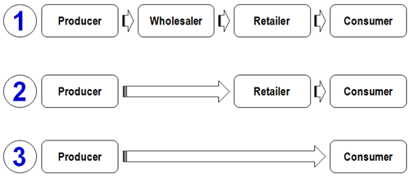

Consumers:
Usually individuals who buy product/services for personal use and not for manufacture or resale. A consumer is someone who makes the choice as to whether or not they will purchase an item at the store, and is someone who can be influenced by marketing and advertisements.
Agents (occasionally called brokers and not illustrated in the caption above) are also intermediaries who work between suppliers and retailers, but their agreements are different, in that they do not take ownership of the merchandises they sell. They are independent sales representatives who typically work on commission based on sales volume, and they can sell to wholesalers as well as retailers.

iii. What is the importance of market coverage decisions in a distribution process?

Salespeople must take into consideration many factors when choosing the right level of distribution coverage. However, all sellers should understand that distribution creates costs to the organization and some of these expenses can be passed along to customers (e.g., shipping costs) but others cannot (e.g., the companies need for additional staff to handle more distributors). Therefore the method of determining the right level of distribution coverage often comes down to an analysis of the benefits (e.g., more sales) versus the cost associated with gain the benefits.
There are three main levels of distribution coverage - mass coverage, selective and exclusive which as summarized as follows;
- Mass Coverage – The mass coverage (also known as intensive distribution) strategy endeavours to distribute goods extensively in nearly all locations in which that type of product is sold. This level of distribution is only feasible for relatively low priced products that appeal to very large target markets. A product such as Pepsi-Cola is a typical example since it is available in a wide variety of locations including supermarkets, convenience stores, vending machines, hotels and many more. With such a large number of locations selling the product the cost of distribution is extremely high and must be offset with very high sales volume.
- Selective Coverage - Under selective coverage the seller purposefully seeks to limit the places in which his type of product is sold. The reason of this strategy is tied to the size and nature of the product’s target market. Products with selective coverage appeal to smaller, more focused target markets (e.g., see consumer shopping products such as designer clothes, cosmetics etc.) compared to the size of target markets for mass marketed products. Consequently, because the market size is smaller, the number of locations needed to support the distribution of the product is less.
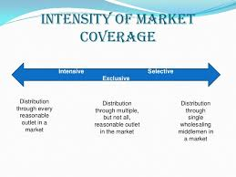
- Exclusive Coverage - Some high-end goods target very fine and specific markets that have a relatively small number of customers. These customers are often characterized as “discerning” in their taste for products and seek to satisfy some of their needs with high-quality, although usually expensive products. These buyers of high-end products usually also require a high level of customer service from the channel member from whom they purchase. These requirements and features of the target market may lead the marketer to sell their products through a very select or exclusive group of resellers. Another type of exclusive distribution may not involve high-end products but rather products only available in selected locations such as company-owned stores, such as NIKE, Channel and the like. While these products may or may not be higher priced compared to competitive products, the fact these are only available in company outlets give exclusivity to the distribution.
It is worth noting that while the three distribution coverage options detailed above serve as a guide for predicting how distribution intensity works, the advent of the Internet has brought into question the effectiveness of these established schemes. Basically all products available for purchase over the Internet are distributed in the same way - mass coverage.
Mindful of the factors affecting distribution decisions (i.e., marketing decision issues and relationship issues), the marketer therefore has several options to choose from when settling on a design for their distribution network. For marketers the choice of distribution design comes down to the following options;
- Direct Distribution Systems
- Indirect Distribution Systems
- Multi-Channel or Hybrid Distribution Systems

iv. How would you differentiate between conventional channels and single transaction
channels?

Conventional marketing channels clearly consist of one or more of manufacturers, wholesalers/distributors and retailers that operate under independent ownership. Each of these independent businesses answers to its own owner, shareholders and/or board of directors. In a vertical marketing system model, one member of the channel either owns or wields sufficient leverage to control and coordinate the activities of other members in the channel. These channel members continue to operate as distinct entities but become accountable to one owner or the most powerful channel member. ASDA, for example, exerts sufficient power to direct much of the activity of manufacturers and wholesalers, while Bridgestone owns all the elements of its marketing channels.
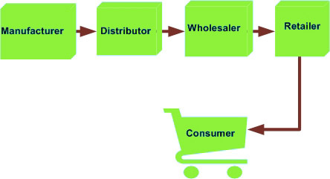
As independents these entities of a conventional marketing channel focus on minimizing costs and maximizing its own profits with little regard for other channel members. A powerful chain of supermarkets, for example, might negotiate a favorable deal with a wholesaler and give no consideration to the impact of that deal on the relationship between the wholesaler and various food producers and suppliers. Members in vertical marketing systems however tend to recognize the symbiotic nature of the relationship between all channel members and aim to maximize benefits through cooperation.
Conventional marketing channels, by default, limit the responsibility of each member of the channel. Retailers clearly focus efforts on selling products to customers, while manufacturers focus on making products and wholesalers fret about getting the goods from one to the other. In a typical vertical marketing system, the majority of responsibility tends to fall on one channel member. The larger the company is means this additional responsibility tends to pose fewer problems due to larger and usually strong management teams. Contrary for a smaller company involved in vertical integration, the management problems can prove significant.
 A great number marketing transactions arise in supply channels with the acceptance that the trade will be a one-time occurrence and not repeated. Examples of single-transaction channels include, construction, international trading, capital equipment purchasing, real estate sales and bond ownership transfer but to name a few.
These forms of supply channels are normally temporary and founded for the sole purpose of facilitating a unique transaction. Once completed, the basis of the channel is no longer required and is closed. Although unique in nature if the transaction becomes successful to all parties this may lead to future business and a case by case basis or on a more permanent conventional market basis.

v. How can logistics operations affect the pricing?

Transportation is one of the most important elements in determining an organization’s overall logistics costs. Companies are constantly trying to figure out the most efficient and cost-effective way to get their products from source to client. What factors and trends determine the best way to deliver your products? What factors influence freight demands?

Detailed below are some of the current market influences that need to be considered and input into a company’s decision making process and/or transportation demand;
- Shrinking capacity; The economy, an acute driver shortage, government regulations, and other factors are tightening capacity in the freight industry.
- Tightened budgets; When looking to cut costs and improve profit margins, companies tend to look at transportation as one of the first functional areas to save on costs.
- Economy; Trends or changes in the national or regional economy affect the manufacturing and distribution process therefore affecting the demand for transportation. Clearly Brexit, for instance, is having and influence in the UK at present but it is too early to determine what effect this will have.
- Developments in technology; Technological advances have streamlined and increased the productivity of company operations, created efficiencies for drivers and optimized the overall freight management process.
- Lead time; Advanced lead time notice can have an incredible effect on a shipper’s freight spend. It is advantageous for hauler’s to make sure that their internal functional areas are clearly communicating as to when product will be ready to ship. Giving as much advance notice as possible to 3PL or carriers will also help reduce shipping costs. Ample lead time could also provide you with different diverse options such as rail or barge which could prove to be much more cost effective.
- Equipment type; The best type of equipment to move products should always be considered, initially and at periodic reviews. Keeping to a particular type of equipment to ship products could very well affect the bottom line freight spend. It could be more cost effective to use a specific type of equipment from time to time.
- Driver-friendly facilities; It is important for shippers these days to provide “driver-friendly” facilities. The logistics team need to communicate and work with the drivers so the whole process becomes more efficient especially at load times. Some of the larger facilities are maintaining driver break rooms to include showers, vending machines and the like and all of these factors and more are contributing to stronger relationships between shipper and carrier.
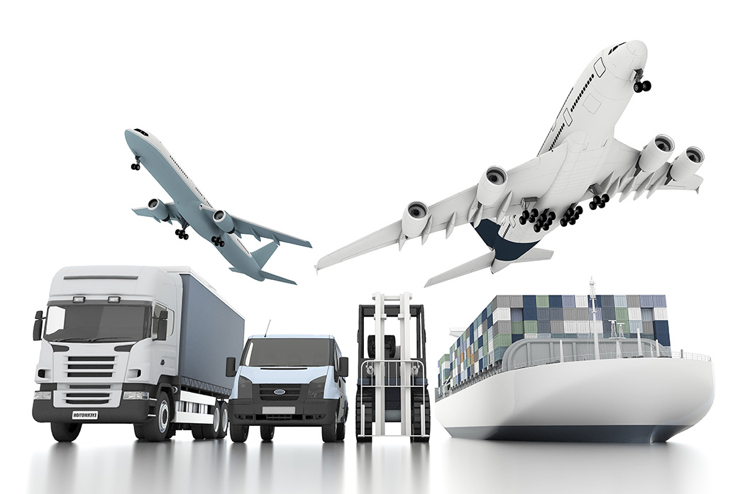
Obviously all of the above comes at a cost and this is another aspect of marketing plan that directly works in partnership with logistical operations. Management must ensure that contracts between entities clearly defines pricing breakdown that will decide which party has accountability for performing differing types of the logistics activities. These correct pricing practices have a conventional bearing on the timing and control of logistical operations.

Historically the price of products and materials included transportation and logistical costs but nowadays most companies acknowledge that services like transportation are now recognized as separate items and costed accordingly.
2. Discuss the fundamentals of pricing strategy in supply chain management. (7)
It is important that accountability is determined with regards to pricing, logistics activities, title and liabilities. The following are the two main methods adopted by the business;
Free on board (FOB) is a contractual term that refers to the requirement that the seller deliver goods at the seller's cost via a specific route to a destination designated by the buyer. The example below demonstrates how FOB works;
A breakfast cereal dealer purchases 500,000 boxes of cereal from Company XYZ. Company XYZ manufactures the cereal in Malaysia which will then be sold in shops around the UK. If the purchase contract says "FOB, ABC warehouse, Portsmouth, UK" this means Company XYZ will pay the loading and shipping costs to get the cereal from its Malaysian factory to the ABC warehouse in the UK. The cereal becomes the property of ABC once it arrives at the warehouse, meaning that if the consignment of boxes are lost, destroyed, or stolen on the way to the UK, Company XYZ is liable because it still owns the goods while they're in transit. Likewise, if they are lost, destroyed, or stolen after they reach the ABC warehouse, they are liable.
FOB terms and conditions will always indicate when the risk of loss shifts from the seller to the buyer. This are important especially to participants in international transactions and particularly for contracts involving delicate items or items that are vulnerable to theft.
The example above illustrates the concept of FOB Destination, which is the standard and most common FOB term. But some contracts use FOB Origin pricing model, as illustrated below with numerous other models, whereby the buyer becomes the owner at the time and place the product originates. Buyers may prefer FOB Origin terms if they feel they can get a better deal on shipping than the seller can. It is important to note that the Uniform Commercial Code (UCC) generally assumes a transaction's terms are FOB Origin if a purchase contract has no specific FOB language in it. This makes the buyer responsible for freight and damaged goods.
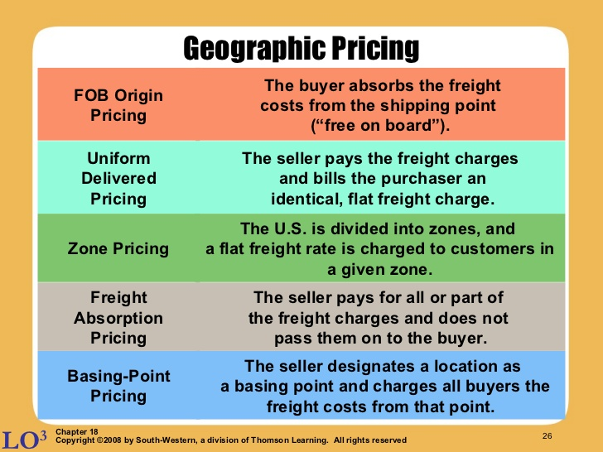
The delivery price, often known as Uniform Delivery Price (UDP), is the price at which one party agrees to deliver the fundamental commodity and at which the recipient agrees to accept delivery. Delivery price can also refer to a stock's selling price in options contracts. Delivery prices are set by clearinghouses.
This model is based on a type of pricing in which the buyer would be able to buy at the same price irrespective of its location. Here the seller includes the transportation charges and keeps the price same for all the locations in that zone. Hence the demand doesn’t get affected by the distance from which the goods are procured.
There are other variations of the main two pricing models to consider whereupon the seller pays the transportation charges of delivering the product to the customer and accounts for it in the price of the product such that it is same for all customers. In these models, the seller owns the product till it is delivered and these are illustrated above and detailed as follows;
- Single-Zone Pricing
Single-Zone Pricing: In this type of UDP model, the seller charges all the customers the same delivered price. This is also known as single zone price or postage stamp pricing. Most of the time sellers form zones depending upon the location and keeps the price same anywhere in that zone. But different prices may be charged for different zones.
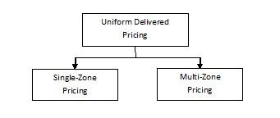
- Multi-Zone Pricing
Multi-Zone Pricing: In this type of UDP model, geographical areas served by the seller are further divided into zones, depending on the distance from the seller’s dispatch point’s location. Customers in different zones (i.e. across zones) are charged differently but all customers within one zone pay the same delivered price.
- Freight Absorption Pricing & Basing Point Pricing
See the narratives within the illustration above for details
3. “Channel mapping and matrix approach are of significant importance for a channel design process.” Discuss this here. (8)
When developing the companies channel map, it is important to work, if possible, with a willing, engaged counterpart manager from the customer. He or she will help you understand the customer’s operation and estimate the costs, and in the process this will help develop a close working relationship.
The second step in channel mapping is simply to trace the product flow through both companies, identifying each step in the process. Very quickly, the important points of leverage will be seen. Typically, a number of costly redundant functions will be found, and this will unearth some key points of information, that is readily available in one company, that will really help the other.
The third step is to approximately estimate the steps in the process. As with profit mapping, a 70% accurate information model is almost always sufficient. At this stage of the process, it is very important to be comprehensive in costing and consider all the pre-requisites, as illustrated below.
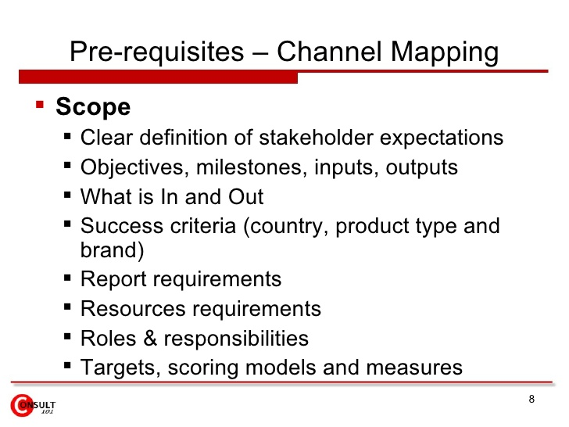
In addition to the three steps already identified an alternative method should be considered at this stage which is known as the matrix approach. Most companies have distribution channels that serve numerous clients and matrix approach entails extending the concept of separation and provides insight into the most appropriate participants and structures to accomplish objectives. As can be demonstrated in the illustration below;
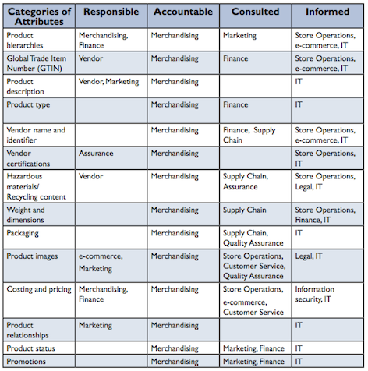
Once a step-by-step understanding of the intercompany product flow are completed, and an estimate of the cost of each step, opportunities for improvement will literally jump off the page. This valuable new view almost always shows very easy, lucrative opportunities to quickly improve profitability for both companies.
Channel mapping however is not a one off event and needs to become a core component of the company’s profitability management process (especially for the key accounts in their portfolio). Every element in the process is hugely beneficial and if regular review work is carried out with key customers on the channel map, managers will develop close, trusting relationships with their customer counterpart managers.
Company managers, and their customer counterparts, then need to use the developed and revised channel map to discover opportunities for profit improvement, and this will also initiate a broader set of managers in both companies to develop comfortable patterns for working together. They will have many occasions for easygoing talks in which they will get to know each other’s deeper hopes and concerns and this will naturally lead both to work together to develop new ways to create mutual value.
In this way, channel mapping, which starts as a way to develop operating efficiencies, transforms naturally into a core element of an extremely productive strategic partnership. When this is achieved both company and customer will strongly and steadily grow their market share and profitability for years to come.
It is worth remembering, that developing the same ultra-productive relationships with your key suppliers as well, will also help harvesting profit and strategic benefits for years to come. Upstream or downstream, channel mapping is the key to ongoing success.

Student Statement:

By submitting this assignment, I confirm that this is my own work.

Student Signature | Raymond Wilson | Date | 23rd Oct 2016

For Tutor / Assessor Use Only
Total Marks
Marks Obtained
Percentage / Grade

