
Assignment Cover Sheet

Student Name: | Karl Goodwin
Student Number: | 3870
Course: | Diploma in Construction Management level 4
Assignment NO: | No 5

Marking Criteria:
We expect the learners to write minimum one well expressed point in three lines against each allocated mark. This means one needs to write 15 lines with 5 well expressed points to get high grades for a 5 marks question.
For high grades use examples and illustrations where appropriate.
Please insert your completed assignment ( in word format) here:

Site Organisation

1. Give short answers for the following questions: (20)

i. What do you understand by the term ‘site organization’?
My understanding of Site organisation, would come under “Housekeeping”.
How organised is the Site Manager’s paperwork is it filed correctly in the correct folders are they up to date, are the RAM’s updated correctly etc.
This Site Organisation should be managed from the top all the way down to the bottom layers of the site.
Its everyone’s responsibility to make sure the site is safe and well organised.

These basic checks should include all stocked items like materials, tools, vehicles and anything else that will need to be stored. Here are a few examples of site organisation:

- Items will need to be stored away from all elements of the weather as best as practicably possible.
- Protection from Damage are these areas protected from moving vehicles or from people that could potentially damage them
- Are the items secure and safe from theft
- Are the Items easily accessible so they don’t have to be double handled
- Are the items stocked safely and correctly as to not cause a falling hazard
- All passage ways and exits should be clear of materials as to cause a obstruction or fire or trip hazard.
- Are the items clearly labelled
- Is the ground on which the materials are on stable and well drained
- Are dangerous chemicals safely stored correctly and are not a fire hazard, are they correctly labelled
- Is there correct firefighting equipment if a fire does break out
Are Site Vehicles correctly and safely stored away, are they secure

ii. Highlight the importance of preparing the site road suitable for the movement of heavy construction equipment.

Construction plant is a vital part of the construction process. This means Plant stability will often depend on the conditions and the integrity of the ground on which it is to pass over. If the ground does indeed fail the plant will have a Risk of over-turning or collapsing, this has been well documented in the past where there have been countless serious accidents and quite a few fatal.

A construction site layout and topography will often dictate the general layout and features of the site and where site roads will go. Slopes and land shapes will often determine the locations of roads. Hill grades should be below 10 percent where possible unless there is no other choice. Access roads leading up or down hills need to be carefully thought out, Careful Risk Assessments, Environmental Assessments and Civil Engineers will need to examine the land before works can commence.

Access is the next thing to then consider in site planning, what type of vehicles or plant are going to be using this site road, is the road going to be a single site road or a two-way road. All vehicles will need adequate turning space and parking space this will also need to factored in the design. Will the need to pass key points within the site, like the offices, Skips & Waste Areas, Storages Areas, Main Construction Area, Parking Area and the Loading and Unloading Areas will all need to be considered so will the segregated pedestrian paths this will also include safe pedestrian crossings. Speed limits will need to be enforced and one way traffic is practicable, should be implemented into the design. Any areas that will have deliveries or loading / unloading the ground will need to be made sure it is firm and solid and level, for health and safety reasons and most loading and unloading vehicles have tilt alarms that won’t allow them to operate without being within a certain gradient.

The topography of the land must insure that there is enough drainage, if there isn’t enough drainage planned into the construction of the road, there could be serious soil erosion and washouts. Bogy land and soil sampling must be done to allow for careful planning of the road, ditches and drainage can often help with this.
The quality and materials of the road must also be considered with the type of plant and vehicles that will be using the road. Heavy plant can often damage soft roads; costs and time constraints will also have a big role to play in the type of site road that will be built. During the construction phase the maintenance of the road must be kept within good working order to prevent pot-holes and ruts from appearing and damaging vehicles.

Obtaining Ground information
The Construction Site must be assessed to ensure that it is reliable and more than sufficient for the traffic throughout the duration of the project. This process will be to gather as much information as possible to determin the ground suitability for heavy construction plant.
Once the plant has been selected, load forces imposed by the plant can then be worked out on in relation to the ground suitability. Once this is satisfactctory this results can then be communicated to those responsible to setting up.
If however the assessment comes back unsatisfactory and the ground will not be able to bear forces of the plant load, careful measurements and assessments will need to be calculated to rectify the situation.
This can be done in the following ways:

- Provisions of a granular working platform
- Ground Stabilisation or Piled Foundations
- Reduction of Task / Loads
- Use of Support Equipement
- Reselection of Plant

Temporary construction roads are normally built using imported stone to the site. For a 1000 Metre long road by 4 Metres wide and a depth of 300mm this will normally require around 3,000 tonnes of imported stone which will require around 150+ trucks to deliver, which is not enviromentally sustainable, as after the Construction site starts to close down the stone will then have to be removed as it will be classed as waste and will have to be recycled before it can be used again.

The construction process will include the following activities:
- The Removal of all Vegetation
- A Complete topographical survey
- soil bearing capacity surveys
- trial pits and soil samples
- Archaeological Surveys
- Deliver plant and equipment to the site
- strip topsoil from road formation width
- Dig drainage channel widths
- Allocate safe area to store all top soils or remove from site
- Excavate / grade formation to required depth using bulldozer
- Install required sub-base drainage / land drains using excavator
- Import and lay stone sub-base and compact in max 300 mm layers using vibrating roller
- Form surface drainage channels by scarifying subsoil beneath channel and replacing topsoil in channel shape

The total cost of this can be in and around the £55,000+, This would be to high an environmental cost with all the trucking to the site, and there are far more better options availble that are not so labour intensive and cost intensive.

Other options are track mat, which are more than capable of supporting the weight of the heaviest of trucks and plant. This however is only justifiable for the construction of a temporary road for six weeks or less, after this period the sums of renting the mats will soon exceed the price of the stone.

iii. List the precautions to be taken for the storage of cement at a construction site.
Cement will become damaged if water or moisture gets into contact this the cement powder. This can be often a hard thing to store on a building site when there is little protection such as buildings to store the Cement in.
Builder can often order weather proof cement bags so cement can be stored outside, but these weather proof bags often cost more to buy.
The easiest option if no building is available is to store the bags in mobile storage containers to keep out of the weather.

The precautions to take when storing Cement are as follows:

- Keep Cement away from moisture or water
- Ensure bags are weather proof
- Stack the cement bags in such a manner to facilitate their removal and use in the order in which they are received
- Keep cement bags out of the elements and store inside a building if possible.
- Ensure cement bags are not stored on the floor and on pallets
- Ensure good ventilation
- Stack the cement bags close to each other to reduce circulation of air
- Do not over stack the cement, this will prevent lumping under pressure. Maximum should be no more than 4 bags width ways and 15 bags high.
- Unsure stock rotation, so older bags of cement are used first
- The cement bags should be arranged alternately length-wise and cross-wise, so as to tie the stacks together and minimize the danger of toppling over
- Plan-ahead, so no prolonged storage of cement is stored.
- Always read the COSHH sheets and the manufactures instructions for storing bags of Cement.

.
iv. What will you do to prevent scaling and rusting of structural and reinforcing steel?

The corrosion or rust of structural reinforced steel is electrochemical reaction that reacts with the presences of moisture and oxygen. If one of these chemicals is absent, the rust or corrosion will not occur. It is normally the iron that oxidises that creates the rust within the steel, there are various types of corrosion that can occur within steel, here are a few examples:
- Pitting Corrosion

This type of corrosion is a form of corrosion that cavities or ‘Pits’ are produced in the Steel. Pitting Corrosion is classed as the more dangerous from of corrosion as it is often more difficult to detect and design against.
The Different types of Pitting are: Narrow & Deep, Elliptical, Wide & Shallow, Subsurface, Undercutting, Horizontal and Vertical.

Pitting Prevention: can be prevented through the correct selection of materials with known resistance to this. The control of the pH / chloride concentration and temperatures.

- Crevice Corrosion
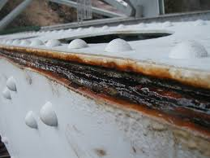
The corrosive factors of crevice rusting tend to happen on edges where metal-to-metal or metal-to-non-metal are in contact with each other, the scale of this type of corrosive depends on a few factors: The geometry of the metal: depth, gap size and the surface roughness. The material composition will also have a role to play in the corrosion this can include the PH, temperature and halide ions and oxygen.

Crevice Prevention: This can often be designed out of the system. Using welded joints instead of riveted or bolted joints. Eliminating lap joints, by welding joints continuously down the length of the lap. Avoiding any stagnant conditions.

- Bimetallic Corrosion
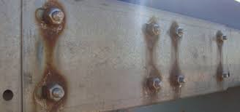
Often known as Galvanic Corrosion this type of corrosion is accelerated due electrical contact with another type of noble metal or a non-metallic conductor. The least corrosion resistant of the two will start to corrode at an accelerated rate while the other will have reduced corrosion.

Bimetallic Prevention: To prevent Galvanic Corrosion, several methods can be applied:
The Selection of similar metals should be as close as possible to the galvanic series. Insulate metals where possible where dissimilar metals are used. Apply coating to one or both metals. Avoid nuts / bolts or other fastenings that far not close in the galvanic series.

Steel Protection
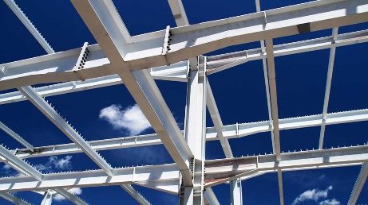
The rate at which structural steel will corrode will often be down to the atmospheric conditions. The best way to protect structural steel is to prepare the surface in such a way that it will protect it from these atmospheric conditions. This is generally accepted as the most important factor affecting the total protectiveness of reinforced and structural steel.
The performance of this protective coating is often judged by its ability to adhere to the surface of the steel. First the steel must be prepared in such a way as to clean it; steel can often have residual mill scale and small degrees of rust. The most common way to remove this is through abrasive blast cleaning. This cleaning introduces a suitable degree for the protective coatings as most spray coating systems need a coarse surface to adhere to efficiently.
The paint protective systems will usually consist of three coats, The Primer, The Build Coat and the Finishing Coat which is the last coat which can be done before the steel is delivered to site on can be done on site. The applications of the protective paint can be applied in with different mediums depending on the make of the coating. The methods of application are:
- Air Spray
- Airless Spray
- Electrostatic Airless Spray
- Standard Brush
- Roller
Airless sprays over the years has become the common method of application of paint coatings to steelworks. Brush or Roller applications tend to be used on the edges and sharp corners or if application is need to be used onsite.

Metal Coatings
There are other ways of coating Structural Steel, which are classed as Metallic Coatings. The four main methods are:
- Thermal Spray
- Hot Dip Galvanizing
- Electroplating
- Sherardizing
Electroplating and Sherardizing are not used with Structural Steelworks but can be used for fittings and fasteners.
The protection of metallic coatings are mainly dependent on the choice of metal coating and the thickness of the coating and not so much the applications.

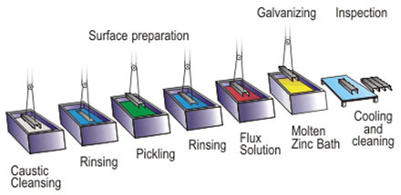
Hot-dip galvanizing is a process that involves the immersing of the metal components into a bath of molten Zinc alloys at a temperature of about 450°C and then withdrawing it to build up layers of an average thickness of 85μm for structural steelwork. This coating is tough, abrasion resistant and will provide cathodic protection where needed.

Other Factors
Other factors to take into consideration when dealing with structural steel will be the storage of the steel. Storing the steel out of the elements is the most effective way to store steel although this is not always practicable working on construction sites. Storing steel correctly out of the elements will help prevent the steel from distorting and corroding, if this is not optional wrapping the steel up or getting it delivered to site the exact day that it is required will reduce the effect of the elements greatly. If storage of the steel on site is necessary, then the steel must be stacked in a way to prevent damage. This will include stacking the steel in an orderly manner that will save on double handling the steel and reduce the risks of the steel becoming damaged. The steel should be correctly labelled up and accessible, steel should be storage off the ground to avoid the puddling around the steel. If any chips occur on the protective coatings of the steel, then this should be sealed with a protective paint coating as soon as possible to avoid further possible damage by corrosion.

v. How does exit control help in site protection?

The Site Exit point is often the last point of call to everyone, deliveries, trades and the public so is very important with Health & Safety, Site Security, Site Control, fire safety and with who is leaving the site. This exit must be kept free from hazards and obstructions to allow the safe exit encase of an emergency.
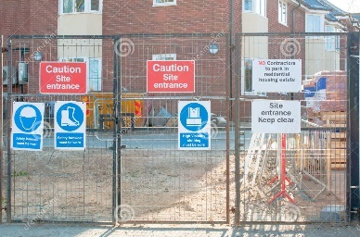
The Site Exit is normally kept close to the Site Offices so management can keep an eye on who is leaving the site. If this is not possible a security guard is normally kept on duty to monitor everyone leaving the site and making sure they sign out when they leave. This can also be where the signing in and signing out book can be kept. Appropriate signage is also needed here, with emergency contact numbers for out of hours’ problems. Adequate lighting should also be made available, some sites will have the space to have separate exit routes others will often have to use the same route in to get out. Again, this will need to be thought out correctly. Heavy barriers can also be used on the exit gate when there is a high risk of vandalism or sabotage, this can also be used to temporarily close the road when needed.

2. Discuss the advantages of providing fences for construction sites (5)

Temporary Fencing
Health and Safety Legislation now requires that all sites are now fenced off. This is to prevent unauthorised personnel from entering the construction site unchallenged, and to prevent the general public from the work and dangers of the construction site which comes under the ‘General Duty of Care’ Construction Site fences have several functions:

- Defines the limit of the Construction Site or Compound
- Acts as a Physical Barrier Preventing Access and Theft

Two Common Forms of Site Fencing are used to surround Construction Sites:

- Solid Sheet Materials
- Open Welded-Mesh Fabric Panels

The use of Heras fencing which easily clips together and fixes to concrete or PVC feet, is a quick cost effective, favourable and temporary option among many construction sites.
Standard fences are made in accordance with the recommendations of BS 1722, which covers 13 different forms of fencing.

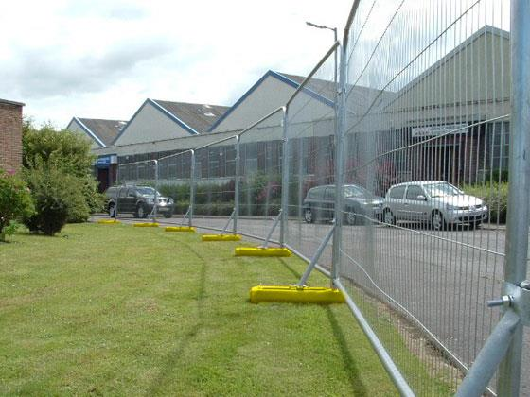

Hoarding Fences

Hoarding fencing is a close-boarded fence or barrier normally erected adjacent to a highway or a public footpath. This type of fencing often provides a better level of protection to the public from dust and noise that often entail constructions sites. Under Section 172 and 173 of the Highways Act 1980 it is necessary to obtain written permission from the local authority to erect a hoarding. This is often given in the form of a licence and will set out the conditions and will give details of the acceptable duration and other provisions like the need for lighting during darkness etc.

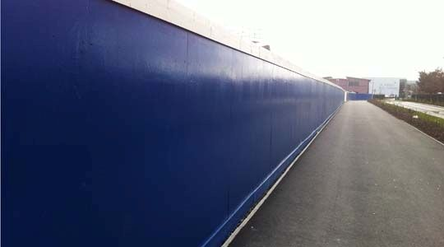

The advantages of having site fences are as follows:

- To ensure Construction workers and the public know where the site boundaries are.
- To give the Construction site good security and to restrict theft as much as possible.
- To prevent anyone just walking onto the site mistakenly and getting injured.
- To stop kids playing on the site once the site is closed.
- To help with the health and safety of the site.
- To help monitor who is coming on to the site, as everyone will need to use the Gate to access the site.
- to restrict noise and debris from the site

3. How is the provision of site electricity different from building electricity? (5)

The UK’s Building Regulations covering the use of electricity at work comes under a series of regulations and standards, these are as follows:

- Electricity Supply Regulations 1988
- Electricity at Work Regulations 1989
- Health and Safety at Work etc. Act 1974
- Construction Design and Management Regulations 2007
- BS 7671: Requirements for Electrical Installations (Institution of Electrical Engineers Wiring Regulations 17th Edition) – Section 704 Details Provision for Temporary Installations and Installations on Construction Sites
- BS 7375: Code of Practice for Distribution of Electricity on Construction and Building Sites
- BS 4363: Specification for Distribution Assemblies for Reduced Low Voltage Electricity Supplies for Construction and building Sites
- BS EN 60309-2: Which Specifies Plugs, Sockets Outlets and Cable Couplers for the Varying Voltages Recommended for Use on Construction Sites

The application and use of these regulations and standards ensures that site electricity can be used safely during the construction phase period of the project.
Construction sites will often shy away from using 240V mains power due to the wet and damp conditions and hazardous working environment on construction site and 240V has the potential to kill the risks of using this Voltage is classed as a Very High Risk. Construction Site now as a rule of thumb have adapted to using 110V.

110V Single Phase (Reduced Voltage) Equipment
- Portable Handheld Tools
- Site Floodlighting Other than Fixed Floodlighting
- Portable Hand-Held-Lamps
- Local Lighting up to 2kW
- Small Items of Plant

Part P of the Building regulations. These Regulations must be adhered to when dealing with electricity of any sorts. Often Construction sites are in places were no mains supply in located, this can often have its own issues when working on sites, as temporary offices often need lighting and sockets for electrical devises like computers and machinery etc.

There are different ways you can get power to a site, the two-main ways to get power to Construction sites is either a diesel generator or mains supply off the power grid.

Most portable site cabins come with built in generators that can supply more than enough power for a small site.
If the site is larger with no grid supply a larger separate generator can be supplied which can supply a large number of site offices and bit of equipment.

If the site location is close to a mains electrical supply, then often an electrical meter can be installed directly off the mains supply by a local authority this must only be carried out by a competent and qualified electrician and must conform to UK building regulations Part P. The local electricity supplier will need the follow information for a meter to be installed on a new Site:

- Construction Site Address
- Site Location Plans
- Maximum Anticipated Load Demand in kW
- Final Load Demand of the Completed Building
- Date on Which Temporary Supply will be Required

Applications for a temporary supply should be made at the earliest time possible due to long periods required to get connected to the Mains grid.

As the Offices are classed as outdoor spaces there must also be suitable electrical protection in place to minimise the potential hazards of outdoor and site conditions.

The work should also follow the National Electrical Code procedures and make sure all detailed drawings are supplied to the Electricity Supply Authorities showing the temporary installation and equipment and any other machinery that will be powered off the mains supply.

The main difference between Site Electricity supplies and normal building supplies is that the Site Electrical supply is often temporary and must be disconnected and removed at the end of construction site use, whereas mains supply is permanent and will not need removing after works are completed.

Student Statement:

By submitting this assignment, I confirm that this is my own work.

Student Signature | K Goodwin | Date | 10/01/2017

For Tutor / Assessor Use Only
Total Marks
Marks Obtained
Percentage / Grade

