
Assignment Cover Sheet

Student Name: | SHAKEEL AHMED
Student Number: | 1507
Course: | DIPLOMA IN ACCOUNTING & FINANCE LEVEL 4
Assignment NO: | 13

Marking Criteria:
We expect the learners to write minimum one well expressed point in three lines against each allocated mark. This means one needs to write 15 lines with 5 well expressed points to get high grades for a 5 marks question.
For high grades use examples and illustrations where appropriate.
Student Name: Shakeel Ahmed
Student ID# 1507, Assessment #13,
Page No: 1
Q: 1)
What is Capital Budgeting? Capital budgeting is the process of allocating capital after determining project feasibility. Determining project feasibility is a 3 part process
Step 1] Qualitative Analysis – Relationship/Branding feasibility, Socio-Cultural & Political feasibility
Step 2] Forecasting Performance – Financial Modeling & Structural analysis (Most critical!) Step 3] Quantitative Analysis –IRR (or MIRR), NPV, Payback period and other quantitative analysis Note: Step 1 & 2] are far more critical & demanding, however, the focus of this article is Step 3]
What’s all the fuss about? In real world situations, a company may have a choice of investing in several competing projects at the same time while resources may be sufficient for just one. This is where it may have to make a choice as to which project must be selected based on feasibility measured on different dimensions (at times one conflicting with the other). By dimensions we mean Qualitative & Quantitative factors the weights of which may change based on circumstances and priorities. E.g. for building a stronger/long-term relationship with a large prospective client a manager may choose to overlook quantitative factors in anticipation of securing future projects. However, as mentioned earlier Qualitative factors are beyond the purview of this article. Now, when choosing between quantitative methods one might come across conflicting results. E.g. Project A may have a superior IRR while Project B may have a better NPV. Which metric should one choose and what are the pitfalls involved in calculating them? This article delves into popular quantitative project analysis techniques with a view to cut through the haze and get to the most appropriate/robust method suited to real world situations
What is IRR & how does it work? IRR is one of the most popular return analysis tool used in Project Appraisal, Private Equity Deals, LBO analysis & calculating Bond YTMs too! Put simply, Internal Rate of Return measures the return generated by an asset assuming that the
Student Name: Shakeel Ahmed
Student ID# 1507, Assessment #13,
Page No: 2

reinvestment rate of cash flows thus generated, is the same as the IRR itself. In Short: IRR is an iterative process where reinvestment rate is the same as the IRR itself! Note: When measured correctly, IRR equals the Compounded Annual Growth Rate (CAGR)
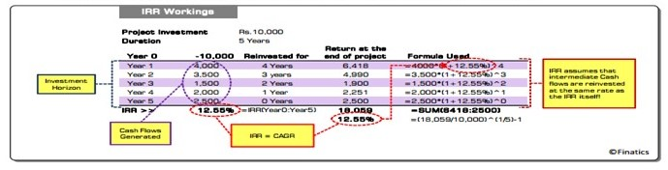
What is MIRR and why is it considered better than IRR? The biggest problem with IRR, as cited by popular academicians, is that the Reinvestment Rate of interim cash flows is same as the IRR itself. In real world situations however, a company may not have the opportunity to get the same IRR as before. Put simply, IRRs of each new project will differ and hence the manager must find a way to incorporate that change instead of just assuming the same RR (Reinvestment Rate) as IRR. MIRR to the rescue: The Modified Internal Rate of Return provides the flexibility of modifying the RR as desired. Managers may find it difficult to forecast RRs down the investment horizon and hence a safe assumption would be to set it equal to the Cost of Capital, below which, incremental projects will result in ‘Value Destruction’ (The concept of EVA™). In Short: MIRR delinks the Reinvestment Rate from IRR thereby giving the manager an option to choose a different/more realistic rate (usually Cost of Capital) thereby giving a more reliable conclusion.

Student Name: Shakeel Ahmed
Student ID# 1507, Assessment #13,
Page No: 3

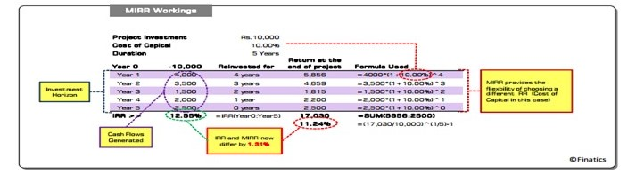
Does that mean MIRR is the best? No. Both IRR & MIRR fail to capture the Present Value of money and are hence called ‘Internal’ Rates! The best method must factor Internal Return as
well as the Cost of Capital to determine Present Value. The Net Present Value (NPV) method aims to capture both and hence is the preferred choice by managers the world over
What is NPV? The NPV method ‘discounts’ operating cash flows at a rate that captures the cost of capital (i.e. the capital used/contributed to generate cash flows). The NPV method aims to capture the amount available after meeting the cost of all capital contributors (all claimholders). In fact, the NPV method is what leads to the concept of value creation through Economic Profit. Thus even if the IRR of Project A is better than Project B, a relatively lower Cost of Capital may swing the decision in favor of Project B. In Short: A positive NPV is a must and the higher the better. The relationship between NPV and IRR is that “IRR is the rate at which NPV = Zero” When Cost of Capital is more than IRR the NPV will be Negative
Note: Discounting/Compounding is beyond the scope of this article
Now what’s Cost of Capital? Suppose you were to setup a business you would start by estimating the asset requirement based on the market you want to cater (Local, National or International) and then determine how it must be funded. E.g. If Assets worth Rs.10,000 must be bought you may be able to invest just Rs.3000 while the balance Rs.7000 may have to be

Student Name: Shakeel Ahmed
Student ID# 1507, Assessment #13,
Page No: 4

borrowed (i.e. Raising Debt). Now, you will have a certain opportunity cost of the money invested (popularly measured by CAPM) say 15% while the lender of Rs.7000 debt may ask for a fixed return of 7.86%. This implies that you will have to generate a minimum return of (15% x 3000) + (7.86% x 7000) = Rs.1,000. Implying a minimum return of 1,000/10,000 = 10%, also called the Weighted Average Cost of Capital (WACC) or simply Cost of Capital.
Note: The explanation was an oversimplification of the process and real world calculations are far more complicated

How does NPV work? From the example above if we assume that the business generates Cash flows of Rs. 4,000…3,500…1,500 …2,000…2,500 over a 5 year horizon. The NPV would be calculated as under:

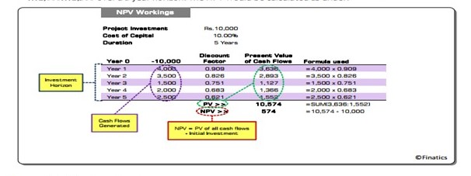
Finally what do I choose? NPV will always rule above all, as the Return on Funds deployed must always exceed their cost (i.e. IRR must always be > WACC). Between IRR & MIRR, IRR will always result in more ‘noise’ as compared to MIRR and will hence result in an incorrect feasibility study. What may appear to be just a 1-2% difference would result in huge difference
Student Name: Shakeel Ahmed
Student ID# 1507, Assessment #13,
Page No: 5

when measured in monetary terms rather than percentages! In Short: The order of preference must be NPV, MIRR & IRR. However, the answer is not that simple, read on…
What’s the larger picture? It should be noted that the Structural Analysis (i.e. Revenue Stream, Payment Schedules etc.) and Financial Modeling (i.e. actual framework of the Income Statement, Balance Sheet & Cash Flow Statement that will be used to create the forecast) of the projected cash flows is the most critical, the results of which are used as an input for any kind of quantitative analysis (i.e. IRR, MIRR or NPV analysis!)
What’s the bottom-line? Now that you have understood that quantitative analysis is just a small part of a much larger framework. It should now be obvious that blindly choosing one metric over the other would be naïve! Although NPV is a superior metric it does not by itself disclose scope for improvement. This is the very reason why we recommend that a project should not be rejected simply because it has a lower NPV, unless there is no way to improve it. Let’s see how…
IRR = Max Potential Return: IRR reveals the maximum return potential of a project assuming no interference from external factors like funding constraints and the ‘funding mix’. Put simply, if two projects have identical Funding Costs the one having a higher IRR will have a higher

NPV and hence should be selected. This also implies that NPV should be first ‘tested for improvement’.
Testing NPV for improvement: NPV is affected by two components – IRR of cash flows and Cost of Funding. IRR of projects is far tougher to improve as compared to the ‘Funding mix’ (which in turn determines the Cost of Capital i.e. WACC). Theoretically, IRR can be improved by improving efficiency, but that’s a different story altogether! In most cases, it is more or less controlled by external factors, typically industry specific. Comparatively, WACC is more elastic and some critical steps may help reduce it!
Student Name: Shakeel Ahmed
Student ID# 1507, Assessment #13,
Page No: 6

The role of Capital Structure in managing WACC: Optimum Capital Structure, by many, is believed to be a theoretical concept as practitioners believe that following a ‘Target Structure’ is nearly impossible as market conditions will not allow one to keep it stable unless the firm is at a ‘Matured stage’, where expansion needs are limited and capital management becomes far simpler! High growth companies are driven by Capex and the funding mix is not as important as getting the right amount while for matured companies the priority reverses! Many practitioners believe “Raise money when you can, and not when you should” However, if debt is raised without really being required at a certain time it will increase the risk and hence the Cost of Equity. Modern theory suggests that Optimum Capital Structure should be based not on interest tax shields but rather the risk specific to the firm and industry on a long term basis.
Risk-Expected Return relationship: Incremental risk increases the cost of equity, irrespective of whether cash rewards (dividends) are paid or not. If there are senior claimholders over Equity the Cost of Equity is bound to increase and the higher the claim of seniors higher the Cost of Equity. Put simply, it is this risk that can and must be tested for improvement.
Basically, risk can be broken into two broad categories – firm specific (fairly elastic) and industry specific (mostly inelastic). Firm specific risk can be further broken down into Operating & Financial Risk.
- Operating risk results from fixed operating costs such as Fixed Assets, Rent, Lease etc. One way to curb operating costs is to control excess capacity additions in good times – Easier said than done! This is the most common cause of risk, typical in cyclical sectors where ‘bad timing’ of capex can increase risk by under utilization of capacity.

- Financial risk is an outcome of fixed financial costs i.e. Interest. As mentioned before this is difficult to control and is dependent on too many factors (mostly external) only few of which can be controlled by a company. Put simply, if a company has superior operating risk managing
Student Name: Shakeel Ahmed
Student ID# 1507, Assessment #13,
Page No: 7

capabilities it will be perceived as less risky by the debt issuer and will thus reduce interest cost as well.
In Short: Companies with poor operational performance will always have higher financial costs/risk. From the above discussion it should be clear that operating risk is easier to control and will help reduce overall risk thereby reducing the cost of capital and increasing NPV!
Bottom-Line: IRR (or more correctly MIRR) should be used to judge maximum potential of a project based on which a firm must try to reduce risk to maximize NPV. Easier said than done but the right way out!

Q: 2)
This chapter discusses the preparation and processing of an Environmental Impact Report (EIR) in accordance with CEQA. This chapter also discusses the preparation and processing of documents related to an EIR including, a Notice of Preparation (NOP), a Notice of Completion (NOC), Certification, Findings, Statement of Overriding Considerations (SOC), and a Notice of Determination (NOD). The chapter also includes information on the preparation and processing of a Supplemental EIR, a Subsequent EIR, and an Addendum to an EIR.

Student Name: Shakeel Ahmed
Student ID# 1507, Assessment #13,
Page No: 8
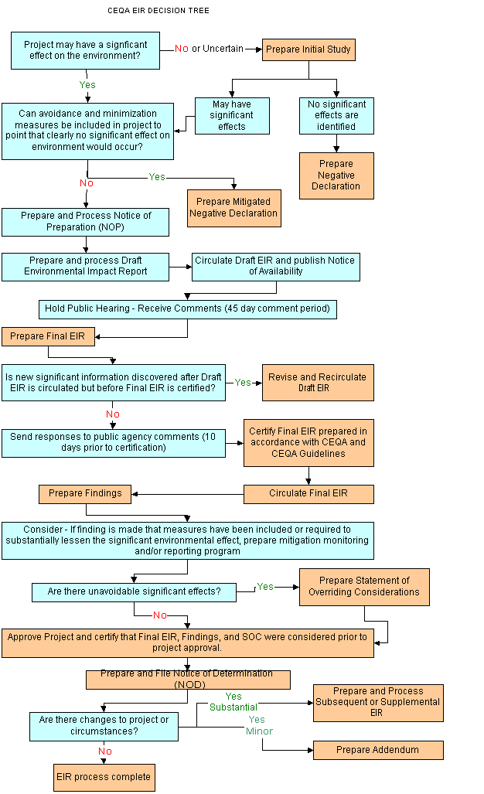
Student Name: Shakeel Ahmed
Student ID# 1507, Assessment #13,
Page No: 9

The overarching purpose in preparing an Environmental Impact Report is to provide the public and the decision-makers with detailed information about a project’s environmental effects, ways to minimize the project’s significant environmental effects, and reasonable alternatives to the project.
Under the California Environmental Quality Act (CEQA), an EIR must be prepared whenever there is substantial evidence, in light of the whole record, that a project may have a significant effect on the environment. In accordance with California case law, if the Department is presented with a fair argument that a project may have a significant effect on the environment, it shall prepare an EIR even though it may also be presented with other substantial evidence that the project will not have a significant effect.
If a project is subject to CEQA and does not qualify for an exemption, the next step in the CEQA process is to determine whether the project may result in a significant effect on the environment. If it is unclear whether the project may have such an effect, then an initial study is conducted to determine the nature and extent of the project’s effects. If the results of an initial study reveal that the project may have a significant effect on the environment, then preparation of an EIR is appropriate.
If it is clear that a project will result in a significant effect on the environment and an EIR will be required, the initial study process can be skipped and work can proceed directly on the EIR. In this case, the EIR must still focus on the significant effects of the project and indicate briefly the reasons for determining that other effects would not be significant or potentially significant.
Let’s start with the quote “cash is a fact, profit is an opinion" (Rappaport 1999, p.15).
Profit is in most measures based on the firms’ earnings, and research has suggested that managers actively are managing the earnings (Rappaport 1999). Firms “manage” their earnings dependent on a number of accounting rules and reservations, for example, the bad debt reservations (revenue recognition), deferred earnings , write-offs, accrued revenues, …etc. There could be multiple reasons for managing the earnings, for example, firms may
Student Name: Shakeel Ahmed
Student ID# 1507, Assessment #13,
Page No:10

want to “meet investor expectations” because investors provide the firm with funds and financial incentives. Or there could be environmental uncertainty or risk considerations (timing between cash inflow and the delivery of a product or service) (i.e. magazine subscriptions)
The next issue is WHAT is performance? Firm performance is not a very well defined theoretical construct. The firm performance measure depends on WHAT you want to measure. There are many performance indicators, more than I can list on this medium, and each has its advantages and disadvantages. But in general you can divide them in effectiveness measures and efficiency measures. A firm can for example be very efficient but not effective, or the other way around. And financial/market measures and accounting measures.
Most efficiency related profit measures measure the utilization of the firms’ resources. For example, the firms earnings as a percentage of firm size. In that way they also account for firm size effects. Deflating a profit measure for firm size is important if you want to compare different firms. But with this deflation you introduce also noise or distortions in your measure.
A firm could have a positive profit margin but be at the same time in (financial) distress, and then the question is, do you consider this a good or bad performance. Again this depends on WHAT you want to measure as performance. If the sales revenues of a firm are decreasing, but the firm is able to reduce its expenses/cost at an equal or faster phase, than it still makes profit at a reduced cash flow. You can consider this a good performance considering the circumstances. But the firm has a strategic problem, why are the revenues decreasing? This could be a sign that the firm is losing market share, has outdated products / services / technologies / is loosing its strategic fit (evolutionary fitness (Helfat, 2007)). Think of the Fosters’ S-curve (Foster, 1986). Or maybe other reasons. In this context the performance of the firms could be considered bad and immediate action is required.
When you use the cash flow measure you will see, up to a point, still a positive cash flow. And depending if and whit what measure you deflate the cash flow to account for firm size, it could
Student Name: Shakeel Ahmed
Student ID# 1507, Assessment #13,
Page No:11

also be a positive cash flow indicator for performance. You could detect the decreasing performance by looking at the change in cash flow year on year, but if you want to compare firms you have to deflate the annually cash flow difference for firm size. Herewith you could introduce new distortions. In sum, there are no easy answers, it depend on what you want to measure in which context.
Coming back to the main question, What is the relationship between cash flow and performance of an entity? : Cash flow and profitability relationship.
Cash flow is a performance measure that measures the difference between cash inflow (i.e. sales remittance or actual sales), and cash outflow (i.e. purchases) net of the accounting measures (i.e. cost vs expenses) and uncertainty and risk. So, cash flow is the less sensitive (for managerial manipulation) accounting performance measure, but doesn’t account for liabilities, risk and uncertainties. Profit is a performance measure that accounts to a certain extent for uncertainty and risk, but is susceptible to the manipulation of earnings by the firms’ managers. The relationship between cash flow and profitability depends on the used accounting rules and the degree of earnings manipulation of the firm’s managers. If the firm cash flow and profit measure are highly correlated, you can very carefully and tentatively assume that the earrings manipulation of the firm is limited.

Student Statement:

By submitting this assignment, I confirm that this is my own work.

Student Signature | SHAKEEL AHMED | Date | 31/07/16

For Tutor / Assessor Use Only
Total Marks
Marks Obtained
Percentage / Grade

