
UNIT
-
1
Introduction to Coaching
_{and Mentoring}
Learning Outcomes
By the end of this unit the learner will be able to:
✓ Understand how coaching can be used to develop their team

Unit 1

Introduction to Coaching and Mentoring

Coaching and Mentoring
The terms coaching and mentoring are often used interchangeably. They seem synonymous, and while there are similarities and some overlap, there are also significant differences we want to bring to your attention.
A mentor is someone who shares their wisdom and can facilitate action that has a positive effect on our careers and lives. In Greek mythology, Mentor was the trusted advisor to Odysseus. Our use of the term mentor dates back to 1699 when French writer François Fénelon wrote Les Aventures de Telemaque, (Telemaque was Odysseus’ brother), and the main character in the story is Mentor. This book gave us the modern use of the term mentor: counselor or teacher; trusted friend; one with wisdom and experience to share.

Certificate in Coaching and Mentoring Level 2
Mentor | Protégé
Mentorship programs in workplaces and universities are based on the idea of matching new employees with more experienced staff, who will advise and provide insight. In the workplace, mentors can advise, help with career advancement, provide professional development advice, and build networks.
The student of a mentor is often referred to as a mentee. However, the accurate term is actually protégé, and if you take it a step further to the Greek myths, would be called Telemachus.
Mentorships often evolve from a previous relationship (such as professors or previous bosses) and can also be formed with a current boss. Mentoring is usually done informally and is unpaid. There is not always a set agenda, and contact ranges from very frequent to on an as-needed basis.

Matching Mentors
First, read the left-hand column, which is a list of mentors to some very famous individuals. Then, write the name of that person’s protégé (from the list below) in the right-hand column.
- Alexander the Great
- Sir Richard Branson
- Sir Anthony Hopkins
- Wolfgang Amadeus Mozart
- Helen Keller
- James Cameron

Freddie Laker | Sir Richard Branson
Aristotle | Alexander the Great
Roger Corman | James Cameron
Sir Lawrence Olivier | Sir Anthony Hopkins
Johann C. Bach | Wolfgang Amadeus Mozart
Anne Sullivan | Helen Keller

Defining Coaching

What Coaching Is
Distinct from mentoring, coaching is a conversation that helps people develop their skills, achieve success, and reach their goals. Coaching is a way of expressing the truth, confronting tough issues, and is centered around language that inspires. It is usually one on one, although there is team coaching going on now too.
Since work-related goals are often set by someone else to ensure the company’s success, one of the coach’s roles is to help the employee link their own motivation to corporate goals.

What Coaching Is Not
Although a coach can help someone perform better, coaching is not a performance management tool. Be careful of people who ask for coaching for what are really disciplinary problems rather than coaching issues. Disciplinary matters such as tardiness, attendance issues, insubordination, breach of contract, or inappropriate conduct are not part of the coaching conversation, and should be managed within their own, separate, context.

The Coaching Formula
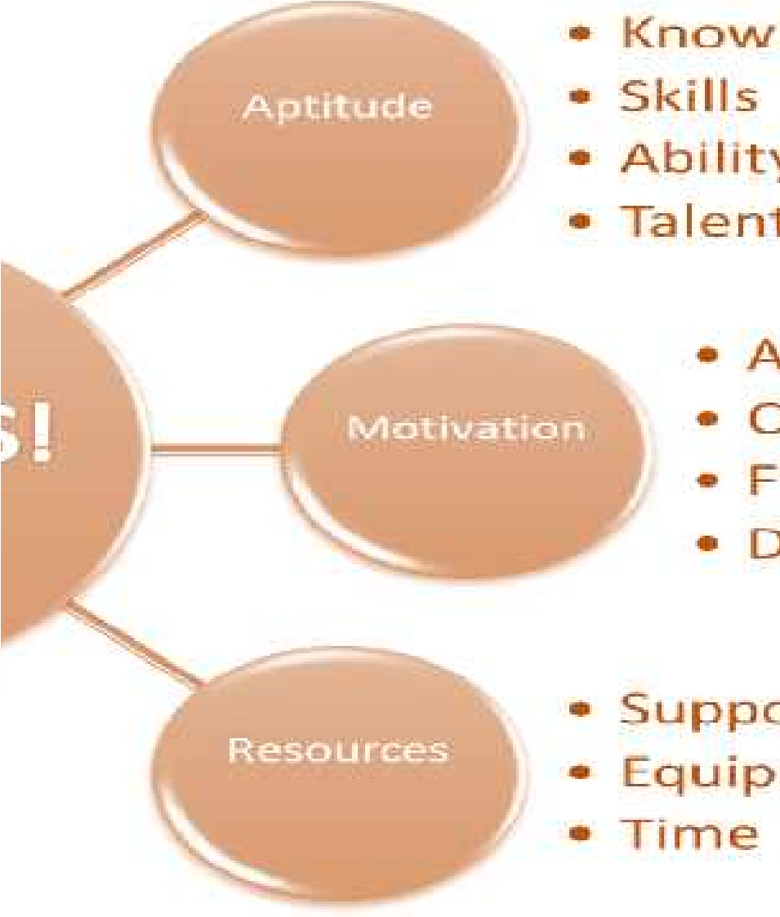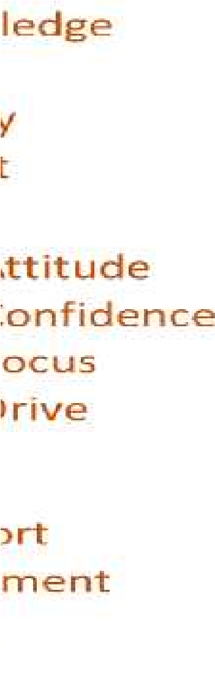
Certificate in Coaching and Mentoring Level | 2

The Three Factors
In order to be successful, there are three things that we need to consider:
- Aptitude: The knowledge, skills, ability, and talent to reach your objectives.
- Motivation: The attitude, confidence, focus, and drive to reach your objectives.
- Resources: Having the support (people and things), tools, and time to reach your objectives.
With these three factors addressed, people have the ability to be successful. A coach can help with all of these elements and to reach success at any level. The coach can also help to shift from small successes to moderate ones, and onward to high levels of success.

Coaching Skills
Coaching has evolved to become an expected competency for supervisors, and as it has evolved, so has the way that we coach. Effective managers at all levels recognize the need to develop the employees they supervise. By helping others expand their capabilities and improve their performance, managers and supervisors have more time to work on the things that will improve their own performance.
Managers and supervisors who are most effective at developing employees have incorporated the skill of coaching into their management style.

Coaching should not be confused with career counseling or performance reviews. Although coaching is related to both of these activities, it differs in that it is the day-to-day, hands-on process of helping employees recognize opportunities to improve their performance and their capabilities.
This skill requires you to have skills that allow you to analyze ways to improve performance, plan mutually acceptable actions, create a supportive and helpful climate, and influence employees to change behavior in positive ways.
Critical skills:
- Interpersonal communication skills
- Helping skills
- Mentoring
- Teaching skills
- Challenging skills

Coaching Assessment Review
Coaching Assessment and Scoring

Introduction
This self-assessment will give you the opportunity to look at your current coaching levels. You do not have to share your answers in the upcoming class, so please be very honest with your answers. Remember that you are enrolled in a coaching and mentoring course as a way to improve your coaching skills, so don’t worry if you do not have a particularly high score. This will be a starting point before training gets underway.
We’ll discuss what different scores mean during the course.

Assessment
For each item, indicate the degree to which you believe you use the skill or behavior by indicating your appropriate number from the scale. If you believe the description is "very characteristic" of your own behavior, write down "5." If it is "very uncharacteristic" of your behavior, write down "1." If your assessment lies somewhere between the extremes, use 2, 3, or 4, as appropriate.
 |  | Score | Area
1. | I make contact with employees and talk to them as individuals on a daily basis. | 3 | Communica  tion Skills
2. | I am approachable. Employees feel comfortable coming to me to |  | Communica  tion Skills

 | discuss issues. |  | 3
3. | I know my employees as individuals. They feel that I care about their welfare. |  | 4
4. | I am a good listener. I pay attention when others are speaking to me. |  | 4
5. | Conversations are two-way, with both parties exchanging views. |  | 4
6. | I try to identify the real problem rather than try to fix symptoms. |  | 4 | Helping Skills
7. | I encourage employees to find their own solutions to problems. |  | 3 | Helping Skills
8. | I encourage creativity or innovation. |  | 4 | Helping Skills
9. | I am always open to new ways of doing things. |  | 4 | Helping Skills
10. | I ask employees to take responsibility for their own problems. |  | 2 | Helping Skills
11. | Employees feel safe telling me when they have made a mistake. |  | 2 | Teaching Skills
12. | Employees are never made to feel inferior because they have made a mistake. |  | 4 | Teaching Skills
13. | Employees are encouraged to develop new skills or knowledge. |  | 4 | Teaching Skills
14. | Employees feel I am patient when they are learning a new skill. |  | 3 | Teaching Skills
15. | I recognize employee strengths and help them use those strengths whenever possible. |  | 4 | Teaching Skills
16. | I suggest networking opportunities to employees. |  | 2 | Mentoring Skills
17. | Employees consider me a resource on administrative matters. |  | 3 | Mentoring Skills
18. | Employees consider me a resource for suitable career options. |  | 4 | Mentoring Skills
19. | I encourage employees to apply for positions that suit their strengths. |  | 2 | Mentoring Skills
20. | I give employees advice for managing their way in the organization. |  | 3 | Mentoring Skills
21. | I help employees confront excuses. |  | 2 | Challenging Skills
22. | Ultimately I hold employees responsible for their own development |  | 3 | Challenging Skills
23. | I give feedback on my observations without being judgmental. |  | 3 | Challenging Skills
24. | I help employees recognize unproductive behaviors. |  | 2 | Challenging Skills
25. | I am future-focused rather than past-oriented. |  | 4 | Challenging Skills
 |  |  | 80 | Score
Scoring

100-125 Points
Your coaching is capable of building real momentum for the people that you work with. Your own continued growth will help to support and encourage growth in the people that you are working with.

60-99 Points
You probably have good relationships with the people you are working with, and at times you are creating good momentum. Have a look at your ability to listen, ask thought-provoking questions, and provide feedback. See where you can develop additional strengths and watch your results get reflected in your ability to coach.

40-59 Points
This is an underdeveloped skill for you, but you have a good start. Look at the individual sections in the assessment and see if there are specific areas you need to address. Your fastest route to success might be in taking coaching specific training, as well as hiring coach to work with.

Below 40 Points
We suggest that you work on elements of communication, such as listening skills, asking questions, interviewing, and any other areas that need developing. Spend several weeks on this, and then come back to the questionnaire and repeat it. Sometimes we need to work on fundamental skills before we can launch directly into coaching.

Test Your Knowledge
Of the areas identified above, which two or three areas are most important for you personally to develop?
Interpersonal communication skills
Helping skills
Mentoring skills

What steps are you willing to take to develop further?

I am willing to undergo more training.

What support do you need to develop these skills?
I think that by teaching and being observed, feedback will be very useful in developing my skills.
Who will you ask for help?
I will rely on my tutor and the people I work with.

When will you get started?

Today.

