
Assignment Cover Sheet

Student Name: | Tracy Kam
Student Number: | 3200
Course: | Diploma in Fashion
Assignment NO: | 9

Marking Criteria:
We expect the learners to write minimum one well expressed point in three lines against each allocated mark. This means one needs to write 15 lines with 5 well expressed points to get high grades for a 5 marks question.
For high grades use examples and illustrations where appropriate.
Please insert your completed assignment ( in word format) here:

Choosing the Right Material

Assessment 9 Total Marks: 30

Q: 1: Write short notes on the following topics: (9)

- Engraved roller printing –a separate roller engraving is used for each color in the pattern The design is rolled onto the fabric as it passes through the printing machine .

- Flat- bed screen printing
-is used a screen spread over a frame .The portions of the design to be printed are made of porous nylon that allows the color pass through the screen .Is versatile but expensive .
- Rotary screen printing
the roller itself is porous in the areas to be printed . Dye is forced into the roller cylinder and through its porous screen printing , leaving no breaks betwwen screens .

Q: 2: What is the difference between weft knitting and warp knitting? (6)
Weft knitting is happens when the loops run across or in a circle . This is less expensive method of converting yarn into fabric while knitting , are multiple yarns used and the loops run vertically

Activity

1. Examine the fibre content labels in the clothes in your wardrobe. How many garments are made from natural fibres? How does the fibre content affect the care of the garments? (7)
In my wardrobe , most of my garments are made of cottons as its easy maintained and 100% wash machine .I also have wool and silk but not as much as its expensive and must care properly such as by dry wash or hand wash .Cotton absorbs very fast and easy to maintained and iron .
2. Visit a local fabric store and find examples of a plain weave, a twill weave, a satin weave, and a
non woven fabric. Collect swatches of each type. (8)

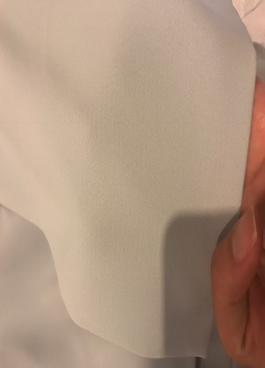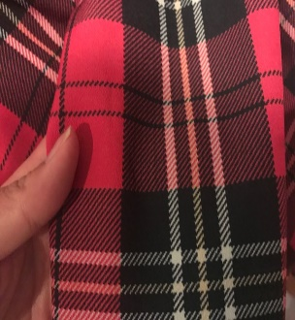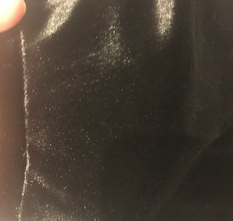

PLAIN WEAVE TWILL WEAVE SATIN WEAVE

V NON WOVEN FABRIC
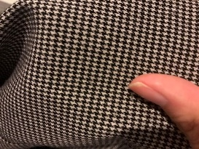

Student Statement:

By submitting this assignment, I confirm that this is my own work.

Student Signature | Tracy Kam | Date | 22112016

For Tutor / Assessor Use Only
Total Marks
Marks Obtained
Percentage / Grade

