
Assignment Cover Sheet

Student Name: | Brendan Reilly
Student Number: | 5029
Course: | Diploma in Construction Management
Assignment NO: | 5

SITE ORGANISATION

ASSESSMENT 5
1.
i.
The term ‘site organisation’ is the layout, the access and egress, the lay down area for materials, the delivery area, the car park the onsite office the lunch room. All the staff and workers need clean facilities & amenities. There should be easy access fire escape and meeting areas. There is a lockup yard for machinery and heavy equipment. The construction team and manager should organise this.

ii.
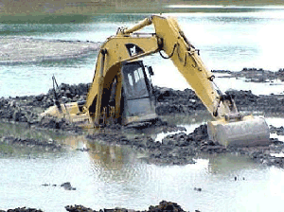
Throughout the life of the construction project heavy machinery will come and go on the job. This means that delivery of these machines and the movements and mobility around site make road preparation and maintenance very important. The roads leading up to the job could cause problems as trailers carrying the machinery e.g. excavators, graders and forklifts can way upwards of 50 ton and be 30m long. This must be addressed before a delivery can even be ordered. The road may be old uneven and not adequate for a large delivery. Onsite you could have bitumen roads that can’t be damaged meaning tracked excavators can be a problem. There could be no road at all but the ground is soft and breaks up making a mess. If this is not addressed and monitored you can have serious repercussions.

iii.
Precautions to be taken into account for the preservation and storage of cement are:
- Store in a place dry warm and free of any moisture
- Provide adequate ventilation
- Stack on wood 150-200mm off the ground and away for the wall
- Pack the cement bags together 4 wide and max 15 high so weight pressure doesn’t split the bags.
- Use older stock first
- Plan deliveries so there is the right amount of overlap
- Do not store for more than 2 months
- If humid climate cover with waterproof material

iv.
Scaling and rusting of reinforced steel can be a problem on site and a costly one. Scaling has four stages of corrosion from clean and structurally sound to where its being eaten away, this stage the function or fitness of the equipment will be comprised or greatly affected. To prevent this happening on site you can preserve it by coating it in a cement wash before stacking and keeping it raised off the ground.

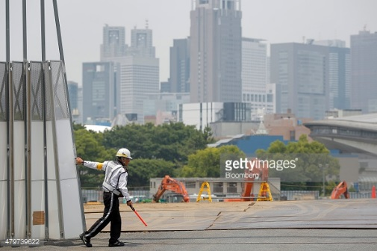
v.
Control on entering and exiting the site needs to adequate for the site and location it’s in. A small project starting out in an open field miles from any town will require less protection and security than a large project in the middle of high risers going straight out onto a busy main road. Protection can also be for the people inside as well, in forms of security cards, lights, barriers and cameras.

2.
Site fencing is a priority. it is the first obvious line between public zone and construction zone. A construction site can become hazardous and dangerous the moment safety measures are ignored. Putting temporary fencing around a construction site is one of the first safety measures that you should take.

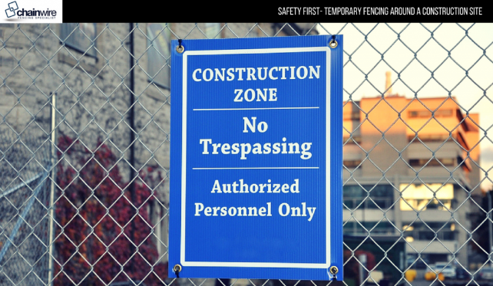
Fencing will fend off trespassers from accessing the building site and also provide security for the construction materials and plant. Those trespassing the site can easily be injured, and that can lead to a legal battle. Fencing of the construction site is a mandatory requirement in most places because of these legal and safety reasons.
The ‘advantages of providing fences for construction sites’ (seems the question wants me to talk about giving fences to sites??) But the advantages of HAVING fences on site are numerous. As I briefly mentioned Security to keep people in and out as you do not want random people trespassing. It prevents unauthorized people, children & animals entering site. It is also used for privacy from the public or neighbours. Recently advertising has become a major part of it, explaining what’s being built and Information for the public. On in the inside site information e.g. fire exits procedures and local information.

3.
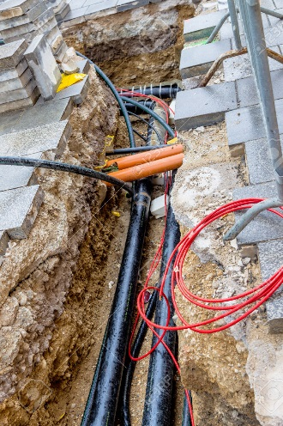
The provision of site electricity to building electricity is different in that the initial power for site maybe run off a temporary supply depending on the size of the job. A large site in the city will go straight on to the grid. Knowing the power required is imperative to not over load the system which could cause a serious hazard.
Several sources can be used if needed a main line and temporary generators around site can be very useful as temp works move around site. If The grid is not accessible and the generators can’t produce the volts required for a big job then a temporary substation can even be built and provide for the entire job until it’s finished.
The permanent structure/s will be tapped onto the local authority grid as soon as practical and safe to do so or if completely isolated like a gas plant or mining facility a permanent substation built.

Student Signature | B.Reilly | Date | 11/2/17

For Tutor / Assessor Use Only
Total Marks
Marks Obtained
Percentage / Grade

