
Assignment Cover Sheet

Student Name: | Rebekka Annika Schendel
Student Number: | 1391
Course: | Working with Patterns
Assignment NO: | Unit 12

Marking Criteria:
We expect the learners to write minimum one well expressed point in three lines against each allocated mark. This means one needs to write 15 lines with 5 well expressed points to get high grades for a 5 marks question.
For high grades use examples and illustrations where appropriate.
1. Multiple Choice Questions.
a) The flat pattern method is necessary for the areas like;
I. Flowing designs
II. Pants or sleeves
III. Skit’s bottom
b) The draping pattern method helps the designer to;
I. See proportions and lines of the design exactly as they will look three dimensionally on the wearer
II. See the proportions and design exactly as it will look on the trousers and sleeves
III. See proportions and lines of the design as it will look on the shirt
c) Pattern grading decides;
I. How should a pattern look like
II. How pattern increase or decrease in sizes
III. How the patterns are drawn

2. Define the followings:
a) Dart, grain line, hem line
Dart can be defined as a sewed fold which makes the flat fabric more suitable to the body form. Here are two examples of darts, the thirst one shows the dart from outside and the second from inside:
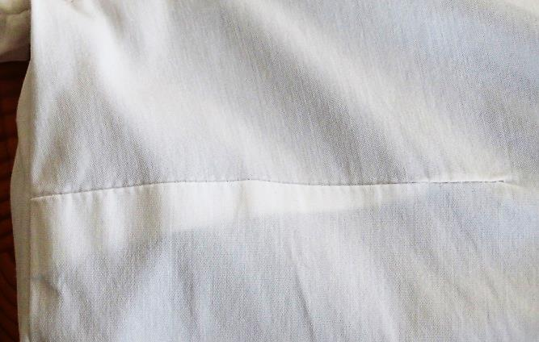
Darts makes a flat fabric well-fitting to the body form and can make the garment more comfortable to the customer. Here are two examples how darts can look like:
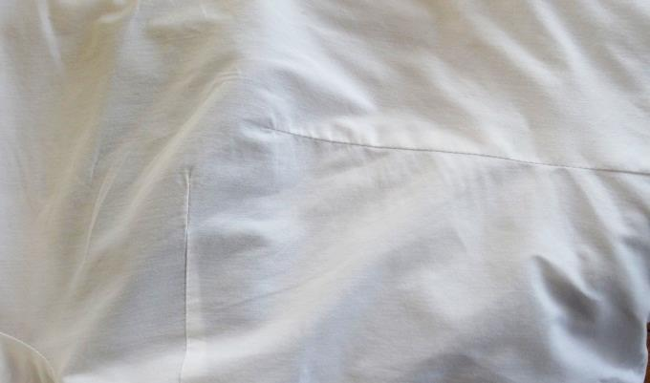
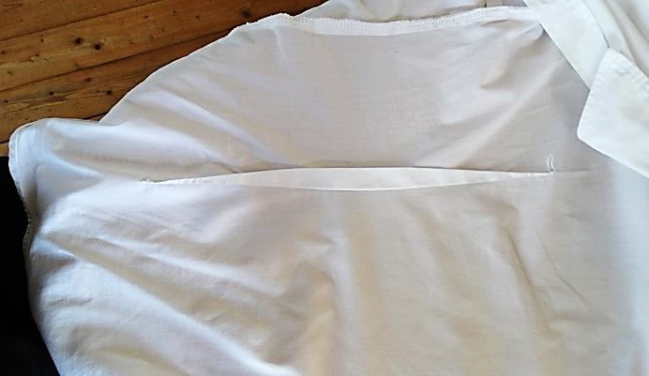
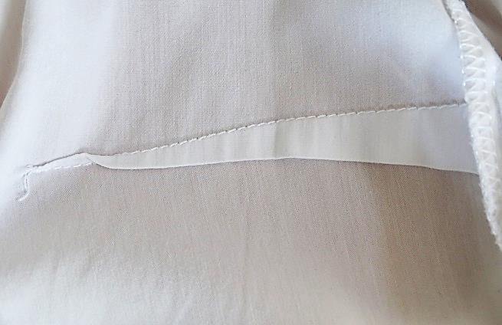
With grain line is meant the line which indicates how you have to lay the pattern on the fabric. The grain line runs always parallel to the selvages.
The hem line shows where the end of the garment wen finished will be or how long the garment will be wen finished.
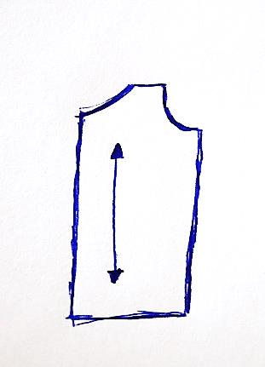

3. Define the followings:
a) Selvages, length wise grain, bias
With selvages is meant the finished end of the fabric which comes out of the loom.
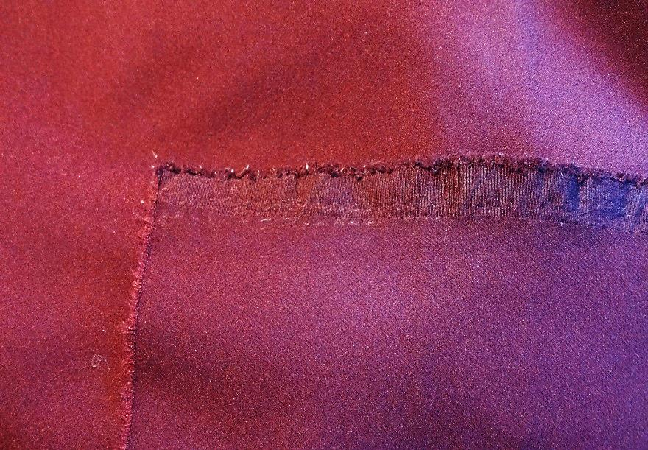
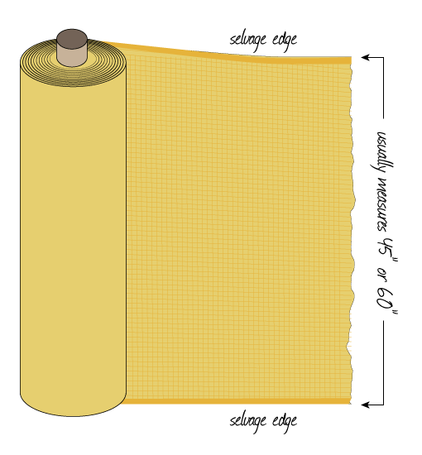
Length wise grain can be also called warp which runs parallel to the selvages.
With bias is meant the direction which is diagonal (45°) to the selvages or length wise grain. Garments which are cut in this direction are very stretch able. Bias the diagonal direction to the selvages is the most flexible and stretch able direction of the fabric.

4. Explain step by step the following processes:
a) ‘placing the pattern pieces on grain’,
To place the pattern pieces on grain you first have to cut the pattern out of the paper. If you have a multi size master pattern you first have to copy (trace) the size which you want on a pattern tracing paper and then you can cut the traced pattern out of your paper. The next step is to lay the pattern correctly on the fabric. On each pattern is a grain line this grain line must lay exactly on the length wise grain line of the fabric, which is always parallel to the selvages of the fabric. Lay your pattern piece on the fabric so that the grain line on your pattern lays parallel to the selvages of the fabric. Check it by fixing the pattern with a pin on the fabric and measure the length on both sides from the selvages to the grain line on your pattern. If you cannot see the selvages on your fabric for example because somebody have cut it away you can make a check by the most fabrics to find it out, it works this way; stretch your fabric in all directions – the direction which is the most inflexible is the length wise grain. Orientate yourself on the yarns on the end of your fabric and cut your fabric right to have something like a selvages.
b) ‘Pinning and cutting out the pieces’.
Pinning your pattern on the fabric, make sure that the stitch goes through your fabric especially if you have folded your fabric. Stich about every forth inch a pin and everywhere where is an edge or where the pattern change the direction. So now you can cut out your piece carefully if it is a simple project. If not then first you have the trace the pattern to your fabric with a pen or hard hand soap or a cutlery. Then take the pattern carefully from the fabric by taking one pin away and fixing afterwards before taking away the next pin. If you have finished you can began to cut with a good scissor only used for fabric. Cut carefully with a sharp dressmaker’s shears and do not lift up the fabric to high by cutting the fabric, try by cutting to hold the fabric so closed to the table as possible.

Picture references:
3. Question: www.sewingschool.org
All others are made by myself.

Student Statement:

By submitting this assignment, I confirm that this is my own work.

Student Signature | Rebekka Annika Schendel | Date | 01.12.2016

For Tutor / Assessor Use Only
Total Marks
Marks Obtained
Percentage / Grade

