
Assignment Cover Sheet

Student Name: | Chidnand Harripersad
Student Number: | 2347
Course: | Diploma in Forensic Accounting
Assignment NO: | One

Marking Criteria:
We expect the learners to write minimum one well-expressed point in three lines against each allocated mark. This means one needs to write 15 lines with 5 well-expressed points to get high grades for a 5 marks question.
For high grades use examples and illustrations where appropriate.

Please insert your completed assignment ( in Word format) here:

1. Short Questions:
i) What is fraud?

Fraud is a legal term defined as an intentional act whereby one person misrepresents facts to someone else. This person knowing that such misrepresentation is false but will induce the other person “to act.” (i.e., make decisions). This manipulation of facts results in injury or damage to the other person.

Fraud dictionary definition, “Fraud is something said or done in a dishonest way to trick people. An example of fraud is when a person promises that you can make a lot of money” (yourdictionary.com, 2016), but then takes your money and disappears.
The Fraud Triangle:
“The concept of the Fraud Triangle was developed by American criminologist and sociologist Donald R. Cressey, renowned for his extensive research into the minds of white-collar criminals. Frequently referred to as Cressey's Triangle, the theory articulates three critical elements that must be simultaneously present for a typical individual to engage in fraud.” (Wisegeek, 2016).
The three conditions are illustrated below:
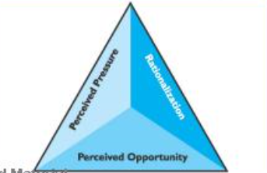
(Albrecht, et al., 2014)

The three legs of the triangle are:
- A perceived pressure (level of debt or simple greed)
- A perceived opportunity (the person is in a position of authority)
- Rationalization (everybody is doing it)

Fraud is such a broad topic that it will be helpful to divide it into three broad categories: corruption, asset misappropriation, and financial statement fraud. These can be further broken down into sub-categories. The Ethekwini Municipality in Durban South Africa provides examples of fraud on its website (Ethekwini, 2016)
- Accepting or giving anything of material value to get an undue favor or to avoid issuing of traffic fines etc.
- Any breach of Municipal Finance Management Act.
- Any breach of Supply Change Management Policy.
- Computer fraud.
- Conflict of interest.
- Creation of fictitious vendors.
- Deliberate omitting to report any such acts of dishonesty.
- Deliberate withholding of any information which could assist in investigating any irregularity.
- Disclosing confidential or proprietary information to outside parties for financial gain or other reason.
- Disclosing to other persons security measures or activities engaged in or contemplated by the eThekwini municipality.
- Double salary payments.
- Duplicate payments from the similar invoice.
- Extortion involving municipal employees in the performance of their duties.
- Failure to put in place internal controls thus causing financial loss to the eThekwini municipality.
- False /inflated invoices.
- False sick leave, overtime or qualifications.
- Forgery or alteration of any document or account including cheque, bank draft, stock records or any other financial document relating to transactions with the eThekwini municipality.
- Ghost employees.
- Housing subsidy fraud.
- The illegal connection of water and electricity.
- Illegal or irregular sale of Municipality property.
- Irregular allocation of low-cost houses.
- Irregular destruction, removal or inappropriate use of records, documents, furniture, fixtures, material and equipment.
- Issuing of false business licenses
- Misappropriation or theft of funds, securities, supplies or other assets.
- Procurement fraud.
- Purchase for personal use.
- Unauthorized deduction of employees salaries.
- Any dishonest, fraudulent or corrupt act or other similar or related inappropriate conduct.

1. Short Questions:
ii) What skills are most important to the successful practice of forensic accounting?
Amongst others here are some skills that a forensic account needs to possess:
- Analytical
- Detail-orientated
- Ethical
- Responsive
- Insightful
- Inquisitive
- Persistent
- Skeptic
- Evaluative
- Function Well under pressure
- Generate new ideas and scenarios
- Confident
- Makes people feel at ease
- Team player
(www.bolconline.co.uk, 2017)

- Analytical and detail orientated:
A Forensic Accountant needs to have a firm grasp on data analysis. When reviewing Finacial Statements and the supporting documents, they need to analyze if the transactions are valid and if they have been recorded properly. To be able to notice abnormalities that are not apparent. When reviewing a local body corporates financial statements, I noticed an above than inflationary increase in insurance costs and an unusually high Accounts receivable balance. The chair stated that the Balance Sheet and Income statement fairly represents the activities of the Body Corporate. Upon further investigation, we found that several tenants have not paid their levies and this had to be written off as bad debts (i.e., not shown as a current asset). The insurance company increased the rates based on insurance paid out in cash to the Chair. There were no repairs done. The Chair was removed from her seat.

- Ethics, Intuitive, Insightful, Inquisitive, Persistent, Skeptic and Evaluative
A Forensic Accountant should have strong interpersonal skills. Intuitive Insightful, Inquisitive, etc. This should be supported with strong Ethics and a code of conduct.

- People skills
A Forensic Accountant should be adaptive, be a team player and be able to break the ice so to speak.These people skills are an essential skill set required by a Forensic accountant.

1. Short Questions:
iii) What qualities of mind and/or body should a forensic accountant possess?
Core Skills:
- Effective communicator
- Simplify the information
- Critical/strategic thinker
- Identify key issues
- Auditing skills
- Investigative ability
- Investigative intuitiveness
- Synthesize results of discovery and analysis
- Think like the wrongdoer
- Understand the goals of a case
- Tell the story
- See the big picture
- Organize an unstructured situation
- Solve unstructured problems
- Research skills
- Solve structured problems
(www.bolconline.co.uk, 2017)
- Effective communicator:
A Forensic Accountants communication skills both written and oral are key to their effectiveness. A close business associate of mine always says that “the data does not lie, it lies in interpretation.” We live in a multicultural dynamic working environment and ensuring what we are saying is understood by the recipients is very important.

- Critical/strategic thinker
This is a core characteristic of a Forensic Accountant, who should be able to think on their feet.

- Investigative ability, Investigative intuitiveness, Investigative skills and a 6th sense:
Not so far from Sherlock Holmes, a Forensic account needs to know how to prod and pry. To be able to literally, sniff out a rat.

- “Child-like” curiosity and the ability to think outside the box:
A Forensic Accountant needs the tenacity, for example, to look at processes and ask the question why no matter how mundane or elaborate the process may seem. I feel that sometimes the things that seem obvious are the thing that we may want to look into.

- Analysis, Audit and Legal Knowledge
A Forensic Accountant must have a thorough understanding of the countries laws, local as well criminal law and a deep knowledge of the judiciary system. He/she may be called to work any number of cases as an expert witness: money laundering, embezzling funds to name a few. Coupled with a strong analytical and Audit abilities, this adds to the core Forensic Accountant skill set

iv) Outline the basic steps involved in fraud investigation?
- Accepting the Investigation
Teams analysis is required. Forensic accounting being a highly specialized field we have to determine whether or not the investigating team has the require experience and skills to undertake the job. Forensic accountants should be well acquainted with investigation techniques, legal requirements and should also be trained in handling/storing evidence.

- Planning and Investigation
Planning the investigation process is the next step. A step by step methodical approach based on the objectives of the project needs to be adopted:
- To determine who, what, where, when and why.
- Who committed the fraud
- What type of fraud
- When was this committed
- Determine why

- To reveal all parties involved
- To determine the scope of financial loss
- To gather evidence
- To suggest measures to prevent future occurrence of fraud

- Gathering Evidence
Gathering evidence is a critical step in the investigation process. The Forensic Accountant needs to be careful not only while gathering evidence but also needs to ensure that the proper chain of custody is observed. Any break in the above lead to the evidence being challenged in court and even deemed inadmissible.

Evidence-gathering techniques include:
  - Scrutinizing the client’s internal controls and looking for gaps that allowed the fraud to occur.
  - Using analytical procedures to compare trends and pattern within the different departments in the business.
  - Analysis large amounts of data using CAAT software to anomalies.
  - Reconciling cash accounts/payments and reviewing documentation.

- Reporting
Upon completion of the forensic investigation. A detailed report and summary of all evidence obtained as well as details as to the extent of the losses incurred. How was the fraud conducted and details on the breakdown of the company’s own control systems?
- Court Proceedings
The forensic account will have to testify in a court of law. Describe the evidence gathering process, custodianship, and details on how the perpetrators were identified. They need to be able to translate their findings to non-accounting people as well as be able to defend their conclusions.

iv) How would you distinguish forensic accounting, fraud auditing, and investigative auditing from financial auditing?
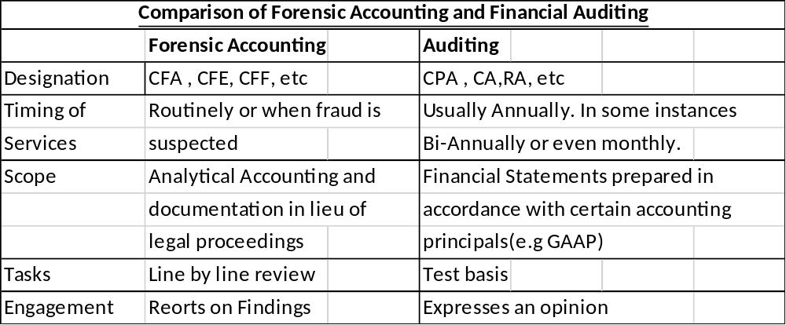

Case Study:
  - How the investigation for the above case should be started:
- Know your investigating team

A Forensic Accountant is an individual who has a mixed bag of skills. From investigation, techniques to legal requirements. Grom gathering evidence and presentation of this evidence in a court of law. We need to determine if the investigating team has the required experience and skills to undertake the job.

- Planning and Investigation

The next stage is the planning phase. This requires a considerable amount of work. The objectives of the case needs to be determined
- What type of fraud did the administrator commit? How long was he able to do this and how was he able to conceal this?
- Are there accomplices to the fraud? Is the Administrator the only suspect?
- Detailed inspection of the financial records to determine the extent of the financial loss.
- Gathering of evidence and preparation to present in court.
- Optionally to suggest ways of preventing this type of fraud from occurring in the future.

- Evidence gathering.

The forensic team should be well versed in evidence-gathering techniques including the use of CAAT software The gathering custody and presentation of evidence is critical in a Forensic accountants job/ Any breakdowns in the above may lead to the evidence being deemed inadmissible.

- Outline some documents which you think can help disclose the administrator's fraud activities.:

- Bank Statements (compare to documentation)
- Credit Card Statements (compare to documentation)
- Paid checks and check counterfoils (reconcile paid checks to check counterfoils and documentation).
- Receipts and invoices(Hotel, food, entertainment, repairs, etc.)

- If the forensic accountant is to be hired, how should he be chosen?

- Appropriate level of education and affiliation to professional body (CPA, etc.)

- Ability to Identify fraud with little information

The Forensic Accountant will need to pull a rabbit out of a hat. The perpetrators usually leave little or no evidence of their wrongdoing, and the Forensic accountant will need to be able to work with this minimal information.

- Think out of the box

The Forensic Accountant will need to have a 6th sense about wrong doings. To sniff out a rat. To be able to think like a fraudster.

- Accounting Principals:

The Forensic Accountant need to have in-depth understanding of the Generally Accepted Accounting Principals

- Investigative techniques, skills, and Mentality

The Forensic Accountant will need to have solid knowledge of investigative techniques and its application. His knowledge needs to surpass that of an ordinary auditor and may require him to go beyond the scope of general accounting principals.
- Differentiate fact from fiction:

Forensic accountants are usually employed on suspicion of fraud.

They will need to determine the act of wrongdoing based on evidence rather than rumors or allegations.

- Evidence gathering techniques;

The Forensic account must be an expert in evidence gathering, retention and presentation techniques.

- Interpretation of Data:

Data may have various interpretations. A Forensic accountant may need to know all interpretations and be able to choose the one that is most consistent with the business.

- Should the administrator be interviewed? If so, at which stage
- Yes they should be interviewed. This will need to be at the Forensic Accountants discretion. Early in the interview process only if they are deemed to be a flight risk or suspected to destroy evidence. Later in the interview process after testimony from key witnesses.

BIBLIOGRAPHY:

References
Albrecht, S. . W., Albrecht, C. O., Albrecht, C. C. & Zimbelman, M. F., 2014. https://www.amazon.com. In: Fraud Examination. Boston: Cengage Learning, p. 34.
Ethekwini, M., 2016. THE OMBUDSPERSON AND HEAD OF INVESTIGATIONS. [Online]
Available at: http://www.durban.gov.za/City_Government/Administration/city_manager/City%20integrity%20and%20%20Investigations/Documents/ombuds.pdf
[Accessed 12 November 2016].
Wisegeek, 2016. [Online]
Available at: http://www.wisegeek.com/what-is-a-fraud-triangle.htm
[Accessed 12 November 2016].
www.bolconline.co.uk, 2017. Brentwood Support Materials. [Online]
[Accessed 2017].
yourdictionary.com, 2016. [Online]
Available at: http://www.yourdictionary.com/fraud
[Accessed 12 November 2016].

Student Statement:

By submitting this assignment, I confirm that this is my own work.

Student Signature | Chidnand Harripersad | Date | 15/01/2017

For Tutor / Assessor Use Only
Total Marks
Marks Obtained
Percentage / Grade

