
Assignment Cover Sheet

Student Name: | Raymond Wilson
Student Number: | 2362
Course: | Diploma in Logistics and Supply Chain Management
Assignment No: | 5
Marking Criteria:
We expect the learners to write minimum one well expressed point in three lines against each allocated mark. This means one needs to write 15 lines with 5 well expressed points to get high grades for a 5 marks question.
For high grades use examples and illustrations where appropriate.
Assessment #5 Total Marks: 30

1. Give brief answers for the following questions: (14)

i. What is purchasing?

Purchasing is the first stage of Materials Management process. Purchasing, in reality, means the procurement of goods and/or services. The objective of purchasing department is to arrange the supply of materials, spare parts and services or semi-finished goods, required by the organization to produce the desired product, and normally, these are obtained from some agency or source outside the organization.

The purchased items should be of specified quality, in desired quantity, available at the prescribed time and ultimately at a competitive price. Thus, purchasing is an operation of market exploration to procure goods and services of desired quality, quantity at lowest price and at the desired time. The Suppliers who can provide standard items to meet this criteria are usually shortlisted and/or selected.
ii. Define the term ‘procurement.’

Quite simply procurement is the act of obtaining or buying goods and services. The process includes preparation and handling of a demand as well as the end receipt and approval of payments. It often involves the following steps;
(1) purchase planning,
(2) standards determination,
(3) specifications development,
(4) supplier research and selection,
(5) value analysis,
(6) financing,
(7) price negotiation,
(8) making the purchase,
(9) supply contract administration,
(10) inventory control and stores, and
(11) disposals and other related functions.
One of the difficulties in defining the term ‘procurement’ however is that it does not deal with a single action or process (as indicated above). Procurement covers the complete range of events from the identification of a need for a good or service through to its disposal or cessation. The term ‘procurement’ is very similar to the term ‘supply management’. It can therefore be argued, especially by those involved, that procurement is also defined as one of the following;

- Procurement is the business management function that ensures identification, sourcing, access and management of the external resources that an organization needs or may need to fulfil its strategic objectives.

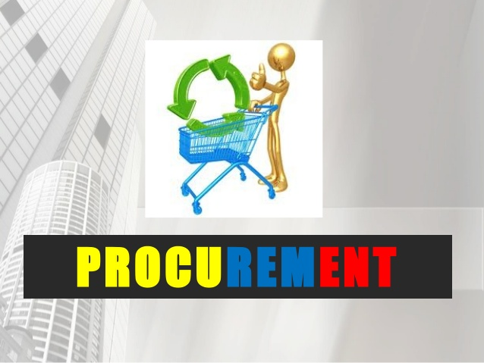

- Procurement exists to explore supply market opportunities and to implement resourcing strategies that deliver the best possible supply outcome to the organization, its stakeholders and customers.

- Procurement applies the science and art of external resource and supply management through a body of knowledge interpreted by competent practitioners and professionals.
iii. What is the importance of procurement in a supply chain?
Today the procurement role is currently receiving increased attention as an important contributor to the overall strategic success of most companies.
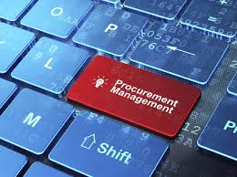
One of the key issues for Procurement, in modern business models, is that as a critical business function it only has the ability to influence corporate profitability when it is operating at a strategic level in the firm. Its development as a strategic function has been relatively slow, especially considering how Sales, Marketing, Engineering, HR and other functions have progressed in business perception and stature over the years. Therefore, the contribution both operational and strategic that the procurement function can (and does) make has yet to achieve its maximum level in many organizations.
It is important to understand there are three separate types of procurement strategy;
- Specific strategies used by the procurement function i.e. single sourcing
- Its role in supporting the strategies of other functions and of the firm as a whole
- And, the utilization of procurement as a strategic function of the firm. Note: While it is true to say that these issues are related, they are distinct in terms of how they are executed and also how they impact on the procurement function itself.
The movement of the procurement function from a “passive” or reactive role to strategic role is becoming ever more prevalent across organizations and industries. In many cases, top management has realized procurement’s profit-generating capability.
Thus, it is important for the procurement function to develop along with the other functions as the firm begins to implement a strategic decision-making process as follows;
- As the firm itself evolves, so too does the procurement function (Initially procurement is viewed as a buying function).
- Then the procurement function expands its role, with increased emphasis on quality and cost avoidance/saving.
- The next step is that the procurement function’s importance is recognized by the other functions in the company.
- It plays a key role in supply chain management through its integration with production, scheduling, logistics, sales, and accounting/ finance.
- Finally it assumes a proactive role to support the overall strategic plan.
iv. Who are qualified suppliers?
Qualified Supplier/Service Providers consist of companies which have undergone prior assessment and are consequently deemed suitable to work with organization. These prospective suppliers/service providers should undergo a prior assessment to ascertain their suitability to engage in commercial relationships with the business.
Creating a list of pre-qualified suppliers can add significant benefit to the procurement function from a number of standpoints such as cost optimization, improved service levels, relationship building, timely procurement and risk mitigation.
When establishing a pre-qualified supplier list, a similar process to that of an Invitation to Tender should be followed. A database should be utilized whereby potential pre-qualified suppliers are asked for details of relevant experience (normally through questionnaires). Applicants must sign a declaration and provide documentation such as bank account details, certificates of incorporation, trading license etc. In certain contexts the inclusion of a ‘price list’ element to the pre-qualification process may be deemed a necessity or appropriate.
Where a price list has been included as a component of the process, such lists should be provided to all budget holders to assist in the completion of Supplies Request’s and to the Finance department for ‘double-checking’ purposes. Clearly the price listing is a major element in determining who gets on the list and who is then shortlisted and ultimately used
When applications are received, all short listed companies should be visited by the PC where appropriate. This will ensure that every company on the pre-qualified list has been evaluated independently from the logistics and procurement function thereby reducing the level of risk in the system. When a list of pre-qualified suppliers or service providers is finalized, this list of companies can act as the providers of quotations under a Request for Quotation Procedure process and also these companies can amalgamate to form groups that advertise they belong to an organized, accredited set up that can be utilized and trusted accordingly who are symbolized similar to the illustration below.

v. What is e - procurement?

This term is used to describe the use of electronic methods, typically over the Internet to conduct transactions between awarding authorities or companies and suppliers.

The process of e-procurement covers every stage of purchasing, from the initial identification of a requirement, through the tendering process, to the payment and
potentially the contract management



There are organizational challenges to this kind of set up of course and some of these are as follows;

- Many users are resistant to change, simply due to human nature and habit
- Users may believe that e-procurement will make their job more difficult or cumbersome
- Current roles will change due to the impact of e-procurement
- Economic-Legal
- Level of economic development
- Regulatory framework
- Technological scenario
- Existence of private competitor services
- General Education level

However there are a number of benefits to this procurement strategy in the short term and longer term as indicated below;

Initial outcomes:
- better services;
- cost savings;
- time savings.

Final outcomes:
- improvement of the labor productivity of the public sector;
- economic rationality (organizational efficiency), simplification, transparency and accountability;
- GDP growth.

vi. Outline the main aims of procurement.
Once the diagnostic stage is completed the next stage in developing the procurement strategy is to identify strategic procurement objectives. These should include but not be limited too;
- Procurement objectives for each category of goods and services on the supply arranging matrix and ensuring its consistent and continuous movement.
- Objectives for significant purchases (purchases falling into the leverage, bottleneck and strategic categories on the supply matrix.)
- Objectives for the management of the procurement function.
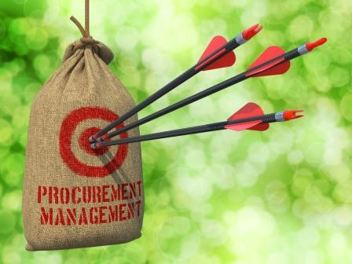
Objectives for the procurement of each category of goods and services should be made based on the procurement portfolio using pre-determined categories. The full results of any earlier or historical analyses should also be used as input. Note: The solutions will vary from organization to organization depending on their procurement profile.
Specific strategic objectives, for significant purchases, would be included if they were critical for the organization, e.g. the impending procurement of an organization-wide Enterprise Resource Planning (ERP) implementation or a high risk commodity critical to a core strategic objective of the organization.
Procurement management aims should also be established using the results of the analysis of the procurement function and capability. These should relate to the objectives defined for each category of goods, works and services and also for any specific, critical and/or significant purchases. These objectives can relate to the roles, responsibilities, structure and reporting, the procurement systems and capacities and/or the procurement skills and capacities. These objectives therefore will vary from organization to organization and also within a specific organization and can vary from month to month, season to season or year to year. Examples of specific objectives could be;
- increase coordination of common user items across the organization
- introduce new e-procurement system(s)
- implementation of ISO 9001
- increase numbers of procurement officers with Qualification/Certification.
vii. Outline some common manufacturing strategies.
Different companies plan and schedule manufacturing production using different strategies. Some companies make goods only after receiving a customer order while others make goods and distribute them to retailers where customers buy “from the shelf” at their discretion. A company strategy clearly has a direct impact on the amount of inventory it carries and that translates into cash available for other requirements. Some of these differing strategies are summarized below:

Chase strategy
Companies that use the chase strategy, (often referred to as a demand matching strategy), produce only enough goods to meet or precisely match the demand for goods. The chase strategy has several advantages as it keeps inventories low, which frees up cash that otherwise can be used to buy raw materials or components, and reduces inventory carrying costs that are associated with holding inventory in stock.

Level production
In a manufacturing company that uses a level production strategy, the company constantly produces goods equal to the average demand for the goods. Scheduling consistently arranges the same quantity of goods for production based on the total demand for the goods

Make-to-stock
In the make-to-stock situation, goods are produced before customers place orders. The retail environment is an example of make-to-stock as goods are produced and put into inventory at the retailer location. The make-to-stock strategy typically allows manufacturers to produce goods in long production runs, taking advantage of production efficiencies and costs.


Make-to-order
Companies that use a make-to-order strategy produce goods after receiving an order from the customer, as illustrated above. Most often a company that uses the make-to-order strategy produces one-of-a-kind goods. Examples can include sheet steel, custom-tailored clothing, custom machinery, building materials and fine jewelry to name a few.

Assemble-to-order
Automobile manufacturers are an obvious entity who use the assemble-to-order strategy. A customer can pick and choose from many features including interior fabrics, exterior paints, seat, engine, wheel or tire options. Once the dealer places the order, the manufacturing plant assembles the standard component parts to the exact specifications.

2. Describe the procurement cycle in details. (8)

All cycles must start somewhere and in most cases, including procurement, this is in the shape of a Plan. Procurement management therefore starts with figuring out what the company needs to achieve its long-term business goals. To do this, a meeting with company executives and stakeholders (i.e. finance, company owners, marketing, production, suppliers, customers of the procurement department customers, etc.) should take place. All of these stakeholders usually have specific needs with regards to procurement management and they should all contribute to the plan accordingly.
Business aims and objectives, the primary goal of a smooth procurement management process, is to help the company’s overall business goals. Once these goals are defined, there must be ways found, like the development of specifications, company material needs, preparation of requests etc., to help meet them to ensure a robust procurement management process.
Stakeholders usually have specific expectations and needs with regards to procurement. The best way to define them is by meeting with these stakeholders, using surveys or hiring external research providers. This should be an ongoing process since needs and expectations may change frequently.
Once the above has been taken into account, all the outcomes need to be formulated into one document. These guidelines, which can now be called the procurement policy, declare how all processes have to be carried out. The policy should be presented to all parties involved. Then the company board signs it, and the company begins to follow it for all procurement processes.

As with most businesses you should always ask yourself “is my current team capable and have they all the necessary skills and motivation” to carry out the processes defined in the procurement policy.
You may find that some of the team members require additional training to Align them and ensure they have a profound knowledge of the specific industry areas required to procure the needed goods and services for the company.
It is important to value the procurement team and work to keep them highly motivated, informed and trained. If you need to hire new team members, look first inside your company and then look at external options.
Procurement is in a constant state of flux and forever evolving due to modern procurement methods, software and bigger/faster data. All companies need to keep their teams on top of the latest developments through training, being member of/participating in professional organizations and industry conferences. These team members should also participate in analyzing and planning the procurement processes, ensuring they are aware of the steps required to document and complete the processes without delays or confrontations leading to discontentment and subpar productivity.
Each company will have a listing of suppliers with whom they have a close relationship. It is important to develop long-term plans and policies together with strategic partners, treating them as if they were team participants you can’t afford to lose.

With a highly motivated, skilled team in place it is now time to Procure the goods and services needed. This process needs to make sure it focuses on satisfying the needs of internal customers and don’t waste time dealing with excessive officialdom.
Selecting the right approach will make it easy to follow the procurement process, get a real-time overview and reduce manual work, thus saving buyers’ valuable time and the following methods should be part of your communiqué with suppliers (when dealing with strategic partners, the process can become even more personalized);
- Finding suppliers – Companies should constantly refresh their supplier list by looking for new ones online, at trade fares, etc. Doing that ensures that the bidding competition focus remains high and find vendors that can give you a competitive advantage over your rivals.
- Tender and RFP processes – Tendering methods like RFPs, RFIs, RFQs and reverse auctions should be used to qualify suppliers and ask for bids. Based on their bids and presentational expertise suitable suppliers can be chosen that will help acquire the highest quality and cost standard products and services available on the market.
- High and low value requests – For running strategic and high value requests more qualitative methods should be adopted. Running these requests requires skills, tools, attention to detail, and clearly more resources. Low value requests may be run by more quantitative ways: for example, by selecting the best of three received bids.
- Negotiations – Qualitative procurement methods should also be used to determine if suppliers are trustworthy and their products/services are of top quality, thus enabling a price negotiation and delivery risk environment.

- Contracting and delivery – Once the suitable product/service provider has been identified and selected, a contract with the terms that both parties have agreed to needs to be signed. Once started, it should be constantly reviewed and monitored to ensure products/services are delivered on time and with the expected quality. Ongoing focus should always consider regular inspection/checks on existing stock, possible substitution materials etc. to ensure no excessive stock is carried and sell by/usage dates are not encountered as these are all drains on the company’s finances.
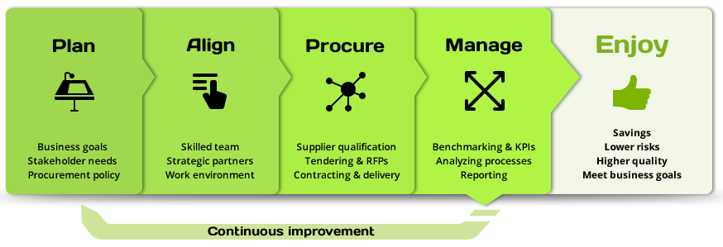
The procurement processes needs to be translucent for buyers, suppliers and stakeholders, therefore it’s essential for procurement managers to have a full overview of the process. This ensures accountability, helps improve procurement processes and allows them to coordinate and Manage the team’s workload.
A clear chain of command needs to be in place in order to achieve accountability and define quantifiable objectives for the team. Thereafter it is vitally important to keep all involved parties well informed about the processes, including benchmarking and reporting and should take into consideration the following;
- Supervising procurement – Make sure all the processes are run according to the procurement policy and best practices for eliminating the risk of fraud and maverick spending. All involved parties should be well aware of the processes being supervised.
- Analyzing processes – To improve the department’s activities, periodically analyze ongoing procurement activities, like RFP processes, spend across different categories, low value- vs. high-value requests, team performance, examine and evaluate quotations, checking for supplier deals etc. Ideally this information/feedback should be gathered and stored on one central procurement dashboard.
- Benchmarking and KPIs – Measuring the departmental success by consistently monitoring the performance of KPIs is an important aspect of the process and is measured using a predetermined benchmarking process. These are the metrics that reveal the success of procurement management.
- Reporting – The procurement manager reports at set intervals to company management, to other stakeholders and to the procurement team. By keeping the process transparent, you can make sure all involved parties are on the same page and are aiming for the same targets and goals.
- Ongoing Continuous Improvement – To deliver top performance, refine the procurement processes when necessary, but also understand that this is an ongoing task. For example, some improvements may require rewriting the policy, others may require adjusting procedures and/or better coordination of team resources.
Helping meet business goals and stakeholder expectations – Procurement management helps the company to rise to meet stakeholders’ expectations and meet their requirements. It helps them perform on higher level and also helps them meet business goals in the long run. With all of this in place it’s potentially time to Enjoy the following;
- Savings – Savings can be achieved in a variety of ways, like reducing delivery errors or increasing quality of products and services. You can also measure the direct cost and the team timesaving achieved through better procurement management.
- Higher value and lower supply chain risks – Building closer relations with your strategic partners will minimize supply chain risks. Combining your strengths with partners’ helps find new innovative solutions to stay ahead of the competition.
- Streamlined and easy to follow processes – You should value a full overview of simplified, standardized processes that are easy to follow for both management and buyers.

3. Which approaches are used to monitor the performance of suppliers? (8)

The term ‘performance monitoring’ means measuring, analyzing and managing a supplier's ability to comply with, and preferably exceed, their contractual obligations. It can also be claimed that monitoring the performance of suppliers can be;

- an aspect of supplier appraisal when the qualified supplier is competing for the renewal of an existing contract
- an aspect of the management of approved supplier lists
- an integral part of the contract management function

It is in a company’s best interest to know that they are getting what you contracted for. This may be as simple as confirming that materials/goods are delivered on time and that they conform to specifications. However, with repeat business and/or more complex service requirements it makes sense to monitor performance against contract requirements over a period of time.

Especially at the start of a contract there is inevitably a degree of risk and uncertainty for the parties involved. As the contract proceeds, both parties learn from experience and the risk begins to diminish as the original contract assumptions come to be tested.
Monitoring the performance of suppliers/vendors is a key aspect of P&SCM, but one which can easily be under-resourced and neglected. When performance monitoring is undertaken post-contract, the purpose is twofold:

- to ensure that the supplier is meeting the performance criteria, e.g. service levels and quality, laid down in the contract
- to identify room for improvement (should there be any)

It is important therefore to hold regular review get-togethers where both parties seek to understand how they can make the contract perform better if required. Meetings between buyers and suppliers should always be two-way, with both parties learning from each other; the buying organization can regularly improve its own performance as a result of supplier feedback.

Unforeseen problems may arise, for example, if a supplier begins to suffer financial strain in discharging its obligations then (commercial nature being what it is) the supplier will begin making behind-the-scenes cutbacks irrespective of what may or may not be specified in the contract. The key here is to address problems when they are still minor and therefore easier to resolve. Furthermore, early warning of a supplier in financial difficulty gives the buyer time to develop alternative supply solutions.

There are three different aspects to the monitoring of supplier performance post-contract;

- Gathering factual, and therefore objective, information about their performance such as lead-times from order, quality standards being met, pricing compliance and whatever else is laid out in the contract. This type of information can usually be obtained from IT systems within the organization in the form of management information. As with all of these aspects, it is good practice to be as consistent as possible in the approach to the performance monitoring.
- Obtaining the experiences of the customers (for example, in respect of service, attitude and response rates). This should be as objective as possible, although in some cases it may, inevitably, be subjective. One way to collect information on performance is by individual interview against a defined set of questions. This can be face-to-face or on the phone but needs to be interactive so that the interviewer can explore the background when necessary. The P&SM function will have to assess the validity of any subjective re-marks. Sometimes commitment is required from customers, such as engineers in the field, to keep records of their experiences of working with a supplier in order that objective factual data can be used. Another way is to undertake customer satisfaction surveys, which can be quite short and distributed by email.
- The supplier's experience of working with the buying organization must be considered in the evaluation, as it might be the case that they are facing unnecessary obstacles or dealing with difficult people.

There are a number of key factors which can be used to assess supplier performance and which can be used as a yardstick for determining whether good practice is being achieved in specific situations. Some examples of these 'hard' issue key performance indicators (together with their sub-categories) are;
• Product quality
• MTBF (Mean Time Between Failure)
• Percentage of incoming rejects (delivery accuracy)
• Warranty claims
• Service Quality (against agreed SLAs)
• Call-out time
• Customer service response time
• On time delivery performance against agreed delivery lead times
• Relationship/Account Management
• Accessibility and responsiveness of account management
• Costs are maintained or reduced

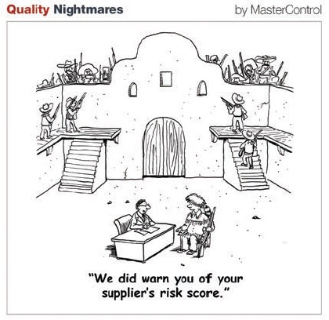

The measures, objectives and targets used in monitoring the supplier’s performance must reflect those that were agreed when the contract was let. That is why it is important to specify a commitment to continuous improvement at the outset. It is generally unfair to the supplier to suddenly introduce a range of measures after the contract has begun unless there is agreed contract variation framework that allows the introduction of such measures in order to meet the aspirations of the parties to the contract in terms of continuous improvement.

Performance monitoring can be a time-consuming task and so the effort and methods should be proportionate to the value and importance of the contract so it is worth noting that performance monitoring is not suitable for all suppliers; however, it is good practice to include supplier measurement, analysis and monitoring in all contracts so that quality, price, delivery and service levels can be monitored to ensure contract performance and compliance. A fair scoring mechanism must be used to evaluate the supplier’s performance so that any scrutiny of the performance monitoring program will be seen as a “level playing field” for all involved.



Performance monitoring should lead to continual improvement from suppliers, it is therefore an assumption that most suppliers would expect a long-term business relationship with the client. This may involve contracts of several years duration, with options to extend for further periods, if the supplier's performance is satisfactory.

Although monitoring performance of suppliers will ideally be directed and managed by the P&SCM function, it need not necessarily be carried out by them. In the event that the monitoring process is managed outside the P&SM function (third part entities), it is essential to ensure the staff have sufficient authority, training and accreditation are used to enable them to carry out their role effectively.

Student Statement:

By submitting this assignment, I confirm that this is my own work.

Student Signature | Raymond Wilson | Date | 14th Sept 2016

For Tutor / Assessor Use Only
Total Marks
Marks Obtained
Percentage / Grade

