
Assignment Cover Sheet

Student Name: | Randolf Delmendo
Student Number:
Course: | Accounting and Finance Level 4
Assignment NO: | 2

Marking Criteria:
We expect the learners to write minimum one well expressed point in three lines against each allocated mark. This means one needs to write 15 lines with 5 well expressed points to get high grades for a 5 marks question.
For high grades use examples and illustrations where appropriate.
1. Give short answers to the following questions: (16)

i. Who is an accountant?
responsible for account keeping; important instrument for financial control; advises the company in fiscal or financial matters; prepares the organisation’s financial statements, such as, the income statement and balance sheet for a particular period. He/she has the responsibility of maintaining supporting evidence and classified facts related to the financial matters of the organisation; and deals with the verification, authentication, and certification of the company’s
accounts.

ii. Describe various roles and activities that accountants perform.

Accountants identify problems with the organization’s operations and its financial position and provide solutions, as well.

An accountant performs financial functions related to the collection, accuracy, recording, analysis and presentation of a business, organization or company's financial operations.

Responsible for Financial Data Management, Analysis And Advice, Financial Report Preparation, Compliance and External Business Affiliations

iii. What type of duties does a controller perform?

a) Designing a functional accounting system and operating it;
b) Preparation of financial statements and reports;
c) Establishing and maintaining systems and procedures;
d) Managing the internal and external audit of the business;
e) Managing computer applications;
f) Exercising cost control;
g) Preparing budgets;
h) Forecasting and preparing analytical reports;
i) Supplying information to top management; and
j) Managing the company’s taxes.

iv. What is a double entry system? Outline the steps involved in Double entry system.

Double Entry: Every business transaction has a two-fold effect in this system, at the giving and receiving ends. The effect of the transaction is recorded in at least two different accounts with equal amounts.

Steps involved in Double Entry System

a) Preparation of Journal: Journal, which is also known as the book of original entry, is the first place where a business transaction is recorded. Therefore, a journal contains a record of all business transactions that have occurred.

b) Preparation of Ledger: It is a collection of all of the business’s accounts. Transactions recorded in
journal are posted to their respective accounts in the ledger.

c) Trial Balance Preparation: It is a summary of all transactions that have taken place and their effects
in the form of a list.

d) Preparation of Final Account: Final financial statements are made at the end of the accounting
period to reflect the organization’s financial performance and its general financial position.

v. What is the meaning of ‘Debit’ and ‘Credit’ in accounting?

The terms Debit and Credit have Latin roots. The term ‘Debit’ comes from ‘debt’, which means to owe. The term ‘Credit’ comes from ‘creditable’, which means to entrust.

Debit and credit can be associated with either increase or decrease in financial amounts; this is determined by the kind of account.

vi. What is meant by ‘Hybrid basis’ accounting? How the entries are recorded using this
method?

In Hybrid Basis of Accounting, certain entries are made on Cash Basis Accounting and other entries are made on the Mercantile System of Accounting.

vii. What is the difference between ‘Real Accounts’ and ‘Personal Accounts’?

Personal Accounts | Transactions that are carried out with a person or a group of persons.
Real Accounts | Related to property or assets.

viii. How do we record the entries using cash basis accounting method?

Simply put, in this type, accounting is based on cash and the entries are made only when cash payments are either made or received. When the cash payments or receipts are due, the entry is not made.

2. What are the main objectives of book-keeping? How would you distinguish book keeping from accounting? (4)

The following are some of the main objectives of bookkeeping:

a) A permanent record of each transaction is maintained through bookkeeping;
b) An organisation’s financial position and soundness can be ascertained by analysing the records on assets and liabilities;
c) Income and expenditure figures of the firm during a particular period help in calculating the profit or loss for that period;
d) It keeps a record of all customers and suppliers, enabling the business to keep track of the money which is received or paid;
e) Business policies can be reviewed and revised in the light of past records maintained through
bookkeeping; and
f) It allows the government to amend business laws, provide licenses, and assess taxation based on a business’s records.

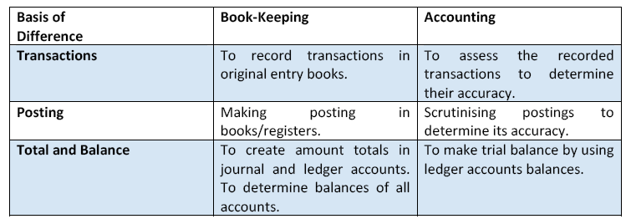

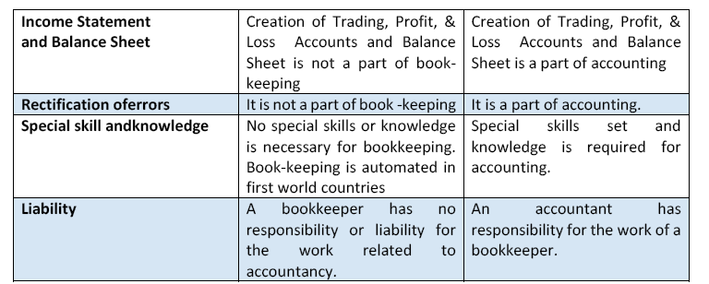

3. Multiple choice questions, Tick the correct answer. (5)

i. Stock is?
• The quantity of goods at the end of the year
• The total value of all the goods purchased during the year
• Items purchased to sell at a profit
• The value of goods left over at the end of the year
• Fixed assets acquired during the year

ii. Which of the following is not an asset?

• Creditors
• Fixed assets
• Cash
• Debtors
• Petty cash

iii. Capital is?

• The total amount of cash in the business
• The amount the bank has invested in the business
• Total of the fixed assets and current assets
• The total amount the owner has invested in the business

Student Statement:

By submitting this assignment, I confirm that this is my own work.

Student Signature | RANDOLF DELMENDO | Date | 16-OCT-2016

For Tutor / Assessor Use Only
Total Marks
Marks Obtained
Percentage / Grade

