
Assignment Cover Sheet

Student Name: | Brendan Reilly
Student Number: | 5029
Course: | Diploma in Construction Management
Assignment NO: | 3

Marking Criteria:
We expect the learners to write minimum one well expressed point in three lines against each allocated mark. This means one needs to write 15 lines with 5 well expressed points to get high grades for a 5 marks question.
For high grades use examples and illustrations where appropriate.
Importance of Estimation in Construction Work

ASSESSMENT 3
1.
i.
Estimating is pricing up the job or project. You need to understand the scope of the work. If you don’t know what the project is trying to achieve, then the tendering stage might not win the contract or it goes well over budget. For jobs that cannot be easily measured accurately an estimator can produce lists for the contractor that express the rates for Items & units, taking off and dimensions calculations, material rates, labour rates & equipment rates.
Estimating is essentially about three things, Money, Accuracy & Speed. Estimating is necessary because those three main points can make or break a contract, A project and a company. The estimating stage will include feasibility studies that contain technical and financial dimensions. This is a very important job and role with numerous variables and activities, which means quantity surveyors and estimators are in high demand.

ii.
The bill of quantities can serve to be a breakdown of scope of work and unit rates. It can be on big projects are large detailed document. It would most likely have in it quantity of manpower & labour, plant & equipment, materials and parts. It will help with planning and scheduling of the project and works.

iii.
The term approximate estimate is very useful, it is the first estimate to take place. If there is a big difference between the approximate estimate and the detailed cost estimate then it may have implications on the go ahead. If the approximated cost is really high then the project would stop without preparing its detailed estimate. But then if the approximated cost is too low then project may be taken up but for detailed estimate design and drawings, but due to the bad approximation it’s cancelled due to lack of funds.

iv.
A Project budget can be drawn up by the client or a construction team. It is what funds are on offer to complete the project from planning to completion. It is what can be used to assess what materials, plant and labour to be used. It can give planners and contractor’s future scope on what can be done to ‘fit the budget’. The plan or construction program can be seen as work relating activities currently in progress and activities to be performed in the future.

v.
Administrative approval is to obtain competent authority for the Project requiring the works to commence. The formal acceptance of the proposal by the authority is termed as Administrative Approval of the work. Then after receipt of this and the expenditure sanction. A detailed estimate is sanctioned by a technical authority of an engineering department empowered by the government to ensure proposals are structurally sound and accurate. They give approval for the initial drawings and cost estimates. This is called the technical sanction.

2.
- Material rate estimates are calculated from experience and previous works on building similar products in similar circumstances. Sometimes the Supplier can give you examples or know what you need depending on the job. Here is a illustration of a Material cost spreadsheet.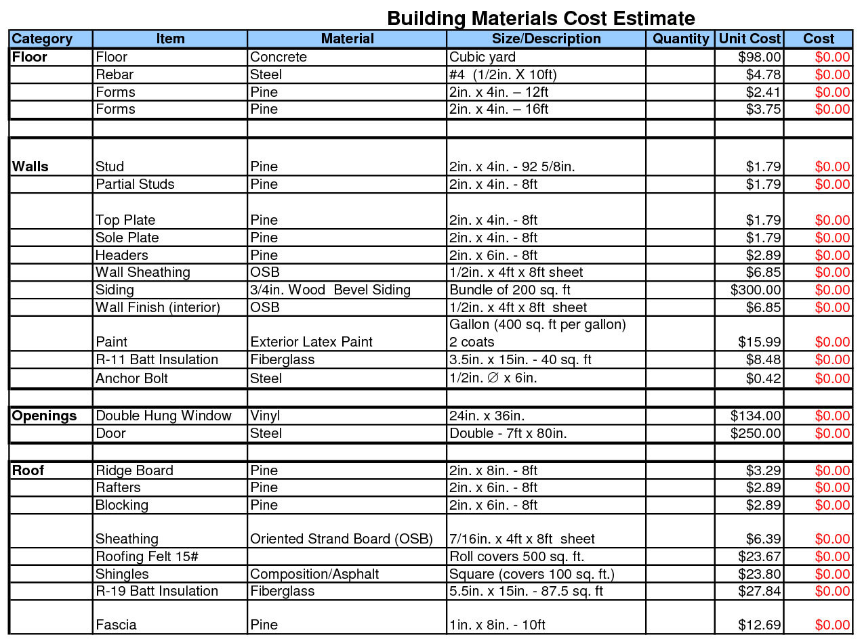

- Labor rate estimates are calculated by separating the the employees and trades by pay scale. Then adding up the hours booked into work plus overheads and overtime to allow for an accurate cost. The estimated time to carry out a task is normally in hours, which should remain constant, however it is possible that minor changes can happen due to the location of the project unforeseen delays etc. It is possible that buffer for time restraint might be needed. This is done by using multiplying with a percentage factor.
Example of hourly rates:
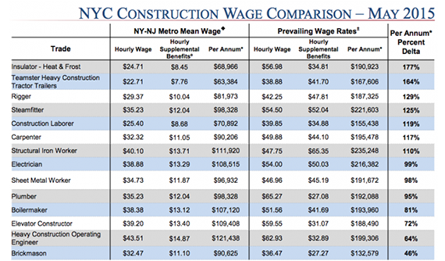

- The equipment rates can be estimated in many ways one such way is to devise a list of prices for each possible piece of equipment that may be necessary including freight and additional parts. They may have different sizes and power depending on the task they are needed for. Following the Job description and hours needed this can help calculate the costing and estimating of the Project. Fuel and perishables might be included in this pricing.

Hire list:

2.
Estimating is an important part of construction, which requires judgment and experience in the industry. Cost estimating requires quantifying scope & applying cost to it. Identifying construction methods and tasks to complete to keep productivity and completion of the project within budget.
Estimators predict the cost of a project for a defined scope to be completed at a defined location and by a specific date. It is so to know what price can be put forward and still make a profit.
Estimators may have different perspectives, for an owner organization, they are involved directly in the economic evaluation of a project. For a contracting organization, estimators determine the probable cost of the contractor’s scope plus the contractor’s profit. This typically makes up the contractor’s bid, tender or proposal.
There will be an initial assessment to get a feel for the project and see if it is feasible, this will look at the works involved in the construction program. Onsite inspections and survey will be done around the work site and its vicinity. Consideration will be taken for safety, security, logistics, access for equipment and materials and their storage.
When the estimator is pricing up they must separate it into different sections like preliminary costs, net costs and gross costs. Plant, Tools and Vehicles are included in the preliminary stage of the bill of quantities. The net cost is the cost of the majority of the work. This includes labour, the wages for all of the staff, and plant and materials also all of the equipment they use.
‘The definition of gross profit is: Calculated as sales minus all costs directly related to those sales. These costs can include manufacturing expenses, raw materials, labour, selling, marketing and other expenses.’ http://www.investorwords.com/2249/gross_profit.html#ixzz154W1cnBN
Estimating is normally booked in two ways, the old way which is called stick estimate and more common now by unit cost which is much quicker for getting a price back to the client.
Overheads is for works to continue on slightly irregular basis. It can be cut if limits to production are made, or if production is halted completely. Overhead expenses are all costs on the income statement except for direct labour, materials & expenses. Overhead expenses include accounting, advertising, insurance, legal fees, repairs, supplies, taxes, bills, logistic delays etc
In construction the overheads of a company are the costs that must be met in order to be able to run the head office. They are basically costs you can't control such as wages, electricity, gas or office rent, usually you will have to recover them because they include admin Risks that we take are a massive aspect to the turnover. The turnover that comes from a company will rise and fall from year to year. The risks you take and the work of your company will change all the time. No year will ever be the same as the last one. There can be similar jobs, projects and contracts but cost will usually never be the same.

Student Statement:

By submitting this assignment, I confirm that this is my own work. Why cost and time estimates are important to every project: o Cost estimates are more than just how much money the owner needs to commit and when is it required; o The ability to accurately forecast completion cost and completion time of projects allows owners, builders, investors, users, and the general community to plan their investments and operations with more certainty and without the adverse impacts that sudden and unexpected surprises give; o Even positive impacts, when unexpected, can have a reduced positive flow on effect.

Student Signature |  | Date

For Tutor / Assessor Use Only
Total Marks
Marks Obtained
Percentage / Grade

