
Assignment Cover Sheet

Student Name: | Aung Min Han
Student Number: | 5645
Course: | Diploma in Construction Management
Assignment NO: | 2

Marking Criteria:
We expect the learners to write minimum one well expressed point in three lines against each allocated mark. This means one needs to write 15 lines with 5 well expressed points to get high grades for a 5 marks question.
For high grades use examples and illustrations where appropriate.
Module 2: Development and Organisation of Construction Projects

1.1
Design Errors - a design with errors practically means incorrect or insufficient representation of project deliverables. It will lead to incorrect application of techniques in achieving result, such that as the actual execution phase of the project unfolds these design errors, attempt to correct it will lead to delay and cost overrun.

Change of Scope - any change in the project scope during execution means that the whole initial project plan will need to be reviewed such that a reviewed budget, schedule and quality will have to be developed. This means more time and resources will be needed as against the initial baseline.

Complexity - in terms of the size of the project, most mega projects tend to have relatively long implementation period. This could be affected by inflation, change in material price and changes in exchange rates such that the initial budget may need to be supplemented for the completion of the project. The result could be cost overrun and long chains of negotiation which will lead to delay.

1.2
Shares - shares may be of several types, each with different rights. Ordinary shares called equity of the company represent the major ownership and risk bearing element of the entrepreneurship. Preference shares are also common, entitling the shareholder to a dividend up to a prescribed level prior to any distributions being made to holder of ordinary shares.

Debentures - these are loans made to the company. The difference from conventional loans is that they are offered to the market at a fixed interest rate and are repayable at a set time.

Bank Loans - most institutions are reluctant to lend long term, particularly to construction firms. The borrower will need to provide a proportion of the finance from internal resources.

Trade creditors - delayed payments to creditors and prompt ones from debtors. The construction industry is well suited for this sort of financial arrangement since completed work is paid for by the client in periodical stages.

1.3
The project controlling phase consists of these processes required to track, review, and organize the progress and performance of a project; identify any areas in which changes to the plan are required; and initiate the respective changes. The processes used in controlling phase are shown below.
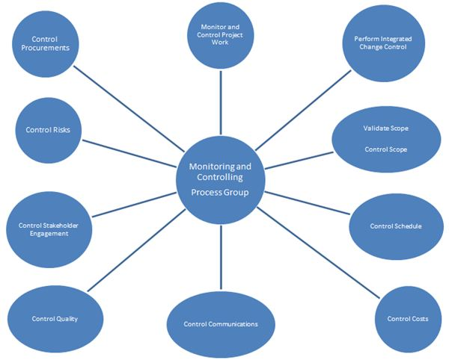

1.4
Creating a project punch-list of outstanding items, and working with the team to close-out the items.
Working with finance and legal teams to ensure that all project-related contract commitments are finalized and closed.
Completing a final accounting of the project budget.
Preparing the final Project Report, which should include the following:
- Evaluation of the success of the project
- Important project data
- Significant project changes and their effect on the project
- Issues requiring further work
- Recommendations for future projects
- Project feedback and questionnaire
Making sure that all project documents and deliverables are collected and documented properly.

1.5
Feasibility studies can be defined as the evaluation of the viability of a development project. It is a tool for analyzing if a proposed task can operate under a given set of assumptions, such as the technology used and the monetary aspects of the construction work.
Technical - involves evaluating the engineering aspect of the project which includes the fields of civil and structural engineering.
Economic - involves evaluating the economic benefit and loss that may result from the project.
Financial - involves evaluating the capability of the organization to come up with the funds needed to complete the project.
Cultural and Social - involves evaluating the compatibility of cultural and social practices, beliefs and status affected by the proposed project.
Political - involves evaluating the status of the political climate that may affect the viability of the project.
Environmental - involves evaluating the capability of the project to secure licenses, approvals and permits in a timely and cost effective way.
Market - involves evaluating the project's impact on the market and its competitors. This also includes the profitability analysis of the project.

1.6
Project Completion Report
- General project information such as project description, start-date, and end-date etc.
- Management effectiveness that summarizes how effectively the management needs of the customer and project were met.
- Lessons learnt that summarizes project lessons learned including the cause of issues, reasoning behind the corrective action chosen, and other types of lessons learnt.
- Administrative closure that summarizes project administrative closure activities such as procedures to transfer the project products or services to production and/or operations; stakeholder approval for all deliverables; confirmation that the project has met all sponsors, clients, and other stakeholder’s requirements etc.
- Contract closure that summarizes project contract closure activities such as formally closing all contracts associated with the completed project.
- Information distribution and archive that summarizes the data archived in the project repository.

2.0
A project is a series of tasks that need to be completed in order to reach a specific outcome. A project can also be defined as a set of inputs and outputs required to achieve a particular goal. Projects are often described and delegated by a project manager. They go over their expectations and goals and it’s up to the team to manage logistics and execute the project in a timely manner.

A standard construction project, in general, has following five major life cycle phases:
- Initiation
- Planning
- Execution
- Performance and monitoring
- Closure

1. Initiation Phase:
The project will be evaluated in order to determine if it is feasible and if it should be undertaken, at the beginning. The project objective or need is identified; this can be a business problem or opportunity.
A suitable response to the need is documented in a business case with recommended solution options. A feasibility study is conducted to examine whether each option clearly identifies the project objective and a final recommended solution is determined.
When a solution is approved, a project is initiated to implement the approved solution. For this, a project manager is appointed. At this stage, the major deliverables and the participating work groups are identified. This is the time when the project team begins to take shape. Approval is then required by the project manager to move onto the detailed planning phase.

2. Planning Phase of Construction Project:
The planning phase involves further development of the project in detail to meet the project’s objective. The team identifies all of the work to be done. The project’s tasks and resource requirements are identified.
In a broader sense identification of each activity as well as their resource allocation is also carried out. A project plan outlining the activities, tasks, dependencies, and timeframes is created.
The project manager coordinates the preparation of a project budget by providing cost estimates for the labor, equipment, and materials costs. The budget of the project already estimated is used to monitor and control cost expenditures during project implementation.

3. Execution Phase of Construction Project:
This is the implementation phase, where the project plan is put into action and the work of the project is performed practically on site. It is essential to maintain control and communicate as needed during each implementation stages.
Progress should be continuously monitored and appropriate adjustments are made and recorded as variances from the original plan. A project manager spends most of the time in this step. Throughout the project implementation, people carry out the tasks, and progress information is being reported through regular project team meetings.
The project manager uses this information to preserve control over the direction of the project by comparing the progress reports with the project plan to measure the performance of the project activities. If any deviation is found from the already defined plan corrective measures are made.

4. Performance and Monitoring Phase of Construction Project:
This stage is all related to the measurement of progress and performance to make sure that items are tracking with the project management scheduling. This phase regularly happens at the same time as the execution phase.

5. Closure Phase of Construction Project
During the final closure, the importance is on providing the final deliverables to the customer, that is:
• Handing over project documentation to the business
• Termination of supplier contracts
• Releasing project resources
• Communicate the closure of the project to all stakeholders.
• Conduct lessons-learnt studies

Student Statement:

By submitting this assignment, I confirm that this is my own work.

Student Signature | Aung Min Han | Date | 17 Feb 2017

For Tutor / Assessor Use Only
Total Marks
Marks Obtained
Percentage / Grade

