
Assignment Cover Sheet

Student Name: | Maria Magdalena Barragan Zermeno
Student Number: | 1619
Course: | Management Level 3
Assignment NO: | 07

Marking Criteria:
We expect the learners to write minimum one well expressed point in three lines against each allocated mark. This means one needs to write 15 lines with 5 well expressed points to get high grades for a 5 marks question.
For high grades use examples and illustrations where appropriate.
Please insert your completed assignment ( in word format) here:


Question 1

What are various best practices for offering feedback?
There is no failure, only feedback.
Robert Allen

Feedback, like any communication, depends on the sender and the receiver, as well as on the message itself. Giving feedback effectively is a skill and like all skills, it takes practice to build our confidence and improve.

Fundamentally, feedback is a good thing. For managers it’s an important tool for shaping behaviors and fostering learning that will drive better performance. When done in the right way and with the right intentions, feedback communication is the avenue to performance greatness. Employees have to know what they are doing well and not so well. For them to really hear our thoughts and suggestions on ways to improve, though, that feedback has to be delivered carefully and frequently.

Feedback can be informal in day-to-day encounters between managers and individual persons or trainees, between peers or colleagues, or formal, for example as part of written assessment of a person’s performance. Giving and asking for feedback should be part of the overall interaction between leaders and employees, not a one-way communication.

If feedback is not given, the person might assume that he/she has no areas for improvement or development. People value feedback, especially when given by someone whom they respect for their knowledge, attitudes or competence. Failing to give feedback is in itself a non-verbal communication, leading to mixed messages and false assessment by the person of his/her own abilities as well as a lack of trust in the leader. Feedback should also be aligned with the overall aims and objectives of the institution or organization in which the person is engaged.

Being able to give effective feedback on performance in both formal and informal settings is one of the key skills of a leader. However, the core principle is: a good relationship and dialogue helps the individuals receive messages appropriately and the feedback should be given so as to help the persons take informed action and responsibility for their future improvement and development.

We sometimes spend a lot of time over-teaching managers how to give feedback. We make it way too complicated! By the time we finish training managers on all of the do's and don’ts of giving performance feedback, they become so paralyzed with fear that they would rather just avoid it.

It doesn’t have to be so complicated, and with practice and patience, we managers can improve the way we provide feedback so that employees will be more receptive to it.

Whether we are giving formal or informal feedback, applying some basic principles will help our feedback to be more effective. Following are tips that can help us give more constructive feedback.


1. - Keep the conversation positive. Even when you have to deliver negative feedback (or outright bad news), the conversation should remain respectful, positive, and preserve the integrity of the people involved. Being positive gets the person in a better frame of mind to hear the other side.

"How do entrepreneurs survive their early failures? They don't view their failures as failures - they view these experiences as feedback, and a prelude to future success."
Kevin Kelly

The most important element in providing effective feedback is establishing an atmosphere of mutual trust and regard. When a feeling of trust has been created, it is easier both to give and to accept feedback because developing a good relationship with a person helps feedback to be received more appropriately. That is why to be effective it is important to develop rapport, mutual respect and trust between us and the other person.

The whole purpose of offering this feedback is to help people change by reinforcing positive behaviors or improving negative ones. The overall focus is on the positive and should be part of the overall communication process and developmental dialogue. Aim to encourage dialogue and rapport.

We need to recognize positive performance and make a point to recognize everyone who performs to expectations avoiding focusing only on outstanding or poor performers. We have to recognize improvement and observe the team member’s performance after the feedback session as well. If improvement occurs, it is important to praise the team member. If improvement doesn’t occur, we need to offer feedback again or coach the person. Feedback therefore involves recognizing those who perform well. We have to recognize team members for their accomplishments to promote continuous improvement. Positive feedback can motivate people to perform even better.

Constructive feedback is more easily received if it is preceded by genuine appreciation for hard work. Given how valuable our staff is to us and our organization, we can’t express enough how much we value them. Negative feedback should also be positive; we need to focus on some of the positive aspects before the areas for improvement:

For example: ‘You picked up most of the key points in the ‘history’, including X and Y, but you did not ask about Z…’

Use positive comments that describe what is well done. Accompany negative descriptions of the work with positive suggestions for improvement and choose words that communicate respect for the person and the work.

Feedback should always be positive. But being ‘positive’ doesn’t mean being artificially happy or saying work is good when it isn’t. Being positive means describing how the strengths in a person’s work match the criteria for good work and how those strengths show what the person is learning. Being positive means pointing out where improvement is needed and suggesting things the person could do about it. Just noticing what is wrong without offering suggestions to make it right is not helpful. An important point to keep in mind is that it’s not kind to always be positive when some criticism is warranted or to take a coddling tone.

Example:
I once supervised a teacher-education student who as part of her fieldwork tutored a 4th grader in math in an inner-city public school.
“He got most of them wrong, but I told him ‘good job’ to help his self-esteem,” she said.
Yikes! This isn’t helpful, and it’s not even truly positive. It’s counterproductive, and it’s not truthful. The student may end up thinking incorrect facts or concepts are correct. Even worse, the student may end up with a sense of entitlement, believing any work of whatever quality is acceptable and that he should be praised for it and not have to do better. Worse yet, he may know most of his answers were wrong and think the teacher is stupid not to have noticed. That teacher will have little respect and not get far with that student in the future. It will be a long year.

However, it is always appropriate to be positive in the sense of “lighting the way forward.” This tone suggests that there is a way forward and that the person is capable of taking it. Tunstall and Gipps (1996) use this image of lighting the way forward to characterize descriptive feedback that makes suggestions for improvement.
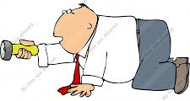
For example, it makes me think of people in a cave with someone who has a flashlight. This person is the leader, at least temporarily, and he or she shines the beam around until everyone sees where to go.

So we have to light the way forward: if we tell a person something is wrong, we have to make suggestions as to what to do about it.


We have to try framing our critique in terms of the positive result we want to achieve, rather than as what’s wrong with the person and make it about the impact the employee could achieve by working differently. We have to ask “What are our goals?”

Sometimes feedback is not received positively by individuals and fear of this can inhibit leaders giving regular face-to-face feedback. People’s responses to criticism vary however constructively it is framed. Individuals often discount their ability to take responsibility for their learning and their responses may present in negative ways, including anger, denial, blaming or rationalization (King, 1999). It is useful to think in a structured way about how feedback might be received and to encourage an open dialogue and receptivity.

If the person we’re giving feedback to gets defensive or lashes out, we need to keep our preferred outcome and preferred working relationship in mind. We can’t prepare for every possible thwarting mechanism someone might throw at us, but we can control our reactions.

And when we do offer plaudits, then we have to praise effort — not ability. Carol Dweck’s well-known research has shown that’s the best way to keep people motivated and it makes criticism feel less threatening and personal. After all, if we’ve been told our whole life, “You’re so smart!” a rebuke might make us wonder, am I dumb now? Focusing our praise on behaviors — “You guys really put a lot of attention to detail into this” or “I’m so impressed with how hard you worked to get this done on time and under budget” — means that when we have to deliver some corrective feedback, people are more likely to take it in the same vein rather than as a personal attack.

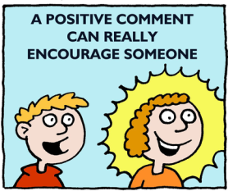
Positive feedback stimulates the reward centers in the brain, leaving the recipient open to taking new direction. Meanwhile, negative feedback indicates that an adjustment needs to be made and the threat response turns on and defensiveness sets in. We don't need to avoid negative, or corrective, feedback altogether. We just have to make sure we follow it up with a suggested solution or outcome.

As managers, we need to weigh the tradeoffs involved in making negative feedback. If we criticize our employees, we will likely provide some corrective information, but we will also put our employee in a bad mood. If an error is so inconsequential that the corrective value of criticism is low, it might make sense for us to keep that feedback to ourselves and focus on potential future improvements, instead of dwelling on past errors.

While motivated professionals appreciate both positive and constructive feedback, managers are often uncomfortable in delivering it, particularly anything deemed as negative. In surveys and research studies, managers who struggle with delivering constructive feedback are concerned that they will not be liked or, they fear creating an incident by offering criticism.

Of course, there are situations when we as managers must provide negative feedback. On these occasions, we don’t have to lose sight of our purpose for offering that feedback: to improve the employee’s performance going forward. As much as we might want to excoriate our employee for what we believe is a spectacularly awful performance, our business gains nothing from it. In fact, shaming our employee is likely to have substantial negative effects on our business.

Giving positive feedback for trivial issues "Great job making the coffee today!" and other trivial comments are likely to generate eye rolls and be perceived as disingenuous by our team members. We have to offer positive feedback when we see noteworthy positive behaviors and we want to reinforce those in the workplace.

We don’t deliver negative feedback in front of team members when that can be avoided and try to find a private place. We could conduct the meeting in our office or schedule a conference room for our feedback discussion.

We need to learn to remain calm; regardless of how upset we are, it never pays to lose control of our emotions and if we need time to gather our emotions we delay the discussion a few hours or at most a day. The intent of feedback is to promote improvement and approach the discussion with this positive attitude.

We end on a positive note and conclude any feedback discussion with a statement of appreciation or praise and express confidence in the team member and his or her positive intentions for the team and ability to improve.


2. - Feedback should be asked for or agreed upon ahead of time, rather than imposed. If it’s appropriate, let people know that you’d like to give them some feedback and what the agenda for the discussion is so that they can also prepare if needed.

"I believe in accessibility. I believe in honesty and a culture that supports that.
And you can't have that if you're not open to receiving feedback."
Mindy Grossman

Feedback should be given when asked to do so or when our offer is accepted; we need to gain the person’s consent and cooperation and we could even encourage the person to self-assess his/her performance before giving the feedback.


‘Ask permission’, this may sound odd — especially if we’re the boss — but we can tip people off that a critique is coming, making them more receptive to hearing it, or we can start the conversation with, “Can I give you some feedback?” or “Do you mind if I share some feedback with you that I think will help you be more effective?”. One strategy for providing feedback is this one, to start by literally saying, “Let me provide you with some feedback.” That statement lets the employee prepare emotionally for what we’re about to say; it also seems to activate the calm, rational part of the employee’s brain rather than the defensive, emotional part. The feedback should be delivered in an appropriate environment, and we need to speak to the person at a time and a place in which the person is ready and willing to hear what we have to say.

When a manager asks for feedback, it helps establish a foundation of mutual respect and partnership. Role modeling receiving feedback non-defensively will help the employee learn to do the same.

Feedback that is requested is more powerful. Then, ask permission whenever possible to provide feedback. Say, "I'd like to give you some feedback about the presentation, is that okay with you?" This gives the recipient some control over the situation which is desirable.


3. - Effective feedback is well timed. In general, feedback is most useful at the earliest opportunity after the given behavior.

“Don’t wait for the perfect moment, take the moment and make it perfect”.
Zoey Sayward

Be timely. If we have ever received a long list of negative feedback comments on an annual performance review, we understand how worthless this input is long after the fact. Feedback of all types should be given as soon as possible after the event.

We need to make giving positive and critical feedback a frequent event. Instead of saving feedback for a big event, like the annual performance review, we can make giving feedback a regular part of our day-to-day conversations and regular meetings.

Try always to deliver feedback as close in time to the occurrence of the positive/negative behavior as possible finding of course an appropriate time and place. Make sure the feedback is as closely connected to the behavior as possible; otherwise it will lose its impact. The passage of time diminishes the effectiveness of our praise or criticism.

Never delay feedback beyond when it would make a difference to the person involved, providing immediate feedback for knowledge of facts (right/wrong). We could delay feedback slightly for more comprehensive reviews of person’s thinking and processing. The closer to the event you address the issue, the better. Feedback isn't about surprising someone so the sooner we do it, the more the person will be expecting it. Think of it this way:

It's much easier to feed back about a single one-hour job that hasn't been done properly than it is to feed back about a whole year of failed one-hour jobs.

The exception to this is if the situation involved is highly emotional. Here, we wait until everyone has calmed down before we engage in feedback. We can't risk letting ourselves get worked up and risk saying something we will regret later. So, if emotions are hot, better we let things cool a bit, if things are heated, we need to take a day to let them cool down. Just do not let it linger for too long.

The purpose of giving immediate or only slightly delayed feedback is to help the person hear it and use it. Feedback needs to come while the person is still mindful of the performance in question. A general principle for gauging the timing of feedback is to put ourselves in the person’s place. When would we want to hear that feedback? Well, while we can still do something about it, surely.

Example:
- Good timing: Returning tests and assignments promptly.
A teacher gave a multiple choice test, scored it later that day, and returned the test to students the next day. After she handed back the scored tests, she spent class time going over the answers. Even this simple feedback about the outcome is good—and is good to do promptly.

- Bad timing: Delaying the return of tests and assignments.
We can all remember those times in school when we thought, “Is the teacher ever going to return that report?” I encourage you to recall those incidents and the accompanying feelings of frustration and of being ignored and use that energy to spur ourselves to return our students’ work promptly.
If students do experience regular, timely feedback, they will most likely understand if an emergency arises and we take longer than usual to return an assignment.

We could schedule regular check-ins with our direct reports, so that giving feedback — both negative and positive — becomes a normal part of the weekly routine.

Give feedback often. Feedback works best when it’s a continual process rather than a formal session once or twice a year. In fact, many experts agree that the yearly performance appraisal is the worst time to surprise an employee with negative feedback. We’re nervous, and so is the employee. With pulse rates up and adrenaline flowing, the natural response is fight or flight, not the thoughtfulness an effective feedback session requires.

We need to practice giving feedback often; soon it will become a habit. We have to praise good performance right away. When negative feedback is required, then we have to talk with the employee within 24 hours.

Be immediate. The adult brain learns best by being caught in action. If we wait three months to tell someone that his or her performance is average, he or she usually can't grasp the changes needed in order to change direction. It's far too ambiguous and relies on memory, which can be faulty. Productive feedback requires giving it frequently. That way, performance reviews are just another collegial discussion.

Here's a hypothetical situation to serve as an example of the benefits of a well-timed feedback

Example: (monthly meetings or quarterly reviews in this example):
While prepping for your April monthly meeting, you notice that the number of cold calls one particular salesperson has made are below minimum productivity standards. You mention this to her and discuss solutions.
Whether you suspect the salesperson is making excuses or the complaints have merit, one goal has been accomplished -- she's been alerted. Her current cold calling volume is unacceptable and she needs to improve those numbers now, not after several more months.
By May, that salesperson's numbers either will or won't be at or above the minimum productivity standard. Again, discuss the situation. Congratulate her on any improvements and offer encouragement if she missed the mark. Revisit the solutions you suggested in April. Set some smaller goals if necessary.
At the end of June, three months have elapsed since that first conversation. At this point, you've offered assistance and coaching on the matter. However, the rep in question has missed quota again.
If the rest of the sales staff hits their cold calling numbers while facing the same obstacles and performing the same duties as the rep in question, something is wrong. It's most likely time to terminate her employment.
While this might seem harsh, it's better for business to cut your losses after three months than to keep an underperforming rep on staff for an entire year.
When a salesperson fails to make quota month after month and you don't do anything about it, the message you send to the whole organization is "We don't hold people accountable here." Salespeople who achieve quota regularly might resent the underperforming salesperson and, worse yet, could lose respect for you. Employees and managers in other departments might begin to wonder how much slacking they can get away with. If this happens, then no one will give you their best effort. The lack of accountability can permeate your entire organization.
Implementing a system of monthly meetings and quarterly reviews can help you determine which salespeople are worth keeping on your team for the long haul. Your sales staff will not take their jobs for granted. Other employees will observe that non-performance isn't tolerated. The entire company will respect you for doing the right thing.
“Believe it or not, if you give feedback, early and often, you become more
trusted as a manager. Managers who are feared are the ones who surprise
people with negative judgements after it’s too late to improve the way they’re
doing things”. Anna Carroll, MSSW (2011)


4. - Feedback should be specific rather than general. To be told that you are dominating would not be as useful as to be told that, “Just now when we were deciding the issue, you didn’t listen to what others said, and I felt forced to accept your arguments or face attack from you.”

"A truthful evaluation of yourself gives feedback for growth and success"
Brenda Johnson Padgitt

“Feedback was almost wholly characterized in terms of short-term rewards – praise and/or team points, ‘smiley face’ stickers etc. – rather than detailed comment on how to develop an idea further or help with particular problems”. These external, short-term rewards have been shown to encourage a comparative focus (competing with others) rather than a learning focus (improving one’s own understandings).

For encouraging deep understanding the feedback should involve “detailed comments on ideas, evidence and techniques. The goal is to understand and feedback should reflect it.” (Brown and Knight 1994, p. 110)

We need to be specific. If our feedback is general or unclear, our message can be misinterpreted. As a result, the message may be ignored and no improvement will occur. We have to offer specific details about the individual’s behavior and its effect on the team, and be specific, or state what the team member did to deserve praise, expressing our appreciation. We have to explain why the team member’s effort was effective and how it contributed to the success of the team.

Be as specific and as objective as possible. Don’t comment on what you think the other person thought or intended and don’t include the distant past.

Example: I noticed that you interrupted Matt in the meeting to make your point about our implementation plan.

Make feedback specific enough so that individuals know what to do but not so specific that it’s done for them. Deciding how specific to make our feedback is a matter of the Goldilocks principle:
Not too narrow, not too broad, but just right.

Example:
I learned this principle the hard way. I had given back an extensive paper to a student at the end of one marking period. I had read it with “pen in hand” and had almost absentmindedly corrected all his mechanical errors. The class had an opportunity to redo these papers for credit, and he did—but all he did was to make the editing changes I had marked for him. It annoyed me to give him credit for work that I had done, but he did make changes, and I had not written any other, more substantive things on his work. So I couldn’t claim there was anything else I had asked him to do, and for about 10 minutes’ worth of correction work, he “revised” a major project. I won’t do that again! The feedback I provided was definitely too narrow. The moral of this sad little fable is this: go for conceptual feedback.

Of course, feedback that is too broad is just as bad. Comments like “Write more” at the top of the paper do not give the student much guidance. More of what? Another vague comment is “Try harder.” What should the student try to do more of or try to do more intensely? In either of these cases, students with good intentions who want to act on our feedback may end up doing counterproductive things.

It helps to use specific vocabulary in our written or oral feedback. “This is great!” is a nice, vague comment, but a better one is “This introduction to Moby Dick is great! It would make me want to read the book.” Now the student knows what we thought was great and also why we thought so. This information will help the student draw conclusions about the writing choices made in constructing that introduction and encourage the student to use them again.

Don’t be dishonestly kind – if there is room for improvement, be specific. When feedback is framed as a means to reach a specific business goal, it becomes an opportunity to solve a problem rather than criticize. People generally respond better to specific, positive direction.

We have to avoid saying things like, "You need to be more talkative in meetings." It's too ambiguous and can be interpreted in a lot of personal ways. We need to say something specific and positive pointed at the task we want accomplished, such as, "You're smart. I want to hear at least one opinion from you in every meeting we're in together going forward."

Try to stay in the ‘here and now’. We do not have to bring up old concerns or previous mistakes, unless this is to highlight a pattern of behaviours. Negative feedback should also be specific It is important to collect any information we need from other people, make notes of specific points, identify areas for improvement. Don’t Generalize.

The more specific we are giving feedback, the better the opportunity for the receiver to understand what behaviors to repeat in the future. Effective feedback is specific to the behavior (either negative or positive). And tell the person exactly what they need to improve on. This ensures that we stick to facts and there is less room for ambiguity.

Example:
If we tell someone they acted unprofessionally, what does that mean exactly? Were they too loud, too friendly, and too casual, too flip or too poorly dressed?

Remember we have to stick to what we know first-hand: We'll quickly find ourselves on shaky ground if we start giving feedback based on other people's views.

Effective feedback is specific. Suggesting, "John, you sure goofed that up," might be true, but it does not tell John what he did wrong. The same goes for telling Mary that she is late to work too often. Instead, we have to describe the very specific behavior and identify the business implications of the behavior. For example: "Mary, when you are late for your shift, it requires us to hold someone over from the earlier shift. This requires us to pay overtime; it inconveniences your colleague, and it may reduce quality if they do not understand your specific job. Do you understand?"

Example:
Imagine that you had just wrapped up a presentation to the executives in your organization, and your manager approached you in the hallway, shook your hand and said, "Great job!" While I suspect all of us would appreciate the accolade, how does that particular piece of feedback prepare you to repeat your great presentation in the future?
It does not!
Positive feedback, much like the constructive type, must be specific and behavioral in nature to be effective. The positive comment feels good, but it does not leave you better able to repeat the positive performance in the future, just as a negative comment: "You sure messed up that presentation," would not tell you what you did wrong. Both giver and receiver benefit by getting specific with feedback.
Now consider the same presentation to the executives as described above, but alter the manager's feedback to you just a bit. "Great job on that presentation today; your competitive analysis was extremely informative and your recommendations were backed with facts. The executive team appreciated your hard work to pull the material together and loved your enthusiasm for the initiative." What a difference between the two feedback scenarios!
In the first example, you were left to wonder what it was, that impressed the executives. In the second, you know that your competitive analysis, your thorough, fact-based recommendations and your passion for the topic all played a part in your success with the presentation. While you might still want to drill in to the specifics of what worked, you are much better armed to repeat all of the positive behaviors in future presentations. (F. John Reh, Management & Leadership Expert)

Other examples:
When you’re giving feedback, don’t speak in generalities; give specific examples. For instance, don’t just say, “You’re slow in getting your assignments done”; instead say, “You turned the quarterly report in late during two of the four reporting periods”. This is true of praise, too; telling a staff member, “I loved the way you organized that spreadsheet; the categories made sense and you made sure it was easy to read on the screen” is very clear about was done well and almost guarantees you’ll be seeing more well-organized spreadsheets in the future.

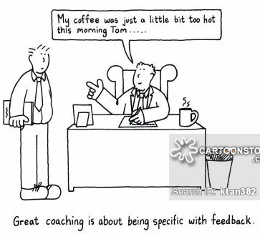

5. - Feedback should be descriptive rather than evaluative or judgmental. Describing one’s own reaction leaves the other person free to use that information or not, as they see fit.

"When they [parents and educators] talk of building self-esteem, they often resort to empty flattery rather than character-building honesty. I've heard so many people talk of a downward spiral in our educational system, and I think one key factor is that there is too much stroking and too little real feedback." Randy Pausch

Word choice matters. Tone matters. For example, we can consider these two comments written in the margin of a student essay:

“You aren’t clear here” and “I don’t see what you mean here.”

Both intend to convey the same thing, but the first sounds more judgmental and the second, more descriptive. So, distinguish between the performance and the personal.

‘What you said sounded judgmental’ rather than ‘you are judgmental’

We have to be specific about what the person has done or not done, without judging her intent. We need to avoid statements that begin “You always. . .” or “You never. . .” And we have to avoid any criticism without making recommendations. Describe, don’t judge.

Example:
- Judgment: “You looked confident when you were presenting.”
- Description: “You kept your hands in front of your body and asserted your points without caveating.”

Avoid jumping to conclusions or seeming like a bully by sticking to the facts. For instance, if employees are leaving early and showing up late, they could be having a family emergency or a health issue. Simply state the behavior you’ve observed and let them explain what’s going on. Before a feedback session, we have to find concrete data that may or may not support our conclusions. Our goal is to gather evidence that will allow us to describe the concrete facts.

Observe team members’ performance. Carefully note what a team member is doing well and what does not meet expectations. Speak for yourself. Offer comments from your own experience or point of view. We have to avoid saying, “Everyone thinks…” or “People are saying…” Instead, we need to say “I saw…” or “I am concerned…” We have to be sincere and tell the team members how a specific action of theirs made us feel.

Explain the impact of the behavior – on you, and/or others. Emphasize how actions affect the team. Team members often don’t realize how their actions and behaviors affect others. Explain to the person the impact of that person’s actions or inaction on others.

Example:

“Susan, when you cut Jamie off in the meeting, I noticed she looked irritated and clammed up for the rest of the meeting. When you don’t hear a person out and interrupt them, they will probably feel disrespected and no longer want to contribute. When the entire team doesn’t feel safe to contribute, our performance will suffer.”

Be tough, not mean. When someone drops the ball at work and we have to give him or her feedback, we have to start by asking his or her perspective on the situation and resist saying how stupid his or her actions were, even if they were.

Negative feedback should be non-judgmental, possibly offering a suggestion: ‘Have you thought of approaching the person in such a way…’


6. - Feedback should be directed toward behavior the receiver can do something about.
"Why fear feedback? Why stigmatize failure in the workplace when
it is bringing you closer to achieving your organizational goals?."
Kevin Kelly

We have to focus on the observations we have regarding a specific behaviour. Feedback is not a judgment but rather a description of events where we have seen that specific behaviour.

Focus on the observed behavior, not the person. Remember, the purpose of constructive feedback is to eliminate behaviors that detract from high performance. If the individual perceives he or she is being attacked personally, they will quickly turn defensive and the opportunity for a meaningful discussion will be lost.

Before a feedback session, find concrete data that may or may not support your conclusions. Your goal is to gather evidence that will allow you to describe:
- Specific behavior. Be specific about what the person has done or not done, without judging her intent.
- The impact of that behavior. Tell the person how her behavior is affecting you, the team, or the business.
- What you want the person to do differently. Your employee can’t read your mind. Be explicit about what needs to change.

We have to reaffirm our faith in the person, and tell them that we still have faith in them as a person and in their abilities; it's just their performance we want them to change. Say something like "you're a good customer service rep, so I'm sure you see the need to be more patient with customers".

Focus on a specific behavior, not the person. In other words, make the feedback about the what, and not the “who.” Focus on specific behaviours that can be changed, not personality traits, giving examples where possible and do not evaluate or assume motives. Use ‘I’ (i.e. own the feedback yourself) and give your experience of the behaviour (When you said…, I thought that you were…). When giving negative feedback, it is essential to suggest alternative behaviours.

Identify, analyze and explore potential solutions for poor performance or deficits in practice. Don’t comment on things that can’t be changed. Feedback should always be constructive – focusing on behaviours that can be changed and which are supportive, formative and developmental.

Suggest (or ask for) alternative behavior; the dialog could start:
• “I think x would be more effective”
• “Can you please…”
• “You could try…”
• “What can you do differently?”

This step is important because only a different behavior will achieve a different outcome and because a specific and tangible alternate increases the likelihood of behaviour change. We have to ensure the recipient has the capability to exhibit new alternative behaviour and set clear expectations.

Don’t Say “try harder next time” Don’t Say “don’t”

Example: In your next meeting, wait until Matt has finished or he asks for your input before voicing your opinion.

It is not fair to individuals to present them with feedback and no opportunities to use it. It is not fair to individuals to present them with what seems like constructive criticism and then use it against them in a final evaluation. Feedback can be the information that drives the process, or it can be a stumbling block that derails the process.

For instance, saying something like “You’re unprofessional” is a recipe for disaster. A character attack provides no information and doesn’t offer any actionable ideas for change. Always describe behaviors, not traits. Don’t dwell on the past; instead focus on what the employee can change in the future.

Good feedback gives individuals the information they need so they can understand where they are in their process and what to do next. When we do give individuals information that they can use to improve, and they see and feel they understand that they can do it, research suggests that many—in some cases almost all—individuals will experience feelings that they have control over their learning, over their own improvement, feelings that are so positive they’ll prefer constructive criticism to head patting and comments like “Good job!”. This feeling of control over learning is true self-efficacy, it is the foundation of motivation for improving, the motivational factor.

We need to observe attentively the impact of a given behaviour and tell the person how her behaviour is affecting us, the team, or the business. And what we want the person to do differently. Our employee can’t read our mind, so, we need to be explicit about what needs to change.

“Strong emotions on both sides, a focus on character rather than on behavior, and a lack of clarity about what needs to change and why are just a few of the factors that can undermine a feedback session” (Mark D. Cannon and Robert Witherspoon in their ‘Academy of Management Executive’ article)

7. - Feedback should take into account the needs of both the giver and receiver of feedback. Feedback is destructive when it serves only the giver’s needs and fails to consider the needs of the other person.

"If you don't get feedback from your performers and your audience,
you're going to be working in a vacuum."
Peter Maxwell Davies

Don’t assume you’re right. Even after we’ve collected our data, we might not have the complete picture. Other people may not see this person’s behavior as we do. Furthermore, the employee will have his own side of the story. “Difficult feedback is rarely about getting the facts right,” says Witherspoon, an executive coach and president of Washington, D.C.-based Performance & Leadership Development Ltd. “It’s about conflicting views, feelings, and values. Reasonable people differ about all these things.”

We have to approach the feedback session with the goal of getting a complete and accurate picture of the situation. Just as we want our employee to listen with a willingness to be influenced by what he hears, we need to be willing to be influenced by what we hear. If the person receiving the feedback doesn't feel comfortable, this can cause the feedback to ultimately be unproductive.

Don’t be tempted to bend the feedback rules for top performers. No matter who is receiving the feedback, it is essential to follow good feedback practice. We need to gather data and details to support our feedback.

After we have told the person what specific, recent actions were inappropriate, and why, we have to stop talking and give the other person a chance to respond to our statements and ask clarifying questions. Then, we define and agree on a mutually acceptable action plan.

We have to agree on what future performance is appropriate for the employee. If there are specific things the employee needs to start doing or needs to stop doing, we have to be sure they are clearly identified. If there is something we need to do, perhaps additional training for the employee, we need to agree on that as well.

We need to remember that feedback is for the recipient, not the giver: so, we have to be sensitive to the impact of our message and consider the content of the message, the process of giving feedback and the congruence between our verbal and non-verbal messages. Aim to encourage reflection through open questions.

It is very important to examine our intentions. What’s the purpose of the feedback? Is it to punish the employee, get it off our chest to make us feel better, or is it truly a help for the employee to improve because we care about them? Feedback is personal, and our intention will affect the way our message is delivered and received.

Then, we allow the feedback to sink in, and let the person process the feedback. It is very important to listen empathetically. Individuals cannot hear something if they are not listening or when they are feeling like it would be useless to listen. Because individuals’ feelings of control and self-efficacy are involved, even well-intentioned feedback can be very destructive “See? I knew I was stupid!” The research on feedback shows its Jekyll-and-Hyde character. Not all studies about feedback show positive effects; the nature of the feedback and the context in which it is given matter a great deal.

Feedback can be oral, written, or visual demonstration; we need to select the best mode for the message. Would a comment in passing the person’s place suffice? Is a conference needed? Interactive feedback (talking with the individual) is best when possible. We could use demonstration if “how to do something” is an issue or if the person needs an example. And then we need to tailor the amount and content of feedback to the person’s situation.

Probably the hardest decision to make about feedback is the amount to provide. Again:
“Not too much, not too little, but just right.” The Goldilocks principle

A natural inclination is to want to “fix” everything we see. That’s the leader’s-eye view, where the target is perfect achievement of all company’s goals. But for real learning and improvement what makes the difference is a usable amount of information that connects with something the person already knows and takes it from that point to the next level. Judging the right amount of feedback to give—how much, on how many points—requires deep knowledge and consideration of the goals in general and our aims or targets in particular and our individual employees.

Our feedback should give individuals a clear understanding of what to do next on a point or points that they can see they need to work on. This requires us to know our employees; for some of them, simply getting clarity and improvement on one point would be sufficient, whereas others can handle more.

We need to try to see things from the other person’s-eye view. On which aspects of the target has the person done a good job? Appropriateness varies case by case, so an important point about audience is “Know whom you’re talking to—and talk to them!”

If the person doesn’t know a more effective behavior, we have to ask if they would like advice. Once the behavior is pointed out, and they understand the impact, it’s often just a matter of stopping the behavior. Or, it’s obvious what they need to do differently. If they truly need help in coming up with alternative behaviors, we need to give them specific examples or offer to role play if that would help. Coaching, using effective questions is an even better way than giving advice.

When giving feedback to individuals or groups, an interactive approach helps to develop a dialogue between the individual and the person giving feedback. It builds on the individual’s own self-assessment and helps individuals take responsibility for learning. A structured approach ensures that both trainees and trainers know what is expected of them during the feedback sessions.

We should encourage people to be proactive in seeking feedback from others as this is often more timely and relevant to individuals’ needs.

Example of taking into account the other person:
Unfortunately, the following example of a bad choice is a true story. An elementary teacher assigned her class to practice handwriting by copying a story from the board. A little boy with a mild learning disability was having difficulty transferring the story he was to copy from the board onto his paper. Using a bright purple marker, the teacher made a slash on his words each time a letter was added or omitted and wrote addition or omission over it. In one place, the student wrote ‘og’ instead of go, and the teacher circled it and wrote reversal. The little boy did not know the words omission and reversal. All he was able to conclude from the purple slashes and strange words was that the teacher thought his paper was bad. He did not understand what he had done or how he might fix it. What he learned from that feedback was that he was weighed in the balance and found wanting. If that happens too often, students give up.

The benefits of individual feedback are that the feedback can be specific to the person’s particular needs and that the feedback is private. Giving feedback based on the particular qualities of a person’s work means the information itself will be of maximum usefulness. Giving the feedback in private means that the person will not have to worry about what peers’ reactions may be. Therefore, we help the person avoid some of the ego protection and face-saving that can get in the way of feedback.

8. - Check that your feedback is clear to the receiver. One way of doing this is to have the receiver summarize the feedback in his/her own words.

"I can't be a hypocrite as a coach because as a player that's what I wanted.

I wanted feedback; I wanted communication from the boss.
I showed up for work, you can yell at me if you want,
but I want input. So that's the kind of coach I want to be."
Adam Oates

Be clear about what you are giving feedback on and link this to the individual’s overall professional development and/or intended programme outcomes. Ensure the individual is aware he/she is to receive feedback (so clearly define the purpose of the feedback session before or at the outset of the session)

Set clear and concise objectives. When team objectives are clearly communicated, team members will find it easier to perform. By establishing clear goals, objectives, and performance expectations, we have a standard with which to measure team members’ performance and to base our feedback.

Good feedback contains information that the person can use, which means that the person has to be able to hear and understand it. A person can’t hear something that’s beyond their comprehension. Clarity is important; the person needs to understand the feedback information as we intend it. Individuals have different vocabularies and different backgrounds and experiences. The criterion for clarity is whether the writing or speech would be clear to the individual person.

Examples of bad feedback clarity:
- Using big words and complicated sentences
- Writing to show what we know, not what the person needs
- Assuming the person understands the feedback

Do not overload the person – identify two or three key messages that you summarize at the end and keep the dialogue moving with open ended questions: ‘How do you think that went?’ which can be followed up with more probing questions.

Example:
Check-Pause for understanding; how the dialog starts:
--Pause--- “Do you remember that?”
“Did I get that right?”

This step is important because then the receivers can acknowledge the observation and arrive at the insight themselves, it ensures that the (same) observed fact is agreed upon and discussed; we have to notice that disagreement here could mean that our feedback is not received well. We have to make sure that we are talking about the same thing!

Finally, we need to check for understanding and agree on clear next steps and a fair way to measure progress and then we have to check our summarized feedback and make sure that the positive aspects and areas for improvement are listed (with supporting evidence).

Explore the situation. Before you can move further you need to understand the exact context in which the behaviours appear, what is the true nature of this demeanor. He/she will try to find explanations and interpretations of how they see the situation.

People usually react to positive reinforcements that detail clearly how they are beneficial to them. This is the moment when we should describe how adjusting this specific behaviour will not only bring benefits to them, but also to the ones around them. The effects of feedback depend on the nature and clarity of the feedback.

Check to make sure the other person understood what you communicated by using a feedback loop, such as asking a question or observing changed behavior. Set a time to get back together to discuss whether the feedback changed performance and whether any additional actions are needed.

9. - When feedback is given in a group, both giver and receiver have the opportunity to check with others in the group on the accuracy of the feedback. Is this one person’s impression or an impression shared by others?

"Why fear feedback? Why stigmatize failure in the workplace
when it's bringing you closer to achieving your organizational goals."
Kevin Kelly

The adage “praise in public, criticize in private” is an old management mantra. But sometimes, we have to be critical in public. Holding people accountable sometimes means discussing performance issues with the group, even if it feels uncomfortable.

In order for a team to be effective, its leader must be able to comfortably offer feedback to team members. Feedback is information concerning the team’s behavior, attitude, relationships, and progress toward achieving objectives. Our feedback won't be productive if it's focused on making the other person feel bad or make them look foolish in front of peers. Leaders that skillfully provide feedback help the team achieve its goals, build the team’s confidence and pride, and help them to succeed.

Providing feedback isn’t solely the team leader’s responsibility, according to Mary Shapiro who teaches organizational behavior at Simmons College and is the author of the HBR Guide to Leading Teams. For starters, that would be impractical. “You can’t be the only one holding everyone accountable because you can’t possibly observe everything that’s going on,” she says. Second, if you’re the only one praising or critiquing, group dynamics suffer. “You want to give everyone the opportunity to say his piece,” she says.

Your job as manager is to ensure that team members are “providing regular constructive feedback,” says Roger Schwarz, an organizational psychologist and the author of Smart Leaders, Smarter Teams. “There needs to be an expectation within the team this is a shared leadership responsibility,” he says.

We have to make sure our team understands that feedback is a shared leadership responsibility. If the same message would benefit a group, providing feedback to the team or group can save time and also serve as a review session. If we speak to the whole team when only a person needs the feedback, we can use the team which has mastered the objectives as the “more experienced peers,” helping us demonstrate the concept or skill.

When a team member does something that negatively affects the team, we usually talk to the team member in private. But this can be a dangerous adage to follow because it significantly reduces accountability, the quality of team decisions, and our team’s ability to manage itself. As Richard Hackman said reflecting on his research, “The most powerful thing a leader can do to foster effective collaboration is to create conditions that help members competently manage themselves.” Here’s why criticizing in private undermines our team and what we can do to build a smarter team starting today…

Example:
You are holding your weekly team leadership meeting. You are discussing with your direct reports how to handle the project delays that have caused the team to miss its quarterly numbers. You know that Ted — one of your direct reports — contributed to missing the numbers by missing two key deadlines. You’ve seen this kind of behavior before from Ted, and you’ve seen the team’s frustration with Ted. You decide not to say anything to Ted in the meeting, but afterward you privately tell him how he’s letting you and the team down.

When you “criticize in private” for behavior that occurred in a team meeting or affects the team, you undermine team members’ accountability to each other. You send the message that team members are accountable only to you, not to the team. You also send the entire team the message that they don’t need to hold each other accountable — you’ll do it for them. In short, you shift accountability from the team to you. You also make it more difficult to solve the problem. If you tell Ted his missing deadlines contributed to the team missing its goals, you and Ted may reach an agreement on how he will change his behavior, and that may inadvertently create new problems for other team members. Or Ted may tell you that other team members made it difficult for him to meet his deadlines, that it’s not his fault; at that point, you’re likely to become a human ping-pong ball, shuttling back and forth between Ted and other team members trying to understand the problem. The information to solve this problem lies with Ted and the other team members. … If it’s difficult for you to give negative feedback, you prefer to do it in private than in the team setting. Leadership isn’t about being comfortable; it’s about being effective, even when you’re uncomfortable. (Roger Schwarz)

Allowing an ineffective team member to continue his or her behavior can prevent a team from meeting its goals and lower the morale and motivation of those team members who are performing.

Examples:

Example 1: Create opportunities for team and individual reflection
Once every quarter, Laree Daniel — chief administrative officer of Aflac, the insurance company — assembles an ad hoc team around a particular customer incident for an in-depth feedback session. “I take a customer case study in which we either did very well or very poorly, and I gather everyone that touched the customer in some form,” she says.
First, Laree makes sure everyone is up to speed. Team members are given a packet of information that includes a write-up of the incident, transcripts of phone calls, copies of customer letters, and copies of the company’s responses. Next, she poses a series of questions to the team: What worked well? Where were the gaps? What can we do better?
The goal, she says, is to get the team to reflect on the company’s behavior from both the customer’s perspective and shareholder’s. “This isn’t about blame and I’m not scolding anyone,” she says. “I am the facilitator and I make it a neutral environment.”
During these feedback meetings, colleagues often have epiphanies. “They realize: I didn’t know my behavior would have that impact,” she says. “It becomes a dynamic learning experience.”
The feedback and information she picks up from those meetings are used to make process improvements. “Often the best ideas come from those people who were closest to the work.”

Example 2: Focus on empowering your team
David S. Rose, the angel investor and CEO of Gust — a platform for the sourcing and management of early-stage investments — has a simple approach when it comes to giving group feedback. “The goal is not to depress the team,” he says. “I try to keep everything upbeat and lay out our strengths and our challenges”.
A few years ago, for instance, he was involved in leading a 15-person technical team at a software company. The group’s biggest issue was its disappointing B2B product suite. “Customers were unhappy and the front-end salespeople were being yelled at,” he says. “As a team, we had some good individual contributors but we needed to get better at working together. I couldn’t just walk in and give feedback along the lines of: ‘These products are terrible; you’re all fired.’ We needed to identify the organizational problems and come up with a prescription for a path forward.”
He broke the team into subgroups of two or three people, and he tasked each with brainstorming how to manage a particular inter-team challenge. The subgroups then provided feedback to everyone else; based on that, the team developed a strategy to improve workflow and communication. “We came up with a plan and the whole team felt empowered,” he says. “We knew what the problems were and we figured out how to solve them.” Within nine months, he says, the products were in far better shape. (Rebecca Knight. Harvard Business Review, June 2014)

Note: Feedback which involves only one person needs to be given privately wherever possible, especially more negative feedback. Avoid giving negative feedback in front of other people, if that is not necessary and address the issues in private, because doing so in front of others can embarrass or humiliate that person and make others uncomfortable. While public recognition is appreciated, public scrutiny is not. Establish a safe place to talk where you won't be interrupted or overheard.


10. - Follow through

"True intuitive expertise is learned from prolonged experience
with good feedback on mistakes." Daniel Kahneman

We have to establish a time to follow-up. Setting a clear date and time to review actions and improvement is an important part of the feedback process. It establishes accountability and improves probability of performance improvement.

Because managers dread giving feedback, they like to feel that once they’ve had the conversation, they’re done. Not so fast! Says Cannon “There is a big difference between understanding and changing,” he says. Your employees’ ability to make that leap requires ongoing support. Thus, follow-through is vital. Ask, “Now what are the next steps you will take, and how can I support your progress?” Plan to meet again in a month.

Make sure you both know what needs to be done to improve the situation. The main message should be that you care and want to help the person grow and develop. Set goals and make plans to monitor and evaluate progress.

The whole purpose of feedback is to improve performance. You need to measure whether or not that is happening and then make adjustments as you go. Be sure to document your conversations and discuss what is working and what needs to be modified.

Consider yourself a catalyst for the change you’d like to see. Suggest specific steps that will help the employee work on performance gaps. Cannon recommends having him gather his own data by asking peers or subordinates for feedback and suggestions on a particular performance area.

If you need to manage poor performance, look over your feedback notes to pinpoint possible problems.

Example:

Have people had the right training and development? Has it been followed through? Do they have all of the resources and equipment that they need?

Finally:

Don’t forget that your feedback says as much about you
as about the person to whom it is directed

Feedback can be very powerful if done well. Good feedback happens when we make sound choices about feedback timing, amount, mode, and audience. It happens when we focus on the work and the process the person used to do it. Good feedback is criterion-referenced and sometimes self-referenced.

Performance feedback is a leader's power tool. Constructive feedback helps to change or eliminate the behaviors that detract from performance and positive feedback helps reinforce those that strengthen performance. Both are essential for success! Use them carefully and regularly in pursuit of great performance.

And remember, after you have delivered the constructive feedback and agreed on a resolution and follow-up plan, move on with the job. Don't harbor ill will toward the employee because they made a mistake. Don't hover over them out of fear that they may make another mistake. Monitor their performance as you do with all employees, but don't obsess.

The suggestions made about clarity, specificity, and so on apply to oral feedback as well as to written feedback. One difference is that when we are speaking instead of writing, we have less time to make decisions about how to say things, and once we have said them we can’t take them back. If we keep in mind the feedback choices we have (clarity, specificity, tone), giving helpful feedback will become part of our repertoire.

Offering feedback can be misused for instance when trying to control people, or to demonstrate superior knowledge. An example of the latter is when people use feedback to convince that somebody is wrong and that they have the right answer.

The feedback cycle starts when feedback is offered or sought. The next step is that the feedback is heard and recognized. The third and last step in the feedback cycle is that action is taken. When exploring feedback we should be aware of all three steps and check to make sure that they are all working.
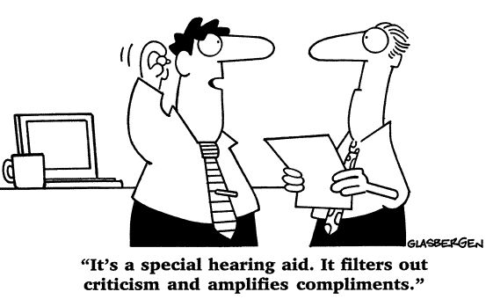

Question 2

Discuss various feedback techniques

Managers in workplaces are on a mission to discover ways to provide employees with performance improvement feedback, comfortably and kindly. Feedback should be specific to the behavior (either negative or positive). Our feedback can make a difference to people.

But first, before the advice: There’s no single formula for delivering feedback effectively. What works best will depend on the issue we’re dealing with, our relationship with the other person, his or her personality, and our own style. If we’re working with a junior associate for the first time, for example, we will handle feedback about a mistake quite differently than if we had worked with the associate for years.

“Just as there are all kinds of employees and personalities there are all kinds of methods to give feedback or review their performance. Through my 26 years, I learned that the same system or model did not work for every employee; I had to adjust based on the employee I was giving feedback to.” (Rick Segel & Matthew Hudson)

There are different techniques for giving feedback:
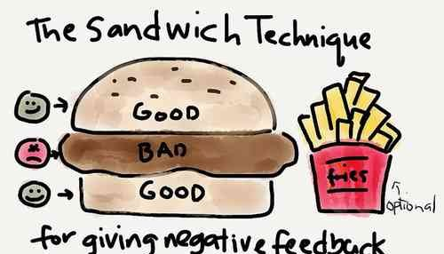
1. - Sandwich format

The feedback sandwich has been recommended in management development, consulting, and Human Resources practices for years. In a feedback sandwich, the manager layers constructive feedback between two instances of positive performance feedback. The formula looks like: start the meeting with positive feedback, then provide the constructive feedback, and then, end the meeting with more positive feedback.

The sandwich feedback technique is a popular three-step procedure to help managers who are ill at ease with providing corrective feedback. So, this sandwich feedback method involves discussing corrective feedback that is “sandwiched” between two layers of praise.

The purported benefits of this technique are twofold:
a. - It softens the impact of the criticism or corrective feedback, and
b. - Given that a manager is probably more comfortable with praising the employee, the manager finds it easier to discuss problems with the employee’s behavior if this discussion begins and ends with praising the employee.

Example:
1. - Suppose that Andy, a new employee at a financial services firm, attended a week-long, offsite training program in New York. Each night during his stay at a hotel, Andy purchased on-demand movies in his room. He included the corresponding $65 charge in his expense report. Andy also dined at very pricey restaurants.
Jean, Andy’s manager, received the expense report for approval. Clearly, the charge for the movies had no business-justification. Jean uses the sandwich feedback technique to decline reimbursement for this expense and instruct Andy to be more prudent about expenses when traveling:
- Praise: “Andy, I am impressed with your development since you joined my team last month. You have used the skills you learned during your training in New York to systematically review our customer’s accounts.”
- Criticism: “By the way, earlier this morning, I was reviewing the expense report from your trip to New York. I notice a $65 charge for on-demand movies. I have to deny this expense since it has no business-justification. I also noticed very expensive meals. I will approve these charges this time. Given our limited travel budgets, I would ask you to be more careful about your trip expenses. You are probably not aware of our company’s travel policy. I have asked Human Resources to give you a copy of our travel policy booklet that details the acceptable expense report practices.”
- Praise: “I am glad you were able to use the skills you learned at this training in New York. I appreciate your hard work and persistence with this customer. Keep up the good work.”

2. - Assume Sofia led a brainstorming meeting for an important project. Habitually, Sofia does not circulate the agendas prior to the meetings she leads. After one such meeting, Sofia’s manager uses the sandwich feedback technique to persuade her to be more organized:
- Praise: “Sofia, we had a very productive meeting. We had the right participants and collected all the necessary inputs from other departments. Thanks for your coordination.”
- Criticism: “Did you notice that the discussions were unsystematic? When you do not distribute an agenda prior to the meeting, the participants do not come prepared. During the meeting, they have to go back to their desks to collect information. Additionally, we tend to spend a lot of time digressing from the meeting objectives. How can you avoid this?” A discussion ensues.
- Praise: “You are doing so well with gathering all the inputs. I am pleased about your diligence in circulating minutes of your meetings and following-up on action items.”

The sandwich feedback technique enables a manager to restructure feedback so it is easier to deliver. The technique also reinforces good behavior and asks for improvements.

Regardless that this approach may be comfortable for managers who seek easy ways to provide constructive feedback, the feedback sandwich may not be as helpful as recommended. In fact, it can get in the way of effective, meaningful feedback and communication that will produce performance improvement results. Here’s why.

Problems with the Feedback Sandwich:

There are three common mistakes that defeat the purpose of sandwiching corrective feedback between two layers of praise. In summary, it’s best to be direct when giving feedback, because the compliment sandwiches are easily spotted as inauthentic.
We will now discuss these three common mistakes that render the sandwich technique ineffective:


Common Mistake 1:

Praise is substantial and obscures the criticism

Example:
Sarah was the head of a committee that organized the annual family picnic at her company. The committee exceeded the picnic budget by 35%. Sarah’s boss uses the sandwich technique to criticize her for her failure to control expenditure.
- Praise: “Sarah, our management was very impressed with the attendance at our annual family picnic. The weather was great. The catered food was excellent. The activities for children were wonderful. You even organized contests for children and family.”
- Criticism: “By the way, you overspent by 35%. You should check your expenses and try to be within budget.”
- Praise: “I understand you worked very hard to coordinate the logistics. I congratulate you for doing a remarkable job leading the committee and for your enthusiasm. Thank you for a job well done.”

In this example, the praise is substantial and obscures the criticism. Sarah may neglect the criticism since the criticism is insignificant and therefore, lost when sandwiched between “heavy layers of praise.”


Common Mistake 2:

Praise is trivial or just-for-the-sake and serves no function

Example:
Suppose that Charlie led a brainstorming meeting for a new product. One of his new fresh-from-college employees proposed an idea that was not practicable. Charlie was annoyed with the idea and responded, “That is a stupid idea. You are thoughtless. You have been here for less than a week. I don’t think you are knowledgeable enough to contribute to our discussions here.”
Janet, Charlie’s boss, observed this interaction. After the meeting, she wanted to criticize Charlie for condemning the new employee in the presence of several other employees. Janet recalled the sandwich feedback technique. However, she could not conceive praise for Charlie. Hastily, she stated something trivial just for the sake of paving the way to her criticism.
- Praise: “Charlie, good job organizing the meeting.”
- Criticism: “I noticed that you openly called the new employee’s idea “foolish” and dismissed it. Don’t you realize he is fresh from college? Did you see his reaction? He felt dejected and showed no enthusiasm during the rest of the meeting. He was probably there to meet people from our department and learn how we manage projects. How can you expect him to feel happy about joining your team? I have noticed that you jump to criticize other people’s ideas in meetings. A good manager encourages participation. I think you should apologize to the new employee. [Pause]”
- Praise: “Hmm … anyway. Good meeting. I liked your flowchart.”

As in the above example, for the sake of sandwiching their criticism, managers tend to offer unrelated—often trivial—praises when faced with the challenge of criticizing their employees. Such praise is inconsequential and, therefore, defeats the purpose of the sandwich technique.


Common Mistake 3:

Employees get tuned in to the praise-criticism-praise pattern

Once managers use the sandwich feedback technique a few times, employees recognize the praise-criticism-praise pattern. They realize that the managers offer criticism after initiating their conversations with praise. Subsequently they learn to discount this praise since such praise is just a lead-in to the criticism.

Compliment Sandwiches are easily spotted as inauthentic which makes the Sandwich Feedback Technique ineffective. A praise followed by criticism undermines the positive impact of praise and weakens the corrective feedback’s significance.

Proponents of the sandwich technique suggest that beginning and ending with specific praise builds recipient’s trust and comfort (Dohrenwend 2002; LeBaron and Jernick 2000), increases receiver’s receptivity to negative comments (Hesketh and Laidlaw 2002), mitigates the effects negative feedback might have on a feedback recipient’s self-image, and increases motivation, receptivity and engagement (Bienstock et al. 2007).

In those instances performance improvement can be impeded since such feedback offers neither suggestions for further improvement nor specific information about what worked in the performance (Kluger and DeNisi 1996; Dweck 1999; Shute 2008). Together these factors suggest that a feedback sandwich is not an effective technique to improve the performance of learners.

Performance improvement feedback that is followed by more positive feedback distorts the importance of the feedback about areas to improve. The employee can be confused about the importance of the constructive feedback. Since sustained improvement is the basis for recommendations about raises and other organizational perks, this places the employee at a disadvantage.
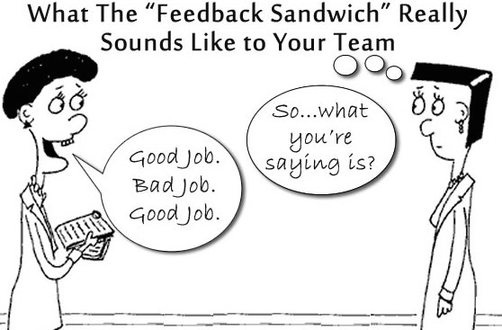

In summary, it’s best to be direct when giving feedback, because the compliment sandwiches are easily spotted as inauthentic. Feedback is effective only when it’s timely, relevant and forthright.

2. - open-ended approach


It is better a more open-ended approach. In this second technique, there is no lead-in. We move right to telling the person what behavior has to be changed.

The best approach recommended to improve feedback then is to provide straightforward, to the point, descriptive communication with examples about what the employee needs to improve.

As said, one of the most powerful tools managers have for developing their staff is providing direct feedback – both positive and corrective. In fact, simply articulating areas in which you’d like to see a staff member improve or develop can go a surprisingly long way.

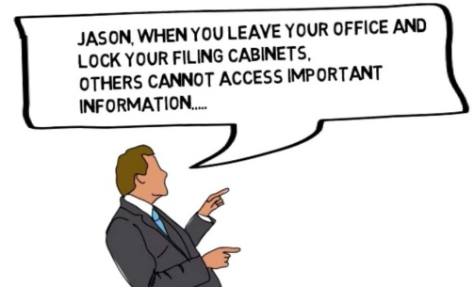
When an employee is scheduled for a meeting, even if it is a regular meeting, the employee anticipates that some feedback will be constructive. Sure, the employee doesn’t like the constructive feedback as much as positive feedback, but the meeting met his or her expectations.

The employee does not feel deceived or fooled. If the employee can expect honest, straightforward feedback from us, the employee will trust us. Beating around the bush is perceived as prevarication.

Immediate feedback ensures that the other accepts our feedback, understands his behavior and attempts to correct it. We need to keep in mind that the point of any feedback conversation is a change in behavior and not to run down a list of items we have been secretly keeping on us for some time now.

3. - individual positive feedback statement

Positive feedback focuses on identifying and reinforcing the behaviors that promote high performance.

Positive feedback is a powerful tool that we as managers can use to communicate the value of the employee’s work and contribution to the organization. It reinforces behaviors that we’d like to see more of on the job. People learn more by repeating successful experiences than by trying to avoid unsuccessful ones. Positive feedback or affirming comments about past or future behavior is all about things that went well and need to be repeated.

We want to encourage people, but we don’t want to come across as a parent figure who praises every little thing they do. It won’t be good for either us or them if they become dependent on us for their fixes of self-worth. On the other hand, positive feedback that resonates with what they know to be a strength or a hard-earned accomplishment will gain us credibility with our employees. If they feel that we “get them,” they are more likely to believe us when we point out improvement needs.

“Great job.” “You’re awesome.” “You’re great to work with.” None of this qualifies as real feedback. The purpose of positive feedback is to make people feel valued and appreciated and to get them to replicate a behavior. Telling someone, “great job” or “you’re doing great work” will make the person feel good (momentarily), but won’t tell her what to replicate. These phrases are vague, and vague positive comments come across as inauthentic at best and unhelpful at worst.

Examples of positive feedback:

1. - Fake feedback: “Great job.”

Real feedback: “You researched three vendors when making a proposal of who we should choose to manage our payroll operations. You included all the necessary information for us to make a decision and presented the information in a one-page table that was easy to read. Your work made it really easy to make a decision. Great job!”

2. - Fake feedback: “You make my job easy.”

Real feedback: “Last week you noticed an invoice that didn’t seem accurate. You researched the invoice and got the mistake corrected before I even knew there was a problem. You make my job easy.”

Another example:
“At the client meeting on Monday afternoon, you ensured that the meeting started on time and that everyone had handouts in advance. All of your research was correct, and each of the client’s questions was answered. I’m proud that you did such an excellent job and put the organization in a good light. I feel confident that we’ll get the account, thanks to your hard work.”

Positive feedback is not about going around saying “Good job” to everyone. It’s about being as specific with your “Keep doing it” feedback as you are with the “Stop doing it” feedback you give.

For example, you might say to a colleague:
“Your introduction really got the client’s attention – we need that with every presentation.”
This way your feedback clearly points to the successes and benefits of a particular action and provides guidance for the future.

Assuming we’re dealing with a good employee, the vast majority of feedback we give should be positive. Positive feedback tells employees that their efforts are appreciated and increases the chances we’ll see more of the same behavior. In addition, positive feedback is a form of creating accountability. If our staff member consistently does a good job but never hears from us about it, she may wonder why no one has noticed.

4. - constructive criticism
“A true friend tells you what you need to hear, not what you want to hear”
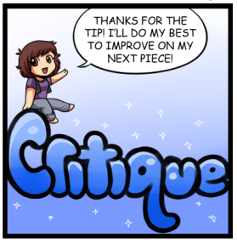
Constructive feedback is focused on identifying and promoting change in behaviors that detract from high performance. Constructive criticism feedback or corrective comments are about past behaviour. These are things that didn’t go well, things that don’t need to be repeated next time.

When it is well timed, well targeted and well said, constructive criticism can help direct growth, motivate staff and offer relief from confusion. Well-timed criticism occurs shortly after the error has occurred since the longer we wait to give feedback, the less effective it will be. It also takes into account the pressures of the moment and the employee’s readiness to listen.

We have to provide the employee with an opportunity to ask questions and react to what we say. Good supervisors are fair; they don’t drop bombs and run off.

While some may not appreciate this approach, asking the other person if they would permit negative feedback is a great method to opening dialogue. It eases potential tension that could arise when the advice or feedback is unsolicited.

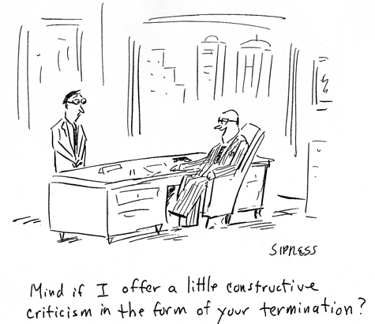
Well-targeted criticism is tailored to a particular employee performing a particular skill. Too much feedback at one time is not helpful. Well-said criticism is direct, brief and, most of all, specific. Well-said criticism points the finger at the behavior rather than at the person.

Where possible, we give concrete examples for our criticism. This helps the other person to really grasp what we are saying. We have to give the other person a chance to explain and to fix things if possible, making sure this is a two-way conversation. We say what we would like in future and why, and let the other person see the bigger picture and get an understanding of our perspective. And finally we agree on specific targets and timelines. That way, the person receiving criticism walks away with a concrete guide on how to move forward.

- Don’t use vague, insincere praise as a smoke screen to deliver bad news:
“You’re a really good employee, but we have to let you go. Don’t worry! One of our competitors will snap you up in no time.”
This is mixed or conflicting feedback, not a true feedback. Given that the employee is being fired, it is clear that performance deficits vastly outweigh strengths, so any praise at this time is disingenuous.

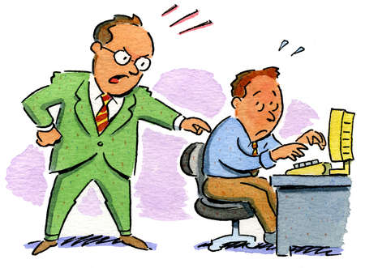
We have to check in with ourselves before we give feedback – what is our purpose? If we can sense anything negative/critical, we are best off not giving the feedback – that part will come across to the other person and they will then stop listening and go into defensive mode.

If the constructive criticism we give is too negative or direct, we might risk destroying a good working relationship with a valued member of our team. Working internationally means we also have to consider cultural factors when delivering constructive criticism and it is very important to handle this with sensitivity.

Assure the person there will be an opportunity to improve. You don’t want the negative feedback to produce negative feelings or negative results.

Remain completely objective throughout the interaction or meeting. Ensure the feedback is factually based. There may be extenuating circumstances that are hindering the other person from performing or acting in the manner they would normally.

- Avoid derogatory language wherever possible.
- Do not insult the person receiving the feedback.
- Avoid using the feedback period as a way to vent or unload stockpiled criticisms.
- Remain professional and impartial during your conversation.
- Avoid comparing the person to someone who you feel is doing a better job.

Example of constructive criticism:
“During yesterday morning’s team meeting, when you gave your presentation, you were uncertain about two of the slides and your sales calculations were incorrect. I felt embarrassed because the entire board was there. I’m worried that this has affected the reputation of our team.”

“Perhaps people confuse the need for using positive feedback with the need for showing empathy when delivering constructive criticism. Showing empathy should make employees feel like you care about them, making them feel more positive and more likely to use the constructive criticism for performance improvement. In all, if you want your employee to accept negative feedback, try showing that you understand that he/she can improve and that you genuinely care about his/her welfare”. (Stephen Young Ph.D.)

Constructive feedback alerts an individual to an area in which his performance could improve. Constructive feedback is not criticism. It is descriptive and should always be directed to the action, not the person. The main purpose of constructive feedback is to help people understand where they stand in relation to expected and/or productive job behavior. Feedback works well when the giver genuinely cares about the person on the receiving end. Trying to score points or undermine someone is not feedback. It’s just old-fashioned criticism

A study, published in the Personality and Social Psychology Bulletin suggests that most people would actually prefer it if they received their bad news straight away, without any attempts to soften the blow. It is generally those giving the feedback the ones who prefer the sandwich based approach. (ADI Sept 4, 2014)

While we want the feedback to be balanced, the overall focus needs to be on the future. Remember no one can change the past; its value in a feedback situation is for context, consequences and concrete examples, not for dwelling, hand-wringing or excessive blame. Always end the conversation talking about the future.

Management is about action and implementation. Leaders are those who can have difficult conversations, who can hold others accountable and can inspire action. You need to prepare for any meeting during which you will provide constructive feedback to an employee. The boss plays a powerful role in the employee’s work life and we need to remember this at all times. (Yes, that is burdensome, but we chose to be a boss with responsibility for constructive feedback.)

If you put off talking to an employee about a problem until you’re ready to snap over it, you’re likely to come across as frustrated and even make it personal. Talk to the person as soon as you realize there’s a problem; don’t put it off. Giving regular feedback is part of the job as a manager; avoiding it would be as negligent as a receptionist who ignores the phone when it rings.

An additional rule has been widely recommended to managers. If we need an employee to improve his or her performance, we have to address only one major improvement at a time. With this approach, the employee can fully comprehend the needed changes.

When discussing the employee’s performance, link the failings to their real impact on the business and on the employee’s coworkers. Help the employee see where their actions are unfavorably having an impact on their company and their career. Focus, too, on the positive results that will occur with improvement.

Areas that we put forth for improvement may already be apparent to the employee. The straightforward approach allows the employee to acknowledge that he or she sees the need for improvement. In fact, the employee may be experiencing frustration about how to approach improvement and get better results. This is an opportunity for us managers to develop a relationship with the employee where the manager is viewed as a helpful resource, a person who is committed to the employee’s success.

The outcome of the meeting should be an action plan with feedback sessions planned at regular intervals. The employee is more likely to improve with clear expectations, due dates, and our proffered regular support.

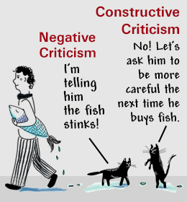

When a manager sugarcoats to the point that her message is missed, or presents requirements as mere suggestions, staffers end up confused about expectations, and the manager ends up frustrated that her “suggestions” weren’t acted upon. Our tone should be kind, but our words need to be direct.

Good managers are clear about potential consequences if problems aren’t fixed, explaining that it could impact the person’s next raise, jeopardize their job, or whatever the case may be. I’ve seen managers give lots of feedback to a struggling staff member but never explicitly say that the person’s job is in jeopardy–so, the staffer ends up shocked when she is ultimately fired. Not only is this unfair to the staffer, who deserves to know the severity of the concerns, but it can create significant anxiety among other employees, who may begin to fear they’re on the verge of being fired every time they receive critical feedback.

The bosses people hate are the ones who can’t explain what they want but are quick to criticize what they don’t want employees to do.

Tips to encourage feedback:


Getting employees to give honest feedback can be like pulling teeth. After all, no one wants to upset their boss with complaints, criticism or suggestions. But just like employees, employers need to hear the good, the bad and the ugly.

While positive feedback encourages people to continue doing what they do well, it’s the constructive feedback that helps people and businesses grow.

Without knowing what's going wrong in our business, we can't fix things, but employees are generally hesitant to be the bearers of bad news. And as Claire Lew, CEO of Know Your Company, pointed out on Signal v. Noise recently, they're often even more reluctant when they suspect that we might not exactly welcome this sort of negative feedback with open ears.

Eliciting honest, constructive feedback from employees can be difficult, but not impossible. The familiar story of "The Emperor's New Clothes" illustrates unwillingness of subordinates to communicate honestly to superiors. Here are ways employers can gain better insight through honest employee feedback:

1. - Reward the person who asks a question:

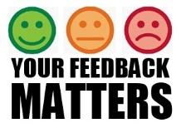
When it comes to giving employers constructive feedback, the greatest motivator is to show employees their feedback is being considered or, better yet, applied. Employers can bet that once an employee has taken the time to give their opinion on a matter, they’ll be watching to see if their opinion is truly valued. Even if an idea or suggestion remains just that, follow up with employees and let them know that their feedback is always appreciated and encouraged. We have to make certain we positively reinforce rather than punish them for such information.

For example:
According to a 2009 Cornell National Social Survey, more employees reported withholding their ideas due to a sense of futility (26%) than a fear of personal consequences (20%). "The biggest reason I didn't give my boss feedback is I believed that even if I did speak up, nothing would change. I believed my boss wouldn't do anything with my feedback. No action would be taken. And if nothing was going to change, what was the point of me saying anything?" Claire Lew, CEO of Know Your Company


Even if we don't agree with or act on the next piece of negative feedback we receive from a member of staff, we need to take a moment to publicly thank that employee for bringing her concerns to us.

Claire Lew offers Amanda Lannert, the CEO of Jellyvision, as a positive example of this principle: "during an all-hands meeting, she publicly thanked an employee who spoke up and gave feedback."

We can create a spot prize that gives us as manager freedom to recognize a particularly innovative idea or business improvement. We can celebrate as well all productive ideas that employees have suggested, however small, to show that everyone can help shape the way our business is run. We praise our colleagues’ work in a timely manner.

We have all known people who seek the views of others with no intent to be influenced by them: "Don't confuse me with the facts; my mind is made up." When others present irrefutable facts and figures, or even a good idea that we may not have thought of before, we don't have to be afraid to alter our position or admit that we may have been wrong. Good leaders often learn from their subordinates. Also, leaders can serve as models for the behavior of others in the matter of not being overopinionated


2. - Set aside time for regularly scheduled feedback sessions.

It is important to create specific days during which employees can come and talk to us managers with any views or issues. We have to consider scheduling feedback sessions. Since it is easier to prevent illness than to treat them, we’d better set aside time for feedback. A planned feedback session will usually get more response than an impulsive: "How are things going?"

Having an open-door policy is great, but it doesn’t always motivate employees to come forward with their comments, suggestions or concerns. The key to bringing out truly honest feedback from employees is to take the time to meet with them in an informal, one-on-one setting.

3. - Use silence to encourage feedback
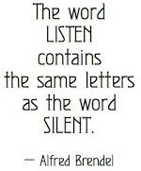
We use silence to promote feedback. We listen and encourage feedback rather than taking issue with comments raised by subordinates.

To receive feedback leaders must listen. Listening is the neglected communication skill. Few managers have had any formal instruction in listening. This lack of instruction is especially interesting in light of research showing that people spend seven out of every 10 minutes awake in some form of communication- 10 percent writing, 15 percent reading, 30 percent talking, and 45 percent listening.

Do we listen when our staffs complain about a customer or a situation? Listen to what people have to say. True listening isn't all that easy; we have to try listening to our staff, actively listening, even though our schedule is full and business is frantic, and we’ll see how trust develops. We need to listen without interruption; we may learn something of real value. Before taking any action, we can ask for time to think and then get back to the person.

Being a good listener is one of the best ways to be a good leader. No one likes communicating with someone who only cares about putting in her two cents, and does not take the time to listen to the other person. Instead, we need to practice active listening. Active listening involves paying close attention to what the other person is saying, asking clarifying questions, and rephrasing what the person says to ensure understanding "So, what you're saying is…". Through active silent listening, we can better understand what the other person is trying to say, and we can respond appropriately.

We need to be careful not to dominate the conversation to the point that we shut the other person out, we have to listen attentively by concerning ourselves with what the other person is saying instead of planning what we are going to say next.
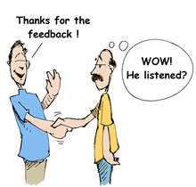

4. - Watch for non-verbal responses.
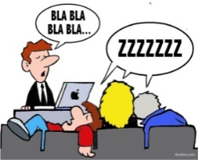
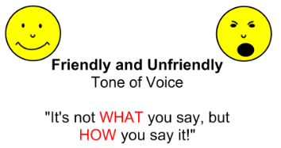
Most people cannot hide or censor their non-verbal responses. So, we have to watch for non-verbal cues. Most persons do not control non-verbal responses as well as verbal ones. The person who says, "I am so happy to meet you" as he draws away from the other person, probably communicates more by actions than by words. As we listen, for example, we often infer from the voice whether the speaker is happy, sad, fearful, or confident. We have to pay attention to other people's non-verbal signals while we are talking. Often, non-verbal signals convey how a person is really feeling. For example, if the person is not looking you in the eye, he or she might be uncomfortable or hiding the truth.

If we can create an aura of approachability, people are more likely to return to us with more feedback. Defensiveness, anger, justifying and excuse-making will ensure that our employees are uncomfortable giving us feedback; they'll only provide feedback if we are approachable and allow them to feel comfortable giving us the feedback. We have to be careful of using body language and facial expressions that encourage the other person to talk.

We need to be approachable. People avoid giving feedback to ‘grumpies’. Our openness to feedback is obvious through our body language, facial expressions, and welcoming manner.

5. - Ask open-ended questions

We have to use statements to encourage feedback. Statements such as "Tell me more about it” or “That’s interesting," or questions that cannot be answered yes or no will help us find out what is going on in our organization. We can start our questions with what, why, when, where, and how to encourage feedback.

We will ask questions to clarify what exactly went wrong; what we did or didn't do. We need to ask questions to clarify things, and then we focus on questions to make sure we understand the feedback.

We need as well to identify areas in which we want feedback. We don't encourage indiscriminate feedback consisting of idle talk of personal gripes about others in the organization. We do communicate our desire for feedback on issues and areas that can help the organization.

Knowing what to ask employees during individual meetings, whether they are performance check-ins, lunches or exit interviews, is crucial to drawing out honest, actionable feedback. Asking questions such as these can help us gain better insight:
- If you were in my shoes, what would you change tomorrow? Why?
- What are you hearing clients (or customers) say about our business?
- What do you enjoy most about your job? Least?
- How can I help you be more successful?

We could as well conduct surveys with our employees, using a core set of questions each time so we can track responses and identify trends.

6. - Assign feedback coaches.


It is one thing to receive feedback from a boss, but it’s another thing entirely to give feedback to a boss. The key to getting candid opinions from employees might just be to allow employees to choose who they give that feedback to.

Example:
The multimedia financial-services company, The Motley Fool, found a way to take the intimidation factor out of the feedback process. Instead of having employees report to their boss when it comes time to give or take feedback, they encourage employees to choose from a list of designated “feedback coaches.”
These coaches are well-versed in handling employee feedback and, most important, take some of the fear out of the review process. Designating a select few to handle employee grievances could be the key to eliciting honest, constructive feedback on everything from management issues to business solutions.

`o`o`o`o`o`o`o`o`o`o`o`o`o`

Effective leaders recognize the importance of good communication for feedback. Feedback problems can cause bottlenecks in the organization. The next time we are tempted to blame subordinates for bottlenecks, we stop and examine a bottle, notice where the neck is and see it is not at the bottom.

Responsible leaders work hard to prevent bottlenecks and keep channels open up, down, and throughout the organization by establishing an appropriate working climate and adjusting their communication behavior to fit the situation, and practicing techniques to improve communication and ways to give and receive feedback in their organization.

Another example:
“It’s time to kill off the suggestions box and the best way I’ve seen to do this comes from marketing agency ‘Quirk’ based in Cape Town, Johannesburg and the UK. They have created a process that let anyone in the company suggest ideas, gather support for them and then have them implemented (or not). When I visited their Cape Town HQ I had a chance to see it for myself, and I think every workplace who wants to give their employees a voice should do something similar. (Alexander Kjerulf, February 10, 2014; founder of Woohoo inc and one of the world's leading experts on happiness at work)
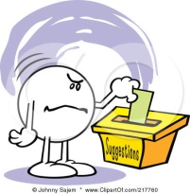
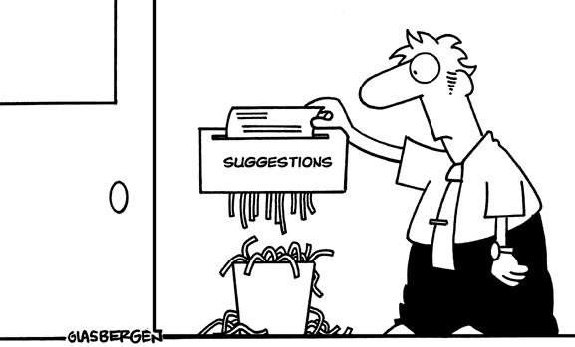
Embrace transparency, just like the marketing agency “Quirk. Brave curious minds” Quirk created a public process in the form of a flow chart on the office wall that allows anyone in the company to suggest ideas, gather support for those ideas (through signatures) and potentially have them implemented.
Suggestion boxes keep ideas and suggestions hidden, rather than empowering employees to voice their opinions, as Quirk’s flowchart method does.

Question 3

How can you master your body language?

“What you do speaks so loudly, I can’t hear what you are saying”
Ralph Waldo Emerson
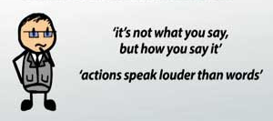
Body Language is a form of non-verbal communication involving gestures, movements, and posture, facial expressions, walking styles, positions and distance; it is the communication of personal feelings, emotions, attitudes, thoughts through body movements. It can be either consciously, intentional or involuntarily, completely unconscious. It is not only our tongue we communicate with but also we speak with our body movements and gestures.

Example:
Imagine that you're on holiday in Italy and you got lost. When you stop someone to ask for directions, you're dismayed to find that they don't speak much English and you don't speak much Italian. You manage to communicate that you're looking for your hotel, and they nod their head emphatically and say 'yes!’ ‘hotel!’ They point down the street and tell you '2 miles', and then make a sweeping gesture with their hand to the left. After thanking them you walk 2 miles, turn left and find your hotel.

In this case, verbal communication was somewhat helpful, but you were ultimately able to find your hotel because of a combination of spoken words and body language. Without the other person's pointing, you wouldn't have known in which direction you should walk 2 miles. And without a sweeping hand gesture, you wouldn't have known to turn left once you had walked 2 miles.

This is an example, which highlights the way that body language aids in our communication with others. Sometimes our body language says it all without having to speak a word. An eye roll, for example, tells the other person that we think something is ridiculous or frustrating.

The Main Aspects of Body Language are:
- Gestures: A gesture is the verbal or non-verbal body movement used to express or emphasize an idea, an emotion or a state of mind.
- Body Movements: This includes the head, eyes, eyebrows, lips, neck, shoulders, and fingers and so on.
- Behaviour: This refers to everything we do which is overt or observable. It is important because it is observable to others.

- Emotions: Refers to states such as happiness, depression, anxiety, milder moods such as feeling of pleasure and displeasure, degrees of excitement or drowsiness etc. An ‘Emotional cue’ is a facial expression, body movement or tone of voice indicative of emotion.

“In today’s hard world we don’t just have to be able to “TALK THE TALK” we’ve got to “WALK THE TALK”

For us managers, our business relationships are all about communication. We already know that. In preparing for an important meeting – with our staff, boss, or clients – we concentrate on what to say, memorize crucial points, and rehearse our presentation so that we will come across as credible and convincing. But we need to be aware that the people we’re speaking to will be subliminally evaluating our credibility, confidence, likeability and trustworthiness – and that their evaluation will be only partially determined by what we say.

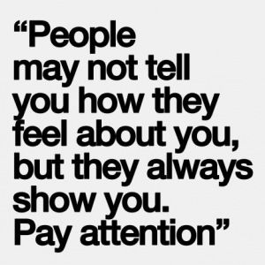
Albert Mehrabian, who taught psychology for several decades at UCLA conducted a research some years ago and talked about the importance of non-verbal communications. He measured how people conveyed meaning in one-on-one situations when the topic had emotional resonance. He paid particular attention to any gap between verbal and non-verbal communications.

Mehrabian’s research showed that in emotional settings, non-verbal communications, such as body language, facial expressions or hand gestures, convey far more meaning than either words or a person’s tone of voice”. Egan Energy Communications, INC March 25th, 2014

His finding tends to be incorrectly generalized though, to mean that it happens in all communications, but this is not always so:
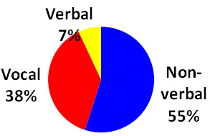
- 7% happens in spoken words.
- 38% happens through voice tone.
- 55% happens via general body language.

Useful extensions to this understanding are:
- It's not just words: a lot in communication comes through non-verbal communication.
- Without seeing and hearing non-verbals, it is easier to misunderstand the words.
- When we are unsure about what the words mean, we pay more attention to the non-verbals.

So, body language is the management of time, space, appearance, posture, gesture, touch, expression, eye contact, and vocal prosody. Our use of personal space, physical gestures, posture, facial expressions and eye contact could enhance, support, weaken or even sabotage our message.

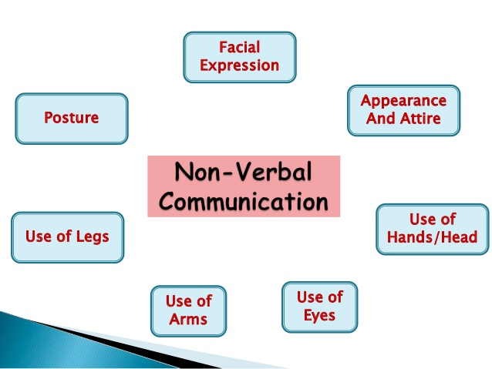

People in the workplace can convey a great deal of information without even speaking; through non-verbal communication. So, good body language is a key to communicating effectively in the workplace and will help us take the next step in our career.

Both our manners and our nonverbal communication speak volumes about who we are. Great body language and impeccable etiquette can give us an edge in the business world. As such, nonverbal communication is a key part of our effectiveness as managers. We need to learn to pay close attention to the other person’s body language and voice tone.

Example of body language:
If you pass a colleague in the hallway and don’t make eye contact, she may jump to the conclusion that you are upset with the report she just turned in.
You may be slouching because you’re tired, but your team may read it as a sign of disinterest.
If you frown in a staff meeting, attendees will probably think you didn’t like what you just heard – and they will keep their opinions to themselves.

In fact, when we make any nonverbal display of anger, irritability, or annoyance, people are more likely to hold back their ideas, limit their comments, and look for ways to shorten their interaction with us.

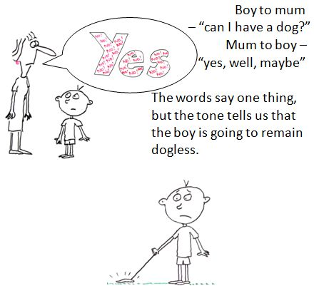
When our non-verbal signals conflict with verbal statements (for example, dropping eye contact and glancing around the room while stating we are being candid, rocking back on our heels when talking about the project’s solid future) we send mixed messages. Research shows that when our verbal and non-verbal signals are out of alignment, people are forced to choose between what they hear and what they see. And subconsciously, they'll believe our body language.

Of course, learning to align body language with intents and messages is only one side of the non-verbal coin. More business executives are learning not only how to send the right signals, but also how to read them.

Example:
The vice president of a Fortune 500 company is speaking at a leadership conference. He’s a polished presenter with an impressive selection of organizational “war stories” delivered with a charming, self-deprecating sense of humor.
The audience likes him. They like him a lot.
Then, as he finishes his comments, he folds his arms across his chest and says, “I’m open for questions. Please, ask me anything”. Suddenly, there is a shift of energy in the room – from engagement to uncertainty.
The audience that was so attentive only moments ago is now somehow disconnected and unable to think of anything to ask.
I was at that event. As one of the presenters scheduled to follow the executive, I was seated at a table onstage with a clear view of the entire room. And the minute I saw that single gesture, I knew exactly how the audience would react.
Later I talked with the speaker (who didn’t realize he’d crossed his arms) and interviewed members of the audience (none of whom recalled the gesture, but all of whom remembered struggling to come up with a question).
A simple arm movement that none of the participants were even aware of had such a potent impact. But why did the executive make that gesture? Did he not want questions? Was he more comfortable standing that way? Was he cold?
I didn’t ask him, because it really didn’t matter. It never does.
With non-verbal communication, it’s not how the sender feels that matters most; it is how the observer perceives how the sender feels.
And crossing arms is almost always perceived as a closed sign of resistance. That’s why our non-verbal signals don’t always convey what we intended them to.
(Carol Kinsey Goman, Ph.D. June 17, 2015)

During the hiring process, the ability to read nonverbal cues can make the difference between a great hire and a big mistake. And knowing when a negotiating partner is bluffing is a skill well worth developing.

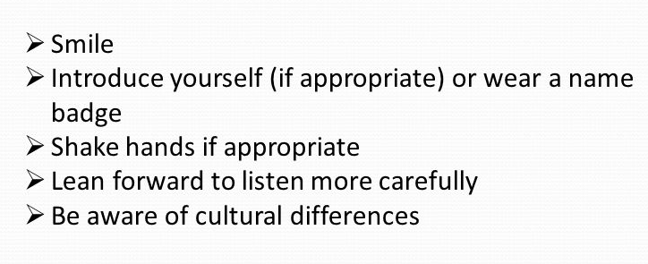
Good body language skills can help our executives influence and motivate direct reports, improve productivity, bond with audiences, present ideas with more authority and impact, and authentically project their personal brand of charisma. That’s a powerful set of skills for any leader to develop.

Peter Drucker, the renowned author, professor and management consultant, understood this clearly:
The most important thing in communication is hearing what isn’t said.

We all know the value of making a good impression, and in order to do that we often choose our words very carefully . . . especially in the workplace. Body language has a very strong influence on how people perceive us. Learning the message that these and other gestures send out to the recipients can help us become a more effective and persuasive communicator. But what if we are sabotaging our best efforts to communicate effectively with our coworkers or clients without even realizing it? Let's take a look at the importance of body language in the workplace, and how we can use it to improve communication and make a positive impression:

Facial Expressions (Head, eyes, eyebrows, mouth):

“We talk with our vocal cords. But we communicate with our facial
expressions, our tone of voice, and our whole body.” Paul Eleman

The face is the most significant and the most photographed part of the human body. The flashes of facial signals are generally spontaneous reactions which a person finds difficult to hide.

The face is the most reliable indicator of a wide range of emotions: Joy and happiness, fear, annoyance, surprise, anger, sadness etc. Facial expressions are highly flexible and changeable. The face can encode a variety of communicative and informative messages.


People will be looking at our face more than anywhere else, so we need to be careful of our facial expressions. If we frown at what someone is saying, they will immediately assume we disagree or disapprove. Worse, someone may capture that on camera or see it from across the room.

When we are actively and responsively listening this shows in our facial expression and our head movements. The head and face are seen to respond fittingly and appropriately to what is being said by the speaker.
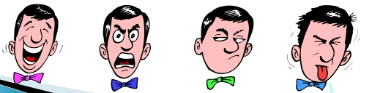
We need to find the appropriate facial expressions and become aware of what our face is revealing to observers, and choose the expression that matches our intended message. Facial expressions are often more convincing than words. They carry the greatest impact in convincing someone of something. We must take care of our facial expressions. We should hide that we are angry and frustrated. The control of facial expressions becomes better with practice and experience.

Facial expressions are one of the most widely observed and studied forms of body language. A pout of the lip can indicate sadness or pitifulness. A crinkle of the forehead can show sadness or anger. A wrinkle between the eyes can demonstrate stress. Of course, we've all seen people try to hide their emotions by plastering on a smile or something of that nature. But if we keep an eye out, we might be able to briefly notice a micro-expression, an extremely quick, unconscious facial expression that lasts for a fraction of a second. Micro-expressions can give us a glimpse of a person's true emotions.


Nodding is relevant to what is being said. Nodding too much can make us look like a bobble head doll! Even if we agree with what’s being said, we nod once and then try to remain still. A nod depicts a positive signal and a ‘head- shake’ signifies ‘no’ or a negative gesture. Head nods show continuing attention, it also depicts what is happening to us emotionally. Heads tilt is a signal of interest. Nodding agreement shows there are no barriers to communication.

We raise our eyebrows to express astonishment. We lower or knit our eyebrows, frown, when we want to show disagreement, displeasure or confusion. Envy or disbelief may be displayed by a raised eyebrow. The raising of one eyebrow shows disbelief and two shows surprise. A frown means ‘I find you puzzling’

Example:
Raised eyebrows indicate surprise, fear, shock, and worry. If someone compliments our new haircut when her brow is raised, it may not be sincere; she may just be in shock that we cut our hair so short!

The Eyes; the eyes can be steely, knowing, mocking, piercing, shifty. They can level a burning glance, a cold glance, a hurt glance or they can be wise, knowing, inviting, scary, disinterested and so on. Pupils dilate when a person is interested. We gaze in order to perceive the expressions of others. We look straight in the eye to get attention. Blinking of the eyes shows the level of comfort. Frequent blinking or winking can be seen as flirtatious. Lack of crinkles around the eyes could mean that a person's smile is not sincere.

Ways of Looking:
- Side long glance is referred to as stolen look.
- Blank stare depicts boredom.
- Sparkling eyes are an attribute of those who have ‘magnetic personalities’.
- Peering over glass depicts being judgmental or critical.
- Dark glasses are worn by those who conceal their genuine feelings.


Example:
Much fuss was made in May 2007 when George W Bush winked at the Queen. The fuss was made because a wink is quite an intimate signal, directed exclusively from one person to another, and is associated with male flirting. It is strange that a non-contact wink can carry more personal implications than a physical handshake. Additionally - and this was partly the sense in which Bush used it - a wink can signal a shared joke or a secret.



The mouth is associated with very many body language signals. The mouth can be touched or obscured by a person's own hands or fingers, and is a tremendously flexible and expressive part of the body too, performing a central role in facial expressions.

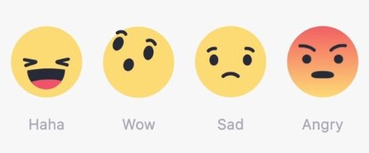
When we are shocked we open our mouth. Blushing is another facial phenomenon that expresses emotion. A shy or an angry person becomes red in face when attention is focused on him.

The mouth when ‘raised’ communicates positive feelings, happiness, optimism. If kept ‘straight’ conceals emotion. ‘Turned down’ expresses sadness, confusion, dissatisfaction. The Lips, when we do not utter a word can be eloquent because silent lips express a wide range of emotions from smile to frown.

Biting lip, one of many signals suggesting tension or stress, which can be due to high concentration, but more likely to be anxiousness.
Pursing lips can also indicate anxiousness or impatience at not being able to speak. Or quite differently can indicate upset, as if suppressing crying.

Cultivate an “expressive face”: We all know someone who has mastered the “expressive face,” and can tell an entire story with a single look. Its importance should not be devalued.

Keep your facial expressions suited to the situation: your expressions should be tailored to the topic at hand. Keeping a smile on our face while answering a serious question may make us look insincere. Match your facial expressions to your words, and you will appear more genuine.

Beware of the “bobble head” effect: When listening to a sad story, for example, or empathizing with a friend, a head tilted to the side and nodding along can indicate sympathy and understanding. However, it does not connote strength and authority, two things you should hope to embody while for example pitching your business. Keep your head upright and keep nodding to a minimum.

Don’t:
- Keep your face bland and impassive
- Smile constantly
- Use inappropriate expressions
- Nod or tilt your head too frequently
Do:
- Use expressions to your advantage
- Remain calm and collected
- Tailor your expressions to the situation
- Maintain an upright neck position

Example:
The speaker—let’s call him Eric—was vivacious and captured the audience. He smiled, but not too much; his gestures were well placed, and showed his passion for the subject. He took up space, but was never overwhelming. His voice was confident, yet accessible.
Years later, I can recall the topic of his speech—the importance of good public transportation—because not only did he present interesting information, he was also engaging, self-assured, and totally in his element. Briana Morgaine

What our audience reads on our face can be just as important as the words they hear. Do our words and our expressions match? Is our face sending the right message? Well-used facial expressions can convey warmth, and tell a story.

Eye contact

There is a proverb that reads, 'The eye is the window of the soul’; the eyes are one of the most important tools in interpreting emotion. The eyes are so transparent that through them “one sees the soul”. We have to look a person in the eye when we talk to him/her. The eyes are one of the most powerful parts of our body language, and can express everything from happiness, annoyance, interest, to pain.


To make people feel good and show our interest we must maintain eye contact. The easiest way to maintain eye contact naturally is to look at the person’s whole face above the tip of his nose. An honest person has a tendency to look us straight in the eye when speaking. At least listeners accept it like that. Frequent eye contact is interpreted as honesty and forthrightness. Staring is interpreted as too aggressive. There’s a fine line between holding someone’s gaze and staring them down. Looking up or looking around is a natural cue that someone is lying or not being themselves. Try to hold steady eye contact. Direct eye contact is generally regarded as a sign of truthfulness; however practiced liars know this and may fake the signal.

The best networkers use their eyes to communicate the feeling that you are the person they are most interested in at that moment. Never let your eyes drift to other people in the room, as if you’re looking for someone better to talk to.

People avoid eye contact with the other person when an uncomfortable question is asked. We need to try to reduce tension and build trust rather than increase tension. We need to look at people to convey the sincerity of our message; we will increase their attention to us by sufficient eye contact. Diversion of eye contact can mean uncomfortableness, disinterest, low confidence, or dishonesty.

Breaking eye contact too soon can make you seem untrustworthy or overly nervous. Hold eye contact a little longer, especially during a handshake. Direct eye contact communicates honesty, transparency and neutral attitude.

- Too much eye contact: dominance, lack of respect, threat, a wish to insult.
- Too little eye contact: not paying attention, impolite, insincere, shy
- Withdrawing eyes: signal of submission


Looking at watch, clock or phone means boredom, anxiousness, impatience, or future-minded. When people are looking at a phone, watch, or clock during a conversation, it is usually a telltale sign that they are in a hurry for it to be over. They may be tuning out the other person and thinking about what they have to do next.

Example:

Mark understands that in the business world in the United States, although there are some exceptions, it is generally expected that you will maintain eye contact a little more than half of the time when you are speaking to someone. Making eye contact projects authority, trustworthiness, and confidence in this culture; Bob instead rarely makes eye contact. He'll look to the right, look to the left, and even stare at his shoes, but he doesn't look at the person he's conversing with. His failure to make eye contact makes some people wonder if he's hiding something. Susan Fenner

Example:
Yet there are few situations where body language is more important still.
Imagine that you're going to watch a presentation on the economic benefits of prison reform. This is a hotly debated issue and one in which you're particularly interested. Unfortunately, rather than engaging the audience and making a persuasive argument, the speaker stood perfectly still behind the podium, looking down at his notes and droning on for forty five minutes. The speaker may have used evidence to make a solid case, but none of that mattered because the presentation was so boring.
In this case, the speaker did a few things poorly. First, by looking down at his notes the whole time, he failed to make eye contact with the audience. Using eye contact when speaking is a great way to engage the audience, but it can also emphasize the content of the speech by reflecting empathy or underscoring the seriousness of what he's saying. Moreover, making frequent eye contact with the audience is a sign of confidence that helps the speaker be perceived as an expert on the subject. David White

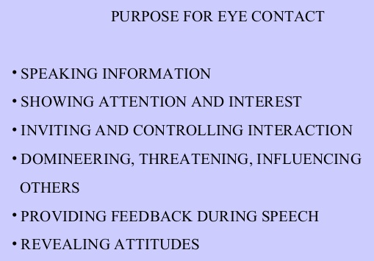

Smile

Smile!!! The most powerful facial expression is the smile. It is the strongest body language signal to influence our first impression, a smile. It is the most recognized signal everywhere. Smiling is an international language. People like persons who smile a lot, because persons who smile send out the message that they are enjoying being with the others, they are relaxed, they are confident.

To make others comfortable, simply smile at them; smiling is our most powerful weapon. Failing to smile can make people uncomfortable, and wonder if we really want to be there. Go for a genuine smile especially when meeting someone for the first time. A genuine smile means ‘I appreciate you’; ‘I accept your ideas’.

A critical message delivered with a smiling face will have a totally different impact than one delivered with an angry face. ‘Smiley face emoticons’ actually were invented to simulate this in text messages as well.

Keeping a slight smile on our face is a good habit to practice no matter what situation we’re in. It makes us look warm and friendly – like someone that others would like to meet.

Smiling is a big part of facial body language. As a general rule real smiles are symmetrical and produce creases around the eyes and mouth, whereas fake smiles, for whatever reason, tend to be mouth-only gestures. A pasted smile is one which appears quickly; this typically indicates suppressed displeasure or forced agreement of some sort.

But also, we don’t want to smile too much. Employed at the right times, smiling can be one of the most powerful and positive non-verbal cues, and especially potent for signaling likability and friendliness. But when the subject turns serious, we need to sport our serious face.


Avoid the “perma-smile”. While it is important to demonstrate our passion for our work, we have to be conscious of keeping our enthusiasm under control. Excessive smiling can make us appear foolish or less professional, so sometimes maintaining a collected demeanor will serve us better. That’s not to say we can’t smile—we should definitely smile!—but the plastered on beauty pageant look will not win over investors, and may ultimately make us look less credible.

- Tight-lipped smile can also be a rejection signal.
- Forced laughter, unnatural laughter is often a signal of nervousness or stress, as an effort to dispel tension or change the atmosphere. Artificial laughter is a signal of cooperation and a wish to maintain empathy.

Example:
Brent is mindful of his facial gestures. He has a warm smile and offers non-verbal feedback by nodding in agreement, when appropriate. Most people respond to Brent's smile by smiling back, and it helps him build trusting relationships.
Jim never smiles. He's polite and cordial, but he doesn't project any warmth. People are a bit wary about Jim because they can't tell if he likes them or not. They're also not sure if their words are making an impression on him, because he keeps the same bland expression at all times.

Hands and arms

We need to gesture with our arms and hands in a natural way, and look at people in the eye. Use positive gestures. When people are proud of what they have done, they usually show their hands quite openly. When they are not, they often put their hands into their pockets, or hide back. Holding our hands behind our back or firmly in our pockets can look rigid and stiff. We have to aim for a natural posture with hands at our sides.

Crossing our arms makes us look defensive, especially when we are answering questions. Crossed arms tend to seemingly act as a protective guard against an anticipated attack or a fixed position which the other person would rather not move. We need to try to keep our arms at our sides. Conversely, arms open and extended toward us generally indicate openness and acceptance.

Context matters! Sometimes someone might just be a little cold. Don’t focus on a single signal, but focus on all of them.


Putting our hand to our cheek or stroking our chin generally portrays thinking, interest or consideration. Cupping one or both hands over the mouth, especially when talking, may well indicate that the person is trying to hide something, while chopping or pointing with our hands feels aggressive. Clenched fists reinforce stubbornness, aggression or the lack of empathy indicated by crossed arms. Clenched hands usually indicate that a person is ready to fight or that they are angry and may get aggressive if further provoked.

The Human hand is a restless organ; when talking with our hands, it's a good idea to not let them go above our collarbone so that our gestures don't seem over-the-top. When not using our hands to talk, we can just place them on our knees. This will help us avoid crossing our arms, which is not recommended.

Arms are quite reliable indicators of mood and feeling, especially when interpreted with other body language. Arms act as defensive barriers when across the body, and conversely indicate feelings of openness and security when in open positions, especially combined with open palms.

Waving our arms around while we talk may seem to portray excitement, but it can also be distracting. Putting our hands in our back pockets may be more casual and comfortable, but it can also look unprofessional. Crossing our arms is also a big no-no in many circles since it communicates a resistance to new ideas. We may celebrate with a close colleague with a quick hug upon receiving good news. An occasional pat on the arm or shoulder might be acceptable as well.

When someone asks us a question, we can talk with our hands and use open gestures. By showing the palms of our hands while speaking, we subconsciously tell people that we have nothing to hide, which signals credibility. Hands behind the head are used by professionals who are confident and dominant.
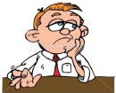
A nervous or jittery person shows restless hands. Fidgeting instantly telegraphs how nervous you are. Avoid it at all costs. Overuse of hands indicates nervousness, excitement, or mania. Limp hands show boredom. Clenched hands often show frustration while clapping of hands shows applause.

We rub our palms together for positive expectation while hands on hips are an aggressive, achiever stance.

One of the more interesting things about body language is that, while it can complement our verbal communication, it can also be an indicator of things that we try to hide. For example, shielding yourself with an arm across your stomach or chest is usually a sign of discomfort; you're literally attempting to cover something up or put a barrier between yourself and the other person. The trick to using body language in a complementary fashion is to use body language that matches your words and intent.

If we observe people speaking at a party, we will find that many stand with their arms or hands in front of them. Their arms could be crossed, or their hands could be clasped in front of their crotch. This could be an unconscious creation of a barrier between themselves and the person to whom they are speaking. Speaking with arms to one’s sides, on the other hand, can indicate openness and friendliness.

Touch is a powerful tool, but in the office it should definitely be limited to hand, wrist, and upper arm. The occasional pat on the shoulder is also acceptable. The reason that these areas are “safe” areas is that research has shown that the higher up the arm you touch someone, the more intimate the touch. So a double handed handshake is less intimate than a pat on the elbow or upper arm. Keep this in mind when meeting people.

We also want to pay attention to their non-verbal cues at our touch. When we touch their hand or elbow do they flinch or move back? Do they grimace? Or do they smile wider and reciprocate the touch. Some people are very uncomfortable being touched and this will show through their body language.

The handshake; this, of course, comes into play to signal openness or goodwill at the beginning of an interaction, and agreement at the end. Palm-to-palm contact is important for sincerity.

it should show authority, but not too much, and it should be firm, but not too firm (I was once told by a boss to lighten mine up a little, as I’d apparently overshot the idea of a “firm handshake,” but that’s another story). Briana Morgaine, bplans.com

Evaluate your own handshake. It must be neither too limp nor bone crushing, but firm. Execute a brief shake, not excessively pumping the other person’s arm. If you suffer from cold and clammy hands, subtly wipe your hand on your pant leg to present a dry hand. Be sure to look into the person’s eyes directly as you shake.

Our handshake should:
- Be firm: A good handshake is firm, but, according to Etiquette International, “not bone-crushing.” So, when greeting, grasp the person’s hand firmly—but not too hard. And please—no limp fish hands. There is nothing worse, and this will surely leave a bad impression.
- Be authoritative: A hand offered palm-up is sometimes considered a sign of passivity and weakness; however, a downward facing palm can come off as overly superior. Strike a balance by offering your hand sideways, giving the impression of equal footing.
- Include eye contact and smile: When shaking hands, make sure to meet the other person’s eyes. Finally, smile! Make this connection memorable—you may not get a chance to make another good impression.

So, remember:
Don’t:
- Crush your associate’s hand
- Offer your palm up or down
- Offer a limp hand
- Avoid eye contact
Do:
- Grasp the hand firmly
- Offer a sideways-facing palm
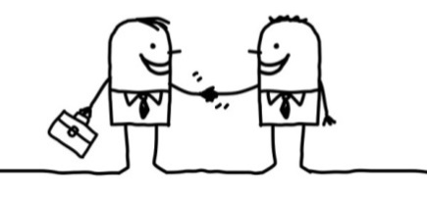
- Make eye contact

Handshaking is appropriate in all kinds of situations: hellos, goodbyes, new acquaintances, congratulations, consolation, and thanking a host at a social event. So be sure your handshake sends the right message to make a great impression.

Example:
I recently heard a story about a firm in the hiring process. They had narrowed the applicant pool down to two equally qualified candidates. What was it that broke the tie between the two applicants? Their handshakes. The person with the firm, warm shake who looked the interviewers in the eyes got the job. The runner-up had a limp grip delivered with cold, clammy hands. The employer was looking for a confident, enthusiastic worker and the job winner communicated those qualities in the very quick exchange of a handshake. (Libby Van Vleet business etiquette expert)

Body posture
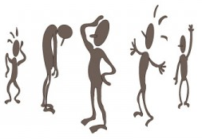
Posture has great significance in interpreting body language. Postulating (adopting a posture) is a very general approach for adjusting, relating with and defending ourselves from various physical environments, social situations, objects and persons. Posture speaks loudly.

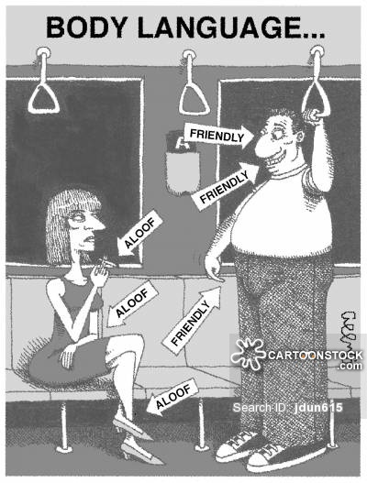
So, aim for good posture in a neutral position, whether sitting or standing. Stand with your arms at your sides, and sit with them at your sides or with your hands in your lap. Pay attention so that you naturally hold eye contact, smile and be yourself.

The way you stand can communicate how open you are to being approached, your energy level, your professionalism, and even the way you were brought up. For example, didn’t your mother ever tell you stand up straight? When you stand up tall and straight, you send a message of self-assurance, openness, authority, energy.

People who tightly cross their legs seem to be saying that they disagree with what you are saying or doing. If people have tightly crossed legs and tightly crossed arms, their inner attitude is usually one of extreme negativity toward what is going on around them. It may be difficult to get agreement.

Avoid crossing your arms, legs, or anything making yourself look smaller. Not only does this make you less confident, it lessens your appearance of power. To combat this, make sure that you stand tall and confident. You will feel more confident, powerful, and in control. Uncrossed arms and legs may be a sign of acceptance of your position or terms.

We also need to consider that when people sit for half-an-hour or more they tend to change their leg positions, which can include leg crossing purely for comfort reasons. Allow for this when interpreting signals.

Crossed arms is a commonly exhibited signal by subordinates feeling threatened by bosses and figures of authority. But as already mentioned before, people also cross arms when they are feeling cold, so, we have to be careful not to misread this signal.

Poor posture can signal lack of confidence, unwillingness, and lack of ability, unavailability, or boredom. It can also indicate that we are not assertive or self-assured. Poised individuals are treated with more respect and are seen as more knowledgeable and reliable. For example: powerful people sit, stand, walk and gesture in ways that exude confidence, competence and status.


When introducing yourself, stand up tall; by now we know that by doing this, we portray power and success. When you have good posture, you also look like you have confidence in yourself. Think about it. If you see someone hunched over and looking at the ground, do they look like they feel confident? Probably not. While lacking energy and courage, we cannot stand perfectly upright and eventually arch in back. This posture is also adopted under threat or while feeling vulnerable.

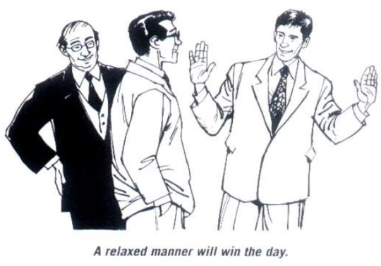
Stand up straight! But not as if you’re in the military. You want to appear open and friendly, not rigid and formal. Slumping and slouching communicate disrespect, laziness, and disinterest in the other person. When leaning back too much you come off lazy or arrogant. If you slouch, you may look tired or unenthusiastic. Find a happy medium where you stand up straight with your shoulders back, far enough away from the other person to allow personal space, and with a sense of energy. If you are trying to appear dominant or authoritative, stand erect with shoulders back, because a slumped position usually indicates insecurity, guilt, or weakness. Open your chest and arms and keep your back straight. This position will make you breathe better and you’ll feel more relaxed. When people show signals of openness that means they are generally feeling very comfortable in your presence which is good.

When at work stand in expansive poses, head up, shoulders back, feet firmly planted to get you in the right mindset. Communicating your sense of self through manners and body language is an incredibly powerful tool.

Stepping back when you’re asking for a decision conveys fear or uncertainty. Stand your ground, or even take a slight step forward with conviction.

Leaning back with both hands supporting the head usually indicates a feeling of confidence or superiority. But you should avoid leaning back in your seat. This could give the impression that you are far too relaxed and don't take things very seriously, while leaning too far forward can seem invasive. Focus on sitting upright, which will help you exude confidence in front of your colleagues.
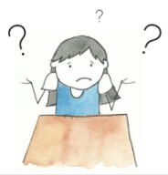
A shoulder shrug means that a person is confused, is apathetic, or does not understand. Good posture demonstrates confidence and control. Slumped posture can indicate low self-esteem or discomfort. A posture that is relaxed and leaning back is an expression of contentment, power and control. On the contrary, a posture of leaning forward with arms hugging oneself and head slightly down is an expression of powerlessness or submissiveness.
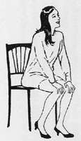
After discovering no reason to seat anymore, we put hands on knees or thighs to prepare ourselves to stand and walk away. You seem to be saying: May I go? So avoid it.

Keeping your shoulders back and your head up not only conveys confidence and positivity, it is also better for your health. You will actually feel better while exuding a great attitude. I already mentioned that good posture makes us all look taller and slimmer; good posture will bring you confidence, health, and an improved appearance. Good posture is not just for the benefit of others. Standing up straight, taking more space with shoulders back and head up actually produces more strength than slouching and contracting in.




Uncertain about each other Openness and acceptance

One way to know how someone really feels about the situation they are in is to watch their feet. People who lack confidence or are nervous will shuffle or slightly kick their feet. They may also fidget with their feet or wind them around furniture. Often, these things are done in a subconscious way. By paying attention to your own body movements, you can learn to lessen these cues that you are nervous or stressed.

Just as your body positioning should be confident and “big,” so should your use of space. Don’t be afraid to move around. Command the space around you, and you will be non-verbally communicating to your audience that you are comfortable with yourself and your work.


Personal space dimensions depend notably on the individual, cultural and living background, the situation, and relationships; however some general parameters apply to most people. We’ve all been there at some time in our lives, slowly taking small steps backwards in an effort to maintain a comfortable “bubble” of space between ourselves and the person encroaching on that space. The close talker! And then, the terror: we have hit a physical wall behind us. There is no more room to retreat. Avoid being this annoying space stealer. Maintain a minimum distance of two feet apart when interacting with others. You may choose to lean in to hear a quiet person more clearly, but then back away to speak yourself. One important consideration may be height differences. Stand far enough away so that the other person won’t have to look up or down at you. Allow a person to have their freedom. You will know if you are violating a person’s comfort level if they keep backing away from you!

If someone comes too close to you try bending your elbows and clasping your hands out in front of you as a barrier. This expands your personal bubble in a subtle way.

When another person displays similar body language to our own, this makes us react unconsciously to feel, "This person is like me and agrees with the way I am. I like this person because we are similar, and he/she likes me too." The converse effect applies. When two people's body language signals are different - i.e., not synchronized - they feel less like each other, and the engagement is less comfortable. Each person senses a conflict arising from the mismatching of signals, the two people are not affirming each other; instead the mismatched signals translate into unconscious feelings of discord, discomfort or even rejection. The unconscious mind thinks, "This person is not like me; he/she is different to me, I am not being affirmed, therefore I feel defensive."

Examples of ‘posture’:
1. - Claude has good posture. He stands tall and commands his space with his chest slightly out and his legs slightly apart. He projects confidence.
Albert tends to slouch, whether he's standing or sitting. It makes him appear to lack confidence and energy. Although his production numbers mirror Claude's, he always looks like he's five minutes away from his next nap.
2. - There was an amazing study done by researchers at Harvard Business School where they had participants come into a lab and split them up into 2 groups. In one group they had them do successful body language—these are expansive poses, great posture poses for 5 minutes. In the other group they had them do unsuccessful body language or defeated body language poses, these are contracted, tightly held arms and legs and low hanging heads also for 5 minutes. They then had these groups go into mock interviews where they had to deliver a speech to evaluators and answer questions. These were videotaped and rated for overall performance, hire-ability, and presentation quality.
The group that stood in the poses of successful body language was rated higher for their speech and was more likely to be hired. Just standing in successful body language for 5 minutes before an interview affected the outcome of the interview. (Vanessa Van Edwards. scienceofpeople.com)

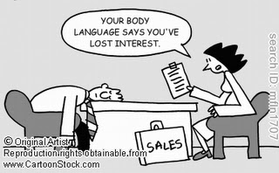



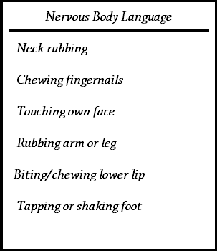

There are many different ways in which we express our discomfort with body language.

Finally

Voice type and other audible signals are typically not included in body language because they are audible 'verbal' signals rather than physical visual ones, nevertheless the way the voice is used is a very significant (usually unconscious) aspect of communication, aside from the bare words themselves. Consequently, voice type is always important to consider alongside the usual body language factors.

Body language is not an exact science; no single body language sign is a reliable indicator. Understanding body language involves the interpretation of several consistent signals to support or indicate a particular conclusion.

It’s important to remember that body language isn't always what it seems. For example, a person who rubs his eyes may not be tired; perhaps his eye is itchy. A person who crosses her arms may not be defensive; maybe she is just cold.
It's also important to note that body language is not universal across the world.

For example:
1. - A nod of the head signifies agreement in the U.S., but it means disagreement in Turkey.

2. - While driving in New Zealand, a tourist couple missed a stop sign and was pulled over by the police. When they explained that they were not from the area and had accidentally missed the stop sign, the police officer gave them a warning. The husband was pleased, so he gave the officer a 'thumbs up' gesture. The officer then proceeded to put the man in handcuffs and called for backup. Why, you ask? A thumbs up is seen as a rude gesture in New Zealand! (Body Language in Different Cultures - Holly DeLuca)

The example above illustrates that not all cultures have the same norms when it comes to body language

Finally, practice! Practice! Practice! Have we got all that? This may seem like a lot to remember, which is why practice is essential. Don’t forget to practice not only what you are to say, but your body language as well.

References & Background Reading

- A Better Way to Deliver Bad News. By Jean-François Manzoni. From September 2002 issue. Managing People. Harvard Business Review
- An opportunity to increase the amount of performance feedback on your team. By Walter Oelwein. March 7, 2011
- Applying Feedback Techniques. By Ben Linders. Mar 17, 2016
- Ban the Feedback Sandwich for Employee Feedback. The Feedback Sandwich Is Not an Effective Method for Feedback. By Susan M. Heathfield. Human Resources. May 30, 2016
- Best Practices for Giving and Receiving Feedback. Oregon Health and Science University. Adapted with permission from the Institute for Clinical Research Education Mentoring Resources, University of Pittsburgh.www.icre.pitt.edu/mentoring
- Body Language. By Gajanan shirke. Published on Jan 12, 2016
- Body Language during a Job Interview. By Adam Nystrom. Chapter 1/ Lesson 20. (study.com)
- Body Language in Different Cultures. Holly DeLuca. Chapter 3/Lesson 18, (study.com)
- Body Language in the Workplace. By Susan Fenner. University of North Alabama. Chapter 1/Lesson 19 (study.com)
- Body Language is Half of Business Communication. By Martin Zwilling. Business Insider. Dec. 20, 2010
- 4 Essential Business Body Language and Etiquette Tips. By Vanessa Van Edwards and Libby Van Vleet. scienceofpeople.com
- Everything you need to Know about Giving Negative Feedback. By Sarah Green Carmichael, senior editor at Harvard Business Review. June 30, 2014
- Feedback That Works. By Cynthia M. Phoel. Harvard Business Review. April 27, 2009
- Feedback: Why the Hamburger Approach is just junk. By Moyra Mackie. March 1, 2013
- Five Steps for Giving Productive Feedback. By Scott Halford. Entrepreneur Middle East. April 7, 2011
- Giving Feedback. Keeping Team Member Performance High, and Well-Integrated. MindTools.com
- Giving a High Performer Productive Feedback. By Amy Gallo, contributing editor at Harvard Business Review. Harvard Business Review December 03, 2009
- Giving Effective Feedback. Clinical Teaching Made Easy. British Journal of Hospital Medicine, March 2009, Vol 70, No 3 (pages 158 – 161)
- Giving Effective Feedback. Activity 3-2A Giving Feedback. Office of Learning and Teaching, DE&T (page 3)
- Giving Effective Feedback. The Leadership Excellence Series. Toastmasters International USA (Pages 1-8)
- How Body Language Complements Verbal Communication. By David White. Chapter 13/Lesson 20, (study.com)
- How Criticizing in Private Undermines Your Team. By Roger Schwarz. Harvard Business Review. March 25, 2013
- How to Deliver Effective Positive Feedback in the Workplace. By F. John Reh, Management & Leadership Expert. May 25, 2016
- How to Give Feedback. By Dan McCarthy, Management & Leadership Expert. April 14, 2015
- How to Give Negative Feedback Properly. By F. John Reh, Management & Leadership Expert. March 21, 2016
- How to Give Effective Feedback to your Students. By Susan M. Brookhart. ASCD Member Book. Association for Supervision and Curriculum Development Alexandria, Virginia USA. 2008.
- How to Give Proper Feedback to an Employee. By Rick Segel & Matthew Hudson, Retailing Experts. July 31, 2015
- How to Give Your Team Feedback. By Rebecca Knight. Harvard Business Review June 16, 2014
- How to Read Body Language. By Karin Gonzalez. Chapter 4/ Lesson 18 (study.com)
- Is Bad Body Language Ruining Your Pitch? Here’s How to Fix It. By Briana Morgaine. Bplans.com
- Kill the suggestion Box – There’s a much better way. By Alexander Kjerulf. February 10, 2014
- Mastering Body Language in Business Networking. By Steve Cartwright. July 16, 2014
- Mehrabian's communication study. Changing minds.com
- Negative Body Language: Examples and Signs. By Karin Gonzalez. (study.com) Chapter 3/Lesson 17.
- Positive Body Language: Examples & Signs. By Holly DeLuca. Chapter 3/ Lesson 16. (study.com)
- Provide Feedback That Has an Impact. By Susan M. Heathfield. June 30, 2016. Training Materials.
- The Compliment Sandwich Feedback Technique, with Examples. By Nagesh Belludi. February 20, 2008
- The Delicate Art of Giving Feedback. By Robert C. Pozen, Senior Lecturer of Business Administration at Harvard Business School. Harvard Business Review March 28, 2013
- The 15 Most Common Body Language Mistakes. By Bernard Marr. Published on Jul 7, 2014
- Using Body Language. Training materials. Changing minds.org
- 3 Ways to Encourage Employees to Give You More Feedback. By Jessica Stillman. July 23, 2014
- 4 Ways to Get Truly Honest Feedback from Employees. By Andre Lavoie, Entrepreneur; CEO and Co-Founder, ClearCompany. May 26, 2015
- What makes corrective feedback helpful vs. awful? By Anna Carroll, MSSW; April 3, 2011
- When to Set Sales Performance Reviews. Why frequency counts in making your sales team more productive. By Suzanne Paling. Entrepreneur Middle East. Jan 19, 2011

Student Statement:

By submitting this assignment, I confirm that this is my own work.

Student Signature | Maria Magdalena Barragan Zermeno | Date | August 22, 2016

For Tutor / Assessor Use Only
Total Marks
Marks Obtained
Percentage / Grade

