
Assignment Cover Sheet

Student Name: | Raymond Wilson
Student Number: | 2362
Course: | Diploma in Logistics and Supply Chain Management
Assignment No: | 1

Marking Criteria:
We expect the learners to write minimum one well expressed point in three lines against each allocated mark. This means one needs to write 15 lines with 5 well expressed points to get high grades for a 5 marks question.
For high grades use examples and illustrations where appropriate.
Assessment #1 Total Marks: 30

1. Give short answers for the following questions. (12)
i. Outline the main benefits of a supply chain.
Effective supply chains, although often complex, give businesses a competitive advantage in the marketplace and help mitigate risks associated with acquiring raw materials and delivering products or services. By applying supply chain management systems, companies are able reduce waste, overhead costs and shipping delays in a scientific way. The benefits of this systematic approach impacts areas ranging from product quality to order turn-around times.
There are certain key areas where supply chains prove particularly effective as follows;

Quality Assurance
Many manufacturers globally relocate their operations to other countries around the world in an effort to cut production costs. As a result, product quality within the supply chain has become an issue whereas defects and rework attributable to poor systems are raising the costs of doing business. One of the advantages of supply chain management is that it incorporates quality techniques and management systems, to improve operations, product quality and reputation.
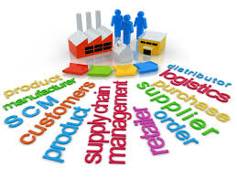

Inventory Buffers
In most types of business, there is inconsistency in customer spending. This requires companies to manage their lists/products in a way that minimizes holding costs while providing enough flexibility to meet customer demands. If inventory levels fall too low, companies may have to pay overtime to produce goods or lose out on revenue by making customers wait or shop somewhere else. Supply chain management systems typically include inventory cushion levels that are pre-determined with vigilant analysis of historical product trends.

Shipping Options
Shipping options need to keep pace with the demands of the marketplace, which requires companies to readjust their supply chains to meet customers’ preferences and needs. Whether it is small or larger bulk orders, sending in a quick and accurate fashion is key for business success. Supply chain management systems therefore help companies determine the optimal ways to ship while reducing costs to the lowest possible level.

Risk Mitigation
Managing risk is a key responsibility for all business Managers, and supply chain management systems allows for the identification of critical risk factors in an organization or with their suppliers. Whether it is product quality, compliance with laws or operational safety, management must mitigate risk in an effective manner. Supply chain procedures assist management with organizing risks and ascertaining the potential for failure. Without these systems, many companies are exposed to risks and liabilities.

ii. Companies in any supply chain can make their decisions individually and collectively in five areas. What are these areas?
There is a basic pattern to how supply chain management works. Each Company/supply chain has its own unique set of market demands and operating challenges and yet the issues remain essentially the same for all. Companies in any supply chain must make decisions individually and collectively regarding their actions in five areas listed and illustrated below;
- Production
- Inventory
- Location
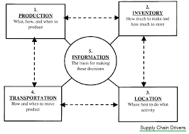
- Transportation
- Information
The entirety of these choices will set the capabilities and effectiveness of a company's supply chain. The decisions a company makes thereafter and the ways it operates and competes in its markets are all very much dependent on the effectiveness of its supply chain. If the plan, for instance, is to oblige a mass market and compete on the basis of price, it requires to have a supply chain that is motivated for low cost. If a company's strategy is to operate and compete on the basis of customer service and convenience however, it needs to have a supply chain optimized for responsiveness. Who a company is, what it can do and where it wants to go is ultimately molded by its supply chain and by the markets it serves.

iii. How is a modern supply chain different from that of the past?
Supply chains have developed in an incredible way in the past few years. Around twenty years ago, the perception of a supply chain comprised only the logistics involved in delivering a product from supplier to market on behalf of the parent company. Basically, goods had to be delivered from A to B and it was not assumed that a supply chain could be exploited to improve margins, revenue and profits. It took an American professor called Marshall L Fisher to see the possibilities and in 1977 he asked a simple question in an article in the Harvard Business Review entitled ‘What is the right supply chain for your product?’. He held out a tantalizingly attractive prospect: Quote; “A simple framework can help you work out the answer.”
This article was a catalyst, as he expressed opinions so radical that they brought it closer to today’s views. Some of the topics visited are summarized as follows which have dramatically changed the way supply chains now operate;
- Dysfunctional
In short, supply chains were largely dysfunctional. According to Fisher (who had already spent 10 years researching and consulting on the fledgling concept of supply chains in various industries, from food and fashion to automobiles), the answer came back to the simple framework, and it is still valid today.
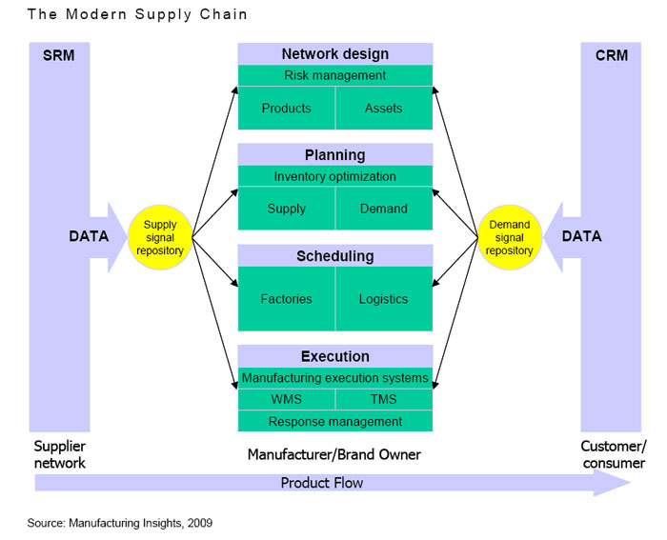
- Functional or not
The construction of such a framework started with a bottom-up analysis of the nature of the demand for the company’s products. Quite simply demand essentially fell into one of two categories. One category was for primarily functional products, while the other was for primarily innovative ones. Both categories required their own “distinctly different kind of supply chain”. Thus, a company had to decide as a matter of priority whether its product was functional or innovative. If it was sold from grocery stores and petrol stations, it was probably functional with a long life-cycle; and it probably faced a lot of competition.
A genuinely innovative product of the time was the IBM ThinkPad with its radical new cursor. Here again, IBM’s supply chain let it down. The computer giant was so wrong-footed by the demand for the ThinkPad that it was in short supply for more than a year. This instance was used by Fisher to encourage companies to think more deeply about their supply chains.
- Catastrophes
A series of catastrophic geophysical shocks in recent years has exposed the vulnerability of supply chains that not only cross borders but encompass entire geographies.
In different ways, Iceland’s volcanic ash clouds, Japan’s tsunami, Thailand’s floods and the US Superstorm Sandy caused significant disruptions that rippled through the chain up to the customer.
Each of these events had differing effects. Combined, they illustrated a frightening fact for risk managers: that the capacity of the weather to destroy some or all the links in supply chains had been greatly underestimated. As a result, only the best-managed companies were able to extricate themselves without significant loss.
Geopolitical
Although industries such as shipping have always faced disruption in many forms, the developing civil war in Ukraine is a geopolitical threat being felt across Europe, by industries as diverse as aviation, tourism, automotive and steel.
Much remains to be learnt about how to prevent – or at least mitigate – the ripple effect and with the current state of world affairs no doubt Logistics and associated supply chains will need to adapt accordingly.

iv. What is Inventory Management?
Inventory management is a very important function that determines the health of the supply chain as well as the impacts associated with financial health of the company’s balance sheet. Every organization constantly strives to maintain optimum inventory to be able to meet its requirements and avoid over or under inventory that can impact the annual financial figures.
Inventory is always dynamic and its management requires constant and careful evaluation of external and internal factors and control through forecasting and review. Most of the larger organizations have a separate department or job function called inventory planners who continuously monitor, control and review inventory and interface with production, procurement and finance departments.
Inventory is an idle stock of physical goods that contain economic value, and are held in various forms by an organization in its custody awaiting packing, processing, transformation, use or sale in a future point of time.
Any organization which is into production, trading, sale and service of a product will necessarily hold stock of various physical resources to aid in future consumption and sale. While inventory is a necessary evil of any such business, it may be noted that the organizations hold inventories for various reasons, which include speculative purposes, functional purposes, physical necessities etc.
From the above definition the following points stand out with reference to inventory:
- All company’s/organizations engaged in production or sale of products hold inventory in one form or other.
- Inventory can be in a complete state or incomplete state.
- Inventory is held to facilitate future consumption, sale or further processing/value addition.
- All inventoried resources have economic value and can be considered as assets of the organization.

v. ‘Information’ is one of the five drivers of supply chain. Discuss the purpose of information in a supply chain.
Information sharing nowadays can radically improve the way companies all over the world and their partners do business, especially as globalization and outsourcing is becoming more relevant, which has and will continue to have a profound effect on supply chain operations. By swapping information such as inventory levels, forecasting data, and sales trends, companies/partners/subsidiaries can reduce cycle times, fulfill orders more quickly, cut out millions of dollars in unwanted excess inventory, and improve forecast accuracy and therefore customer service.
Sharing of information can, in reality, be applied to almost all the core domains of corporate operational activities. Starting from the development chain process where information sharing can happen in the product design stages and product life cycle management activities with both internal and external partners. In the customer chain processes this information sharing can help in formulating customer experience strategies, and increase customer service effectiveness, satisfaction and operations.
In the past manual order processing, spreadsheet dependent and fax/phone method of communication with suppliers made a dent not only to the corporate procurement budget but also generated global operational plans that were out-of-date because of limited-to-no visibility into supplier's plan and operational constraints.
Information sharing, nowadays however, can be most effective and least disruptive for all concerned when done by implementing the available technological tools, which would accomplish the process in a controlled and secured way thereby streamlining the global supply chain operations from supplier to client as illustrated below.
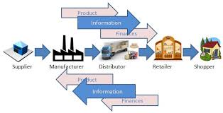

vi. Name various types of inventory.
Inventory of materials occurs at various stages and departments of any organization. A typical manufacturing organization holds inventory of raw materials and consumables required for the production of a product. It also holds inventory of semi-finished goods at various stages in the plant with various departments. Finished goods inventory are normally held at plant locations, stores, distribution centers etc. Further both raw materials and finished goods (those that are in transit at various locations) also form a part of inventory depending upon who owns the inventory at the particular juncture.
Finished goods inventory is held by the organization at various stocking points or with dealers and stockiest until it reaches the market and end customers.

Sample types of Inventory by Function are tabled below;

INPUT | PROCESS | OUTPUT
Raw Materials | Work In Process | Finished Goods
Consumables required for processing. E.g. Fuel, Stationary, Bolts & Nuts etc. required in manufacturing | Semi-Finished Production in various stages, lying with various departments like Production, WIP Stores, QC, Final Assembly, Paint Shop, Packing, Outbound Store etc. | Finished Goods at Distribution Centres throughout Supply Chain
Maintenance Items/Consumables | Production Waste and Scrap | Finished Goods in transit
Packing Materials | Rejections and Defectives | Finished Goods with Stockiest and Dealers
Local purchased Items required for production |  | Spare Parts Stocks & Bought Out items
 |  | Defectives, Rejects and Sales Returns

Besides Raw materials and finished goods, organizations also hold inventories of spare parts to service their products. Defective products, defective parts and scrap also forms a part of inventory as long as these items are inventoried in the books of the company and have some economic value.

2. “Location decisions have strong impacts on the cost and performance characteristics of a supply chain.” Discuss (5)

Location refers to where supply chain facilities are geographically located. These locations must also take into consideration and include the decisions related to which activities should be performed in each facility. The responsiveness versus efficiency trade-off here is whether to centralize activities in fewer locations to gain economies of scale and efficiency, or to decentralize activities in many locations to be closer to customers and suppliers and so be more responsive. When making location decisions, area and regional managers need to consider a range of factors that relate to a given location, including the cost of facilities, the cost of labor, available workforce skills within the area, infrastructure conditions, taxes and tariffs, regional regulations and proximity to suppliers and customers. Location decisions tend to be very strategic decisions (needing careful consideration) because they usually commit large amounts of money to long-term plans.
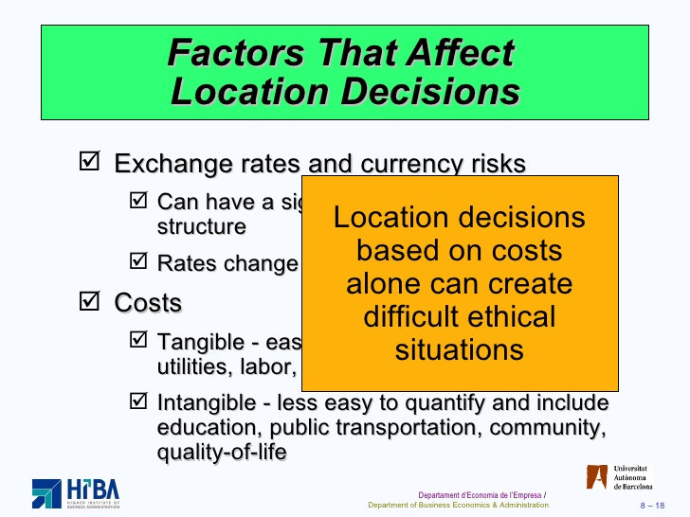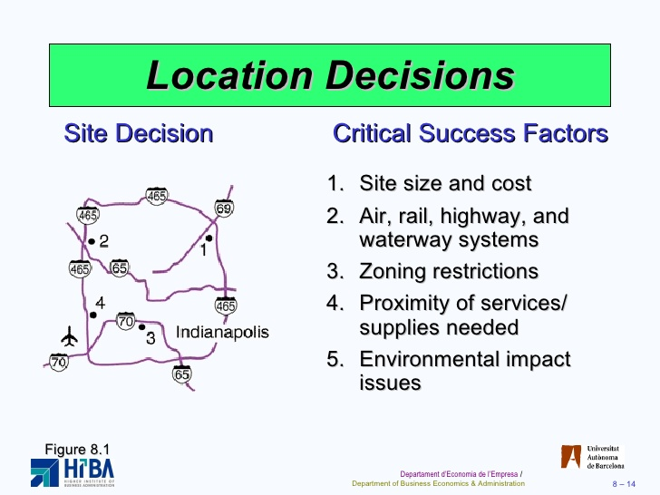

Location decisions also have a strong influence on the cost and performance characteristics of a supply chain, along with a number of other variables, as narrated and illustrated above. Once the size, number and location of facilities are determined, this also defines the number of possible paths through which products can flow on the way to the final consumer.

3. Write short notes on the following participants of supply chain: (5)

a. Producers
Producers normally involve all-inclusive networks of entities, directly or indirectly interlinked and mutually dependent in serving the same consumer/customer. This network comprises of vendors that supply raw material, producers who convert the material into products, warehouses that store, distribution centers that deliver to the retailers, and ultimately retailers who bring the product to the consumer. Supply chains lie beneath value-chains because, without them, no producer has the ability to give customers what they want, when and where they want, at the price they clearly want.
Producers compete with each other only through their supply chains, and no degree of improvement at the producer's end can make up for the absences or shortfalls in a supply chains operations which reduce the producer's ability to compete.
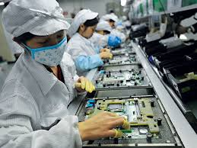
b. Distributers
Distributors can typically offer a better level of flexibility than producers/manufacturers. This includes quicker turnaround times on orders, in some cases in as little as two hours. With customers focused on increasing inventory turnarounds and improving working capital and revenue through operational efficiencies, the distribution channel is critical to maintain inventory strategically located near the customer base. In today’s tight economic environment, customers have come to demand immediate shipment of materials. The infrastructure of manufacturers strives to optimize process efficiencies and distributors are relied on heavily to meet the logistics needs of the customers.
One of the most prevailing benefits that distributors can offer is in the area of product bundling. Customers have the ability to purchase several items from one supplier, greatly reducing administrative and shipping costs.
Most prosperous distributors offer a complementary range of products that can be combined in less than lorry load quantities. If a customer requires resin, additives, pigment and containers as an example, they can combine these on one order, from one supplier, and pick them up on the day they are needed for a production batch.
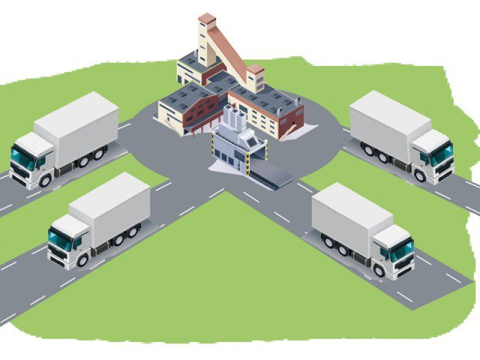
Finally, due to their geographical locality, distributors can usually maintain close relationships with customers to gain an in-depth understanding of their processes, formulations and competitive advantages. Most distributors visit customers on a regular basis to keep up to speed with events and therefore customers don’t have to wait weeks to see someone in case of emergency; distributors can be at the customer’s facility by the end of the shift. Additionally, this level of relationship affords the distributor the opportunity to bring innovative end products that can generate new revenue and profitability. Because of their vast range of market knowledge, distributors can often times help the customer better tailor their research dollars.

c. Retailers
Simplistically, a retailer, or merchant, is a body that sells goods or commodities in small quantities directly to consumers, through various distribution channels with the goal of earning a profit.
In the case of large retailers the items they sell are purchased from a manufacturer or wholesaler and sold to the end user at a marked up price. That's usually where the retailer's profit comes from: That markup. But the term "retailer" doesn't just apply to large stores; another example of a retailer is the small family-operated Bakers in your own town or village.
Normally, retailers don't manufacture the goods they sell. Although there are some exceptions to that rule usually the retailer is the final link in a supply chain that gets a product to a customer. The difference between retailers and wholesalers is that while retailers sell directly to consumers, wholesalers sell their goods to other businesses.
There are four main categories of products sold by retailers. These include food, hard or durable goods (those products that are used over time, such as furniture, electronics or cars), soft goods, like clothing or footwear (which have shorter-term use spans and are often replaced) and arts, such as books, musical instruments or gifts.
Today’s consumers, know what they like, go for what they want, and expect impeccable service during the process. This progression in customer needs has caused the top management of companies to come up with ways to reduce costs (without affecting the quality of product, improving time management and keeping up with the latest trends of the generation.
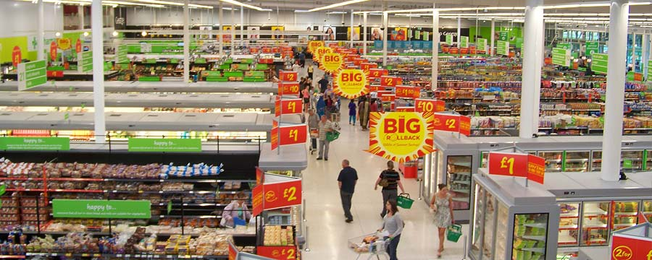
To meet these needs, as described in the previous paragraph, management of the transition of products from manufacturing to the point-of-sales is key. Achieving this by itself would ensure the smooth function of any retail organization however the whole SCM needs to embrace the same for the process to work effortlessly. From the planning of inventory, transition of products and the point of sales, SCM deals with the proper control of it all. A slight shift for the bad to any of the processes in the supply chain could cause dissatisfaction of the consumers and further lead to major risks in business.

Case Study (8)
PE Dairies gives a home delivery service for milk, dairy products, and a range of related goods. SimonHullhasrunthedairyforthepast10years. His product is a combination of goods (the items he delivers) and services (the delivery and associated jobs he does for customers).
There are several specific problems facing PE Dairies. There is, for example, some variation in daily demand, so Simon has to carry spare stock. He cannot carry too much, as dairy products have a short life and anything not delivered quickly is thrown away. Simon aims at keeping this waste down to two percent of sales. There are also problems maintaining a service during holidays or when PE has difficulties with their deliveries. Perhaps Simon’s main concern is maintaining his sales over the long-term. Demand for doorstep deliveries is declining, as people buy more milk at super markets. The number of milkmen in his area has declined from ten in 1990 to three in 2007. Most of Simon’s customers have been with him for many years, but he generates new custom by canvassing, delivering leaflets, special offers, and a variety of other products, etc.
- Describe the supply chain for milk.
Dairy supply chains link the performers and activities involved in delivering milk and milk products to the final consumer; and with each activity the product increases in value. Dairy supply chains involve production, transport, processing, packaging and storage. Activities require inputs – such as financing and raw materials – which are engaged to add value and to transport dairy products to consumers. Every one of these entities of the chain should give the product the maximum added value at the minimum possible cost.
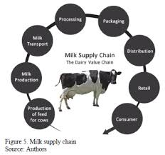
Setting up an efficient, hygienic and economic dairy chain is a serious challenge for most and in the case of PE dairies it is paramount to success. Some of the challenges faced are;
- Difficulties in establishing a viable milk collection and transport system because of the small quantities of milk produced per farm and the remoteness of production sites;
- Seasonality of the milk supply;
- Poor transport infrastructure;
- Deficiency of technology and knowledge in milk collection and processing;
- Poor quality of the raw milk;
- Distances from production sites to processing units and on to consumers;
- Difficulties in establishing cooling facilities.

- Where does PE Dairies fit into this?
Every day in the UK’s around 5,000 milkmen and women deliver products to around 2.5 million homes. They are true early birds, with most dairy rounds starting in the early hours of the morning.
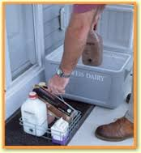
Fresh liquid milk in either environmentally-friendly returnable glass milk bottles or recyclable cartons is the cornerstone of this service, but your milkman can also deliver a large range of other goods as is the case with Simon Hull’s company PE Dairies.
Most of Simon’s customers have remained loyal over the years and it is clear to see why as his delivery staff provide an essential service, as well as being the eyes and ears of the local community. In the past they've helped customers and prevented crime and fires. This type of service is invaluable in today’s society and although demand for these types of services is declining, due to external pressure from ever expanding Supermarket chains, clearly PE Dairies are maintaining existing customers and obtaining new due to an aggressive canvassing and diversity campaign.
Clearly however if any of the identified challenges faced in bullet point one above fail, PE Dairies will also suffer in their attempts to service their customers.

- What specific activities form the logistics in PE Dairies?

PE Dairies, based on their operating strategy, are all about goods delivery and service. As a smaller concern there specialize in milk deliveries and extend to the marketing & logistics of other types of milk solids such as cheese, processed cheese, converted cheese, powders, and components, custom and combined dairy products.
The Company provides its clients with a single source for obtaining a comprehensive selection of dairy products from across the country and handles the logistics of providing the product source closest to the buyer, speeding delivery and lowering transportation costs.

The critical issues they face, in carrying out daily dairy products logistics, are similar to the logistics strategies that are employed by dairy producers around the world in so much as the importance of hygiene, cooling, time, humidity, cost, distance, flexibility and meeting the demand is cannot be overemphasized. Of course other considerations like short shelf life, quality, emulsion, and pasteurization, UHT which depend on the characteristics of the milk and milk products need consideration.
In short, the main aim in the logistics of dairy products is to enable a high standard of qualified, fresh products with a limited shelf-life. The best time for delivery of perishable products is at most 11 days as the key challenge is maximizing the remaining shelf-life.
Thus, an effective logistics strategy for their dairy products ensure and consider the logistics activities that ensure;
- shortest time
- the freshest products,
- the least cost for transportation and
- most utilized customers whom demands are met.

Daily transporting of dairy products is one way to keep food fresh. Unless the time that is spent between collections and selling is short enough, quality problems may occur.

- What are the main problems that PE Dairies has with logistics?
As detailed above, PE Dairies need to deliver the freshest products on a daily basis as the strategy is not to carry additional stock above a 2% of weekly turnover. It imperative therefore that problems are not encountered that affect logistics such as;

Cooling and Temperature:
As temperature is a significant effective on their production of bacteria, the control of milk’s temperature is a critical issue in dairy logistics. Bacterial spoilage can be prevented by controlling the existing temperature. For controlling the temperature of the environment of dairy food, proper cooling systems are obviously needed.

Time:
Time is clearly one of the most important critical issues list that contains hygiene and temperature, because with time there is likeliness for bacterial spoilage or non-freshness of a dairy product. That is why there are batch numbers and best before dates for each product. For maximizing the delivery of perfect products to the customers, the best before dates and batch numbers should be cautiously scrutinized.



Humidity
Humidity is another significant environmental characteristic for high-qualified milk production. Sometimes air might not be appropriate for milk transportation because of being too moist or dry. Moist or dry air has the probability to create a suitable condition for bacteria and other germ reproduction. However, maintaining proper air circulation inside the transportation vehicle and the needed humidity is not so easy.

Cost:
Cost is not exactly effective factor on dairy product freshness but very much so on the profit. The transportation cost, the loss from dairy products remaining after best before dates, the refrigeration cost-- all effects the entire cost manner of logistics of dairy products

Distance:
Distance is a supplementary, but critical issue according to time and cost, because time is important for the product’s transportation as it has to meet a specific best before date and cost is also significant as the amount that perishes before purchase returns to the dairy firm as a loss in that term. Thus, transportation communications are effective on the firm’s profit.

Flexibility:
Flexibility and throughput are also critical issues under the specific times. As one can have less and the other one more demand in the consecutive period of time, the logistics firm should be reasonable and easily adapted to the new demand.

Meeting demand:
After the flexibility issue, meeting demand shares great importance as the utilization of customers has high vitality. If the customer satisfaction is relatively low, the firm will lose customers and sales. Since dairy products have short shelf life and some best before dates to be projected, forecasting becomes more critical in the dairy firms’ operation. Because a better forecasting system brings greater efficiency in inventory holding, more utilization of machines will result in a high increases in firm profits. Besides forecasting, packaging is another essential issue in dairy production because packages have a crucial role on keeping the milk fresh for a long time. Last, according to the critical issues listed above, transportation vehicles should be designed or chosen according to those properties’ availabilities.
Student Statement:

By submitting this assignment, I confirm that this is my own work.

Student Signature | Raymond Wilson | Date | 9th August 2016

For Tutor / Assessor Use Only
Total Marks
Marks Obtained
Percentage / Grade

