
Assignment Cover Sheet

Student Name: | JOHN.LEE
Student Number: | 3026
Course: | DIPLOMA IN CONSTRUCTION MANAGEMENT
Assignment NO: | NO 5

Marking Criteria:
We expect the learners to write minimum one well expressed point in three lines against each allocated mark. This means one needs to write 15 lines with 5 well expressed points to get high grades for a 5 marks question.
For high grades use examples and illustrations where appropriate.
1
(I) Construction site organisation and specific work-related activity must be secured to protect members of the public, guard against theft/damage and to maintain the security of the client’s interests. Perimeter fencing as discussed in question 2 would be first priority, site accommodation, welfare, and toilet block positions would be chosen to give an all-round view of the building work as it progresses. Site roads with pedestrian segregation would be covered in the traffic management plan. Services to the site cabins (in my case hire modules specific for requirements) would be generated electric, tanked waste water under toilet blocks for w/c s and canteen sinks. (Removed on a weekly basis by tanker) and metal lockable containers for material secured storage. The Premises/Site/Operations Manager shall ensure that the minimum facilities are installed and that a suitable cleaning and maintenance schedule is arranged and adhered to. Managers must ensure that water containers marked ‘Drinking Water’ are cleaned and refilled from a portable supply regularly to ensure that the water does not become stale and contaminated. . All pedestrian routes leading to and from welfare must be free from slips, trips and falls. A tidy and well managed workplace provides a safer working environment. Plan and coordinate the delivery and storage of materials to the workface to avoid congestion/obstruction.
Ensure that areas used to store materials, equipment and waste are identified at earliest possible stage. Barrier off/segregate materials. The procurement of materials should be managed to ensure that only the minimum amount of materials are stored on site at any time. Provide adequate waste receptacles as close to the workface as possible. Identify suitable storage areas at pre-construction stage and review/update as necessary throughout the life of the project. All materials must be fully secured and stable and equipment must be stored in accordance with /supplier’s instructions.

(ii) In many cases the roads on sites will be constructed for the purpose it’s needed for. A haul roads position should be planned for easy movement of heavy plant. In the first instant a design calculations would be necessary to prove the load bearing would acceptable and safe. The calculations and road itself would then be deemed temporary works with the need for checks, and documented at regular intervals. Any movement from this road would be directed by an appointed banksman, if taken off site, signage should be in place warning other traffic. When off road an amber flashing light must also be used. Adequate lighting is needed, and segregation, to give traffic management by fencing/ barriers, again with signage and speed limit is also a must. Safety being first priority. If existing roads within site are acceptable for use then dilapidation photographic records are required to save costly reinstatement, or to cost repairs at the end of contract.
(iii)
It is important to manage the storage of materials on site efficiently to reduce the risk of damage, injury and theft.Storage and use of perishable items (e.g. bags of cement) should follow the “first in first out” rule. Protection should be used for materials that can be damaged by weather. Refer to manufacturers/suppliers product guidance to determine special instructions for movement and storage of materials. A good rule is to keep up off ground on pallets, with 400-500mm spacing from steel containers side walls with a set height of no more than 15bags, and 4 wide.
(iv) To prevent reinforcing steel i.e. Rebar or matting from rusting or scaling before being used we treat with rust seal oil, an alternative is to cement wash, these will also stop corrosion after set in concrete slabs or foundations. Structural steel would normally be delivered to site pre- primed then covered, chocked off and ground prior to fitting.
(v) With an exit / entry in place site protection can be well maintained, when a controlled barrier is in use then full protection is achieved as signing in and out of site would be necessary. If its position leads onto main roads then safety is achieved when entering or exiting the site as traffic could be directed by an appointed person

2 When planning fencing and hoarding, the following must be considered;
Nature and type of the construction work. How heavily populated the local area is,
Whether there are vulnerable people nearby e.g. children etc. rights of way, is there pedestrian routes running through site, is there any client requirements e.g. public vision panels, security arrangements, lighting requirements, access for emergency services. The requirement for perimeter security fencing for any work site is to be determined by a risk assessment. Proprietary fencing and hoarding must be erected in accordance with the instructions supplied by manufacturers, suppliers or designers. Fencing/hoardings/signage must be designed in accordance with temporary works procedure. Signage and site specific information boards along with hazard signage must be displayed. Proprietary fencing systems (including gates) must be anti-climb and measures must be taken to prevent unauthorized persons (including children) from accessing beneath fencing and gates. Ensure that there is no risk to the general public from collapse, sharp edges, splinters, protruding wire or other defects. Perimeter fencing/hoarding should be inspected daily with a recorded inspection at least weekly. A formal close down procedure of the site should be in place to ensure that the site is correctly secured at the end of the shift. A minimum 3m high fence/hoarding must be erected around the base of any tower crane with access control door or gate in place e.g. digital lock or similar. Any alterations or removal of security fencing must be authorised by site management only. Documentation needed in place for fencing would be Temporary Works design drawings. Manufacturer’s instructions. Information specific to other hazards e.g. underground services etc. A Fencing checklist example which I use on site,

SITE ORGANISTION – SECURITY, HOARDINGS, FENCING & SIGNAGE
Project:
Contract No: | Date:
Name of Person Undertaking check or safety monitoring:

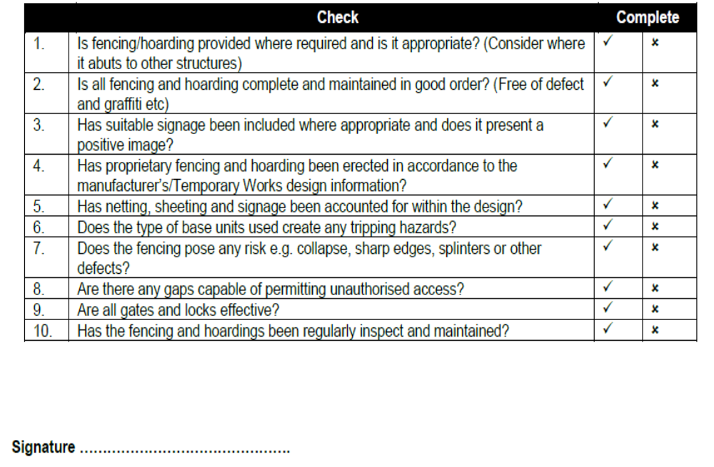

3; The provision of site electric mainly on our sites would be supplied from diesel generators, which are housed in their own separate container. They are lockable and monitored on a daily basis. Supplied from specialist hire companies, maintenance, and fuel being part of the hire agreement. From the generator container outdoor mains power leads feed the site accommodation, welfare units, toilet blocks, site lighting and any outside power points. On some occasions power is taken from the existing buildings on site if say a new extension is part of the project undertaken.

.

.

.

.

Student Statement:

By submitting this assignment, I confirm that this is my own work.

Student Signature |  | Date | 13-11-16

For Tutor / Assessor Use Only
Total Marks
Marks Obtained
Percentage / Grade

