
Assignment Cover Sheet

Student Name: | Tracy Kam
Student Number: | 3200
Course: | Diploma in Fashion
Assignment NO: | 5

Marking Criteria:
We expect the learners to write minimum one well expressed point in three lines against each allocated mark. This means one needs to write 15 lines with 5 well expressed points to get high grades for a 5 marks question.
For high grades use examples and illustrations where appropriate.
Please insert your completed assignment ( in word format) here:
Assessment 5 Total Marks: 30
Q: 1. Give short answers for the following questions: (8) I. What is meant by ‘weight and hand’ in textile industry?
Weight and hand means adding weights to various part of the fabrics , and its canbe looks bulky . Sometimes its like adding additionl stuff such as fabrics , assessories to the garments .

II. Name the warm colours. How best these can be used in dress designing?
Warm colours are red , yellow ,orange , blue , green , purple , white , grey , black , beige
Warm colors suitable for dress designing as its look confortable , fresh

III. Why it is important for a designer to consider the scale of a pattern, when using patterned fabric in dress designing?
Scale of pattern can determine the structure of the garments , as its must complement with the designs .alSO if the garment contains many lines the design of fabric must be plain .
IV. What is the difference between conventional design and geometric design?
Conventional design means when an object from nature is adopted to suit the purpose of the object and becomes decoratives , the motif ceases to be naturalistics while geometric design is not from the nature, it derived from circles , rectangle , parallel lines.

2. Define the term colour dimension. Explain the following terms; (6) Hue, value, intensity
Hue –enables to tell one color clearly to another color such as red from blue or green
Value – Refering to dark and lights variation of light strength in a color . It could run from white to black ( light to dark ). The lighter value are called tints and the darker are called shades .
Intensity –Relevant to brightness ( strength ) or paleness ( weakeness ) fo a color .Bright is considered high density while pale is low density ,

3. Write short note on the following; (6) Basic Shapes in dress designing
Shapes is defined as the outer dimensions or contour of an object It also encloses space and impacts of an object .Basic shapes in dress designing are flare or tight , circular or straight , line or raglan.The shapes could be
- Triangle
- Inverted tiangle
- Oval shape
- Square
- Round shape
- Hourglass
- Comnibations

Project

1. Look through costume books for pictures of an historic dress. Using these inspirations, design a garment using the line, shapes, colours and details from the historic garment in a new combination for our
lifestyle. (10)

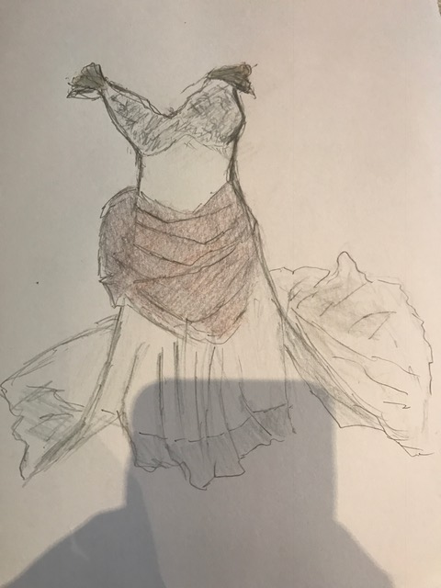historic dress , this garment is pair up with diagonal lines abd curve lines . Middle part can seen the semi curve line that follow accordingly your body shape Warms color apply on this garment such as light purple , white as make it looks more comfortable ,

Student Statement:

By submitting this assignment, I confirm that this is my own work.

Student Signature | Tracy Kam | Date | 17112016

For Tutor / Assessor Use Only
Total Marks
Marks Obtained
Percentage / Grade

