
Assignment Cover Sheet

Student Name: | TAMSANQA LEEROY NDHLOVU
Student Number: | 3093
Course: | LOGISTICS STRATEGY AND OPERATIONS
Assignment NO:

Marking Criteria:
We expect the learners to write minimum one well expressed point in three lines against each allocated mark. This means one needs to write 15 lines with 5 well expressed points to get high grades for a 5 marks question.
For high grades use examples and illustrations where appropriate.
Please insert your completed assignment ( in word format) 1)i)There are 3 different types of decisions namely Strategic,Tactical and Operational
ii) Tactical decisions are those that are taken to implement the strategies within an organization over the medium term. They focus on resource utilization and operations and involve fewer resources. They are risky but less then strategic goals.
iii)The Logistics strategy involves strategic decisions, plans and policies and culture that are related to its supply chain management.
iv)The value added strategy is a process in the supply chain comprising of a sequence of activities, each of which adds worth to the final product.
v) The 3 main factors to be considered in an Logistics strategy are 1) Higher strategies the logistics strategy should be aligned with the organisation’s mission statement and corporate strategy 2)The business environment factors which the company is not in control of such as market conditions,Technology,social conditions or Political conditions. 3)The organisation’s distinct competence which include employees,finances,Products and Technology
vi)Logistics related decisions and policies have direct impact on corporate strategy ie supply chain designs,location and size facilities and since logistics involves the major resources including storage and transport.It has direct impact on an organization performance including financial measures like reliability.
vii)The main areas that a Logistic strategy emphasizes are cost most organisations desire to achieve low costs,
Customer Service Logistics manages stock levels, speed of response, delivery times

Timing Customers usually want products in a prompt way, so a genera logistics strategy
promises fast deliveries

Quality:Customers require higher quality in all commodities.

Product flexibility:This is the capability of an organisation to tailor products to individual
specifications.

viii) A LEAN STRATEGY is reducing the whole cost of logistics while ensuring satisfactory levels of customer service.Its objectives are to do each operation using less amount of every resource.ie people,stock,space
ix) The main purpose of a LOGISTICS AUDIT are to gather pertinent information about current performance and practices of logistics, it gives an organized review of existing operations,describing the events,costs,resources,performance and all other related costs.

2)The steps involved in a Logistics strategy are Perform a logistics audit. The external audit offers a study of the business setting in
which logistics function.
The internal audit evaluates higher strategies from a logistic viewpoint but it
gives the background and larger aims for logistics, its strategic focus
Design the general features of supply chains, which are able to deliver the needed
services. This includes the design of the network, place of facilities.
Set particular goals to illustrate what every logistics activity must attain. The
internal audit depicts how well the present logistics attain these goals, and identifies areas
that require improving.
Design the most excellent organisational structure systems, and controls to hold
up the logistics network.
Benchmark logistics which review the performance of most important organisations
define methods to compare real performance with planned best, and competitors’
performances.
Execute the strategy set the circumstances for lower logistics decisions level.
Monitor genuine performance repeatedly looking for perfection keep the
strategies up to date, and present feedback.

Charlotte organizes her Logistics using a lean logistics strategy and it seems she aiming to reduce the whole cost of logistics while ensuring satisfactory levels of customer service.
Her company expansion would mean more costs in Logistics.The main problems she may face is that if there is a sudden demand for her herbs lean operation may not cope with the demand and she may need to adopt an Agile logistic operation.There will be need to closely monitor customer demands and respond fast to changes and a need to modify logistics to demands from individual customers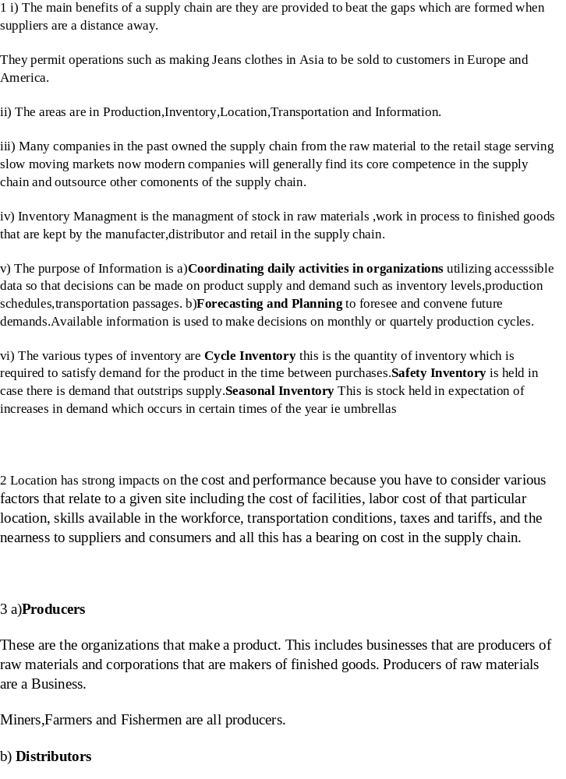re:

Distributors are businesses that take inventory in mass from producers and supply a bundle of associated product lines to consumers. Distributors are termed as wholesalers.
They usually sell in large quantities to their Customers.
Distributors are businesses that take inventory in mass from producers and supply a bundle of associated product lines to consumers. Distributors are termed as wholesalers.
c)Retailers
Retailers stock inventory and sell in lesser quantities to the common public. This business also closely tracks the demands and preferences of the consumers that it sells to. It advertises to its consumers and often utilizes some blend of price, service, convenience and product selection, as the primary draw to attract consumers for the products it sells.

The Supply Chain of milk
Milk moves through a farm, tanker collection,dairy, bottling plant, distributor, and supermarket before we purchase it.
PE Dairies is a dairy,bottling plant and distributor in the logistics chain.
PE Dairies specific activities in Logistics are Customer Service ,Demand Forecasting,Order processing,Transportation,Inventory (warehousing and storage)
The main problems PE Dairies face is in Demand Forecasting because there is variation in daily demand,and having Inventory that can support a spike in demand.

Student Statement:

By submitting this assignment, I confirm that this is my own work.

Student Signature | TAMSANQA LEEROY NDHLOVU | Date | 30/01/2017

For Tutor / Assessor Use Only
Total Marks
Marks Obtained
Percentage / Grade

