
Assignment Cover Sheet

Student Name: | Annur Zara Liyana Othman
Student Number: | 1227
Course: | Diploma of Fashion Design
Assignment NO: | 13

Student Statement:

By submitting this assignment, I confirm that this is my own work.

Student Signature | 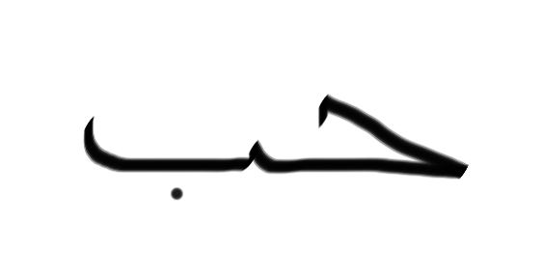 | Date | September 4th 2014

For Tutor / Assessor Use Only
Total Marks
Marks Obtained
Percentage / Grade

Sewing Basics
Unit 13 Brentwood Open Learning College
Assessment 13
1. Give short answers for the following questions:
I. What is the use of fusible webbing?
Fusible web is used for hemming or for bonding two layers of fabric together; it is available in narrow strips for hems, or in 18″ (46 cm) widths for fusing larger areas.
In other words, Fusible web is a man made fiber that will melt when heated. When placed between two pieces of fabric, the melting action of the web causes it to fuse the fabrics together. It is not woven or knitted.
Fusible web is available in rolls, similar to tape, in various widths, by the yard in the interfacing department of most fabric stores and in pre-packaged pieces.
To use fusible web, the fabric should be washed first to prevent fabric finishes from stopping the fusible material from melting into the fibers.
Always read the directions that come with the fusible web you buy! Test your iron on an inconspicuous area to prevent ruining your garment.
Fusible web is available in various weights. Use the weight that is closest to the fabric you will be fusing.
Although it may be tempting to use a heavy weight fusible on everything to make sure it stays "forever", it may seep through the fabric leaving a melted mess and it is difficult to sew through. Heavy weight fusible will gum-up the sewing machine needle.
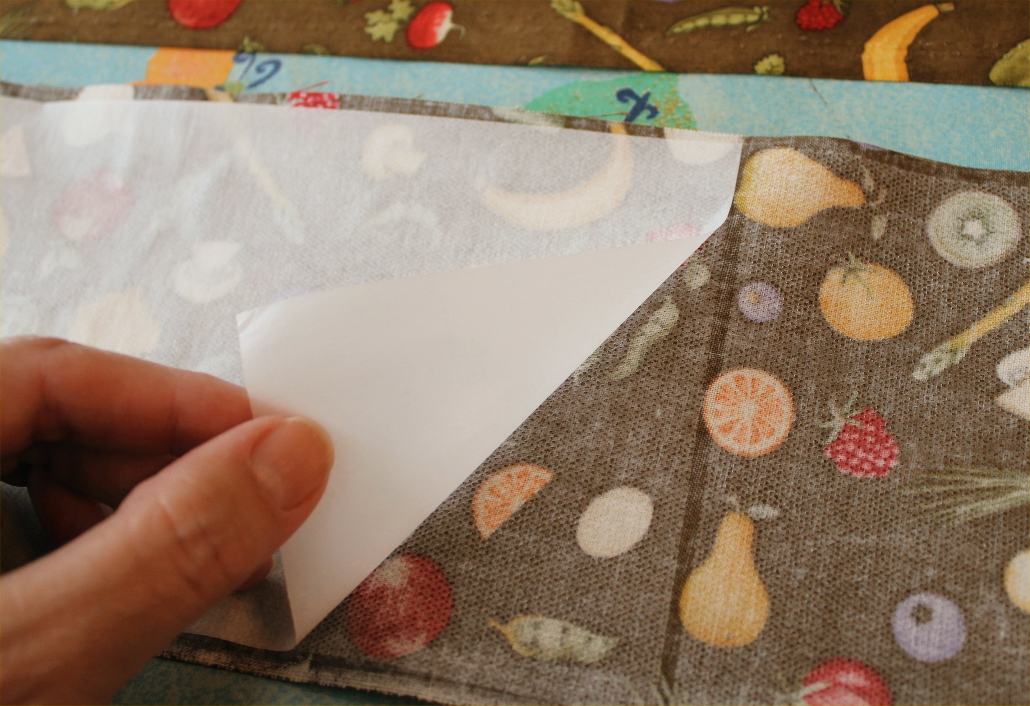
The example of fusible webbing on a fabric usage.
II. How should the fabric storage area be organized?
As a garment maker, you should have organized fabric storage. There are few options that you can choose in making it keep organize.
There are different ways to categorise your fabric:
*By Colour: whites, blues, tans, reds, greens, etc.
*By Style: plaid, stripe, toile, polka dots, floral, contemporary graphics, holiday, etc.
*By Texture: cotton, rayon, denim, velvet, silk, canvas, leather, etc.
*By Purpose: fashion clothing, crafts, etc.
Safely store your fabrics by:
*Folding neatly and place in plastic containers. Label the outside by cutting small swatches of each fabric.
*Hanging fabric in a closet with a skirt or pant hanger. Multi-tiered hangers with clips can save space and help prevent wrinkles.
*Placing smaller amounts of fabric in large Ziploc bags.
For protect the fabric from damage, you should control the room temperature.
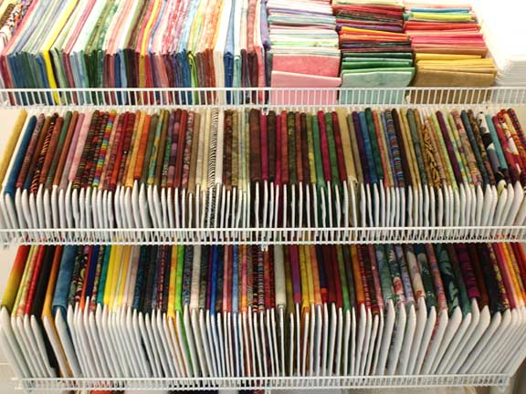
The example of fabric storage area.

III. Why it is important to have a separate storage area for storing patterns?
Its important to have a separate area for storing pattern because the pattern usually made in pieces and easy damage also easy lost. You have to keep your pattern tidy in a box or container to make sure all of the part store nicely and always there when you need them. Since its easy damage, you have to lining it nicely and put it normally in a sturdy photo box, plastic container, pretty rectangular basket ect. Also label the container based on these categories;
Style: shirts, slacks, skirts, dresses, etc.
Size: infant, children's, teens, adults
Gender: male, female
Choose one system and apply it continuously.
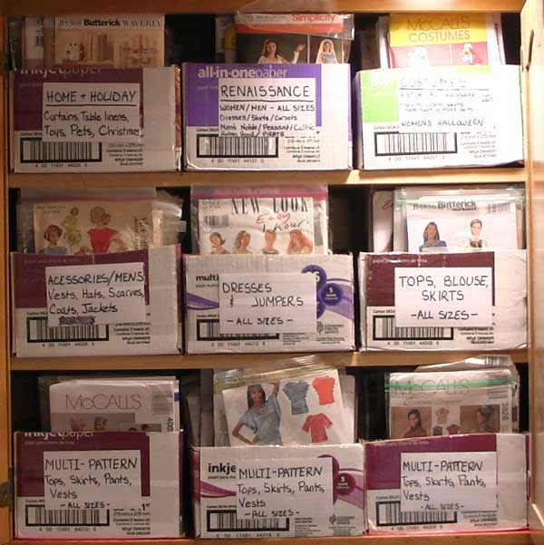
The example of pattern storing area.

IV. What is the difference between diagonal basic stitch and dress maker basting stitch?
Diagonal basic stitch
The diagonal basting stitch is a temporary measure, used to hold two or more layers of fabric together. The aim of using such a stitch is to stop the layers of fashion fabric from moving and to gain a greater control during garment construction. The stitch itself (when looked at) has diagonals of thread showing to the right side of fabric, whilst the underside shows only a series of small parallel stitches.
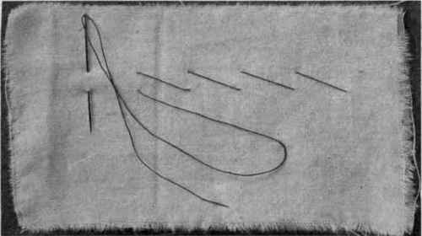
The example of diagonal basic stitch.
Dress maker basting stitch
The used is similar to diagonal basic stitch which used as temporary measure and for holding two or more layer together. But this dressmaker basting stitch can be done by take one long and two or three short stitches.
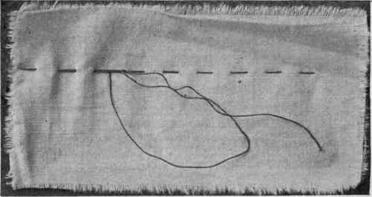
The example of dressmaker basting stitch.

2. Define the followings:
Hemming, combination stitch, back stitching, shirring, gathering, gauging, whipping

Hemming
Hemming can be defined as garment finishing method, where the edge of a piece of cloth is folded narrowly and sewn to prevent unraveling of the fabric. In hemming turn in the edge of the fabric ¼ inches, then turn second time, and baste to under fabric. A bias hemming tape may be stitched on to avoid turning hem under. Blind hemming is done like hemming but in larger stitches through the fold and only one thread on under side. It can’t be seen in the right sight. Slip stitching is done for very fine work and its visible on both side. Take up one thread on underside and fold and one on underside on fabric.
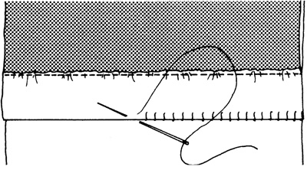
The example of hemming

Combination stitch
Combination stitch can be define as two running stitches followed by one backstitch. It is stronger than a straight running stitch, but not as strong as backstitching.
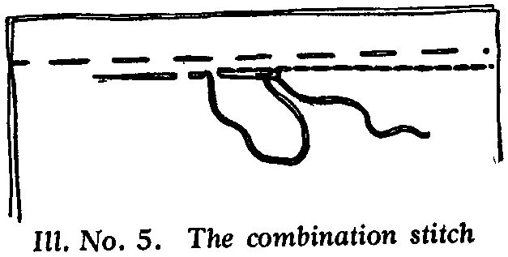
The example of Combination stitch

Back stitch
Back stitch can be define as the strongest handmade stitch. Take a tiny running stitch, go back to the end of the stitch, through to the wrong side, and out again to the right side at a distance from the end of the last stitch equal to one running stitch. Continue going back and under, being sure to work in a straight line. This stitch is a must for the important area in the garment.
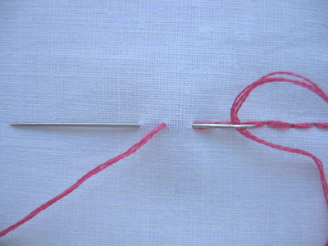
The example of Back stitch

Shirring
Shirring can be define as the effect gotten by two or more rows of gathering. Make two or three lines of running stitches not more than 1⁄4 inch apart and, holding all the ends together, gather and fasten threads around a pin.
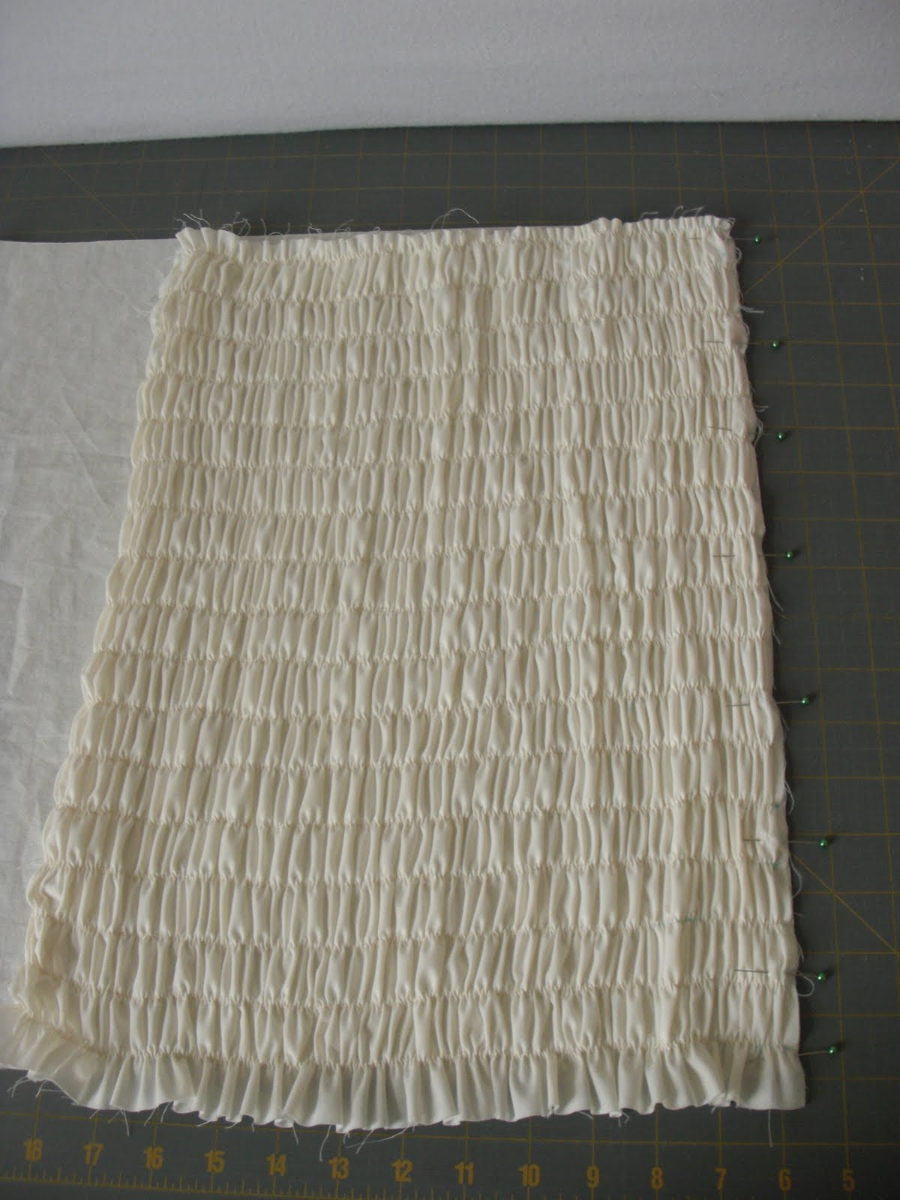
The example of Shirring

Gathering
Gathering can be define as the stitching effect. Make a row of running stitches, but at the end, do not fasten. Leave a piece of thread about four inches long, and, holding this tightly, push the material back gently so as not to break the thread. Wind the thread around a pin to hold. So then the fabric will be gather and I will give an effect that used widely in making garment.
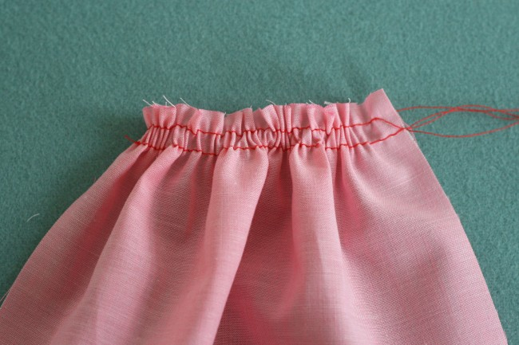
The example of Gathering
Gauging
Gauging can be define as a stitching that bring a large amount of material into a small space. Do two or three lines of uneven basting, making sure that corresponding stitches lie directly in line, one above the other. Pull up threads as in gathering and shirring.
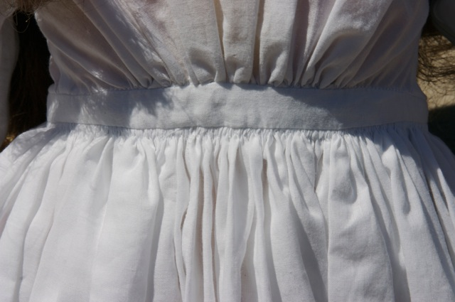
The example of Gauging on a dress.
Whipping
Whipping is the stitching can be done to get the fine finishing edge. Roll edge to be whipped a little at a time, wrong side facing you, hold roll tightly, and make tiny slanted stitches that pass under, not through the roll.
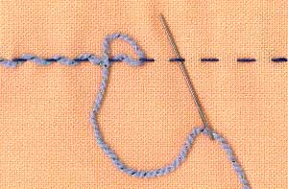
The example of Whipping

3. Explain the following types of seams and where each of the following seam is used?
Whipped seam, curved seam, strap seam, lapped hem stitched seam, tucked seam

Whipped seam
Whipped seam can be define as is used for piecing when fabric is not wide enough to cut full pattern. Be sure grain of piecing is the same as the grain of garment / sewing project, turn in edges, and overcast with tiny stitches. In other words, it used to combine two parts like to combine in front and back part on the cloths.

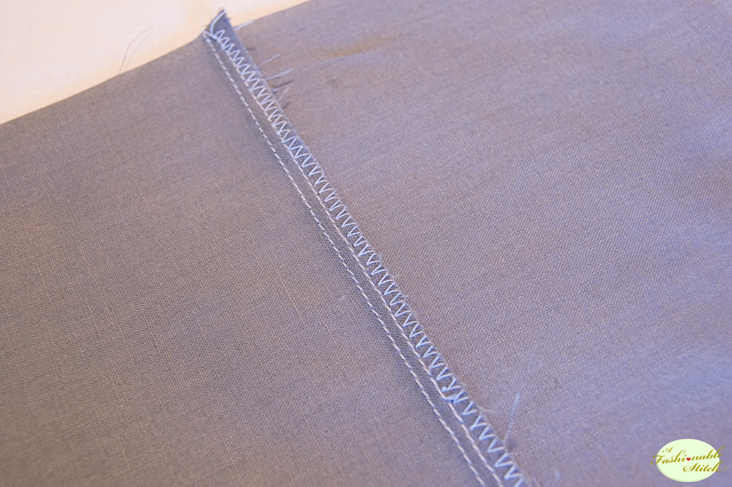
The example of Whipped seam

Curved seam
Curved seam can be refers as the seam that must be clipped or slashed in several places to make it lie flat. This is important for smooth finish. It used in the curve part like for the shoulder and sleeves part. Also apply in the curves finishing edge and the trousers.
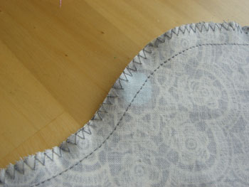
The example of Curved seam

Strap seam
Strap seam is used for decoration. Plain seam is made and pressed open. On the right side, baste a strip of material with edges turned in, and edge stitch both sides. Braid and other trimmings may also be used. Not only for decoration, it used for seal the seam.
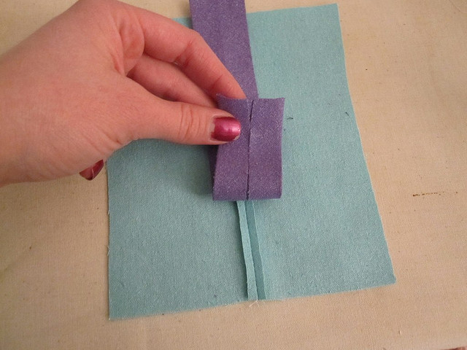
The example of Strap seam

Lapped hem stitched seam
Lapped hem stitched seam is done by lapping seams, as explained under lapped seam. Hemstitch over the basting, trim away seam on wrong side. This method give a beautiful finishing and it used to hide the seam without expose the stitch obviously.
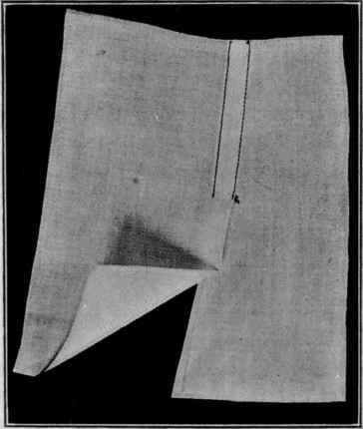
The example of Lapped hem stitched seam

Tucked seam
Tucked seam is similar to lapped seam except that the final stitching is done not at the edge, but at a distance from the fold. The effect is like that of a tuck. It widely used to make the effect of folding without using too much fabric on it. Its also popular in use for the curve part in the garment. The tucked seam will slightly make the open measure in width becoming smaller why fold and tuck it a little and make a stitch on it.
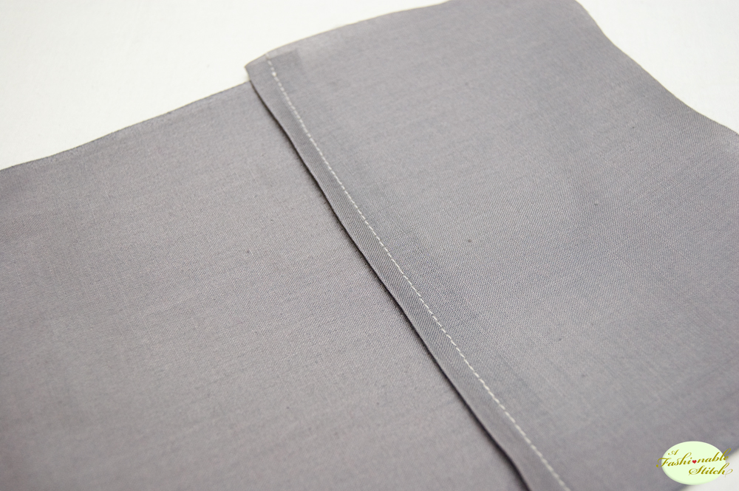
The example of Tucked seam

Reference
Information: BOLC note unit 13, Hongik University Fashion lecturers, Fashion websites, Fashion blogs, Sewing website.
Images: Google images, Fashion website, Sewing websites.

