
Assignment Cover Sheet

Student Name: | MARY NWOSU
Student Number: | 3187
Course: | Interior design
Assignment NO: | 1

Marking Criteria:
We expect the learners to write minimum one well expressed point in three lines against each allocated mark. This means one needs to write 15 lines with 5 well expressed points to get high grades for a 5 marks question.
For high grades use examples and illustrations where appropriate.
Please insert your completed assignment ( in word format) here:

An Introduction to Interior Design

Assessment 1

Question 1:

- The two main branches of interior design are residential and commercial interiors. Name at least three sub-branches in which an interior designer can specialise.
Kitchen and bathroom
Windows and draperies
Lighting

- Discuss the role of an Interior Designer.
An Interior Designer is one who improves the function and aesthetic quality of an interior space thus improving the quality of life, increasing productivity, and protecting health and safety and welfare of the people. They carry out projects that include planning the basic layout of the space and understanding of technical issues such as lighting etc. An Interior Designer places more emphasis on Planning, functional design and effective use of the space. When planning a space, an interior designer is expected to consider the building and life safety codes; understand environmental issues and the basic construction and mechanical systems of the building.

- Briefly describe the sequence of working procedures in a residential project.
Residential projects are for private residence. It could involve a whole residence or part of one. A residential project usually follows a sequence of working procedures as stated below:
1. Careful interviewing to establish the client’s programme and budget.
2. Developing design concept.
3. Obtaining client’s approval for that concept.
4. Making estimates.
5. Making authorised purchases.
6. Supervising and installing.
This job may include planning, designing, executing and furnishing a complete private house or apartment or only a specific room or part of the room. It may also include consultation to technical services on painting and wall covering schedules, color coordination and also specifications for specially built units, Developing layouts or floor plan. Consulting with architects and craftsmen as well as producing other presentations and drawings.

- What should an interior designer know in order to develop a clear idea about the function of a room?
In order to have a clear idea about the function of a room, a designer would have to know the purpose for which the room will be used and is being planned for i.e. what it is needed for, would it be a guestroom, utility room, a Nursery or a ballroom. How the room would be used and who will use it. The function of a room is about practicality, comfort and the detailing which are required in the room.

- When planning an interior design scheme, how important it is to consider a mood for a room. What it is actually?
Mood relates to how an individual wants to feel when in the room thus the effect of a room. Mood could also be referred to as the atmosphere of the room. A room could either have a relaxing, cool or cosy feel to it. The mood of a room depends greatly on the function of the room as well as the climate one lives in. Lighting, colours and texture have a great effect on the mood of a room, a bright light in a room sends a different feel to a subdued light and so does a bright or neutral colour hence it is important to pick the right colours and light to fulfill the requirements of the mood that is actually required.

Q.2. What is the difference between residential and commercial interiors? How the interiors of the following areas differ in both of these setting;
Residential interiors refers to private places whereas commercial interior has to do with public areas, here, a designer plans and designs spaces in commercial areas and businesses, this branch of interior is vast and broad, it ranges from banks to shopping malls, factories and hospitals.

- Bathrooms
The functions of a bathroom and how it would be used in a residential space is different from those from a commercial space. A commercial bathroom is a high traffic area thus must be designed to fit that purpose. For example, the number of people using the bathroom in a stadium during a major game would defer from users in a small clinic or those in a family house. Understanding this would help decide how large it is going to be, the number of toilets and urinals, sinks, hand drying fixtures and the rest. Commercial buildings are usually larger (See picture below) than residential hence require greater responsibility for safety and structural integrity.

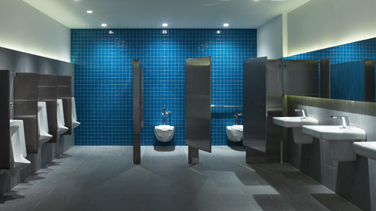
Commercial bathroom

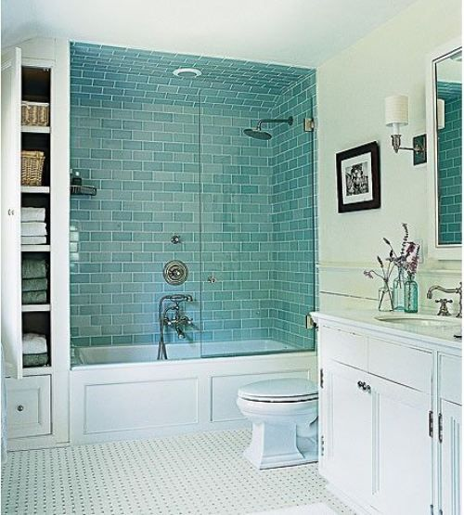
Residential bathroom.

- Sitting areas

A sitting area is a place where several people can sit, as mentioned above, design is determined by its function. The major difference would be in the number of people i.e the size. A sitting area is a residential home is denoted for comfort, often smaller and a lot cozier formed by sofas whereas a commercial area, might be small or large depending on its purpose, mostly formed with a number of armchairs.

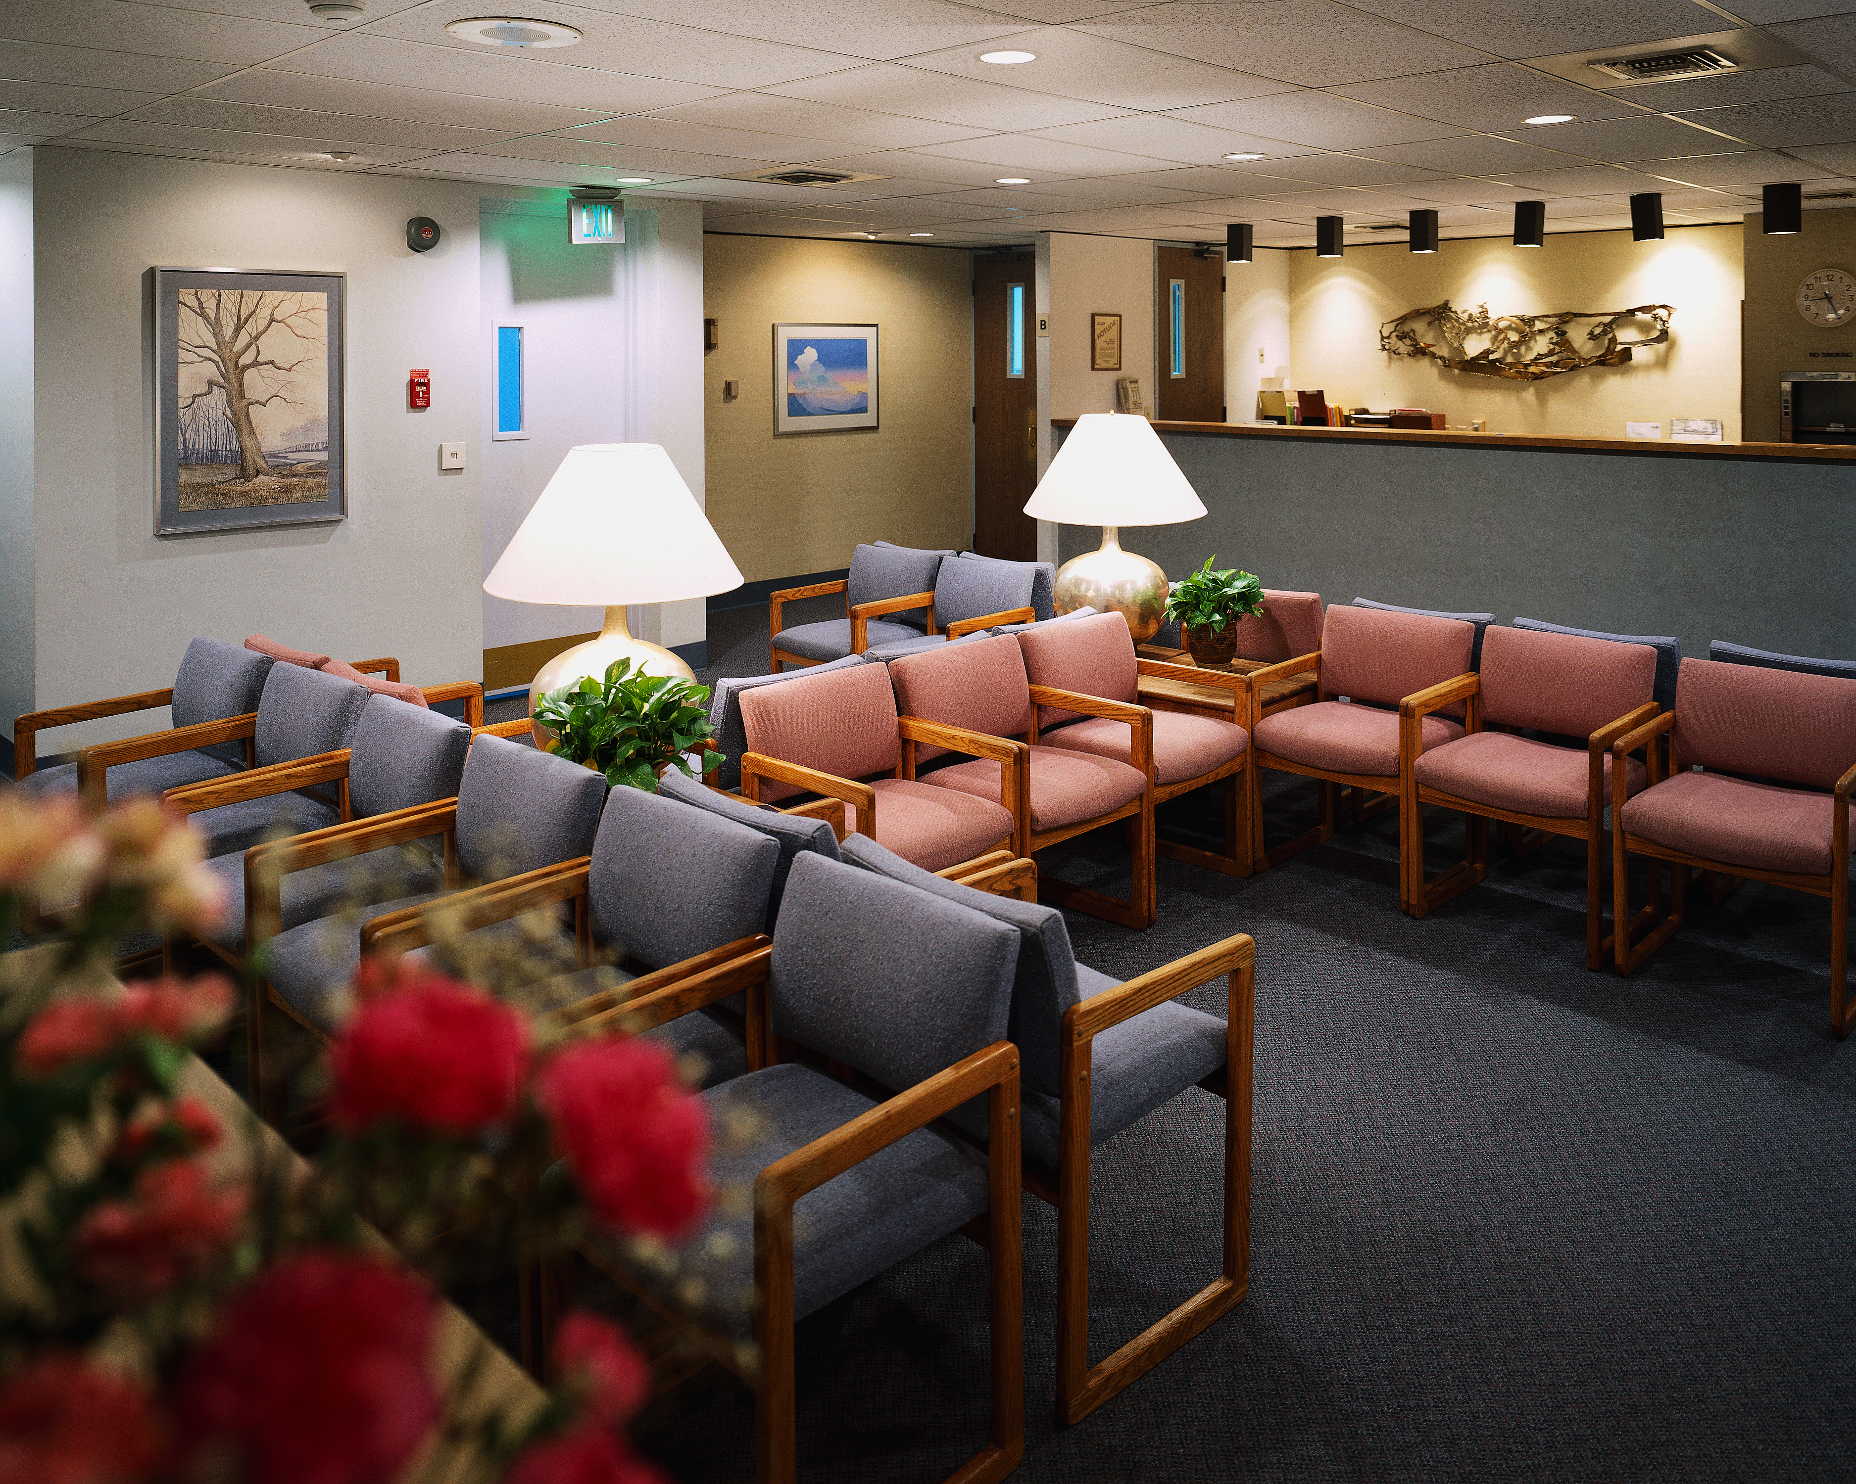
Commercial waiting area

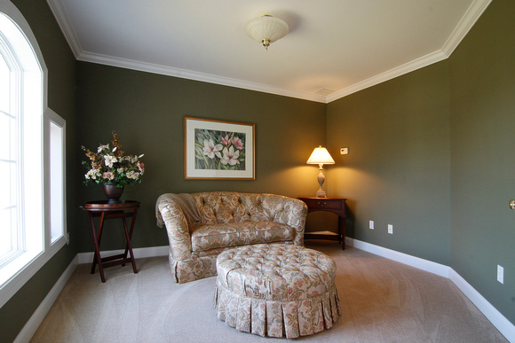
Residential waiting area

- Cooking areas
In a commercial cooking area the size of the restaurant, hospital or hotel is also taken into consideration, the type of equipment’s and appliances used are much larger than residential kitchens (see pictures below) additionally, kitchen layout differs from residential design, movement patterns to allow free flow is considered in commercial kitchen, more gas outlets, multiple sinks etc safety is taken seriously in commercial kitchens there are also health and safety requirement an interior designer must take into consideration.

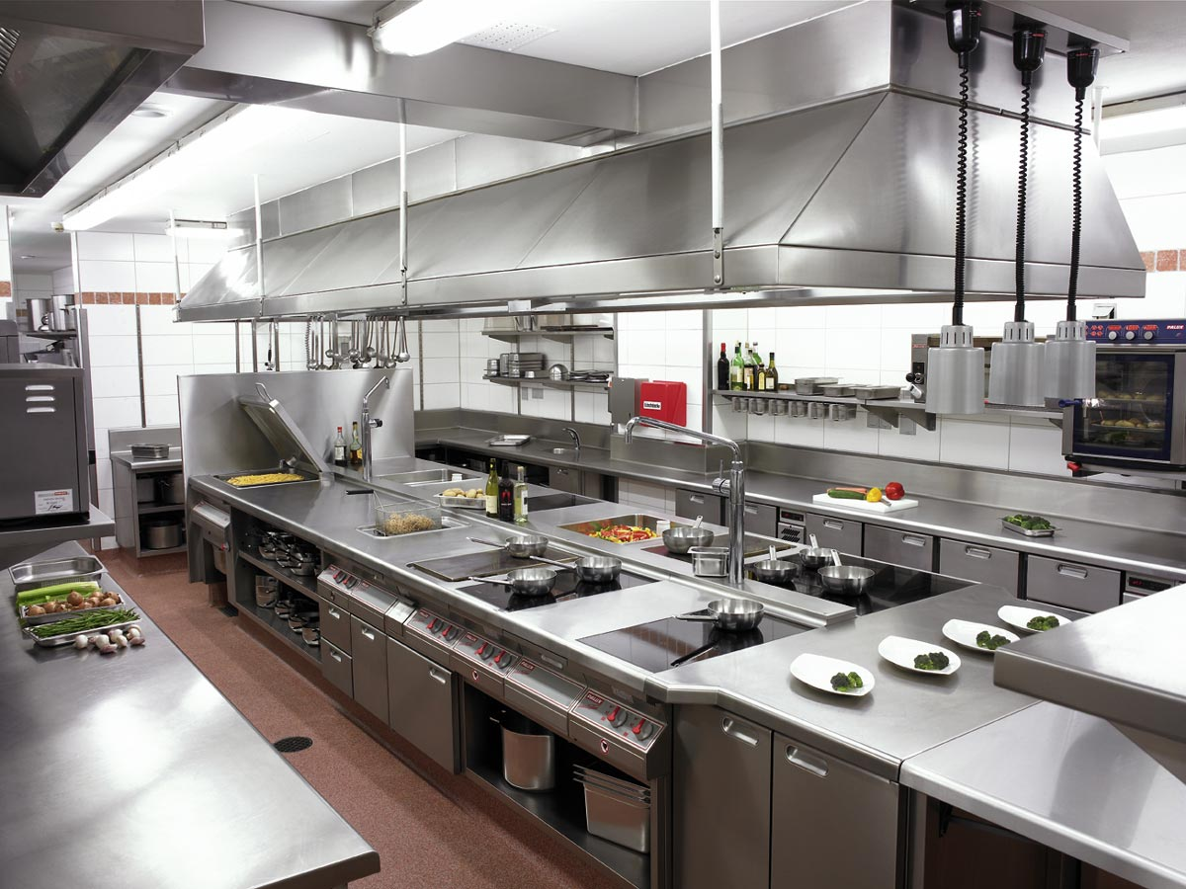
Commercial kitchen

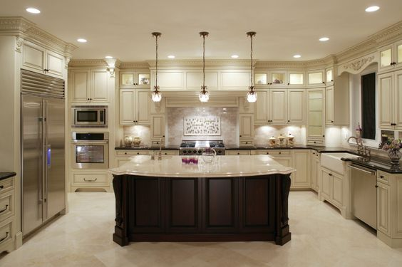
Residential kitchen

Case study (7)
George is an interior designer; his specialised field is residential interiors. He has received a call from a potential customer who wants to redecorate his house and wants to discuss this with George. Their meeting has been scheduled for the next week. If George gets this project what in do you think would be the sequence of working on this project? Re-write the stages of the project given below to show how exactly these will follow each other in the project.

• Careful interviewing to establish the client’s programme and budget
• Developing a concept
• Obtaining client’s approval for that concept.
• Making estimates
• Making authorised purchases
• Supervising and installing

Student Statement:

By submitting this assignment, I confirm that this is my own work.

Student Signature | MARY NWOSU | Date | 07/11/2016

For Tutor / Assessor Use Only
Total Marks
Marks Obtained
Percentage / Grade

