
Assignment Cover Sheet

Student Name: | John Wozniak
Student Number: | 2725
Course: | Level 4 Diploma in Construction Management
Assignment NO: | Ten

Marking Criteria:
We expect the learners to write minimum one well expressed point in three lines against each allocated mark. This means one needs to write 15 lines with 5 well expressed points to get high grades for a 5 marks question.
For high grades use examples and illustrations where appropriate.
1.1 Vendor management is a discipline within a purchasing arm of an organisation that involves the buying of specialist materials plant and equipment. It is highly plausible that the vendor management team must acquire the aforementioned items from overseas. The Space Program is an excellent example of this, where materials are not readily available. The Vendor Management Office is likely to work closely with a company’s legal team.

Components of Vendor Management are;

- Choosing the Right Source. The vendor must be able to demonstrate that the purchasing orders can be fulfilled as to the client requirement, right price, right quality. There are many examples of when this element of VM goes wrong. Honda had to recall thousands of its cars due to faulty airbags (Bloomberg, 2016). Those airbags were manufactured by Takata, an automotive parts company.

- Identifying the Right Source of supply. This process will determine which suppliers are best to meet the company’s requirement and expectation. Ensuring the this process is effective will mitigate against the risk of failure, both from a financial and reputation view.

- Selection a source. This process is will be determined by the company’s own strategy. A number of questions should be asked in order to determine the best source, including;
  - How many suppliers are needed?
  - Are suppliers reliable?
  - Do suppliers provide value for money?
  - Does the supplier have financial security?
  - What deals are likely to be made in order to give a competitive advantage?
  - Is a long-term partnership likely to be fostered?

- Vendor Registration and Development. A Pre-qualification Questionnaire (PQQ) will be sent to all prospective suppliers, this will provide assurance that suppliers understand what is expected of them.

- Vendor Rating. A process used to determine a ranking system for each prospective supplier. This is a subjective process based on the qualification criteria that is set out and form part of the overall Corporate Governance policy. The ratings can be populated in a table of graph to give a visual representation. Such information can be used to determine which suppliers are preferred and which suppliers should be avoided.

1.2 Macro and Micro factors should be taken into account when identifying the most appropriate supply chain. Questions must be asked such as; Are sources being procured internationally, and if so are there any political implications with that prospective supply chain? If procurement is being carried out internationally what is the market forecast with regards to the exchange rate etc? On a micro level the supplier must be scrutinised for pre-qualification, a number of factors include;

  - Obtaining past records including financial statements.
  - Records on delivery
  - Level of expertise of supplier’s production staff
  - Recommendations from other businesses
  - Are suppliers accredited – for example ISO 9001

One supply chain factor at the front of every business leader’s mind is one of ethics. Questions are being asked about the transparency of that supply chain.

1.3 There are several definitions of Vender Rating. The Cambridge Dictionary sums it up as a measurement of how good a seller is, based on the opinions of customers:
Vendor Rating is a formal process conducted by the Vendor Management Organisation. Building the framework for the criteria for evaluation;

- Pricing Factors
  - Competitive pricing, are they competitive with other vendors?
  - Stable pricing, do prices remain the same or do they fluctuate?
  - Accuracy of pricing, what are the variance from purchase orders to invoices received?
  - Billing cycle, what is the time between delivery to a bill being initiated?

- Quality Factors
  - Compliance, is the vendor complying with the terms and conditions in the purchase order?
  - Support, what first and second line support is available and how long into the lifecycle of that product does it last for?
  - Reliability, how reliable is the product? Are there any case studies supporting claims of reliability?
  - Warranty, what is the length and provision of that warranty?

- Delivery Factors
  - Time, is the vendor able to deliver the product on time?
  - Lead time, what is the lead time required for each product?
  - Packaging, what is the standard of the packaging and are there any specific material handling instructions that must be adhered to?
  - Documentation, is the necessary documentation present with each item?

- Service Factors include technical support, agreed resolution policies and the quality of vendor reps, are they able to handle complaints in the right manner and with professionalism?

Disadvantages to the Vendor Rating process boils down to the ‘human’ element. Have all questions been posed carefully. Has the vender answered each question honestly? Are the decision makers able to make an objective decision without favouring anyone vendor or a favourite vendor?

1.4 ISO 9001 companies undertake a rigorous process of developing their Quality Management System (QMS). This is an International Industry standard and provides a consistent framework for performance, reliable service and continuous improvement. The British Standards Institution (BSI, 2016) argue that out of 82% of companies that embraced ISO 900, 57% attracted new customers and 66% improved quality of their products.

Companies with an ISO 9001 accreditation can provide assurance that an integrated approach to business is visible, including leadership and risk management and improvements are made through internal auditing.

Companies without the ISO9001:2008 or ISO9001:2105 accreditation can’t claim to demonstrate the aforementioned attributes and frameworks.

1.5 The legal aspects of purchasing and procurement must be understood to prevent financial penalties, protect the integrity and reputation of the business, to ensure that compliance is being met through contracts with third parties. The purchasing official must understand that they have no personal liability providing that the all legal requirements are met.

2. Training underpins everything that is executed within a company. The learning curve in figure 1 (below) illustrates that the more and individual spends on a task the more proficient that individual becomes.

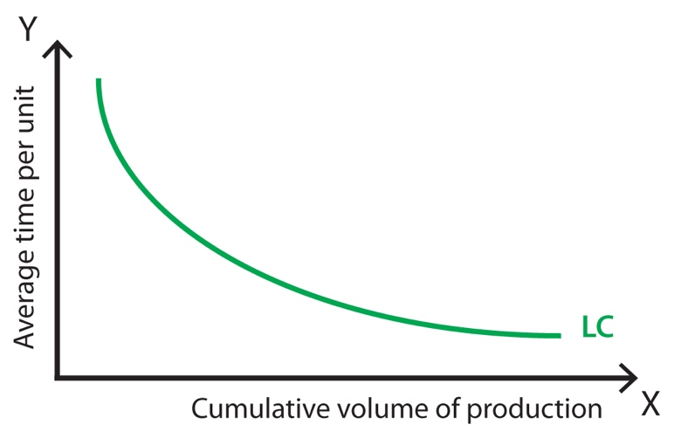
Figure 1 - The Learning Curve

Training Needs Analysis (TNA) should be conducted to understand the task and the process that an individual/s must go through in order to be proficient at that task. The TNA will identify as to whether or not the company can deliver the training or whether or not it must be outsourced.

A good learning and development policy framework will identify ways to shorten the learning curve. That may be achieved in a number of ways, including, On The Job Training, bespoke courses and trial and error.

Take example manual handling, such training can not only eliminate personal injury but it can provide assurances that materials are not damaged in the process, which in turn has a knock on effect on material costs.

Estimates should be made into whether or not certain approaches to shortening the learning curve are cost and time effective. Capturing lessons identified is one method to identify improvements.

The overall aim for any company is to ensure that its employers reach the optimum level of employment at the earliest opportunity. Work place inductions often provide the benchmark for all training requirements.

Student Statement:

By submitting this assignment, I confirm that this is my own work.

Student Signature | John Wozniak | Date | 27 Nov 11

For Tutor / Assessor Use Only
Total Marks
Marks Obtained
Percentage / Grade

