
Assignment Cover Sheet

Student Name: | FATIMA CRUZ
Student Number: | 3537
Course: | DIPLOMA IN BUSINESS ADMINISTRATION
Assignment NO: | 2

Marking Criteria:
We expect the learners to write minimum one well expressed point in three lines against each allocated mark. This means one needs to write 15 lines with 5 well expressed points to get high grades for a 5 marks question.
For high grades use examples and illustrations where appropriate.
Please insert your completed assignment ( in word format) here:

- Define the term “Management”.

It is defined as the process of organizing and coordinating different activities in a business in order to achieve its goals, together with the people inside the organization, with given sufficient time and resources. It is also the process of making decisions for the company, from the smallest decision to make until the most complicated and crucial decision. It is how the people forecast/foresee everything around their business to reach its success.

- List different levels of management.

Lower-Level Management
- Report to Middle Management
- Work should be executed on time
- Responsible for achieving the best services of the organization
Middle-Level Management:
- Report to Top Management
- Supervise first-line managers
- Manages resources and give tasks to lower-level
Top-Level Management:
- Setting goals for the whole organization; for each department
- Conceptualizing ideas and ways how to achieve these ideas
- They Plan, decide, and take control of everything in the business

- Define the term “equity” as a principle of management.

Equity motivates the employees to work and perform their duties and responsibilities. This will illustrate that if an individual has a high perception of equity, the more he or she will be motivated to work, as he or she sees fairness in their workplace. He or she will be dedicated to work as the company treats everybody with fairness and justice. Otherwise, if an individual perceives a low level of equity or fairness in the workplace, he or she will be demotivated to work, which may result to low level of quality towards his or her work. For example, employee A has a higher salary and gets a lot of benefits but he or she has less workload than employee B who has a low salary but has more workload. This shows that the company is favourable of employee A than employee B, and it may result that employee B will resign or leave the organization. This also demonstrates imbalance of work load and compensation they get from the company.
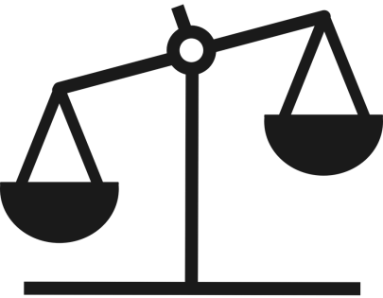
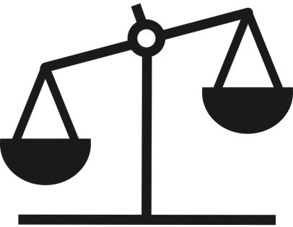
Employee B
Employee A

Work
salary
load
salary
Work
load

- State the various functions of management.

Planning
- Determining the goals to achieve
- Setting up the time frame, budget, and resources in order to achieve the goals
- Arranging of ways how to achieve the goals
Organizing
- Manager gives tasks to the team
- Work distribution
- Manager will control and supervise the team member’s work if the work is being executed as per the goals set
Coordinating
- Coordination within the team is crucial as they will be able to check if there are some conflicts in the tasks given to them.
- There should be harmony in working to avoid problems in the future
- Communication is very important in all relationships. Thus, good communication in work place will be a great help to have a successful job

Controlling
- The manager assures that the quality of his team members are in line with the goals they set
- He must ensure that the quality of work is aligned with the company’s standards
- Match the expression given in column 1 with These given in column 2
Column 1 Column 2
a) Management as a discipline i) team of managers
b) Management as a process ii) code of conduct for professionals
c) Management as a group iii) developed and grown through practice and Research
d) Management as a profession iv) series of inter-related activities

i. The following table contains the function, position and different levels of management.
Pick one from each column and make a meaningful combination.
Levels of Management | Positions | Functions
- Top | b) Board of Directors and Chief Executives | (iii) Defining the objectives and formulating the policies
- Middle | - Departmental heads and Manager | - Identifying the departmental objectives and guiding lower level towards achievement of those objectives
- Lower | c) Supervisors and Foreman | - Carrying out the operations and their supervision

Q.2. “Planning is looking forward; whereas controlling is looking back”. Explain the statement.

This quote means that when you plan something, you look forward to its results. But in controlling, you have to look back as you might have done wrong during the first few steps, that you might have overlooked and you were not able to double check. Planning is just the beginning of everything, where a businessman set goals and ways to achieve the plans, but, on the other hand, this is not the end of everything. You have to control towards its achievement with the help of contingency plans. For an example, an event coordinator is planning a wedding event. She is planning it very creatively and extravagant so her customer will be satisfied, but during the execution of the plans, some areas failed to perform due to some reasons. Thus, she has to control these activities by looking for other options or suppliers. A businessman has to recheck the previous stages so the plan will be successful.

Case Study
The directors of Vision Tech have reorganized their business. William Davis is now Chairman, Vijhay Singh finance manager, and Irene Rogers is the floor in charge (supervisor). Keeping in view the above situation answer the following questions:

- What is meant by the hierarchy of management?

Hierarchy of management is the organizational structure in a business, which has respective power and authority for each level. This hierarchy separates the authority and responsibilities in the company. Every organization has to establish an organizational structure to keep a harmonized working place as it gives description to each employee what are their functions as imposed in their position. It is also called as the “blue print” of the company’s employees and their job titles. This hierarchy maintains the integrity of the professionals.

Management hierarchy forms a path of accountability for each action in the company. This is not to point anybody to blame, but rather, escalate the problem to the right person in the company who should be responsible for those problems. Hierarchy also helps the employees to guide one another to develop their competencies towards career development and growth. Also, hierarchy shows career paths for the employees for them to achieve their goals and unleash their potential in being one of the corporate leaders. This will be used as career ladder for them to reach their position they want to attain in the future.

- How does William Davis know about any problem on the factory floor?

As William Davis is the chairman of the company, all of the employees under him will report to him about the updates regarding their business. He has the right to know the updates from his subordinates. As per the function of top level management, they are setting the goals to achieve and they assign the activities accordingly. Hence, they have to identify if these goals are being achieved or not so they can control it and take actions. The manager might have reported the problem in the factory floor to the chairman.

- Who determines the objectives for the business?

William Davis as he is the chairman of the company, who determines objectives for the organization.

- Who will ensure that the work is carried out properly and on time?

Irene Rogers as she is the supervisor and supervises the rest of the employees under her. She needs to oversee the employees if they are executing the work in alignment with the goals set by the management. She will supervise and orient the employees according to company’s standards. She has to use the resources wisely without compromising the results.

Student Statement:

By submitting this assignment, I confirm that this is my own work.

Student Signature | FATIMA CRUZ | Date | 12 DECEMBER 2016

For Tutor / Assessor Use Only
Total Marks
Marks Obtained
Percentage / Grade

