
Assignment Cover Sheet

Student Name: | Rachael Boon
Student Number: | 1501
Course: | Diploma in Fashion Design
Assignment NO: | 7

Marking Criteria:
We expect the learners to write minimum one well expressed point in three lines against each allocated mark. This means one needs to write 15 lines with 5 well expressed points to get high grades for a 5 marks question.
For high grades use examples and illustrations where appropriate.
Q: 1: Give short answers to the following questions: (20)
- Which type of materials should be chosen for the dress of a thin person? And when choosing a stripy print which type of stripes would you recommend for the dress of a thin person?
A thin person would have many options on which materials they could wear. However they have to choose fabric that does not cling to their figure, for example silk or satin which reflect the light, and materials that add volume to the figure standing out from the silhouette. When choosing a print with stripes for the design, it is important that the stripes are horizontal to widen the silhouette rather than elongating the figure. I think a wider stripe with contrasting colours, e.g. navy and white, would be best suited creating an illusion and drawing the eye across the body.

- How would you design a dress for a person with large waist and hips? Which designing techniques would you apply? (5 marks)
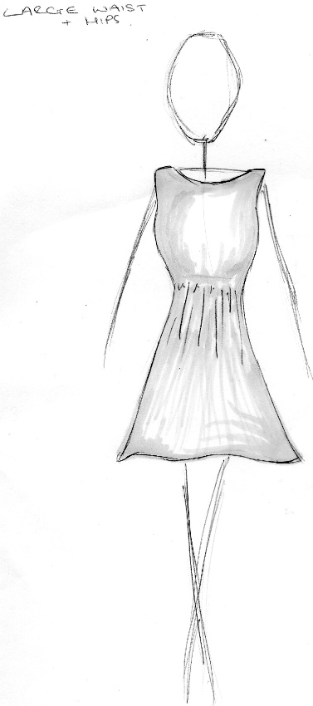
When designing a dress for a person with large waist and hips I would emphasise the centre of the dress, maybe with a light block colour surrounded by a darker panel either side. I would then have a flared skirt, starting slightly lower than the natural waistline, drawing the eye back out away from the waist. (illustrations)

- 'A person with stout figure must never try wearing a dress which is too tight for him/her'. Discuss ( 5 marks)
It would be unsuitable for a stout person to wear a garment too tight for them. The fabric would cling to the body and create and unflattering silhouette. Lighter, less clingy fabric would be more flattering as it would brush over their shape and create the illusion of a more hourglass figure. Dull and dark colours would be most suitable. Whilst a dress too tight would be less flattering, a lightly fitted dress would make the silhouette flow better, adding weight to the bottom half and creating a balance.

- How would you design a dress for a person with round shoulders so as this is less noticeable.
(5 marks)
If I were to design a dress for someone with round shoulders I would have set in sleeves, putting the shoulder seam about half an inch back from where I’d normally put the shoulder line. I would use a short collar to fill out the space between the neck and the beginning of the curve. This would be directly above a vertical panel going from the neck to the waist, drawing the eye inwards and down away from the shoulders. (illustration)
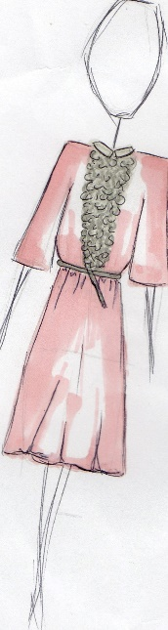

Activity

Make a collage of the pictures from a magazine, people wearing dresses unsuitable for their figures. For each picture explain how this could have been designed correctly for that person’s figure. (10)
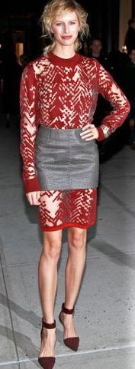
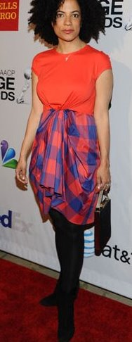
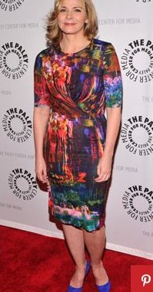
1. 2. 3.

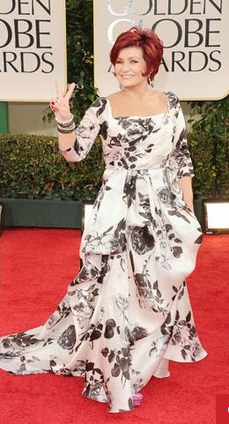
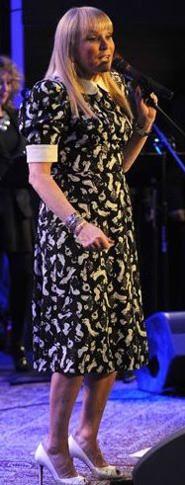
4. 5.

In picture 1, the silhouette of the dress itself is suitable for Kim Catrell’s bodyshape, however I would not have used the fabric with a pattern such as the one in this design as it is too ‘busy’ for the dress. Kim has curves anyway, so by using a busy fabric I feel it draws the eye in all directions across the body making it appear larger, rather than accentuating her assets. I would have used a plain or darker fabric, for the whole dress or even just around the waist and stomach areas to draw attention to her hourglass figure.
In picture 2 I feel the dress is completely wrong for Angela Weiss’s figure. The bold colour blocking paired with the strong check on the skirt makes to eye drawn to the bottom half of the body. Whilst this isn’t always a bad thing, the roushing in the centre of the dress draws attention to the stomach area. I feel the jaggered line around the waist is not flattering and doesn’t make the most of Angela’s figure. If I was to design this dress again, I would have the bottom of the dress in a darker or plain colour. I might also bring the gathering to the side to draw the eye across the body instead of out at the front.
I would change the fit of the dress in picture 3, to cling to Koralina’s figure. Her petite frame is lost with this dress as the pattern is too busy as well as the dress not quite fitting her arms and thighs properly. Even though this might have been Koralina’s aim, I feel her shape is hidden and with the bottom half as one piece of fabric and fitted sleeves it would create the illusion of an hourglass figure.
Jackie Deshannons dress in picture 4 is a very traditional style of dress. However I feel the problems with this dress on her figure are at the top. The bold sleeves and collar draw attention to her upper body, broadening her shoulders. This coupled with the bold pattern of the fabric, draws the eye outwards at the top then straight down creating the illusion of a broader figure. If I were to redesign this dress I would take the white off the shoulders and bring the waist in using thin elastic at the empire line, creating an hourglass figure.
The final picture of Sharon Osbourne is completely wrong for her petite frame. The angular neckline doesn’t flow with the way the dress falls on her body creating almost 2 dresses. The fuller textured skirt of the dress hides any shape that Sharon Osbourne has underneath it. If I were to redesign the dress I would have a rounder or even plunging neckline and have less fabric at the bottom of the dress. I would also make it slightly shorter just reaching the floor, to elongate her leg.

Student Statement:

By submitting this assignment, I confirm that this is my own work.

Student Signature | RACHAEL BOON | Date | 18/04/2016

For Tutor / Assessor Use Only
Total Marks
Marks Obtained
Percentage / Grade

