
Assignment Cover Sheet

Student Name: | Raymond Wilson
Student Number: | 2362
Course: | Diploma in Logistics and Supply Chain Management
Assignment No: | 6
Marking Criteria:
We expect the learners to write minimum one well expressed point in three lines against each allocated mark. This means one needs to write 15 lines with 5 well expressed points to get high grades for a 5 marks question.
For high grades use examples and illustrations where appropriate.
Assessment #6 Total Marks: 30

1. Give short answers for the following questions: (14)

- What is the ‘facility management’ about?

Facility management (or abbreviated commonly as FM) is a management discipline concerned with the integration of processes within an organization to maintain and develop agreed services which support and improve the effectiveness of its primary activities.

Primarily the most important decision that starts this whole management process of is location. It is paramount that a facility is located in the correct location as typically it expensive to shut down or to construct a new one if wrongly located.

The drivers for this therefore are making the decisions in the following three areas;
- The role the facility will undertake
- What capacity is required (allowing for future growth requirements)
- The allocation of suppliers and suitable markets for each local

Once the above decisions have been made, ensuring all variables have been considered and analyzed, the FM as a business function has the objective to coordinate demand and supply of facilities and services within either the public and private organizations. The term “Facility” means something that is built, installed or established to serve a purpose, which, in general, is every “Tangible asset that supports an organization.” Examples of which are real estate property, buildings, technical infrastructure (HVAC), lighting, transportation, IT-services, furniture, and other user-specific equipment and appliances.

Generally FM covers two main areas: 'Space & Infrastructure' (such as planning, design, workplace, construction, lease, occupancy, maintenance, furniture and cleaning) and 'People & Organization' (such as catering, accounting, HR, IT, marketing, hospitality etc.).
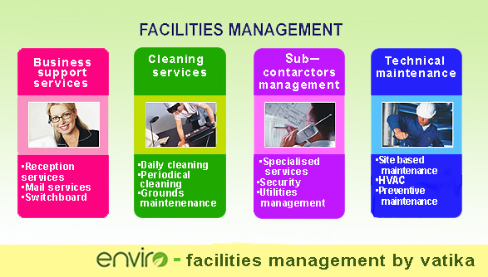
FM may also cover activities other than business services, as illustrated in the VATIKA web page extract above, and these are referred to as non-core functions, and vary from one business sector to another. FM is also subject to continuous innovation and development, under pressure to reduce costs and to add value to the core business of public or private sector client organizations. Facility management is supported with training and professional qualifications often coordinated by FM institutes or associations, and formal degree programs exist at undergraduate and graduate levels.

- What is meant by the term ‘milk run deliveries’?

Cyclic goods deliveries, also called Milk-run, originates from northern pastures of the United Kingdom and is a method of transportation and delivery, which was created for solving the problems of transportation and delivery of milk. Trucks transported bottles filled with milk to every gate in accordance with the routes predesigned by the law of intelligent vehicle path planning and collect the empty bottles on the back way to milk house. Nowadays this goods-taking scheme is applied to production, distribution, and other activities in logistic based businesses around the world as illustrated below;

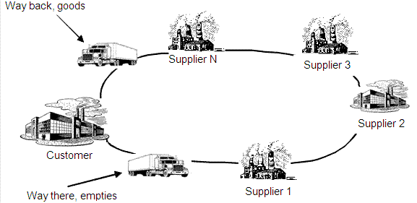

A predetermined route is designed based on customer demand and along the way there are pickups and drop offs/deliveries. This can also be done in secondary distribution as required (e.g. smaller trucks deliveries to small stores, or parts deliveries to dealers).
A small scale milk run business model can yield small and stable returns.. but things get more complicated when this model is expanded . This business model is also done at a Less than Truckload (LTL) and parcel delivery and courier companies, although they tend just to be called routes in a network and not necessarily milk runs.
Alternatively in a Full Truckload (FTL) model, carriers operate on a point to point business plan where they have long-term contracts with a third party logistics company or shipper -- and therefore have diversified their risks. Additionally, many FTLs pursuit full or partial freight loads to add additional revenue when it makes sense -- IE the variable costs can be covered and/or when there is the possibility to introduce themselves to new potential customers. There is more flexibility in the FTL business plan to leave trucks idle.

- What is meant by the term ‘reverse logistics’?
Reverse logistics covers all operations related to the reuse of products and materials. It is in reality the process of planning, implementing, and controlling the efficient, cost effective flow of raw materials, in-process inventory, finished goods and related information from the point of consumption to the point of origin for the purpose of recapturing value, rebate or proper disposal. Remanufacturing and refurbishing activities also may be included in the characterization of reverse logistics.
The reverse logistics process includes the management and the sale of surplus stock as well as returned damaged, defective or poor quality products. Normally, logistics deal with events that bring the product towards the customer. In the case of reverse logistics, the resource goes at least one step back in the supply chain. For instance, goods move from the customer to the distributor or even to the manufacturer.
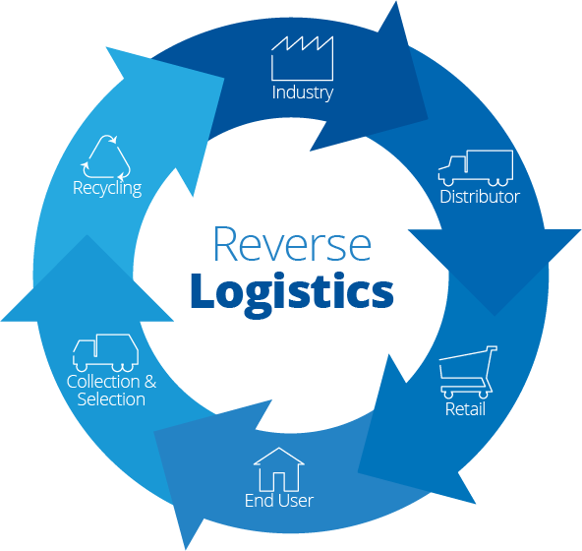When a manufacturer's product moves through the supply chain network under normal circumstances, it is to reach the distributor or customer. Any process or management after the sale of the product involves reverse logistics. If the product is damaged, defective or fails to meet the specified quality criteria the customer would return the product.
The manufacturing firm would then, at its own cost, have to organize shipping of the defective item, testing the product, dismantling, repairing, recycling or disposing the product. The product would travel in reverse through the supply chain network in order to retain any use from the defective product. The logistics for such matters is reverse logistics (as shown in the illustration above).

- Deliveries can be made to customers from two sources. What are these?
The simple difference between a warehouse and a distribution center can be found in the length of storage and immediate operation of each facility. A warehouse is usually used to store goods for longer periods of time, while distribution centers concentrate on faster turnover or quantity of goods as described below.
A warehouse is normally a commercial building for storage of various goods. Warehouses are used by a range of businesses such as manufacturers, importers, exporters, wholesalers, transporters, customs etc. and typically they are large plain buildings in industrial areas of cities, towns and villages.
They will usually have loading areas (docks) to load and unload goods from trucks.
Sometimes the bigger warehouses are designed for the loading and unloading of goods directly from airports, railways or seaports. They often have cranes and forklifts for moving goods, which are usually placed on standard pallets loaded into special pallet racking of a standard size. Stored goods can include any raw materials, packing materials, components, spare parts or finished goods associated with agriculture, manufacturing and production.
A distribution center, although often similar to a warehouse size wise, and regularly with refrigerated and/or air conditioned is stocked with products to be redistributed to wholesalers, retailers or even directly to consumers. Distribution centers are usually thought of as being demand driven and tend to have a large and ever changing stock of goods.
Distribution centers are the basis of a supply network, as they allow a single location to stock a vast number of products. Some organizations operate both retail distribution and direct-to-consumer out of a single facility, sharing space, equipment, labor resources, and inventory as applicable.
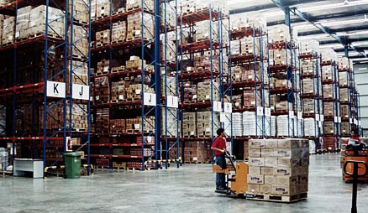
A typical retail distribution network operates with centers set up throughout a commercial market, with each center serving a number of stores. Some of these centers for companies such as UK’s food retailers Tesco, ASDA etc. can service 50–100 stores. Suppliers ship truckloads of products to the distribution center, which stores the product (often temperature controlled) until needed by the retail location and ships the proper quantity.
- Describe the procedures involved in production scheduling.
Proactive production planning needs to begin well before any sales take place and will help reduce stress, lower costs, improve customer service and increase profits if carried out correctly. There are a number of steps to be followed such as;

Demand Forecasting
The first step in planning production is to always estimate the companies demand needs. This is done by examining historic sales and production history for the past year or two to determine if there will be peaks and valleys during the coming year. Talk to customers to discuss their buying plans and have your sales manager submit his targets for the year by week, quarter, and month, depending on the volume of your sales and need for precise production scheduling.

Analyze Your Supply Chain
Review how long it takes to get materials to make products once they have been ordered, how long it takes to create items, storage capacity availability and the time it takes to ship product. This will help prevent bottlenecks that will occur if one of the links in the supply chain causes problems.

Plan Your First Draft
Based on the initial demand forecasts, create the first draft of a production schedule. Look for potential bottlenecks, rush periods or slow periods that can be levelled out. For example, if one customer places its order for the entire year at one time, negotiate delivering that company’s orders two to four times per year in partial shipments. This will reduce the need to use production capacity at one time for this large order, use warehouse space to hold it and stress shipping capacity to get the orders out.

Review Your Labor Needs
Using the initial draft production schedule, evaluate the labor needs need to be evaluated and identified. Ways to reduce the use of overtime or more-expensive contract employees by attempting to eliminate busy periods should be considered for example, if the customer that orders all of its product once each year won’t take delivery early, you might still pre-produce the company’s order to avoid labor difficulties, storing the product in your warehouse until it’s required.
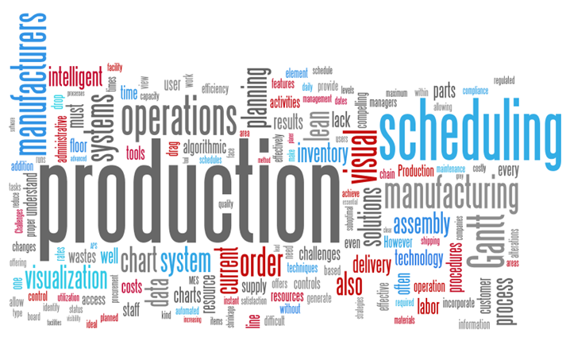

Assess Your Cash Flow
The company’s sales and accounting departments need to analyze the required cash flow. This will help determine whether or not the company can carry inventory that has been pre-made to avoid production spikes. In some cases, more-expensive labor may be needed later, rather than producing extra inventory now, because the cash or credit is not available to buy the supplies to build that inventory. By using the initial draft production schedule data, the company might be able to arrange for more credit or save more cash before peak production times.

Create Your Final Plan
Once the company’s product delivery needs, pre-order production options, cash flow situation and labor needs are identified, the creation of the final production schedule can be formulated. Every aspect of the logistics and supply chain, starting with signed contracts, materials orders, labor schedule, production, storage, shipping and billing needs to be addressed at this stage.

- Outline the procedures for Affective Order Management.

A reliable and efficient system for processing customer orders is crucial to any business success. Without it, departmental operations will blunder, front end representatives will suffer, and customers are more likely go to a competitor that offers better quality and reliable service. Time, money, and resources can be saved just by developing a proper order-processing guideline. It’s important therefore for the company to come up with the best procedure that will help you run the business smoothly and keep customers happy.
The following steps should be considered;

Use a standard order-taking form.
By using only a standard order form a company will eliminate any confusion both internally and externally. It doesn’t matter whether a customer service representative takes the order over the phone, or if a purchaser directly fills out a form from a company website, a standard format should be used. Some order details might be different depending on the actual item, such as options to choose color palettes, volume, or size. Make sure these details are included on the form so everyone will literally be looking at the same page.
This way, whoever fills out the form knows what information is needed, and makes sure that all pertinent information is gathered.

Do not accept incomplete order forms.
If any information is missed from the order form, there will be delays in processing it because there is a need to verify what exactly is required in the order. This will cause backlogs and will waste a lot of time and money. To avoid delays there should be a system in place that makes sure the order form is returned and completed before it is processed.

Confirm the order with the customer.
Confirming the order means that there is acknowledgment that the order forms were received, and that you’re about to process it. Make it clear that the customer should make contact if there are any problems. You may opt to require the client to verify the order, but it’s often not necessary; your acknowledgment to the customer is what matters.
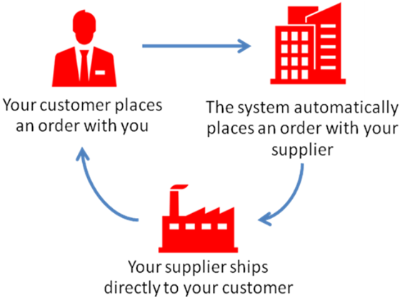

Circulate the filled out order form internally.
This is the time to distribute the order form to the departments and individuals who will perform any action connected to carrying out the particulars of the order, such as the finance team, backroom operations, manufacturers, shippers depending on the nature of the business.

Let the customer know the order status.
Interconnecting with customers throughout the process is vitally important. If there are delays or problems, let them know immediately instead of keeping customers in the dark. Give them the details of the order once it ships: tell them who the carrier is, what the tracking numbers are and the expected date of delivery etc.

Ask for customer feedback.
After the customer receives the order, take the time to get some feedback. Many businesses skip this step, but it’s one way of knowing your client’s sentiments and getting insights into what needs to be improved with your order processing system.
Take the time to develop the best order-taking system that works for your customers and backroom operations. This way, it will be smooth sailing for your business and your clients remain satisfied and loyal.
- Outline the benefits of outsourcing supply chain operations.
To many small business owners and new startups, the term outsourcing essentially means expense. While it is true that outsourcing various tasks will result in some type of expense, in many instances, the return on investment makes the initial costs worthwhile.
Whilst there are many everyday jobs that can easily be handled in house, there are others that are best left to companies and professionals who have the experience and means to get the job done in a more effective manner, supply chain management being a prime example.
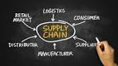
A third party logistics (or 3PL) provider offers businesses a one stop shop solution for all their assembly, inventory, packaging, warehouse, and distribution needs. In fact, many small businesses who have invested in working with a reputable logistics provider have maximized their profitability and improved the quality of the service they provide to their customers.
There are a numerous advantages that business owners can benefit from outsourcing their supply chain management needs. Below are a few reasons that need to be considered if outsourcing such needs;
- An established 3PL provider has already done the groundwork necessary to build a diverse resource network. These developed relationships allow 3PLs to execute a business’s supply chain needs in the most efficient, yet cost effective manner. This means less overhead and improved productivity.
- When a company outsources to a firm that has logistics and 3PL services that include inventory management, warehousing, assembly, packaging and distribution under one roof, this saves a great deal of time and money. It reduces the time and money that would need to be put into finding suitable space to store products, a means for transporting these products, and qualified staff to carry out the execution process.
- Learning an effective way to manage your supply chain could essentially take up a great deal of time. The same goes for hiring a team of staff and providing them with training. As such, an established 3PL provides industry experience to make sure that your supply chain needs are handled professionally. They are aware of the best methods and are essentially on top of the latest developments and technologies that can streamline processes to improve productivity and customer service. Hiring a 3PL provider frees up your time to focus on other core business tasks.
- Another advantage to outsourcing your supply chain management needs is scalability and flexibility. As business needs develop or fluctuate, the company will need to be able to adapt accordingly. Not having enough space, manpower, or transportation could prove damaging to the business. Equally detrimental is having too much space, manpower, or means of transportation when during an “off season” or down time. A 3PL provider on the other hand has the means to adapt to the needs of your business no matter how often those needs might change.

2. “The more flexible, responsive, and cost effective the supply chain is, the more likely the product will be to succeed in its market.” Discuss this (8)

The majority of global supply chains are not equipped to cope with the world we are now entering. Most SC’s were engineered, some brilliantly, to manage stable, high-volume production by capitalizing on labor-arbitrage opportunities available in China and other low-cost countries. But in the future when the relative attraction of manufacturing locations changes quickly, along with the ability to produce large volumes economically, such standard approaches can leave companies dangerously exposed.
That future, spurred by a rising tide of global conflict, uncertainty and business complexity, is coming sooner than many companies expect. Some of the challenges (turbulent trade and capital flows, for example) represent perennial supply chain worries turbocharged by the downturn which started in 2008. Yet other changes, such as those associated with the developing world’s rising wealth and the emergence of credible suppliers from these markets, will have supply chain implications for decades to come.
A few pioneering supply chain organizations are preparing themselves for the future in two ways. First, they are “splintering” their traditional supply chains into smaller, nimbler ones better prepared to manage higher levels of complexity. Second, they are treating their supply chains as hedges against uncertainty by reconfiguring their manufacturing footprints to weather a range of potential outcomes. The stakes couldn’t be higher, quote;
“In our industry,” says Jim Owens, the former chairman and CEO of construction-equipment maker Caterpillar, “the competitor that’s best at managing the supply chain is probably going be the most successful competitor over time. It’s a condition of success.” Jim Owens made this remark in an interview conducted by Hans-Werner Kaas on September 20, 2010.
The financial crisis of 2008 dramatically amplified perennial sources of supply chain uncertainty—notably the trajectory of trade and capital flows, as well as currency values—even as the crisis sparked broader worries about the stability of the financial system and the depth and duration of the resulting recession. While many of these sources of uncertainty persist, it’s important to recognize that new, long-term shifts in the global economy will continue to pressure supply chains long after more robust growth returns.

Splintering gigantic supply chains into smaller, nimbler ones can help tame complexity, save money, serve customers better and therefore ensure success in the market place. The following is an example;
A US-based consumer durables manufacturer was losing ground to competitors because of problems with its legacy supply chain. Years before, the company, like many global manufacturers, had sent the lion’s share of its production to China while maintaining a much smaller presence in North America to stay close to the majority of its customers. One legacy of the move: all of its plants, relying on a unified production-planning process, essentially manufactured the full range of its thousands of products and their many components.
Now, however, increasingly volatile patterns of customer demand, coupled with product proliferation in the form of hundreds of new Stock Keeping Units each year, were straining the company’s supply chain to the point where forecasting- and service-related problems were dissatisfying key customers. In response, the company examined its portfolio of products and components along two dimensions: the volatility of demand for each SKU it sold and the overall volume of SKUs produced per week. Armed with the resulting matrix the company began rethinking its supply chain configuration.
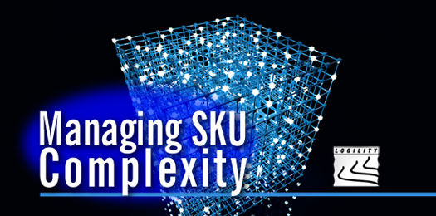
Ultimately, the company decided to split its one-size-fits-all supply chain into four distinct splinters. For high-volume products with relatively stable demand (less than 10 percent of SKUs but representing the majority of revenues), the company kept the sourcing and production in China. Meanwhile, the facilities in North America became responsible for producing the rest of the company’s SKUs, including high- and low-volume ones with volatile demand (assigned to the United States) and low-volume, low-demand-volatility SKUs (divided between the United States and Mexico).
For overseas operations, the company continued to have its Chinese plants produce finished goods on the basis of long-run forecasts, as they had done before. The forecasts were now better, though, because planners were no longer trying to account in their models for the “noise” caused by the products with highly volatile demand.
Together, the changes helped the company reduce its sourcing and manufacturing complexity and to lower its cost of goods sold by about 15 percent. Meanwhile, it improved its service levels and shortened lead times to three days, from an average of ten. Quality also improved across the company’s full range of products.
Project (8)
Take a critical look around you and see if you can see examples of poor logistics. You might find, for example, that a train is cancelled, a bus arrives at the wrong time, a delivery of goods arrives after the promised time, a shop runs out of a product that you want, a town center is poorly laid out, and so on.

What could you do to improve these operations? Produce your findings in a report.

I currently am working on a Project in the middle east. The Upper Zakum offshore field is located in the Arabian Gulf, 84 km from Abu Dhabi. The field is divided into four geographical producing areas (Central, North, South and West) consisting of processing facilities at Central Complex (CC - the focal point of the Field) plus three Satellite Platforms, South Satellite Platform (SSP), North Satellite Platform (NSP) and West Satellite Platform (WSP).

ZAKUM Development Company (ZADCO) has embarked upon an Upper Zakum Field
Development (UZFD) program which is aimed at achieving a target oil production plateau rate of 750 MBD from the UZ field and to sustain this production target for at least 25 years and in the long term to attain ultimate recovery of 70% of proven reserves utilizing artificial islands based drilling and production centers together with the use of existing surface facilities on satellite platforms and central complex platform to the maximum extent possible.

To achieve the above objective, four new artificial islands (Central Island, North Island, South Island and West Island) are being constructed. Each Island will host new facilities mainly comprising Drilling Area, Processing Area, Utilities Area, Accommodation & Non-process Facilities Area and Harbour Area. Each Island, with the exception of Central is approximately 710M by 450M in size (see photo below)

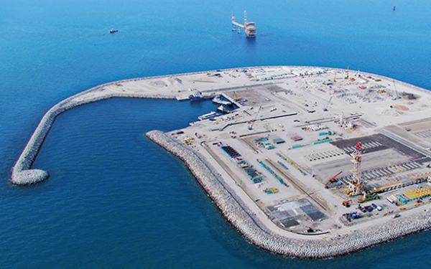 As can be seen in the photo’s below “real estate” space is at a premium now that construction activities have peaked and we have a serious issue with logistics and storage.
A realistic plan (forecast) was created with the following components;
- Logistics plan
- Manufacturing plan
- Procurement plan
- Inventory deployment plan
Clearly however a realistic and accurate plan is dependent on the quality of the input from the different business functions, such as manufacturers suppliers and contractors but to date we have not seen a 100% accurate plan yet even though the better the plan is, the higher the customer satisfaction, and the lower the overall cost would be.

There are of course a number of reasons for the failure to date such as late subcontractor deliverables, poor productivity, bed space restriction etc. which combined have resulted in all stakeholders “fighting” for the available space needed for laydown and storage which has resulted in a major coordination program.

Materials originally arrived based on an agreed schedule/sequence but due to the delays indicated above this has resulted in every conceivable space being used for material laydown either for construction or drilling purposes.

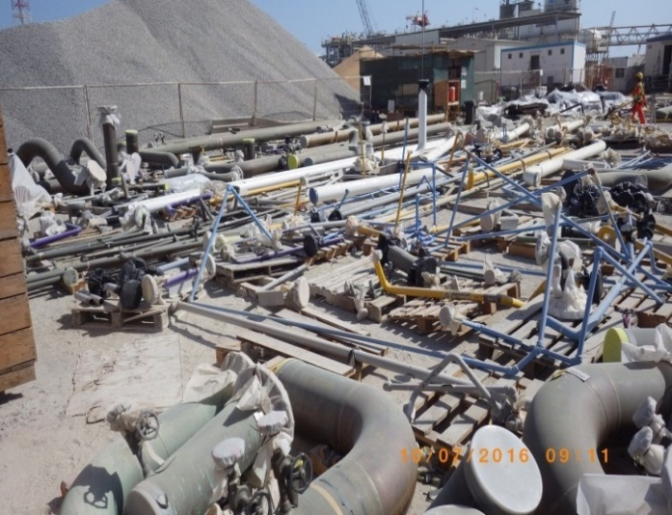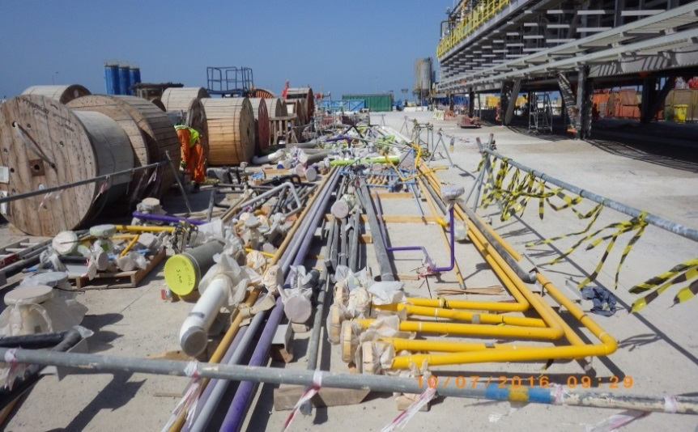
Although the project is now well progressed we are still receiving out of sequence materials and consumables and endeavors’ are under way to ease the pressure on the Island with regards to deliveries and storage moving forward.
Some of these actions are as follows;
- Improve Communication and Scheduling
The schedule is updated on a regular basis however a significant amount of material is currently on the Island and cannot be installed for numerous reasons. Better communication between the Island and the onshore marshalling yards has however resulted in material that will now be required in the next two months (based on the updated schedule) being shipped and efforts are underway to ensure this material is installed and this will mean storage space is then available for the next two months requirements and so on. Previously received materials no longer required, which is taking up valuable real estate, is being sent back to the onshore facilities and will be re-dispatched at a time it will be required in future.
- Invest more in Training
Although normally a common problem in the logistics business training is not necessarily an issue on this project. It is fact that a typical large distribution facility has 40% turnover rate per year and depending on geographic location it could be more. Good training programs are essential and could increase productivity 10-20%. Why? Training and validation of training assures that all associates understand the “steps for success”.
Opportunities however have been taken to further train personnel . This training will continue to be given to each participant to ensure that the main points are learned as historically different people learn in different ways and that typically there needs to be an average of six repetitions for training to be fully absorbed.
- Improve Productivity
Now that we have entered the cooler winter months it is time to significantly improve the productivity of the workforce. In the summer months we are subjected to daily temperatures in excess of 40 Degree Celsius and the workforce, by law, can only be subjected to 20 minutes of work and 40 minutes of rest for outside activities. This is managed closely however unless you increase the workforce by 200% (impracticable as there is no bed space) then obviously productivity will drop 66%.
During the months of November to March the temperature drops significantly and therefore the existing workforce productivity must be optimized accordingly so that materials can be installed in sequence and therefore this will free up valuable laydown areas for new material arrival.
Conclusion
It is worth pointing out this is not all about Logistics. There is clearly a breakdown of a number of processes such as Planning, Procurement, Communication and so on.
All of these need to be addressed to ensure Logistics are used more efficiently as all materials supplied to the Island is marine dependent (supply boats, barges, ships) and this is a costly operation. The coming months will be vital to get the project back on track and to ensure the logistical effort is optimized correctly.

Student Statement:

By submitting this assignment, I confirm that this is my own work.

Student Signature | Raymond Wilson | Date | 15th Oct 2016

For Tutor / Assessor Use Only
Total Marks
Marks Obtained
Percentage / Grade

