
Assignment Cover Sheet

Student Name: | Sharron Fox
Student Number: | 3789
Course: | Warehousing and Material Handling
Assignment NO: | Ten

Marking Criteria:
We expect the learners to write minimum one well expressed point in three lines against each allocated mark. This means one needs to write 15 lines with 5 well expressed points to get high grades for a 5 marks question.
For high grades use examples and illustrations where appropriate.
1
- Aims and functions of warehouses : Generally Warehouses are Distribution centres and logistic centres holding large amounts of goods at a central point for easy distribution onwards to the end user. Whilst mainly used for storage they are utilized for other functions also for various other jobs such as packaging, labeling and making goods ready for retailers other functions such as 3PL servicing and managing inventory.

Aimes : Storage, safe storage and keeping in good condition, customer service levels, high productivity, error free movement, picking material quickly, Flexible, rotation of stock, whilst complying with HSE.

- Public and private warehouses. : Owning a facility is costly so they may use private or public warehouses.

Private warehouses being owned or leased by a business and marketed as their own and running the warehouse themselves. Gaining more control over part of logistics and allows the facility to be incorporated into its activities and logistics.

Public warehouse being a self governing business making money by charging fees to be used. These could be bonded warehouses, cold stores, bulk and specialist stores.

- Advantages of a public warehouse : Main advantage being flexibility.

Flexibility to deal with changing demand, possibly due to seasonality; • Ability to supply skills and knowledge that the business does not have internally; • Access to the newest equipment and practices; • Avoiding big capital investment, giving higher return on investment; • Easy access to a wider geographical regions; • Allowing immediate tests of working in new areas; • Use of economies of scale to lessen warehousing costs; • Consolidating loads with other organisations to decrease transport costs; • Certain high quality and well-organized service; and • Flexibility to deal with varying conditions, removing risks from dated practices and technology.

- Manual warehouses : Not equipment orientated, picking etc is done manually by a picking bin and going around the isles picking what is needed – similar to supermarket shopping.

- Automatic warehouses : Costly to set up, the mechanized equipment being very expensive and a high investment which in time by quicker processed will pay for themselves of a long period of time. Usually found in extremely big stores that shift large amount of stock around.

Equipment may be : automatic picking vehicles, loaders and unloaders, fork lift and cherry pickers, cranes etc

- Main materials used for packaging : Internal and external packing material, filler material and specific labeling. Pallets and containers dependent on the environment, weight etc
Five main components of packaging being : Glass, Plastic, Cardboard, Wood and Metal.

2) Activities of a warehouse : Many activities take place within a warehouse.

Receiving goods from sellers, identifying and relocating them
Unloading delivery vehicles
Quality control
Labelling
Movement of stock
Assembling orders
Picking and packing orders
Loading vehicles
Stock control

3) General layout of a warehouse : Design is a significate consideration in laying out the warehouse and understanding its key functions, from physical plan of storage racks, offices, loading and unloading areas. Understand the top rotation items and keeping them closer to hand whilst the slower movers can be further away.
The decisions will be a long term decision so must be the correct one, investing both money and time, loading and unloading bays, handling systems for moving goods around, picking and packing bays.
Understanding what type of racks and how many are going to be needed, how high will dictate the type of picking items you may need such as a cherry picker, the type of picking equipment will dictate the space needed between each racking bay

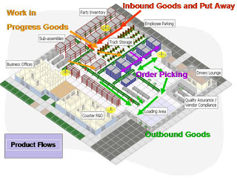
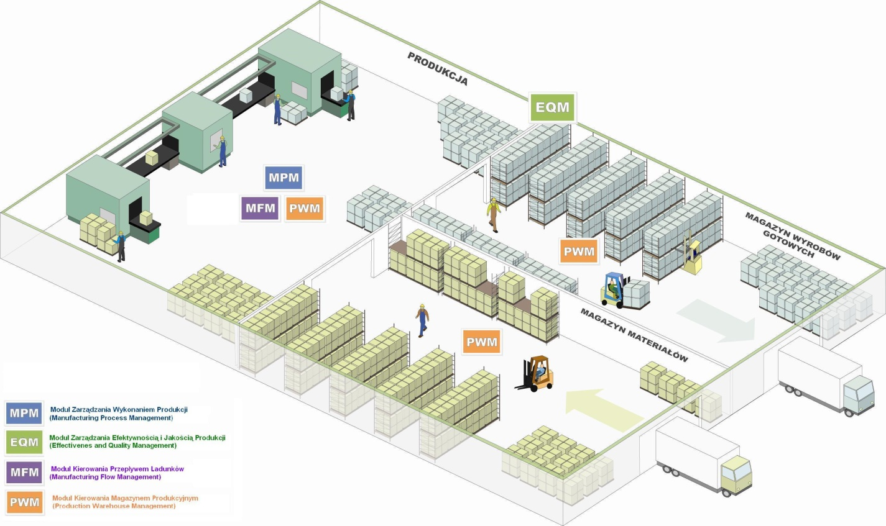

An inefficient layout of your warehouse can have a negative effect on your business. Decreasing productivity, creating inventory control issues, errors in shipping and posing safety risks. When it comes to laying out your warehouse, it is important to exploit its full space. Everything should be accessible and in the right location, allowing staff to carry out their duties in the most efficient way. Ensuring every square foot of space is properly utilised, within your warehouse, will keep overhead costs to a minimum and increase productivity.
Warehouses can be fast moving which is worth creating segments in the warehouse that are well defined. For example, your returned products area should be in a separate part of your warehouse that is enclosed by a fence and clearly marked. This ensures that returned products are not mistaken for stock.
It is also important to keep shipping and receiving areas separate and located in different areas of the warehouse to avoid improper staging of freight merchandise.
Design your warehouse so that inventory does not need to be moved more than once. It usually does not make sense to store items in one place and then move them to another place later.
The goal of the warehouse layout is to optimise your warehousing functions and achieve maximum efficiency and space utilisations.
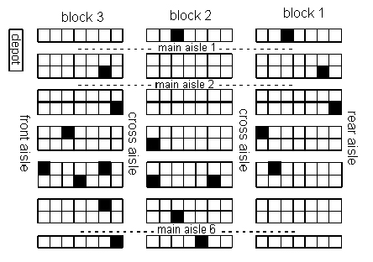

Student Statement:

By submitting this assignment, I confirm that this is my own work.

Student Signature |  | Date | 20.2.17
For Tutor / Assessor Use Only
Total Marks
Marks Obtained
Percentage / Grade

