
Assignment Cover Sheet

Student Name: | Constancio R Estibeiro
Student Number: | 1504
Course: | Diploma in hotel management level 4
Assignment NO: | 2

Marking Criteria:
We expect the learners to write minimum one well expressed point in three lines against each allocated mark. This means one needs to write 15 lines with 5 well expressed points to get high grades for a 5 marks question.
For high grades use examples and illustrations where appropriate.
Please insert your completed assignment ( in word format) here: Constancio Roque Estibeiro
Student No. 1504
Unit 2
Managing front office operation
Assessment 2.
1.
(I). Front office is like the mirror of the hotel. It is the first place where customers arrive and come in touch with the staff. The front office activities start from the time a guest calls or sends in a request for reservation. The reception desk performs the function like the sale of rooms, guest registration, room assignments, handling of guest request, maintenance of the guest account, cashiering along with handling mail and providing information. The financial tasks usually handle by the front desk personnel include receiving cash payment, handling guest folios, verifying cheques and handling foreign currency and credit cards. The activities of front office are (a) Sell guest rooms: Here the front office accept reservation, handle walk- ins and perform the registration process. (b) Provide information on hotel service: Concerning internal hotel operation and about external events and location. (c) Coordinate guest service: Liaison between front and back of the house areas and handle guest problems and complaints. (d) Chart room status report: Coordinate room sales and housekeeping occupied status, on-change status, out-of-order status. (e) Maintaining guest account: Construction of folio and account, Posting to folios (updating) Supervision of credit levels, Documentation of guest’s transaction. (f) Settlement of guest account: Preparation of guest statement. Reconciliation of folio. Perform the checkout procedure. (g) Construct guest history file: Record the guest’s personal data for future reference.

(pg. 1)

(II)
Reservation system is a computerized system that stores and distributes information of a hotel, resort or other lodging facilities which assists hotel manager in managing their online marketing and sales, allowing them to upload their rate and availabilities to be seen by sales channels of the central reservation system.
Types of Reservation: (a) Guaranteed reservation: In the guaranteed reservation the hotel assures the guest that the required rooms shall be blocked after confirmation. Guest must provide the method of payment. If the guest does not show up or cancel properly, the guest will be charged for one night accommodation. If the hotel fails to provide the room for a guaranteed reservation, legal penalties can be applied if the guest files a complaint. (b) Non- Guaranteed Reservation: Insures that the hotel agrees to hold a room for the guest until a stated reservation cancellation hours (usually 6p.m.) on the day of arrival.

(III)
Front office is one of the most important part of the hotel. It is the front face of the hotel business. The basic duty of the front office is to manage all the departments of a hotel which includes the housekeeping, accounts and online reservation. However the most important of them all is the performance at the front desk where they are required to receive the guest and visitors. The front office manages a lot of financial items of the hotel. They compile the guest list as well as prepare the check in and check out forwarding it to other departments. The front office manages and handles the meetings, sort mail, answer the phone and fix up appointments top management, maintenance of record and details, data entry and other office communication. The front office people are the one who welcome the guest and their impressive gestures can impact the future business. They will help customers about problems and complaints. They will show customers the way and carry the luggage for them. The different parts in the front office of a hotel which included reception, providing services when customers asked, mailing information, concierge and employees who manage with money (cashier). The front office of a hotel industry is perhaps the most important area of the organization.

(pg. 2)
(IV)
The organizational structure of the hotel’s: Front office varies depending upon whether the facility is a small business or a large resort, certain roles are found within all organizations. It include Front office manager, The desk clerk, Reservation manager, Cashier, Night auditor, Concierge, Telephone operator, Room key clerk, Bell staff and Elevator operator. In some operation, the front desk clerk act as a cashier, desk clerk, telephone operator and reservation clerk, depending on the volume of the business. The front office Manager who should maintain a cooperative relationships between the front office and other hotel divisions and departments by encouraging communication between all areas of responsibility.

(V)
The responsibilities of front office manager: - Ensuring the front desk provides professional and friendly service for customers. - Working closely with the housekeeping department to improve guest service and foster cross departmental communication. - Act as a manager on duty for the hotel, dealing with complaints, problem solving, disturbances, special request and any other issues that may arise. - Undertake full responsibility for managing operating expenses and purchasing for the department. - To check cashiers in and out and verifies banks and deposits at the end of each shift. - Hold monthly department meetings keeping staff informed of all activities in the hotel, reinforcing standards of excellence and promoting a strong team atmosphere and culture. - Scheduling front staff rota. - To supervise and control all Front of House areas to the standards laid down by the Company, maximizing revenues and profits to agreed budgetary limits.

(pg.3)
(VI)
Reservation reports can include: (a) Room availability report which is listing of the room sold or available that can be made on a daily or weekly basis. (b) Expected arrivals and departure list gives the number of guests who are scheduled to arrive or to leave on a given day. (c) Group status report gives the details of groups to arrive or depart in the week or month, along with information like the group size and whether it is a guaranteed or non-guaranteed booking. (d) Special arrivals list is a list of special guest or VIPs arriving with the details like special request and information about likes and dislikes of the guest. (e) Turn away report is the number of reservation requests denied. (f) Revenue forecast report is a report on the potential revenue from the future room sales, in addition to the regular or latest date reports.
(VII)
Electronic front office operations has computerized system that store and distributes information of a hotel, resort or other lodging facilities which assists hotel managers in managing their online marketing and sales, allowing them to upload their rates and availabilities to be seen by sales channels of other central reservation system. W call accounting is a computer technology application that tracks guest phone calls and posts billing charges to lodging establishment. The most common manual system used by hotels of any type or size is known as whitney system devised by whitney paper corporation of new York in the 1940s. In this system each reservation is recorded on a small, multipart piece of paper mounted in a metal frame, which in turn, is filled in date and alphabetical order on a metal rack. The slips are usually colour coded to denote the type of guest .

(pg. 4)
(2)
Concept of yield management: Yield management is a pricing strategy, based on understanding, anticipating and influencing consumer behavior in order to maximize revenue or profit from a fixed perishable resource like hotel reservation. To achieve maximum revenue, a yield management system needs to have an understanding of what has happened before and what is happening at present, using this historical data to predict what may then happen in the future. So the yield management system will periodically review transaction that have occurred between the consumer and the hotel. Other external information is then fed into the yield management system and this can include statistical data, events such as public holidays, competitor price information, seasonal buying patterns etc. A predictive modeler then attempts to forecast the total demand within a specific period for the services on offer by market segment and price point. The process of yield management optimization help an organization to adjust its prices so that they meet the total demand characteristics of its markets. Yield management is multidisciplinary because it blends elements of marketing, operations and financial management into a highly successful new approach. Hotel use this largely the same way, to calculate the rates, rooms and restriction on sales in order to best maximize their return. These system measure constrained and unconstrained demand along with pace to gauge which restriction to implement e.g. length of stay, non-refundable rate or close to arrival. Yield management in hotel is selling rooms and service at the right price, at the right time, to the right people.
(3)
Check in process: (i) Greet the guest: Receptionists should give warm greetings to the guest when they approach to the front desk. (ii) Verify the guest identity: Checking his/her passport, booking voucher, and confirmation number. (iii)Present the registration form to the guest: Asking the guest to complete the form and sign if he/she agrees with the terms of accommodation arrangement. (iv) Confirm the method of payment: Checking credit card details if he/she wants to pay by credit card. If he/she prefer to pay by cash, they have to pay in advance with cash deposit.
(pg. 5)
Procedures of handling other types of payment e.g. personal checks or direct biling should also be handled with extra care. (v) Check and update the information of the guest’s account in PMS. (vi) Issue room key and give further information: Receptionist should give more information about breakfast arrangement, the operation hours of hotel’s outlets and facilities and how to contact the hotel’s staff for assistance during the day etc. while issuing the key. (vii) Escort guest to the room: Ask if the guest need assistance from the bell boy who can take the guest luggage and escort the guest to the guest room.
Check out process: (i) Greet the guest: While greeting the guest receptionist can take the chance to ask the guest comment about the stay. (ii) Check guest details: checking the name and room number to avoid mistake of similar names. Ask the guest to return the room key. (iii) Check if any late check-out charges should be imposed: Receptionist has to follow the hotel policy for late check-out. (iv) Check for late charges: Ask whether the guest has used same charged services like breakfast or mini bar items. (v) Invite guest to double check the hotel charges: The receptionist should print and present the bill to the guest for checking before bill settlement. (vi) Settle the guest account. (vii) Offer assistance: Ask if the guest need assistance of the bell service, shuttle or arrangement of other transportation. (viii) Update room status and guest history record.

(pg.6)

Activity:
From Ioana Dabija Village Urban Resort Coventry
Our hotel is part of a chain of 20 hotels being one of the biggest as per room numbers and function rooms. We have 146 rooms, 10 function rooms and a leisure centre that has about 5000 members. We are Coventry Village Urban Resorts functioning as a urban resort to facilitate that concept we have our own Starbucks, Restaurant and Pub. Our believe is to try to offer to our guests everything under one roof. The hotel has about 120 employees and its a space that offers a lot of development possibilities to grow for its employees.
As in describing my job role here in Village Coventry I am a senior receptionist and my responsibilities vary. One of my main duties is to make sure that everything runs smoothly and our guests enjoy their stay with us and will return to stay with us on the near future or they will turn to one of our sister hotels in different cities. I am the first person you see when you arrive at our establishment and the last so the impression we leave always has an impact. Offering the best customer service is our pride as well as treating guest with attention to detail care and warmth to make them feel welcomed and taken cared of. I also have a lot of admin roles such as checking the reservations payments back up are all in line and up to date so we are always on top of the situation by professionalism. I deal with phone bookings for accommodation and restaurant along with the other roles. This is a only a glimpse of some of my job roles.
(pg.7)

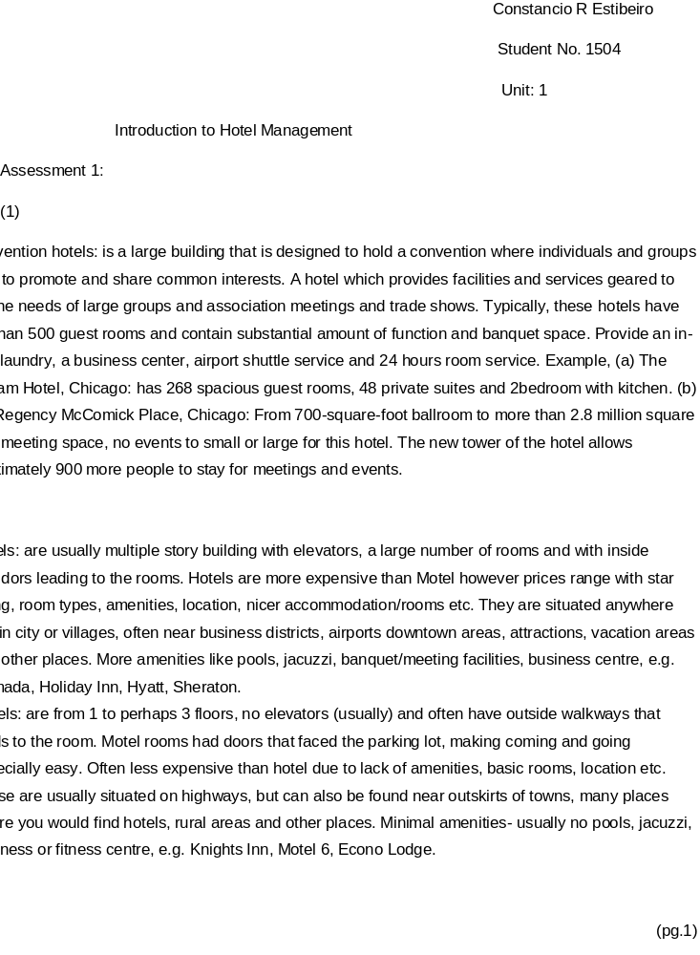

Student Statement:

By submitting this assignment, I confirm that this is my own work.

Student Signature | Constancio estibeiro | Date | 20/08/2015

For Tutor / Assessor Use Only
Total Marks
Marks Obtained
Percentage / Grade

