
Assignment Cover Sheet

Student Name: | Christian Blackmore
Student Number: | 1394
Course: | Construction Management
Assignment NO: | 12

Marking Criteria:
We expect the learners to write minimum one well expressed point in three lines against each allocated mark. This means one needs to write 15 lines with 5 well expressed points to get high grades for a 5 marks question.
For high grades use examples and illustrations where appropriate.
Assignment 12

I What is Human Resource Management? Discuss its relevance to construction industry

Human Resource Management (HRM) involves everything related to the employer-employee relationship and is about supporting and managing the organisation’s people and associated processes. It’s seen as a core business function essential to the organisation’s effective operation.

Effective HRM has become more and more important in recent times:-

- People are the critical resource in the quality and customer service level of any service business.
- Competitiveness requires a business to be efficient and productive – to achieve this operatives must be well motivated, have the right skills and be effectively organised.

Human Resource Management views people as an important source or asset to be used to benefit the organisation and employees. Specifically, it involves the performance of people in achieving the organizations objectives and the satisfaction of personal employee requirements.

HRM has a significant influence in the construction industry. Construction technologies and techniques have advanced considerably but Project Managers should pay more attention to people management as human resources account for the majority of costs in most construction projects.

The ultimate focus of HRM is the people within an organization. Regular planning, monitoring and evaluation are important for the success of HRM. Successful implementation ensures that all employees know their role, career path and also feel part of an organization which is able to manage and reconcile their expectations as well as those of the organization and its objectives.
.

II What is HRD? How is it different from HRM?

Human Resource Departments (HRD) primary responsibility is to keep the associated company staffed appropriately at all times. The main functions of HRD consists of:-

- Recruitment
- Safety
- Employee relations
- Compensation and Benefits
- Compliance
- Training and Development

Recruiting success is measured by the number of positions filled and the time taken to fill those work places. Once new personnel have been hired all required documents and legal requirements for employment must be ascertained. The employer has the obligation to provide a safe working environment for all employees, workplace safety is essential always. A good relation employer – employee is important to maintain at all times for both sides to achieve their objectives. HR Departments also provide the employee induction and training programs, which provides the employee adequate orientation to fulfil the employers expectations.

HRD and HRM are both practices that deal with human resources of a company. Usually in large organizations, there exist entire departments dedicated to HRM where trained professionals work together dealing with both HRD and HRM functions.

HRD deals with functions such as performance development and management, training, career development, succession planning, tuition assistance. HRM deals with functions such as employee training, recruitment, performance appraisals as well as rewarding their employees.

III What is reward and compensation policy?

Company reward policies cover how people are rewarded in accordance with their value to an organisation. Both financial and non-financial rewards are given to employees:-

- Financial reward – Bonus, pay rise, paid time off

- Non-financial reward - career opportunities, company cars, private medical care, free pension entitlement.

The ways in which people are valued can make a considerable impact on the effectiveness of the organisation and is essential for good employment relationship.

An employee reward policy aims to attract, retain and motivate high-quality personnel. If reward policies are incorrectly implemented it can cause significant negative effect on the motivation, commitment and morale of employees.

An effective compensation policy is based on objective and up-to-date job descriptions, effective job evaluation and performance management, and relevant salary administration.
Some elements of compensation that are regulated by provincial employment standards acts include:-
- Minimum wage
- Rate of holiday pay
- Overtime pay
- Equal pay
- How often employees receive their pay
- Manner in which payment is made
- Deductions
- Gratuities
- Payroll records
- Vacation pay

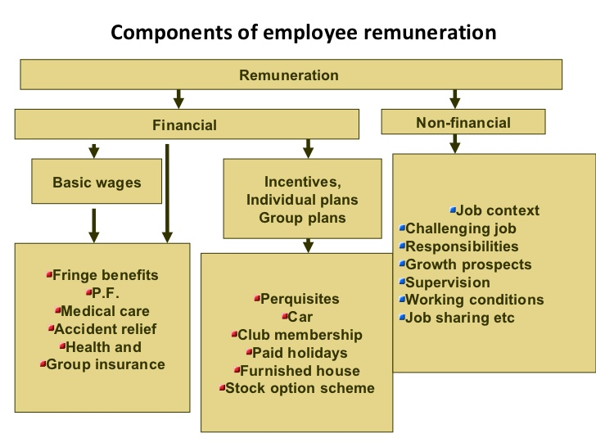

IV What is the importance of discipline in industry?

Discipline in any organization large or small is essential for the company to prosper. To maintain respectful relations by all parties involved a code of discipline was laid down, this code applies to public and private sectors.

Some basic objectives of code of industry consist in:-

- Maintain peace and order in industry.
- Promote constructive criticism at all levels of management and employment.
- Avoid work stoppage in industry.
- Secure the settlement of disputes and grievances by a mutually agreed procedure.
- Avoid litigations
- Facilitate a free growth of trade unions.

Managers should at all-time set good examples of discipline to their operatives, this way respect is always sustained at the workplace. If discipline is not correctly administered problems could be generated between employer and employee like low morale, resentment and ill-will.

Discipline can be very effective when operatives are trusted rather than closely monitored. Giving responsibility and authority can be a morale booster which can result in work efficiency.

V What is voluntary and involuntary separation? Discuss with examples.

Employees are free to leave any employment position when they feel it is necessary, this can be classified into two categories:-

- Voluntary separation – professional or personal reasons
- Involuntary separation – health problems, behavioural problems & organization problems

Voluntary separation - commences when an employee puts forward his/her request for separation from the organization.

This can be due to them seeking a better position or more responsibilities outside their present organization, enabling them to expand their knowledge and skills working at different levels through various organizations two achieve their goal of success.

Personal reasons for separation can for instance be family oriented. A family member may need assistance because of their illness which makes it necessary for the employee to leave their employment.

On some occasions employees once married leave their work position to settle at their partner’s place of occupation.

Involuntary separation – Accidents which cause disabilities or terminal illness may make the employee unfit or invalid to continue in their current occupation.

The employer may be forced to terminate further employment due to misconduct of any employee who does not comply with the rules and regulations of the organization.

Poor performance of employees will lead to managers or supervisors having to give verbal warning; if employee’s performance does not improve then steps will be taken for their dismissal.

VI How is recruitment different from selection?
Recruitment and selection are both part of the employment process, some of the differences between the two are:-

Recruitment - refers to the process of sourcing potential candidates for a job or function. It may be undertaken by an employment agency or a member of staff at the organization looking for recruits. Advertising is generally part of the recruiting process and is achieved through newspapers dedicated to job advertisement, professional publication, job centres or on- site interviews.
Selection – refers to various screening stages of possible candidates for the job in question:-

- Qualifications
- Oral Interviews
- Work performance (job references)

Recruitment – is a positive process as it attracts and encourages a greater number of employees to apply for the position.

Selection – can be a negative process as it involves rejection of a great deal of candidates leaving only a few suitable candidates too choose from.

Recruitment – no contract is established in recruitment.

Selection – will result in a contract between employers and the successful candidate.

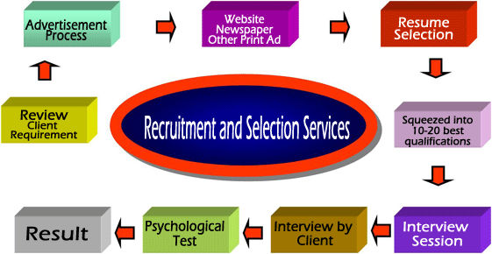

.

- Discuss various techniques for manpower planning.

Manpower planning is an essential part of the overall planning of any business organization. No business will prosper if the following points are ignored:-

- The right amount of people
- The right kind of people
- With the right skills
- At the right time
- In the right places

Manpower planning techniques use a range of data and information from internal and external sources to support overall decisions about future profiles and staffing requirements within the organisation. The results obtained from using these techniques does not necessarily give all the answers but offers a medium to explain the data in a more robust way, this will assist and benefit personnel making the decisions about organisational and skills requirements.

Different sectors have their own ways of using their information in the application of modelling tools, some specific key features are:-

- Manpower profiling.
- Future forecasting – (what is likely to continue and what will change)
- Reference forecasting – (referring to past or similar situations and outcomes)
- Analysis of skills gaps and targeted future planning using qualitative and quantitative data and information.

The internal/external techniques used to recruit personnel in organizations have their advantages and disadvantages, for example:-

Internal recruitment advantages:-

- Personnel working inside the organization will require shorter periods of training, as they are already aware of how the company operates, this will also generate savings to the organization
- Internal recruitment also does not create an excessive amount of disruption to any department for personnel who are accustomed to the work environment in question.
- Organizations offer internal promotions to personnel as motivation to be more work efficient.

Internal recruitment disadvantages:-

- The organization will find it also necessary to recruit personnel to replace promoted operatives.
- An internal worker may not make a constructive criticism of the organization which is necessary to get the company working more effectively.
- There is the possibility of rivalry between personnel who may have been promoted.

The main advantage of external recruitment is that there is the possibility of attracting a wider range of professionals, and provides the opportunity to bring new experience and ideas in to the organization.
The disadvantage for external recruitment is the time and cost to the company to find the correct candidate.

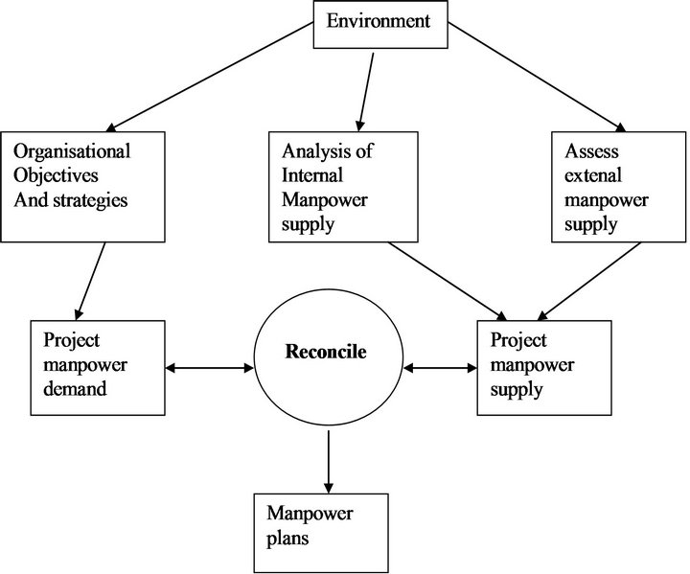

Student Statement:

By submitting this assignment, I confirm that this is my own work.

Student Signature | Christian Blackmore | Date | 20-09-16

For Tutor / Assessor Use Only
Total Marks
Marks Obtained
Percentage / Grade

