
Assignment Cover Sheet

Student Name: | MOHD AIZAT BIN ABU HASSAN
Student Number: | 3894
Course: | Diploma in Marketing
Assignment NO: | # 1

Marking Criteria:
We expect the learners to write minimum one well expressed point in three lines against each allocated mark. This means one needs to write 15 lines with 5 well expressed points to get high grades for a 5 marks question.
For high grades use examples and illustrations where appropriate.
Please insert your completed assignment ( in word format) here:

1. Give short answer to the following questions: (15)

i. What is marketing?
- Marketing is the management process which identifies, anticipates, and supplies customer requirements efficiently and profitably.
- Marketing is the process of planning and executing the conception, pricing, promotion and distribution of ideas, goods and services to create exchange and satisfy individual and organisational objectives

ii. What is the production concept of marketing?
- Production concept of marketing is consumer will prefer product that widely available and not expensive. Meanwhile provider concentrates on achieving high production efficiency, low costs, and mass distribution.

iii. Explain the sales concept of marketing.
- Sales concept an idea which lays emphasis on the sale of goods and services and not the underlying need or want, and it does not really matter whether the products are actually needed by the customer or not. The focus is on sales first and then on marketing.

iv. What are the “four Ps” of marketing mix according to McCarthy?
- The four Ps according to McCarthy include Price, Promotion, Product and Place

v. Explain the term ‘marketing orientation.’
- Marketing orientation is business model that focuses on delivering products designed according to customer desires, needs, and requirements, in addition to product functionality and production efficiency

2. Describe the difference between sales and marketing. (7)

Selling is a substitute for the barter system in contemporary times. According to a business man with concentration on sales, the duty of sales people begins with the completion of production. It becomes obligatory for the sales division to sell what the production division has manufactured. Hard-hitting sales methods are warranted to meet goals without any regard to the requirements of the customer.

Meanwhile, marketing is a larger and all-encompassing pursuit to an organization. The job which begins with detecting consumer requirements is not complete until there is feedback on customer contentment after product utilization. The long chain of events consisting of production, packing, promoting, distributing, and finally, selling according to customers’ requirements constitutes the force backing all the activities.

Marketing & Selling Differences:

SELLING | MARKETING
Focus is on the merchandise | Focus is on consumer requirements
The merchandise is produced first and then the selling strategy is developed. | The consumer requirements are determined first, and then the manufacturing and distribution strategies are developed to fulfil the consumer requirements.
Management is mainly concerned with volume of sales | Management is more concerned with profit
In terms of current products, planning is focused on short duration runs. | In terms of current products, planning focused on long duration runs, with an eye on future expansion.
Emphasis is on the requirements of the seller. | Emphasis is on the desires of the buyer.

3. ‘Marketing is considered to be the most important activity of the present day businesses. Discuss this. (8)

The soul of your business growth lies in its marketing. Most aspects of business activity are depending on successful marketing. Marketing is a process by which a business is introduced and promoted to potential customers. Marketing is important because it helps people to sell their products or services. Without marketing, there would be no way for people to become familiar with your business. You could be manufacturing the best products on the market, but your sales would definitely crash if you fail to implement a good marketing strategy.

People must raise awareness for their business and they must make sure that they stand out from their competition. The bottom line of any business is to make money and marketing is an essential channel to reach that end goal. Creatives explained that without marketing many businesses wouldn’t exist because marketing is ultimately what drives sales.

Business success greatly depends on your reputation. With good marketing, they will be able to build up their brand and ensure that you are leading their business to success. It might take a lot of time to build a reputation in today’s business, but once they build their, all it will take is a great and effective marketing strategy to maintain their reputations.

As your reputation grows, so does your business, which leads to an increase in sales and generating more revenue. Higher sales and more income can later lead to the further expansion of your business and, of course, more customers.

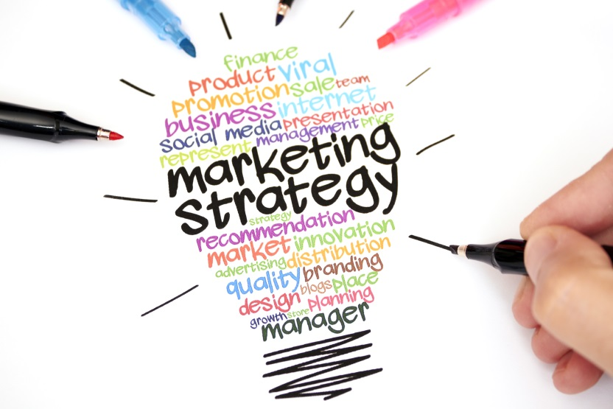

The greatest thing about reputation and brand awareness is that it gets people talking about their brand and they come to a point where their customers actually do a great deal of marketing for them, since customers tell their family and friends about your product or service.

Student Statement:

By submitting this assignment, I confirm that this is my own work.

Student Signature | aizat | Date | 18 December 2016

For Tutor / Assessor Use Only
Total Marks
Marks Obtained
Percentage / Grade

