
Assignment Cover Sheet

Student Name: | Yassim ELFASSI
Student Number: | 3405
Course: | Diploma in Logistics & Supply Chain Management
Assignment NO: | 08 : Inventory Management

Marking Criteria:
We expect the learners to write minimum one well expressed point in three lines against each allocated mark. This means one needs to write 15 lines with 5 well expressed points to get high grades for a 5 marks question.
For high grades use examples and illustrations where appropriate.
Please insert your completed assignment ( in word format) here:

1. Give short answers for the following questions: (15)
i. What is Inventory Management?
An INVENTORY is generally described as goods and products businesses hold to resale them to end users. Stocks are finished goods and products or sometimes, there are raw materials that businesses hold in order to sell to the end-user (customers). The procurement department is responsible for controlling flow of raw material into an organization but the purchase timing and quantity of material to be purchased are critical to decide. This section will try to explore these critical issues, which are the major part of inventory management policies. Although stock keeping is essential yet the delay in material flow also causes the formation of stock. Every organization keeps stock, no matter what the nature of the business is.

ii. What is the purpose of keeping stocks in a supply chain?
The main cause for keeping stocks is to provide a buffer between variable –and sometimes unambiguous – supply and demand Think of food delivered to a superstore, which is usually delivered in large amount– maybe a truckload at a time – however only a smaller quantity is sold to individual customers. The consequence is a stock that is replenished with each delivery, and is reduced with the passage of time in order to coincide with demand. The stocks grant a cushion between supply and demand. They enable the supermarket to keep working efficiently, even when transportation of goods is delayed or if a sudden higher demand from customers arise.
The major motive of keeping STOCKS is to make it act as a buffer between supply and demand. They let operations to continue easily and evade disruptions.

iii. What is a reorder cost?
The cost organization incurs for placing repeat order. This might contain
Allowances for preparing an order, communication, receiving, delivery, checking, testing, utilization of equipment and follow-up. Sometimes, costs like quality control, transport, categorization and mobility of received goods are also included. In practice, the best approximation for a reorder cost usually comes from dividing the annual cost of the purchasing department by the number of orders sent out.

iv. Define the holding cost.
It is the cost of keeping one unit of stock for a unit period of time.

v. What does the procurement department do in a supply chain?
Procurement “is the process of getting the goods and/or services your company needs to fulfill its business model.
At the time of buying materials, there is a lead time between placing the order and its delivery to the company’s store rooms. . This is the time an order takes to be prepared and sent to the supplier. This time allows the supplier to make or accumulate the materials and organize them for shipment, ship the goods back to the client, allow the client to receive and verify the materials and put them into stock. Depending on situation, this lead time can differ. Suppose the lead time, represented by L, is constant.
To make sure that a delivery arrives just as stock is running out, we have to put an order a time L earlier. The easiest way of finding this point is to check current stock and place an order when there is just an adequate amount left to last the lead time. With constant demand, D, this means that we place an order when the stock level falls to LD, and this point is called the reorder level.

Reorder level = lead time demand = lead time x demand
ROL = LD

In practice, the inventory control system helps to have a continuous record of the current stock, update this with each transaction and sends a message when the time for placing an order arrives.
Normally, this message is sent to a procurement department; with e-procurement or some sort of alliance the message is sent directly to the supplier; with ECR systems the message is sent both to the supplier and other relevant divisions down the supply chain.

2. Discuss the main reasons for keeping the stocks. (7)
The major motive of keeping STOCKS is to make it act as a buffer between supply and demand.
They let operations to continue easily and evade disruptions.
Stocks specifically -
• act as a buffer between various operations of supply chain;
• helps in estimating unexpected demands or at unexpected times;
• controls small or delayed deliveries;
• gives a benefit of price discounts on bulky orders;
• enables to purchase stock at lower prices which are expected to rise;
• eases the purchase of rarely available;
• allows to manage seasonal operations effectively;
• reduces goods transportation costs;
• provides shield during emergencies; and
• may be more profitable during periods of higher inflation

3. Discuss, in detail, the costs involved in keeping the stocks. (8)

Holding Cost: It is the cost of keeping one unit of stock for a unit period of time – for instance,
the cost incurred by Air France to hold a spare engine in stock for one year. The apparent cost is
tied-up money. This is either borrowed (there are interest payments) or it is cash that could be
used somewhere else (there are opportunity costs). Other holding costs result due to storage
space, loss, handling, and special treatment, for example refrigeration, insurance and
administration. Another problem is obsolete material. It is the stock that was kept so long that it
lost value, like obsolete spare parts or expired food Products having shorter life cycles, may have
faster obsolescence. On the other hand, if your materials are being moved much faster through
supply chains, then in many conditions the amount of obsolescence is declining. It is complex to
give distinctive values for these, but a rule for annual costs as a percentage of unit cost, has:

% of unit cost
Cost of money 10–15
Storage space 2–5
Loss and obsolescence 4–6
Handling 1–2
Administration 1–2
Insurance 1–5
Total 19–35

Student Statement:

By submitting this assignment, I confirm that this is my own work.

Student Signature | 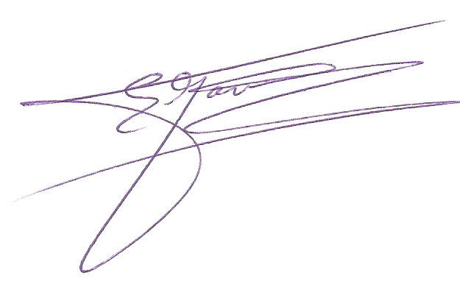 | Date | Dec.27th 2016

For Tutor / Assessor Use Only
Total Marks
Marks Obtained
Percentage / Grade

