
Assignment Cover Sheet

Student Name: | Anna Steel
Student Number: | 2983
Course: | Diploma in Accounting and Finance
Assignment NO: | 001

Marking Criteria:
We expect the learners to write minimum one well expressed point in three lines against each allocated mark. This means one needs to write 15 lines with 5 well expressed points to get high grades for a 5 marks question.
For high grades use examples and illustrations where appropriate.
- Give short answers for the following questions: (18)
  - Define ‘Accounting’.
Accounting is the practical execution of detailed financial record keeping of a business entity or operation. It enables the ongoing tasks of summary and classification pertaining to transactions and events of a monetary and financial nature as well as the interpretation of the above records.
  - Explain the primary objectives of accounting.
The primary objectives of accounting can be described as follows:-
Record Keeping – This is the methodical task of recording data, keeping records of financial transactions that occur within a business or operation on a day to day basis. Record keeping is a fundamental part of accounting and the basis for all accounting objectives.
Determine the results of a business or operation - determining results is effectively the determination of profit and loss or income and expenditure for the business or operation. These statements will allow business operators to have a clear idea of net gains or loss the business or operation has sustained in a specified period.
Determining the productivity of a business or operation – Ascertaining the productivity of a business is key to its success. This is reflected through financial statements relating to income & expenditure, assets, liability and enables business owners to establish the success or the ‘health’ of their organization.
Correctly representing the liquidity of the business or operation – Liquidity of a business or operation refers to its ability to meet immediate and short term financial obligations, including basic outgoings as well as payment of dividends and repayment of loans. The liquidity of a business or operation is reflected in its financial records.
Safeguarding business properties – Included in the business or operations record keeping are records of assets which are essentially physical or intellectual items that are owned by the entity. By keeping accurate records of assets the business or operation is able to protect themselves against false claims.
Facilitation of decision making – The keeping of financial records and statements enable a business owner or operation to form analytical views about their business or operation and therefore aid them in decisions being made about their entity.
Legal requirements – There are numerous laws and legal requirements that govern business owners and operations. The keeping of accounting records is the only way to satisfy all of the legal obligations placed upon a business or operation.
  - Discuss the limitations of accounting.
Whilst accounting enables a business or operation to continually assess their value in terms of profits and liabilities through reporting, there are a number of limitations to accounting that can at times lead us to deceptive conclusions.
In theory, record keeping is an accurate way of establishing the financial position of a business or operation. However, there are many factors of a non-financial nature that impact the operation and financial standing of a business. Factors such as the ability of those managing the business (management skills) as well as the consumer market can have great financial impact on a business or operation. It is not possible for record keeping and account reporting to ascertain the effects of these on the business.
Because accounting relies on both actual information and assumed and projected information the accuracy of the information being generated by the accounting system put in place by a business or operation can be limiting. Assumed and projected information are subjective and therefore not accurate.
Something not able to be reported on in the financial statements of a business or operation is the true market value of assets. Conventional rules of accounting are applied to the value of assets held by a business. These assets can include both physical and intellectual properties. It is possible that some assets listed in the records actually hold no financial value at all. Therefore it is not a true representation of the value of assets held by a business or operation.
Through accounting procedures and financial reporting it is possible to inflate the value of a business. This is known as window dressing and occurs when those preparing financial records reflect an increased profit margin than is actually true.
An example of window dressing is where a company holds back payments that are due until required financial reports have been run to improve the appearance of the financial statements. Payments are then made after financial reporting is complete giving the impression there is a larger amount of cash available to the company than there actually is.
Changing price levels are another limitation of accounting. My understanding of this is that the value of money is able to change regularly. This is not something that can be reflected in the financial statements of a business or operation. An example of fluctuation in the value of money is exchange rates. A business or operation may base its financial calculations on an average of the exchange rate when it actually fluctuates on a daily basis.
  - Explain the term “recordative”.
Recordation is the actual process of registering the financial transaction in the official records of a business or operation. The information being recorded can include but is not limited to physical transactions of a financial nature, as well as depreciation of an asset(s).
Though I have found no reference to ‘recordative’, my understanding is that it means to bear or contain a record. The ‘books’ of a business or operation contain all of their financial records. The role of accounting is to collect raw data relating to the financial transactions of a business and keep a record of it.
  - What types of activities are included in data evaluation?
The following activities are included in data evaluation for accounting. Analysis is the main activity and can include the analysis of cash flow, analysis of profits and or loss, analysing varying financial statements as well as evaluating various options when deciding the financial path of a business or operation.

  - Outline the main functions of accounting considering the following groups; • Lenders, Employees, Customers - Please suggest information that each one is likely to need from accounting statements and reports.
There are multiple users of the information generated by the process of accounting. These include but are not limited to Investors, Customers, Employees, Government, Management, Creditors. Accounting provides information to each of these stakeholders in different ways that is pertinent to their own interests and requirements.
Lenders rely on accounting to inform them about the reliability of a business or operation. A lender will look to financial records and statements to determine the value or liquidity of a business and their ability to repay either a short term or long term loan. The financial statements of a business or operation will be used by a Lender to determine if they will do business with them or not.
Employees are an integral part of any business or organization. In todays professional work place an employee’s contribution can be crucial to the success or failure of a business entity. A motivated employee is far more productive than an unmotivated one. An employee, particularly a motivated one can use accounting to assess their own personal output in their role and within the business. Employees can also use accounting together with their employer to track and settle renumeration due to them as well as tracking of bonus’ due to greater productivity and profitability.
A profitable business does not exist without customers. Customers play a different role depending on the type of business. Customers will utilise information generated from accounting to assess the financial standing of a business and its ability to be reliable and continual.
- Discuss the role of accountants in modern business organisations. (4)
The role of an accountant will differ between organizations depending on their size, output and turn over. A small business may only require the accountant to record data and generate reports, where as a lager business may expect an accountant to not only manage the financial data of a business but also analyse the reports being generated and possibly provide advice based on the information being collected and generated.
Financial data management is essential to the running of any business or operation. The accountant is responsible for collecting the financial information of a business or operation and maintaining it accurately. With this information an accountant is able to accurately prepare financial reports that they can use to analyse the financial standing of a business or operation. With the information collected and analysed the accountant is then able provide advice or recommendations relating to specific financial concerns or situations.
An accountant is integral to ensuring that a business or operation is complying with their legal requirements such as taxation as well as their internal reporting deadlines to business owners or to investors/share holders.
- What is accounting cycle? Outline the basic steps included in accounting cycle. (4)
The accounting cycle refers to the complete ‘circle’ of accounting procedures and responsibilities. There are eight (8) steps to the accounting cycle, it’s referred to a cycle as it relates to a specified period of time and once the cycle is complete for the specified period it begins again.
Step 1 – Transactions – These are the physical financial transactions made by a business or operation and can include, sales, payment of loans, aquisition of assets, payment of wages etc.
Step 2 – Journal Entries – The journal is the first place the transactions are recorded. They are listed in chronological order that the transactions take place in. The journal can also be known by the name “book of original entry”.
Step 3 – Posting – The journal entries of each transaction are posted to the relevant account. These accounts form part of the business or operation’s General Leger. The General Leger is where you can find a summary of the accounts.
Step 4 – Trial Balance – At the end of an accounting period the trial balance is prepared. This can take place monthly, quarterly or annually. The purpose of preparing a trial balance it to make sure the business or operations book keeping entries are correct and therefore ‘balance’.
Step 5 – Worksheet – Often when calculating the trial balance for the first time discrepancies appear. Whilst tracking where the errors are, a worksheet is used to record them. Once all errors have been identified the trial balance is redone to ensure accuracy. Items that can be found on a worksheet include depreciation of assets or one time payments that require money to be allocated to them on a monthly basis.
Step 6 – Journal Adjustments – Posting adjusted journal entries occurs once all errors have been identified and your trial balance reflects all accounts are in balance.
Step 7 – Preparation of Financial Statements – Once the trial balance is accurate the financial statements of the business or operation are prepared, these include profit and loss statements as well as the balance sheet.
Step 8 – Closing the Books – The final step in the accounting cycle is to close the books. The books are closed for revenue and expense accounts at the end of the accounting period and cycle begins over with a zero balance in the accounts.
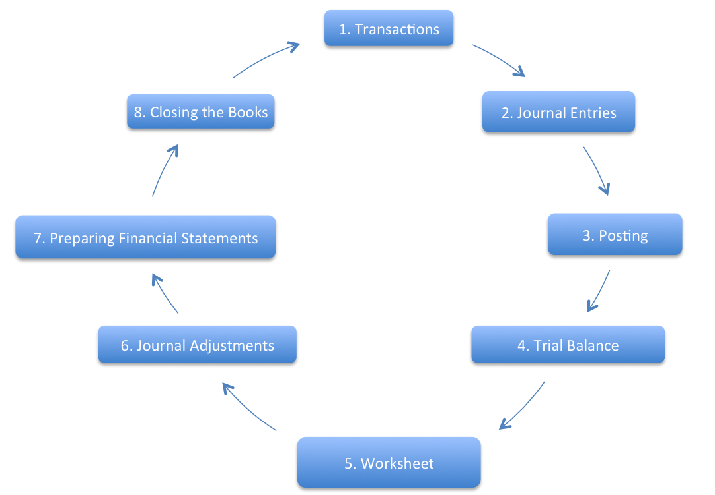
ACTIVITY (4)
List the various accounting activities that an organisation under takes and give reasons for each as to why that particular activity is performed in the organisations.
- Record Keeping – Records are kept to enable a business or operation to assess is success in the market. It also enables a business or operation to comply with government regulations and laws that it must adhere to.

- Data Analysis – Analysing the data recorded through record keeping enables a business or operation to judge its health or success in the commercial market.

- Preparation of Financial Statements – Financial statements are the tools used by business owners and operators as well as accountants to make decisions about the ongoing performance of the business or operation.

- Compliance – A business or operation must comply with varying regulations to satisfy government bodies and laws. They do this through financial reporting.

- Data Analysis Reporting – Reporting on the data benefits the business or operation and enables them to make decisions that effect its future.

- Physical Transactions – These are performed in order to make and receive payments of all types.

Student Statement:

By submitting this assignment, I confirm that this is my own work.

Student Signature | ANNA STEEL | Date | 27/10/16

For Tutor / Assessor Use Only
Total Marks
Marks Obtained
Percentage / Grade

