
Assignment Cover Sheet

Student Name: | Yassim ELFASSI
Student Number: | 3405
Course: | Diploma in Logistics & Supply Chain Management
Assignment NO: | 1239576766SUPPLY CHAIN ASSESSMENT 1

Marking Criteria:
We expect the learners to write minimum one well expressed point in three lines against each allocated mark. This means one needs to write 15 lines with 5 well expressed points to get high grades for a 5 marks question.
For high grades use examples and illustrations where appropriate.
Please insert your completed assignment ( in word format) here:

1. Give short answers for the following questions. (12)
i. Outline the main benefits of a supply chain.
Supply Chain are developed to beat the gaps, which are formed when suppliers are some distance away from consumers. They permit for operations that are best completed – or can simply done – at locations that are far-away from sources of materials or customers.

ii. Companies in any supply chain can make their decisions individually and
Collectively in five areas. What are these areas?
These areas are Production, Inventory, Location, Transportation, Information

iii. How is a modern supply chain different from that of the past?
Old Supply Chain way was vertically integrated business serving slow-moving mass market once tried to own much of their Supply chains.
The Modern Supply Chain way needs to be more flexible and receptive to face the high speed moving market and businesses perform “Virtual Integration”. Companies locate other companies whom they can work with to carry out the activities called for in their Supply Chain

iv. What is Inventory Management?
Inventory management is the process of ensuring that a company always has the products it needs on hand and that it keeps costs as low as possible.

v. ‘Information’ is one of the five drivers of supply chain. Discuss the purpose of
Information in a supply chain.
Information is utilized for two purpose:
• Coordinating Daily Activities related to the implementation of the
other 4 main Supply Chain drivers (Production,
• Forecasting and planning to foresee and convene future demands.

vi. Name various types of inventory. Inventory, Location, and Transportation).
• Cycle inventory
• Safety Inventory
• Seasonal Inventory

2. “Location decisions have strong impacts on the cost and performance
Characteristics of a Supply chain.” Discuss (5)
When making location based decisions, managers are required to consider various
factors that relate to a given site including the cost of facilities, labor cost, skills
Available in the workforce, transportation conditions, taxes and tariffs, and the
Nearness to suppliers and consumers.

Location decisions are fairly strategic decisions as they involve large amounts of
Money to long-term plans. Location decisions have powerful impacts on the
Performance and cost of characteristics of a supply chain. Once the number, size,
and location of facilities are determined it also helps in defining the Number of
Feasible paths through which products can run on the way to the end customer.
Location decisions depict a company’s fundamental strategy for building and
Delivering its products to market.

3. Write short notes on the following participants of supply chain: (5)
a. Producers
• For tangible items and industrial products
Shifting to areas of the world where there is LOW costly labors.
I would like to highlight that in the learning material page 17, it is saying the opposite: ………. to the world where there is costly labor….. Is this correct?

• Producers in the developed World Europe, America and some parts of
Asia are increasingly producers of non-tangible items and services.

b. Distributers
• Distributors are businesses that take inventory in mass from producers
And supply a bundle of associated product lines to consumers.
Distributors are termed as wholesalers.
• Distributors cushion the producers from variations in product demand by
stocking inventory and doing a lot of sales work to discover and service
Consumers. For the consumer, distributors complete the “Time and
Place” function—they supply products when and where the consumer
Wants them.

c. Retailers
• Retailers stock inventory and sell in lesser quantities to the common public.
This business also closely tracks the demands and preferences of the consumers
That it sells to.

Case Study (8)

• Describe the supply chain for milk.
Milk moves through a farm, tanker collection, dairy, bottling plant, distributor,
supermarket and end consumer

• Where does PE Dairies fit into this? What specific activities form the logistics in PE
Dairies?

- PE Dairies acts like a Distributor.
- Job lot storage
Cycle inventory

• What are the main problems that PE Dairies has with logistics?
- Carrying the right quantity according to customer’s demand
- Keeping waste below 2%
- Maintaining service during holidays
- Maintaining Sales over the long term

Student Statement:

By submitting this assignment, I confirm that this is my own work.

Student Signature | 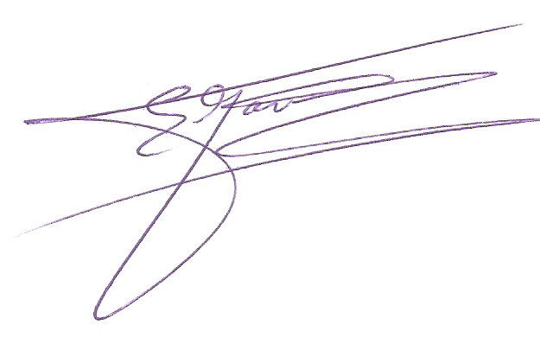 | Date | Nov.23rd 2016

For Tutor / Assessor Use Only
Total Marks
Marks Obtained
Percentage / Grade

