
Assignment Cover Sheet

Student Name: | Shweta Jewlikar
Student Number: | 1610
Course: | Diploma in Fashion Design Level 4
Assignment NO: | 1

Marking Criteria:
We expect the learners to write minimum one well expressed point in three lines against each allocated mark. This means one needs to write 15 lines with 5 well expressed points to get high grades for a 5 marks question.
For high grades use examples and illustrations where appropriate.

Give short answers to following questions.

- How did the First World War influence fashion? Which types of changes were brought about by it?
- The uncertain and upbeat times during the First World War slowed the growth in fashion but with this, some changes were brought. For instance, men’s jobs were demanding them to wear uniform and trousers so the materials used in old garments changed to fabrics such as wool used for uniforms.
- Women were taking new jobs as men were at warfront, and as a result the skin-tight clothes like corsets were replaced by more relaxed ones.
- In some professions like manufacturing and farming, the laborious nature of the job required that men shorten their hair to avoid excessive sweating.

- Describe the characteristic features of the Twentieth Century’s fashion scheme.
- In the Beginning of twentieth century (1910 through 1930s) there were many changes in fashion trends as below.
  - In 1910-1919, French fashion designer Paul Poiret introduced Sorbet pattern dresses and they became very popular.
    - Delphos gowns pattern and Hobble skirts as shown in fig 1 became quite famous in those times.
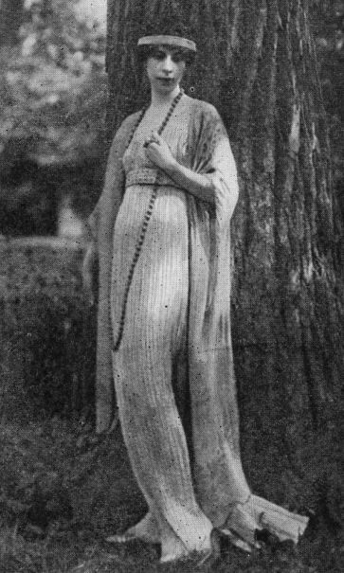
Fig 1.Delphos gown
    - Longer dresses called jupes culottes as shown in fig 2 were proposed but few seemed to like these.
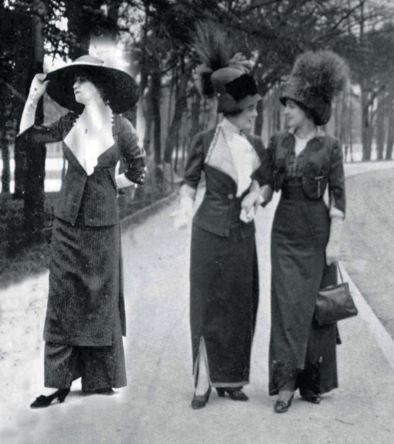
Fig 2. Jupes Culottes

    - The closely wrapped skirts having slits in the front, tunics that were gold-embroidered and turbans sporting feathers as shown in fig 3 were seen.
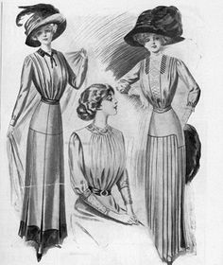
Fig 3.Wrapped Skirts
    - During the war, typically the suits became main stream, replacing uniforms.

  - In 1920s, the discovery of grave of Egyptian Pharaoh Tutankhamen influenced the fashion of short skirt which would partially cover knees.
    - Expensive fabrics such as Gold, Silver, Lamé monkey-fur fringe , and extensive embroidery started becoming more popular.
    - Jersey suits and knit jumpers also were introduced as shown in fig 4.
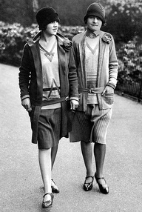
Fig 4.Jersey Suits
  - In 1930s wide pagoda shoulders were introduced by Schiaparelli while in 1936 the double-breasted suit with 4 buttons for men was introduced as shown in fig 5.
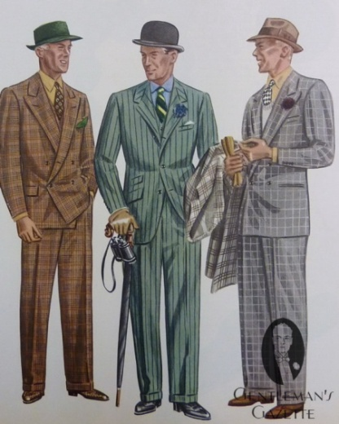
Fig 5. Double-Breasted Suits for men

- In mid twentieth century (1940s till 1960s), which was an austere period of World War II, fashion was relatively simplistic.
  - In 1940s the utility clothes were introduced by Government in England due to shortage of cloth material. Silk was replaced by wool stockings and socks.
  - In 1950s fabrics like Nylon, Perlon , elastics were introduced. Jeans and capri pants were popular among teenagers.
  - In 1960s came the swinging petticoats for teenagers and narrow sheath dresses for women.

- In late twentieth century (1970s - 1990s), following were the key characteristic features of fashion

  - In 1970s hippies were introduced. Also, wraparound tops and bell skirts became a norm as shown in fig 6.
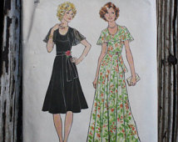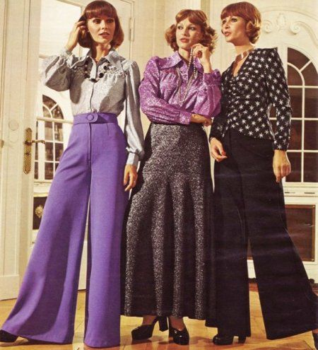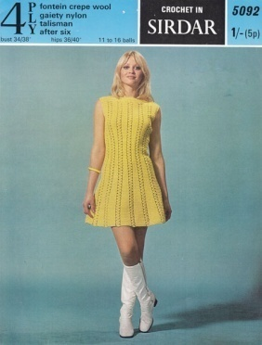
Fig 6.1970s Dresses
  - In 1980s leather skirts and pants suits were introduced. For men collarless jackets and yuppie suits were introduced, few of them are shown in fig 7.
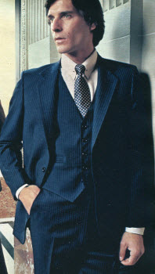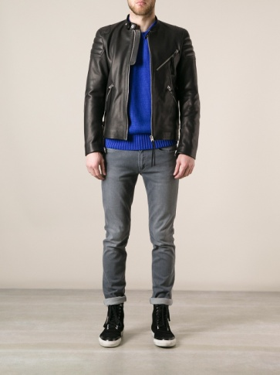
Fig 7.Yuppie suits and Collarless jacket
  - In 1990s leggings, calf-length skirt (shown in figure 8), long blazers, Cargo pants became popular

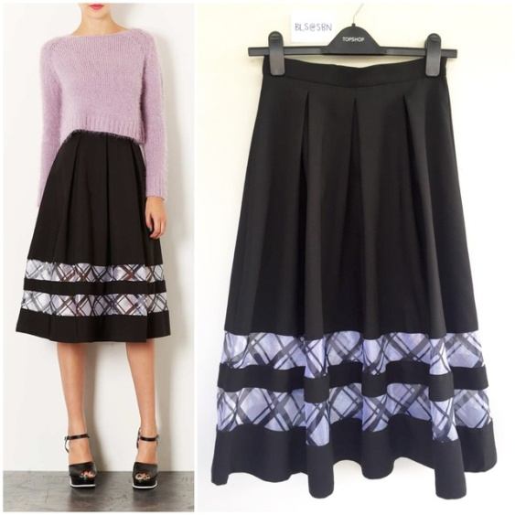
Fig 8.Calf-Length Skirt

- Write brief note on the works of main fashion designers in the 1970s.
- Diane Von Furstenberg (1974) introduced silk wrap-around dress for women and it was suited for all sizes as shown in fig 7.

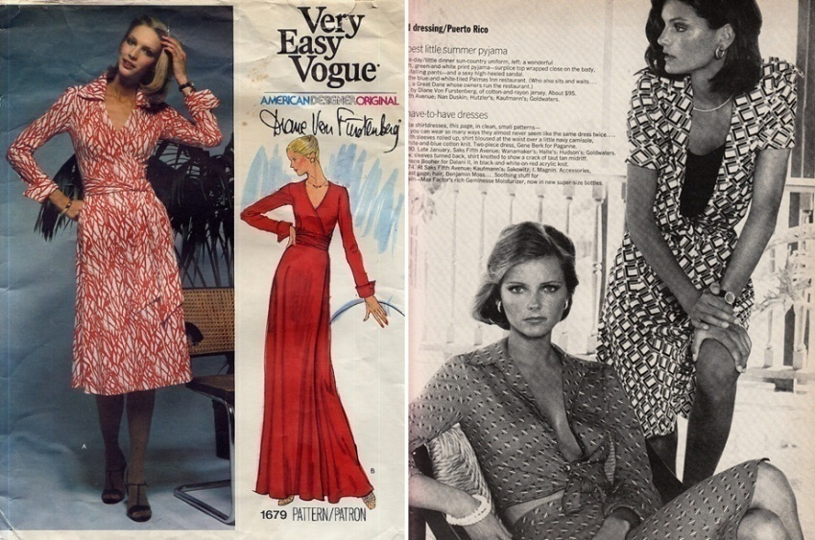
Fig 7. Silk warp
- Giorgio Armani presented his first collection of men's ready-to-wear clothes for spring and summer 1976 under his own name as shown in fig 8. He also produced a women's line in the same season.
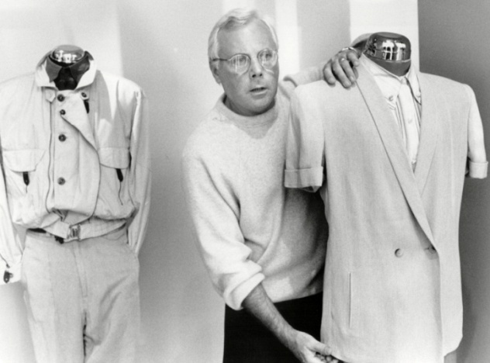
Fig 8. Men's ready-to-wear

- Halston introduced draped gowns and the jersey halter dress as shown in fig 9.

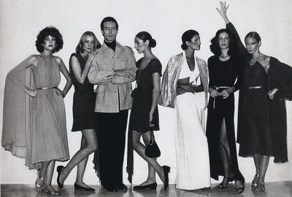
Fig 9. Halter Dresses

- Calvin Klein added sportswear, classic blazers (shown in figure 10) and lingerie to his women's collection.

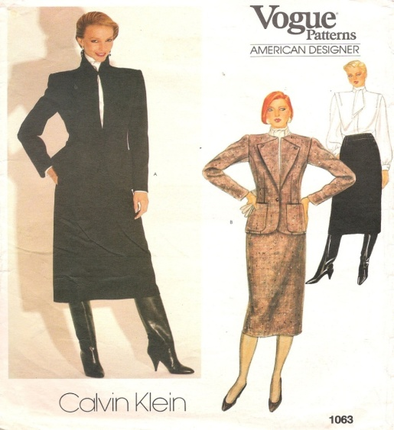
Fig 10.Classic Blazers

- Ralph Lauren in 1970 introduced new menswear line. This was the first time Polo emblem was presented on the cuff of the suit. He further unveiled the collection for women that was available in 24 colours and soon became a classic. Fig 11 shows few of his collections.
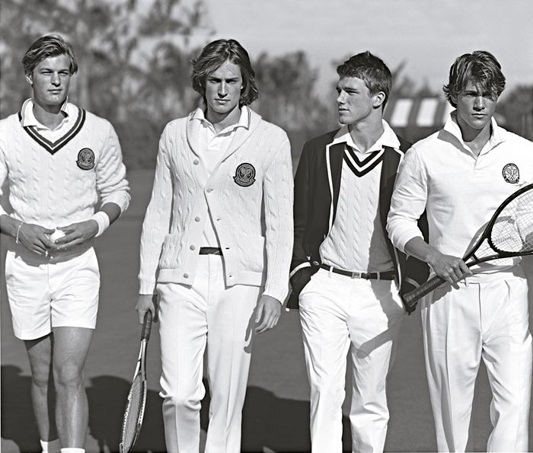
Fig 11.Pollo Collection

- Roberto Cavalli brought a trend of printing on leather, jeans made of printed denim as shown in figure 12.
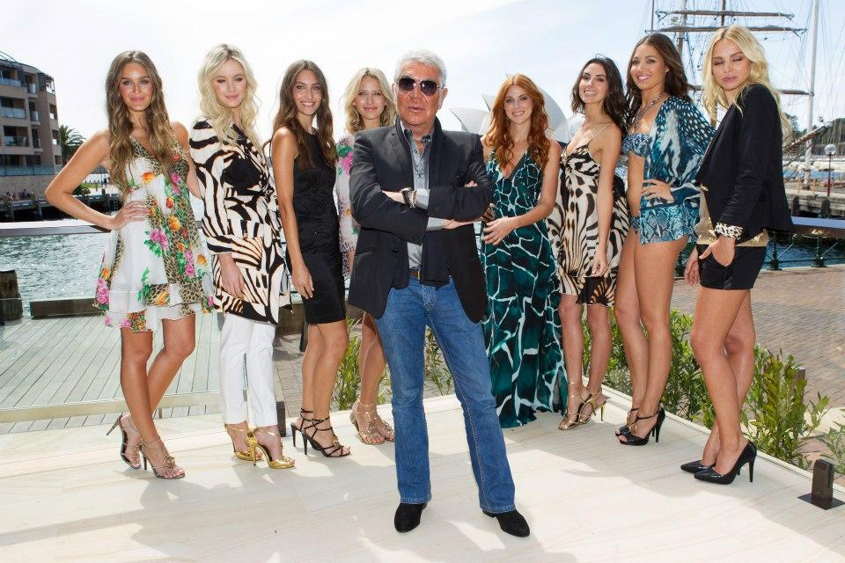
Fig 12.Wild Print Collection

- Yves St Laurent introduced Safari suits for men and women, as shown in figure 13, which received a good reception and their appeal has remained even in 21st century.

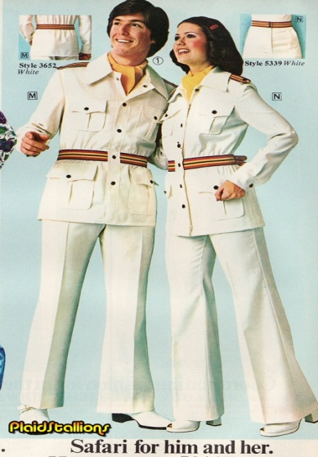

Fig 13.Safari Suit

How did the Nineteenth Century influence the fashion industry? What major changes came about in fashion industry in the early Nineteenth Century and why?

- There were some major developments in fashion industry in nineteenth century:

- Ditto suits as shown in figure 14 were introduced by the end of the century for men and thus came a trend of ready-to-wear clothes, but this costed many tailors their careers.

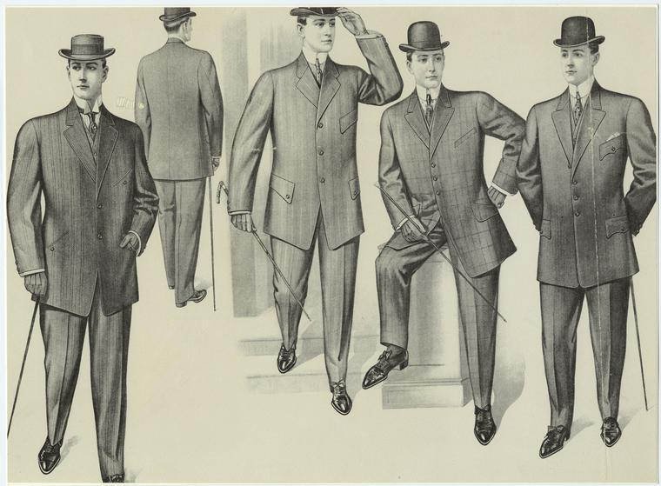
Fig 14.Ditto Suits

- Overall, the tone of men's clothes became less flamboyant. E.g. well groomed icons such as George Beau Brummell started wearing dark jackets with collared shirts and trousers instead of waistcoats. This simplicity in attire for men is reflected in present day as well in the form of dark suits and tuxedos as shown in figure 15

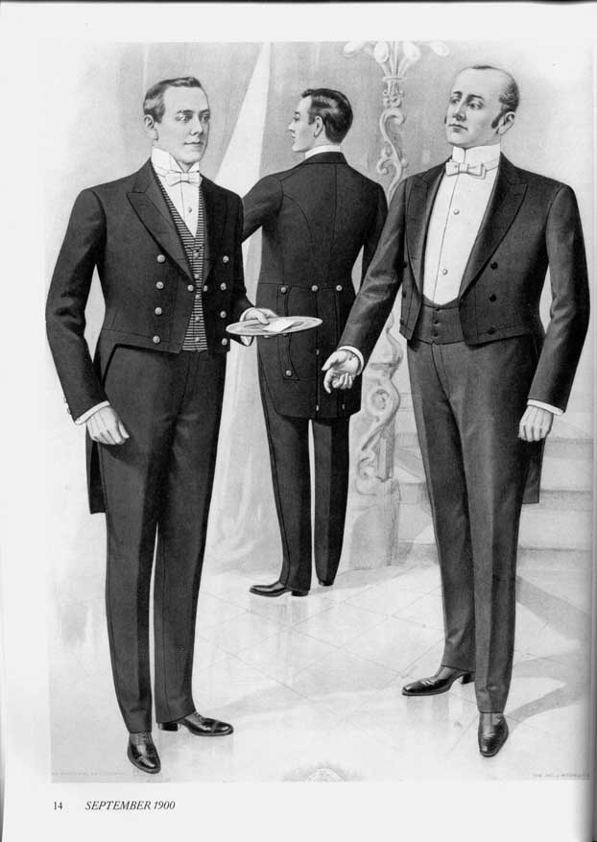
Fig 15. Tuxedos Suit

- While the clothes for men became more somber, the fashion trends for clothes for women changed quite dramatically. Clothes started revealing more of women's bodies than ever before. Large dresses sporting heavy ornaments and having huge sleeves started becoming common as shown in future 16.

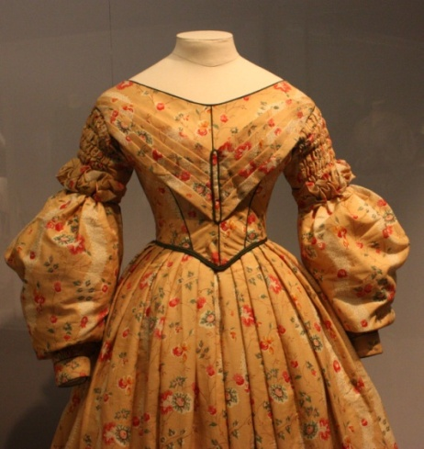
Fig 16. Large dress with huge sleeves

- Over time the clothes started getting slimmer and tighter as the importance of slim waist grew to such an extent that women would compel their daughters to wear corsets to make them more desirable to potential husbands.

- Major changes came in early 19th century:

- As discussed earlier, the use of machines in manufacturing of the clothes expedited the production of garments.
- Women started sporting hats with feathers and lace, and at the same time the shawls and overcoats started becoming mainstream. Eastern and Egyptian influence was seen over jewelry.
- Changes like raised back waist also were seen but later the trend of decoration along neckline along with skirts shaped as cone developed as shown in figure 17.

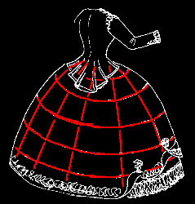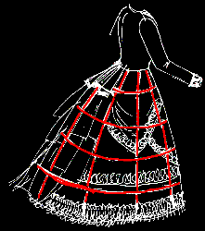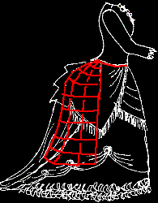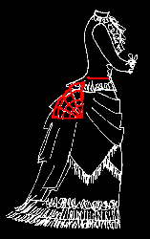
Fig 17. Different Shape Skirts in 19th Century

- Men started sporting linen shirts with high collars and tall hats. Later came the trend of body-tight single-breasted tailcoats as shown in figure 18.

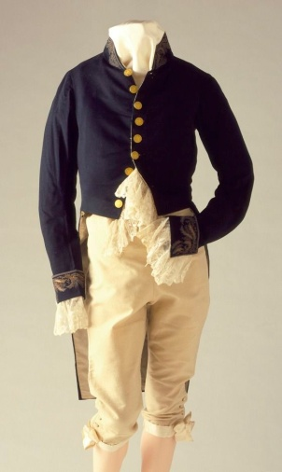
Fig 18. Single-breasted Tailcoat

- Reasons for changes in fashion in 19th century.

- Sewing and weaving machines and other appliances operated by electricity, new dye formulas, and other inventions contributed to the revolution in clothing manufacture.
- Women's clothing started sporting embellishments and machine-made trimmings as the use of machines became mainstream
Activity
Look through some old magazines; cut out pictures showing the fashion trends of the last two decades. Also, find some photos from the latest fashion shoots and compare them. How does modern fashion dresses differ from those of the past? Discuss in a report.
- In 1990s, the fashion was influenced by ongoing developments in technology. The modern style of clothing such as bare midriff and two piece formal and grunge as shown in below figure 19 began appearing.
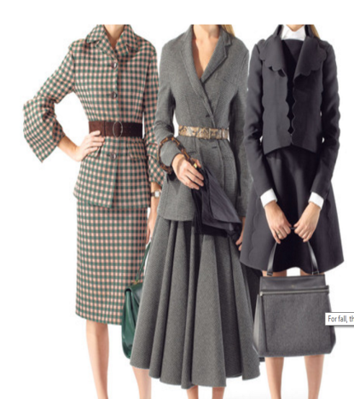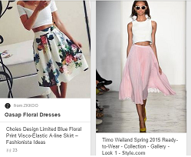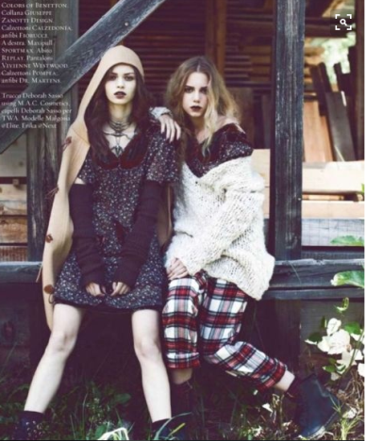
Fig 19: Twp piece suits, midriff and grunge
- There was a trend of loose and colourful T-shirts and longer shorts, along with the tapered pants as shown in figure 20.
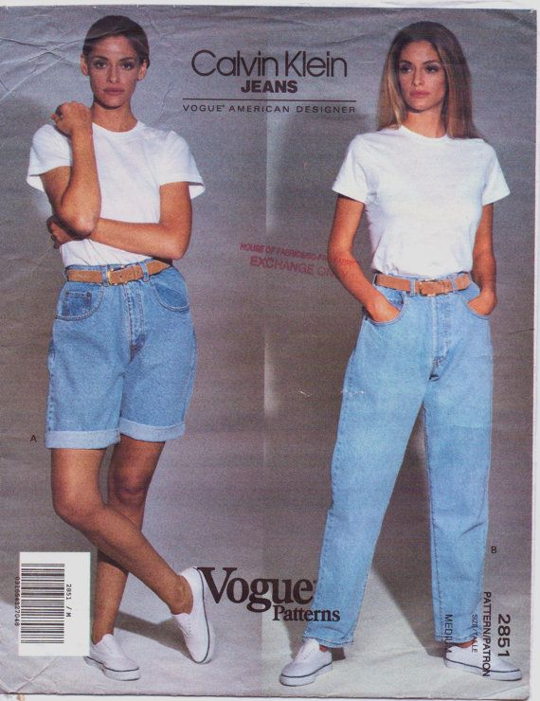
Fig 20.Tapered pant and long shorts
- The most popular daytime dress still was the jacket and the most popular eveningwear was the slender black dress which was worn with black stockings and high-heeled shoes as shown in figure 21.
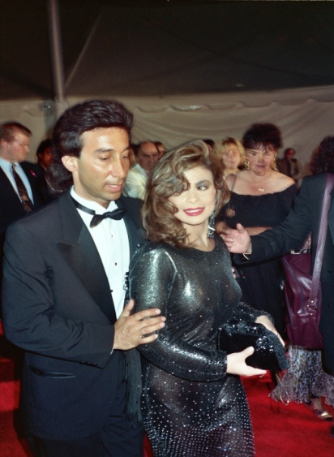
Fig 21. Black dress
- There was appeal of denim jackets, as shown in figure 22, to younger people.
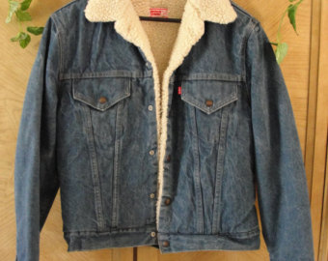
Fig 22.Denim Jacket
- Fashion in 1992 was relatively subdued and black was the popular colour. Women who didn’t like skirts preferred pants with flaring boot-cuts (shown in figure 23) at work.
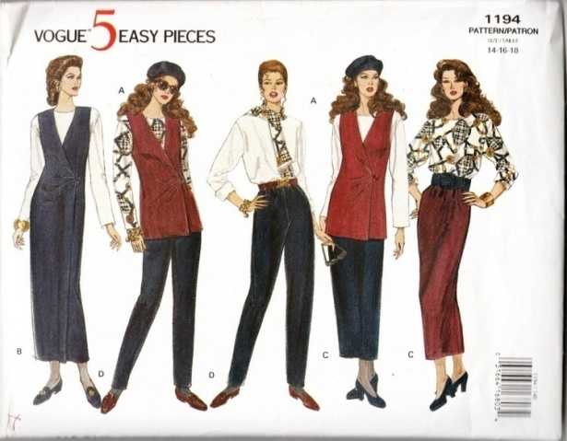
Fig 23.Women in pants
- The animal prints were popular in 1992 and there was a high demand for prints resembling skins of animals such as tiger, giraffe and leopard as shown in figure 24.
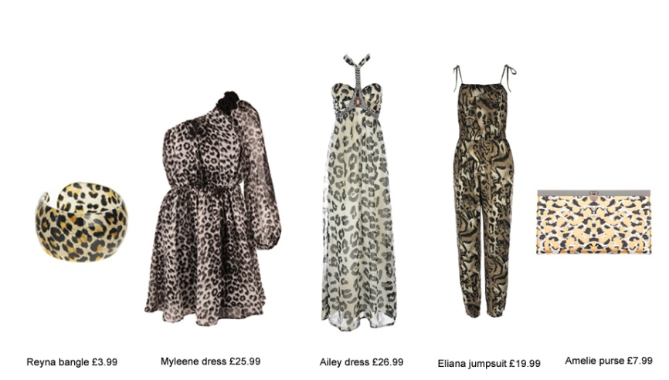
Fig 24.Animal Prints
- Fat cotton T-shirts soon replaced skin-tight T-shirts. Military style jackets as shown in figure also became popular.
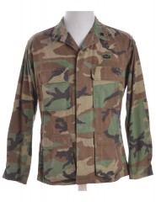
Fig 25. Military Style Jacket

- When the new millennium kicked off, fashion still had an influence of modern era and metallic, shiny colours and straps/buttons became popular in clothes. The dark and reflective tone of the texture of the clothes attracted young crowd, as shown in figure 26.
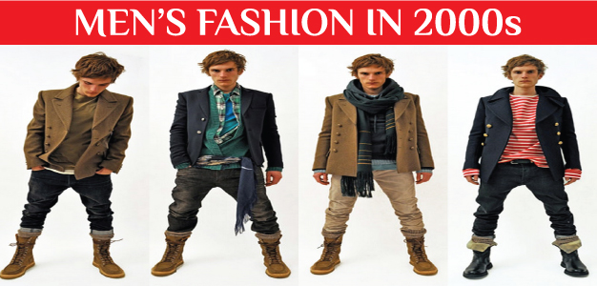
Fig 26. Men’s Fashion in 2000s
- In the early 2000s, the minimalistic styles of 1990s was recycled by fashion designers. The trend later drifted towards adapting more colourful and anti-modern look.
- At the same time the unisex style of 199As for women morphed into feminine and exotic dresses kike denim miniskirts (figure 27) and jackets, ripped jeans and flip-flops.
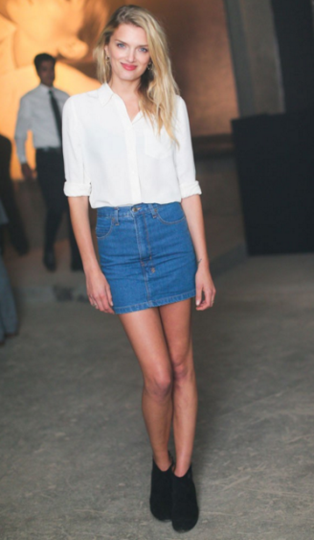
Fig 27. Denim Miniskirt
- In mid 2000s, women preferred low rise skinny jeans and tunics with wide or thin belts. Longer tank tops with blouse and leggings were popular too. Figure 28 shows sample Capri pants.
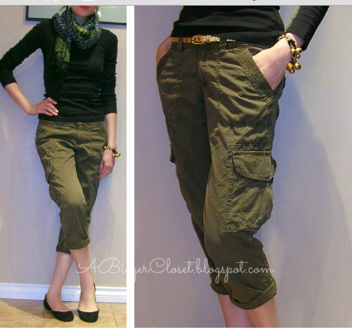
Fig 28.Capri Pants
- In the late 2000s, ballet flats, leather jackets and Ed Hardy T-shirts (figure 29) became a new trend. Black leather jackets, and knitted V-neck sweaters were popular as well. For formal wear, men preferred off-beat two buttoned blazer with matching trouser over classic suits with three-buttoned jackets.

Fig29. Ed Hardy T-shirts
- Floral prints became popular again, along with fur jackets as shown in figure 30.
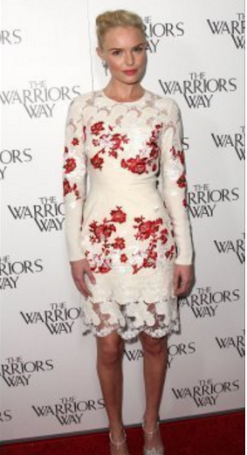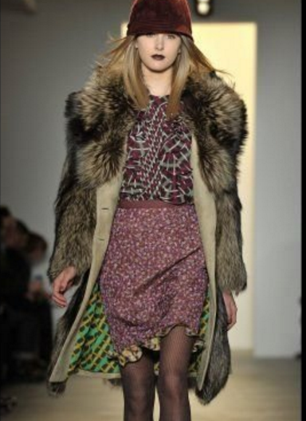
Fig 30. Floral Print and Fur Jacket
- Bigger scarves round the neck, as shown in below figure 31, became more popular.

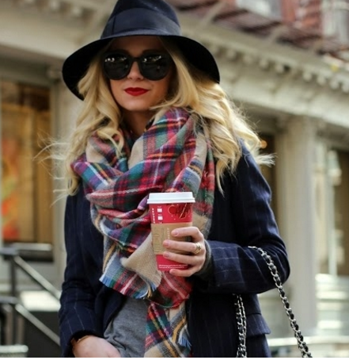
Fig31. Bigger Scarves
- Skater dresses started seeing more takers as shown in figure 32.
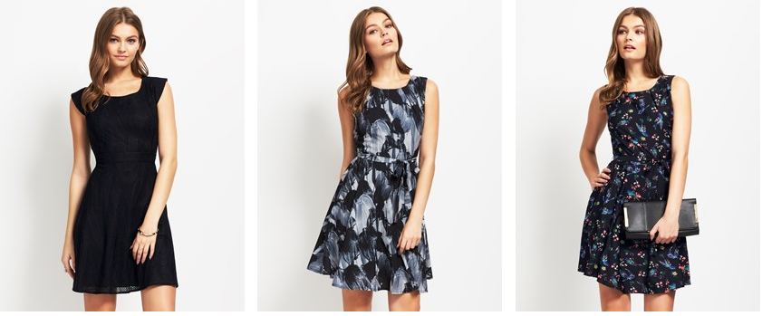
Fig32. Skater Dresses.

- Peplums started replacing the bare midriffs which were a norm earlier, as shown in figure 33.
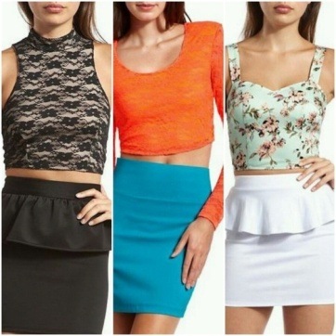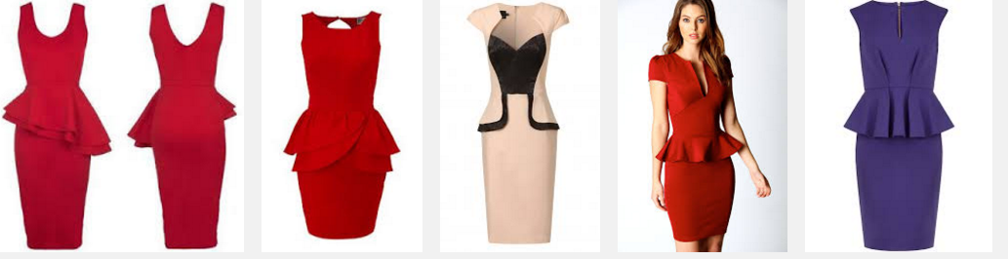
Fig33.a Bare Midriffs Fig33.b Peplums

- There was a gradual change in the taste as skinny and tight pants were preferred over lose and baggy pants popular in the past decades as shown in figure 34.

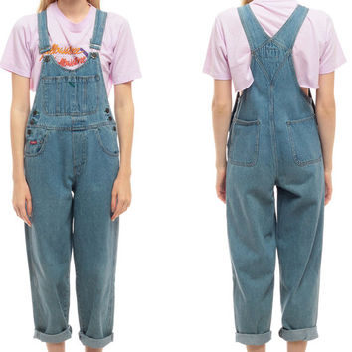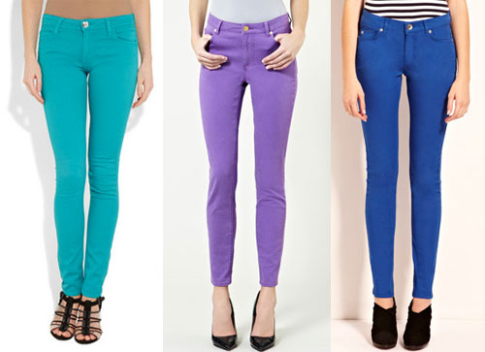
Fig34.a Baggy Pant Figure34.b Skinny and Tight Pants

- Skin-tight jackets started replacing the puffy jacket popular in the past, as shown in figure 35.
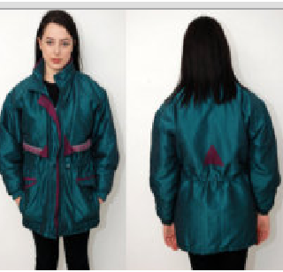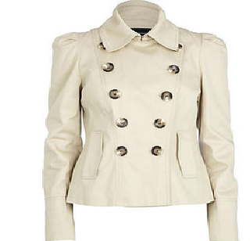
Fig35.a Puffy Jacket Fig35.b Skin Tight Jacket

Student Statement:

By submitting this assignment, I confirm that this is my own work.

Student Signature | Shweta Jewlikar | Date | 15/02/2016

For Tutor / Assessor Use Only
Total Marks
Marks Obtained
Percentage / Grade

