
Brent
Assignment Cover Sheet

Student Name: | Mery Ann Alaba
Student Number: | 1406
Course: | Fashion Design
Assignment NO: | Assessment 5

Marking Criteria:
We expect the learners to write minimum one well expressed point in three lines against each allocated mark. This means one needs to write 15 lines with 5 well expressed points to get high grades for a 5 marks question.
For high grades use examples and illustrations where appropriate.
Assessment 5

- Question

- In the textile industry weight and hand is very important, texture have a physical properties of weight size, bulk, shape light absorption and reflection. Also in hand there is a texture that can make one look heavier or thinner such as; Smooth, rough textures, soft and clingy, stiff fabrics-bulky fabric, shinny texture-dull texture

For all those categories you will identify what is the weight and also can
identify what is suitable for body size.

Hand texture is the element of design that describe surface appearance and feel sensory feeling understood by sight as well as by touch. It is quality of roughness or smoothness, dullness or glossiness, stiffness of softness.

There are various components to determine the texture;

Fibers
Yarn
Fabric
Finish

- There are 3 warm color in industry of textile of fabrics, Red, Yellow and Orange, all colors associate with fire and sun, and stimulating aggressive and lively.

Red – can use in a days of Valentine, love and Romance like a dinner date, when you wear dress in this particular events or days it gives more exciting fiery and like seduction look to your partner

Yellow – can be use in a summer day, bright, sunny, cheerful, friendly and optimistic, best to wear a summer clothes in a beach event and month of summer even though it is difficult color to wear due to the conflict of skin tones, but now a days most of the people even tan, or black using this color because of the adoption of the new fashion style.

Orange- It is a combination of red and yellow color, difficult to wear has a limitation in any occasion or activities to wear on, but for me this color is good for sportswear, summer as well as I said before adaptation in fashion is more approachable in any society right now, not afraid to wear any clothes either red, orange or bright color as long the design or style are inline.

- It is important to the designer the scale of pattern, to show a large print to its best advantage it should not be cut up with seams and details but rather allowed to be the most important element of the garment. On other hand, if a design idea begins with dominating lines and details, then the fabric must be plain and of secondary importance.

Pattern can be large part of how design looks, and the scale of the pattern should match your scale.

The selection of scale of textures should be analyzed in relationship to the
size of the person wearing them. A small sized body wearing large scale
textures can get lost in the textures because of the extreme contrast
between fabric surface and figure dimension.

On other hand pettiness is emphasized by the large-scale texture. Very
heavy people who wear large –scale texture will appear heavier because
there is repetition of size.

- The difference of conventional design & geometric is;

Conventional Design –is an object from nature is adopted to suit the purpose of the object and becomes decorative, the motif ceases to be naturalistic.

While the Geometric Design – is not derived from nature, it is derived from circles, rectangle, triangle, parallel lines and so on.

- 3 Color difference dimension

- Hue – enables us to tell one color from another, such as red from blue or green

- Value – refers to the use of darks and lights, it is variation of light strength in a color, the value scale runs from white & black.

The lighter values are called tints and the darker ones are called shades.

- Intensity – is the relative brightness (strength) or paleness (weakness) of a color. Bright colors are considered high-intensity, pale ones low-intensity. Generally, vivid color should be combined with others of the same intensity for balance.

- There are seven basic shapes of dress designing each season ;

- Triangle – Spanish style fitted bodice, bell gently widening skirt.
- Inverted Triangle – wide shoulders, narrow skirt, dolman or raglan sleeves. Good fashion design style for large bust.
- Oval – Draped and softly molded, very feminine and decorative. Good for proportioned, ideal figure especially suitable for afternoon and evening wear.
- Square – Straight or boat shaped neckline, boxy jackets, capes. Generally this style is very good for the very thin figure, however with proportions well planned and good design can camouflage various figure irregularities
- Round – Wide crinoline lined skirts, petal shapes, puffed sleeves, suitable for formal wear or afternoon frocks. This fashion design is the most attractive on the very young and the very thin figure.
- Hourglass – Wide shoulder, natural wasp waist. Smooth fit over hips and full skirt at bottom. Good fashion design for the tall thin figure.
- Combinations - Outline of any current fashion silhouette can be altered and combined with another, and adapted for the specific figure type. Thus irregularities or lack of ideal figure proportions can be minimized while the general effects of current fashion design style is preserved.

Project : I look “Majesty Queen Elizabeth II” Royal Collection and I Transform into a new combination for our life style.

Before

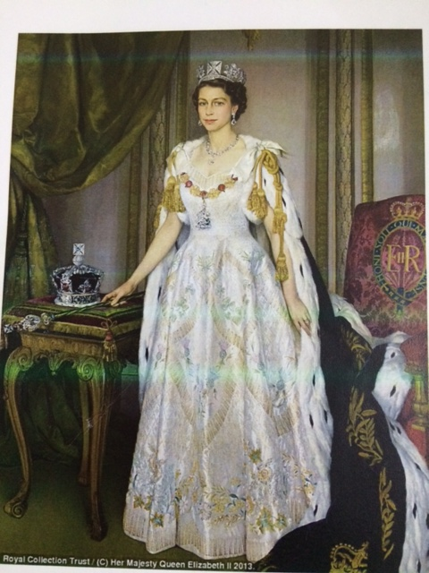

After
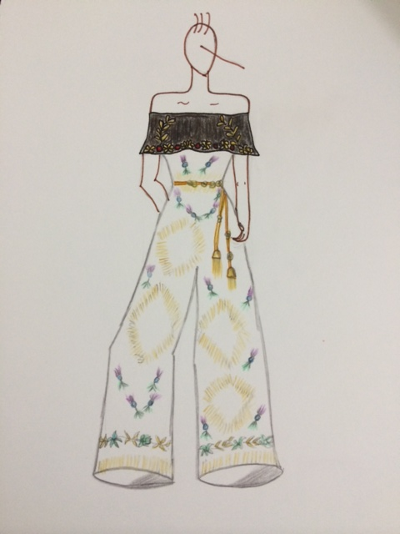

Student Statement:

By submitting this assignment, I confirm that this is my own work.

Student Signature | Mery Ann P. Alaba | Date | 4 June 2015

For Tutor / Assessor Use Only
Total Marks
Marks Obtained
Percentage / Grade

