
Assignment Cover Sheet

Student Name: | Ray Wilson
Student Number: | 1390
Course: | Environmental Management
Assignment No: | 5

Assignment 5 Total Marks: 30

1. What is Urbanization? How does it affect the environment? 10

Urbanization is a word for becoming more like a city. When populations grow, the inhabitants of a place may spill over from city to nearby areas. This is called urbanization. Maybe tall apartment buildings spring up on what had been the outskirts of town, bringing more people there to live and work.

The United Nations announced in 2008 that over 50 percent of the world's population now lives in these urban areas, a milestone in demographic history. This proclamation gave the distinct impression that the majority of people lived in very large cities however, only about 5 percent of the world population lives in the largest cities such as Shanghai, or New York or, sometimes referred to as metropolitan areas. The fact is that over half of the world's population live in places termed therefore it is useful and important to know just how the term "urban" is defined.
In most countries, a large part the urban population actually lives in relatively small towns and villages. The urban population may also be thought of more as nonagricultural than urban in the way those in industrialized countries would naturally tend to perceive it. In its most recent urbanization estimates and projections, the UN Population Division recognized that when urbanization is discussed, "the focus is often on large cities, cities whose populations are larger than many countries."
It is estimated by some sources that the world's urban population will grow by 1.8 percent per year and by 2.3 percent per year in developing countries during 2007 to 2025 and although these are both rather high rates of growth, it is countered by the forecast that by 2020, the world's rural population will cease growing altogether and begin to decline.
In part, the world's urban population will continue to grow simply because towns and villages not considered urban today will grow over time. Equally important, migration to urban areas can be expected to increase as economies grow and the likelihood of earning a higher income in cities increases. Much rural-to-urban migration will take place as a result of hardship, as the rural and landless poor make their way to cities and towns in hopes of any employment. One such manifestation of such disparate reasons for migration is the Indian mega-city of Mumbai, which contains many of India's wealthiest celebrities and business leaders and a relatively comfortable middle class alongside a reported 54 percent of the population living in officially defined slums, similar to photo shown below.
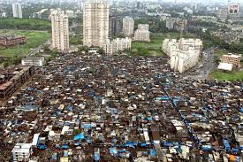 Statistics on the percentage of the world's population living in urban areas also hide the nature of places deemed urban. For example, "urban" is an entirely different experience in many areas of Africa from what it might be in a developed country. In developing countries, many urban residents live in settlements with little access by road, limited availability of electricity, and little or no access to clean water or basic sanitation. The classification "urban" does not automatically mean that the population has become literate or lost its traditional rural values and social customs. In developed countries, the rural population, on the other hand, often has the same access to amenities and services as urban areas and is almost indistinguishable from the urban other than by location or size of place. Excellent road connections, communications, cable TV and Internet, and access too many of the same services and shopping facilities have rendered the urban-rural difference less relevant in developed countries than it once was.
As with any statistical definition, it is always wise to look "under the hood." The world is rapidly becoming more urban; the number of mega-cities in the developing world will grow over the next few decades as cities such as Kinshasa, Lagos, and Jakarta are projected to grow to well over 10 million people by 2025. However, "urban" is not a homogenous term and most of the world's urban population will continue to live in small towns and areas that are a far cry from large cities with skyscrapers and bustling traffic as illustrated below.
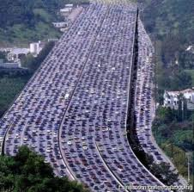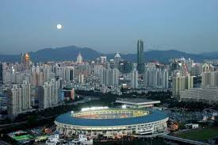

All the aforementioned has resulted in environmental deterioration in a number of ways, such as,
- Encroachment of agricultural and fertile land for housing, industries, construction of roads, dams and other infrastructures needed urbanization
- Depletion in water resources due to increase in the water requirement
- Pollution from the industrial and other urban activities
- Emergence of slums, which deteriorate the surrounding areas.

Urban people change their environment through their consumption of food, energy, water, and land. And in turn, the polluted urban environment affects the health and quality of life of the urban population.
People who live in urban areas have very different consumption patterns than residents in rural areas. Clearly urban populations consume much more food, energy, and durable goods than rural populations. This increased consumption is a function of urban labor markets, wages, and household structure.
Urban consumption of energy significantly affects the climate and helps create heat islands that can change local weather patterns and weather downwind from the heat islands. The heat island phenomenon is created because cities radiate heat back into the atmosphere at a rate 15 percent to 30 percent less than rural areas. The combination of the increased energy consumption and difference in radiation means that cities are warmer than rural areas (0.6 to 1.3 C). And these heat islands also become traps for atmospheric pollutants. Cloudiness and fog occur with greater frequency. Precipitation is 5 percent to 10 percent higher in cities; thunderstorms and hailstorms are much more frequent, but snow days in cities are less common. A simplistic profile is shown below;

- 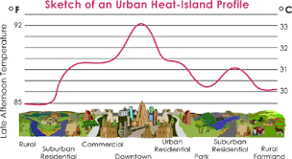

Like energy use and weather patterns identified above many of the effects of urban areas on the environment are not necessarily linear. Bigger urban areas do not always create more environmental problems. And small urban areas can cause large problems. Much of what determines the extent of the environmental impacts is how the urban populations behave — their consumption and living patterns — not just how large they are. Some of these effects are itemized as follows;
- Cities and towns expand due to the ever growing needs of human beings. Therefore they need to survive on the land that is available to them to build large numbers of buildings, more roads, factories, parking places, etc. For all these, land is secured either by diverting agricultural land or by cutting forests. As they grow these communities occupy the productive crop lands and rich forests that surround these societies. Therefore, the land with all its biological resources is irreversibly lost.
- The water requirements of these sprawling urban municipalities also increases as they grow and almost all of it has to be met through the water supply system that is in place. These infrastructures are often outdated however and incapable of sustaining the ever increasing demands required.
- Construction of houses, hotels, office blocks and other structures need large quantities of building materials and inevitably this demand is met from quarries, forests and other environmentally sensitive sources.
- Industrial and leisure developments, such as offices, mega shopping centers and industrial estates almost go almost hand in hand now with modern day urbanization and these clearly take up land and use invaluable resources from locations identified above.
- In some locations, especially around the world, beaches, lakes and rivers are often filled to create land to accommodate the growing population. In these places, such as Singapore and Dubai, natural habitat is disturbed and often destroyed. These communities often introduce new types of plants and animals. For example, dogs, horses, cows and other domesticated animals, are often kept and maintained. This urbanization also attracts another class of animals and pests such as rodents, carrion, mosquitoes, houseflies, etc. whilst the loss of the original wildlife goes with saying as a direct cause of this evolution.

2. Discuss the environmental problems faced by the inhabitants of the cities caused by Urbanization. 10
While there is now universal agreement that urban environmental issues are vitally important to maintain the earth and its resources, there is still surprisingly little coherence in how international agencies and others define the urban environment and identify its critical problems. Ultimately this definition is intimately related to how and where funds are allocated and to who can expect to benefit from the resulting environmental improvements. Most of the confusion however arises from the qualifier ‘environmental’ and what it should mean in an urban context as summarized next.

If urban environmental problems are defined and pursued too broadly, then almost all urban development initiatives can be labeled environmental. But if urban environmental problems are defined too narrowly, many of the generalizations noted in the introductory paragraph cease to be true. For example, defining urban environmental problems as ‘the degradation of urban water, air and land’ excludes many of the environmental health problems suffered predominantly by the poor, as well as the extra-urban impacts that threaten regional and global sustainability.
While both very broad and very narrow usage are common in the literature, when people complain of ‘environmental problems’ they are typically referring to damage to the physical environment, mostly caused by other people, and usually with harmful consequences for human welfare, either now or in the future. So common sense suggests that urban environmental problems are threats to present or future human well-being, resulting from human-induced damage to the physical environment, originating in or borne in urban areas.
This definition includes:
- Localized environmental health problems such as inadequate household water and sanitation and indoor air pollution.
- City-regional environmental problems such as ambient air pollution, inadequate waste management and pollution of rivers, lakes and coastal areas.
- Extra-urban impacts of urban activities such as ecological disruption and resource depletion in a city’s hinterland, and emissions of acid precursors and greenhouse gases.
- The efficiency of many cities is adversely affected by traffic congestion and water pollution. The rising costs car/road maintenance and the treatment of contaminated water for industrial and domestic purposes are damaging the productivity of urban economies.
- Waterborne diseases are found most commonly in low-income neighborhoods as a result of inadequate sanitation, drainage and waste collection services. Health is also at risk due to pesticides and industrial effluents emissions.
- Uncollected and improperly handled solid waste can have serious health consequences. They block drainage systems and contaminate groundwater at landfill sites. Most cities are unable to manage the increasing amounts of hazardous wastes generated by rapid industrialization and this adds to the environmental issue as alternative land fill sites are used/developed.
- Conversion of agricultural land, reclaimed wetlands and forested areas, for metropolitan use and infrastructure, are associated with widespread removal of vegetation to support urban ecosystems and put additional pressure on nearby areas that may be already ecologically sensitive. Groundwater overdraft has led to land subsidence and coupled with over stressed drainage systems a higher frequency of flooding, particularly in the lowest-lying and poorest areas often takes place as illustrated below.
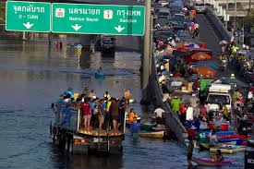
- Expansion in these towns and cities does not have only local environmental impacts but an adverse spin off is also the ecological effect it has beyond their immediate surrounding area. Demanding and extensive exploitation of natural resources to support the urban economies around the world includes excessive extraction of energy resources such as, quarrying, gravel/sand excavation and the use of building materials and the excessive extraction and use of water. All of these contribute to degradation of the natural support systems and irreversible loss of critical ecosystem functions, such as the hydrological cycle, carbon cycle and biological diversity, in addition to conflicts with rural uses of such limited resources.
It does not encompass:
- Problems in what are sometimes termed the ‘social’, ‘economic’ or ‘cultural’ environment.
- Natural hazards that are not caused or made worse by urban activity.
- The environmental impacts of urban activities that are of no concern to humans, either now or in the future.
There are of course some positive impacts to man and the environment such as higher population densities mean lower per capita costs of providing energy, health care, infrastructure and services. Also, urbanization has historically been associated with declining birth rates, which reduces population pressure on land and natural resources.
- 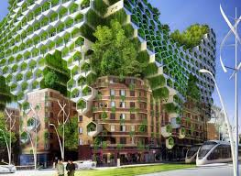

Of course even metropolitan areas can be adapted to make the environment friendlier to mankind and the artist’s impression above need not only be that, but can with the concerted efforts and funding off all, become the norm within urban city centers.

3. What Factors Contribute to Urban Population Growth? 10

Statically as a country evolves from a traditional to an advanced society, the part of urban growth that is due to net immigration follows a simple pattern, which can be described by an inverted U-shaped curve: it first increases, then passes through a maximum, and decreases thereafter. This hypothesis is confirmed by quantitative analysis using time-series and cross-section data. The analysis suggests that in the second half of this century natural increase often provides a slightly higher contribution to urban population growth than net immigration.

Global urbanization trends show that only about 30% of the world’s population lived in urban areas in 1950. This proportion rose to around 50% by 2007 and is projected that the urban share of global population in 2030 will be above 60%

Between 2007 and 2030, the world’s population is expected to increase by 1.8 billion and almost all population growth during this period will be in urban areas whereas the rural population will actually decrease by about 20 million. Clearly this is one of the major reasons for increasing urban population and another is the opportunities and services offered in urban areas — especially jobs and education, while in some cases, conflict, land degradation and exhaustion of natural resources in rural areas are also important. The patterns of rural-urban migration may be city-specific, reflecting, among other things, changes in the city’s economic base, labor market and age structure.

Most evidence available supports the theory that increasing the income and level of education of rural populations accelerates migration and this phenomenon, coupled with the greater access to urban areas, has led to an inevitable increase in rural population’s seeking employment opportunities in urban areas.

Globalization is often considered to be a reason for population growth and urbanization and echoes the fact that the size of the world’s economy has grown many times and has also changed from one dominated by relatively closed national economies or trading blocs to one where most countries have more open economies and where production and the services it needs, including financial services, are increasingly integrated internationally. Technology has increased the already dominant economic role and importance of urban areas worldwide, indicating the growing importance of cities, such as Hong Kong, Singapore and London, in the global economy.

The problems of population growth in urbanized areas has significantly been worsened by inapt incentive systems, such as the “growth-first” strategy adopted by the Governments of many countries, especially in developing countries. In order to attract investment, industrial promotion policies are designed to offer privileges and incentive packages, including low-taxes lax regulations and subsidized infrastructure, with target to urban areas. Industrial growth, combined with inadequate infrastructure, inappropriate pricing of resources and services, and inadequate institutional mechanism to ensure environmental protection, further accelerates environmental degradation in urban areas. All the factors mentioned above have contributed significantly to population and ultimately these Cities and Towns have expanded beyond their original limits.
Urban sprawl is basically another word for urbanization. It refers to the migration of a population from populated towns and cities to low density residential development over more and more rural land. The end result is the spreading of a city and its suburbs over more of the countryside. In other words, urban sprawl is defined as low density residential and commercial development on undeveloped land. Most of the time, people will move from these areas to try to find better areas to live. This has been the way of the world since the beginning.
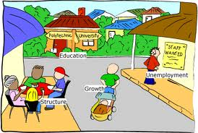
Migration and urban sprawl isn’t something that is just now becoming popular, as it has been around for quite some time and is driven by the needs some of the items illustrated in the caption above. Cities and their suburbs are now becoming overcrowded because of this, but the causes and the effects of the urban sprawl can be caused by a variety of different things. These population growth causes will mainly include;
- Lower Land Rates: Lower cost land and houses in the outer suburbs of the cities, because the centers of urban development have really made people want to stop settling in these areas and want to venture further out.
- Improved Infrastructure: There is increased spending on certain types of infrastructures, including roads and electricity. This is something that hasn’t always been available, and there are still some areas that don’t have these luxuries. That doesn’t mean that they aren’t working on it.
- Rise in Standard of Living: There are also increases in standards of living and average family incomes, which means that people have the ability to pay more to travel and commute longer distances to work and back home.
- Lack of Urban Planning: People love to find areas that are less trafficked and more calm, which leads them to sprawl out to other sections of the town. Unprecedented development, cutting of trees, loss of green cover, long traffic jams, poor infrastructure force people to move out to new areas.
- Lower House Tax Rates: Cities will usually have high property taxes, and you can usually avoid these taxes by living in the outer suburbs because the taxes are usually lower than they would be in other situations.
- Rise in Population Growth: Another factor that contributes towards urban sprawl is rise in population growth. As number of people in a city grows beyond capacity, the local communities continues to spread farther and farther from city centers and the photograph below illustrates a typical expansion in the suburbs of a city.
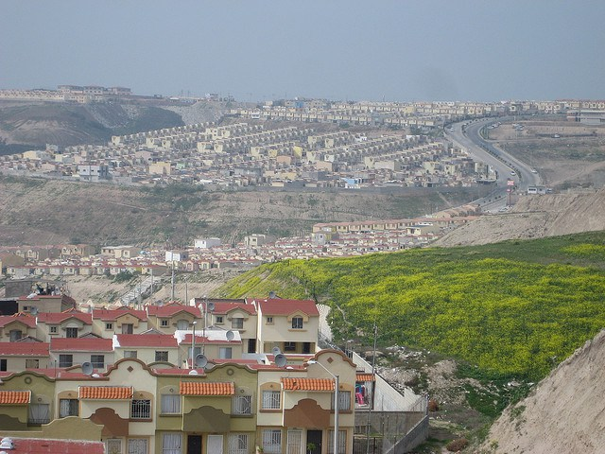
- Consumer Preferences: People in high income groups have stronger preferences towards larger homes, more bedrooms, bigger balconies and bigger lawns. This also causes urban sprawl as this option is not available in crowded cities. People generally look out for low-density residential areas where they can get home according to their preference.

Student Statement:

By submitting this assignment, I confirm that this is my own work.

Student Signature | Raymond Wilson | Date | 20th Apr 2015

For Tutor / Assessor Use Only
Total Marks
Marks Obtained
Percentage / Grade

