•

Fundamentals of Administrative

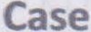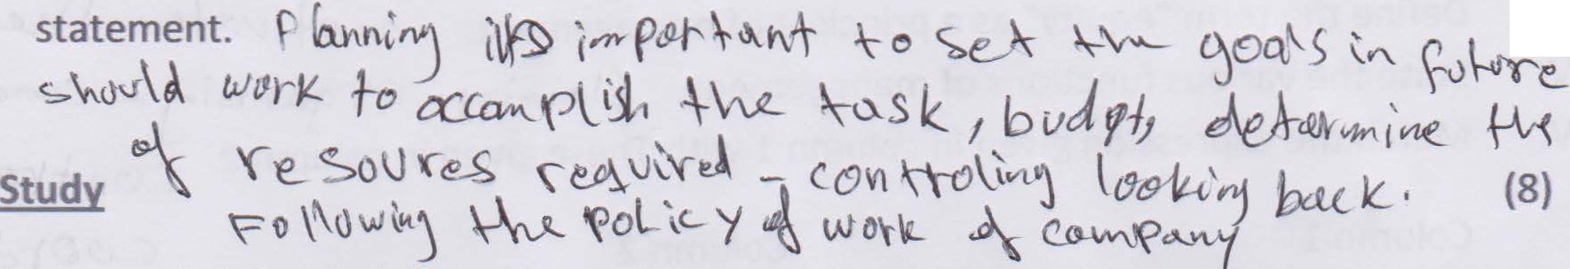Q.2. "Planning is looking forward;whereas controlling is looking back". Explain the

(7)

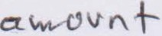

The directors of Vision Tech have reorganized their business. William Davis is now Chairman, Vijhay Singh finance manager, and Irene Rogers is the floor in charge (supervisor).

Keeping in view the above situation answer the following questions:

1. What is meant by the hierarchy of management?

2. How does William Davis know about any problem on the factory floor

3. Who determines the objectives for the business?

4. Who will ensure that the work is carried out properly and on time?

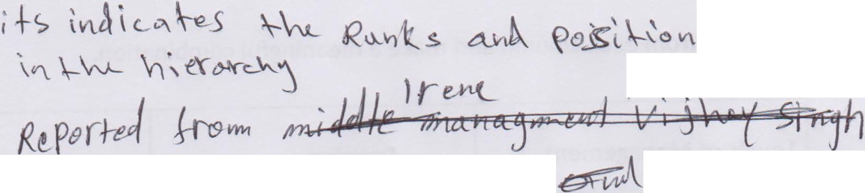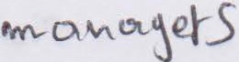

'

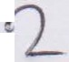

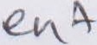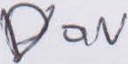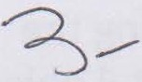

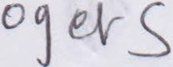L - 

Unit2 Business Administration Brentwood Open Learning College Page2

Fundamentals of Administrative

•
Assessment 2 Total Marks:30

Q: 1:Short questions: 15

I. Define the term "Management". \J\.v,._-\ vv"\.t>-."--1\ t'tS
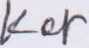II. List different levels of management. \ o '\> - )A\. 6.\ e__ - Lo l..v
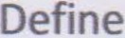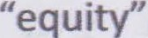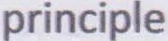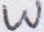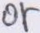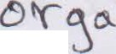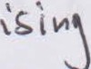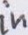Ill. 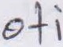 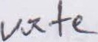 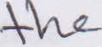 IV. 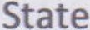  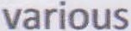    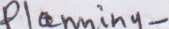  V. Match the expression given in column 1with These given in column 2 Ce>vt '(1? \I.V --

Column 1 Column 2 C' (9f>r'"' cl. \

a) Management as a discipline

b) Management as a process c) Management as a group

d) Management as a profession
i) team of managers

ii) code of conduct for professionals 
iii) developed and grown through practice and ( '£}

Research
iv} series of inter-related activities Q

i. The following table contains the function, position and different levels of management.

Pick one from each column and make a meaningful combination.

Levels of Management
Position Functions

(A) Top

a) Departmental Heads and

Managers.,---....

•
(i) Identifying the departmental objectives ,,.......
and guiding lower level

- . •
}.

towards achievement o those objectives



(B) Middle
b} Board of directors and chief executives
ii) Carrying out the operations and the•·:;.-r-
superv1•s1• on

(C) Lower
c} Supervisors and Forem
111 Defining the objectives
_...., •

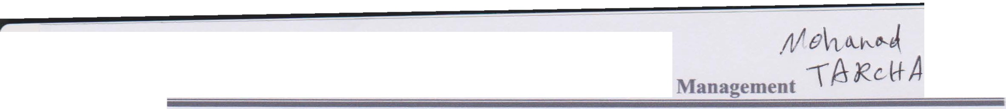and formulating the
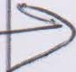policies

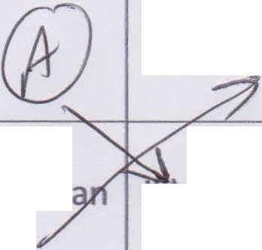Unit2 Business Administration Brentwood Open Learning College Page 1

