
Assignment Cover Sheet

Student Name: | Eguenu Ola Uwe
Student Number: | 2866
Course: | Diploma in Construction Management
Assignment NO: | 7

Marking Criteria:
We expect the learners to write minimum one well expressed point in three lines against each allocated mark. This means one needs to write 15 lines with 5 well expressed points to get high grades for a 5 marks question.
For high grades use examples and illustrations where appropriate.
Please insert your completed assignment (in word format) here:

- Materials management is defined as a management system which is required in planning and controlling the quality and the quantity of the material, punctual equipment placement, good price and the right quantity as required.

Furthermore, materials management can also be defined as the function responsible for the coordination of planning, sourcing, purchasing, moving, storing and controlling materials in an optimum manner so as a pre-decided service can be provided at a minimum cost. Hence, materials management is the process of management which coordinates, supervises and executes the tasks associated with the flow of materials to, through, and out of an organisation in an integrated fashion.

- Materials management encompasses all the aspects of the materials which includes materials cost, material supply and material utilisation. Materials management is concerned with material planning and material control activities. The Scope of material management involves the following;
- Materials planning and control
- Purchasing
- Stores management
- Inventory control

The various functions and objectives of material management can be described as below:

Material planning and control:
This is done based on the sales forecast and production plans. Material planning and control involves estimating the individual requirements of materials, preparing the budget for procuring the materials, forecasting the levels of inventories to determine quantities, scheduling the orders and monitoring the performance in relation to the production and expected output. The productivity of the construction project will be hanged if the material planning process is not implemented properly.

Purchasing:
This includes selection of sources of supply finalisation in terms of purchase, placement of purchase orders, follow-up, maintenance of smooth relationships with suppliers, approval of payments to suppliers, evaluation and performance rating of suppliers. For example, a detailed material list and co-ordination of the purchasing and order of material are significant to assure the material will be available on construction site.

Stores management :
This involves physical control of materials, preservation of stores, minimisation of obsolescence and damaged materials through timely disposal and efficient handling, maintenance of stores records, proper location and stocking. In addition, a store is also responsible for the physical verification of stocks and reconciling them with book figures. The store plays a vital role in an industry’s smooth operations.

Inventory Control :
Inventory generally refers to the materials in stock. Inventory control takes care of the ordering system, fixing the safety stock limits, fixing up the reorder level, the maximum and minimum stock level and reconciling them with book records. In addition, an effective control on inventory is a must for smooth and efficient running of the production cycle with least interruptions.

- Integrated material management is a systematic and dynamic process of management which coordinates, supervise and executes the tasks associated with the flow of materials throughout an organisation in an integrated manner.

The integrated approach of material management requires the material manager to be responsible for all interrelated aspects of the organisation by exercising control and coordinating activities of individual departments. By integrating the various functions under a central materials manager, the integrated approach makes it possible to transmit large chunks of data efficiently and more rapidly while also uniquely identifying activities for each department. Routing all functions of each individual departmental unit to a common material management hub makes it easier to coordinate and control all functions in an optimum manner.

The demerit of the integrated material management approach is that it is based on continuous observation and control is required in order to maintain and keep the system working.

Furthermore, good sales opportunities may be missed because the integrated material management approach takes into account the entire company and not independent functions. For example if purchasing department gets an attractive discount rates on sales offer, the department cannot place the order without considering how effectively these items would be stored hence, it creates problems for the storage and inventory departments.
- Vendor rating is the result of a formal vendor evaluation system in which vendors or suppliers are given standing, status, or title according to their attainment of some level of performance, such as delivery, lead time, quality, price, or some combination of variables. In addition, vendor rating is a system for recording and ranking the performance of a supplier in terms of a variety of issues, which may include delivery performance and the quality of the items. This evaluation helps to avoid disruptions in the production process, and a comprehensive vendor performance assessment procedure is developed in order to serve as a guide to procuring reliable services.

A process of vendor rating is essential to effective purchasing. The various rating techniques utilised in organisations are mainly: Weighted Point Method, Checklist Method, and Critical Incident Method.

Weighted Point Method, this technique takes into consideration factors such as quality, price and delivery schedule. The evaluation is done by assigning weights to vital factors when purchasing items from vendors and the performance of the vendors are assessed based on factors mentioned earlier hence weights are assigned accordingly. The overall weight after the assessment is compared to the benchmark weight and a rating is given to each vendor. The results for all vendors are compared and the best performer is chosen.

The Checklist Method involves circulating a check list of questions on specific factors to the relevant departments to provide their assessment. The results are collated to arrive at a final rating for each vendor.

The Critical Incident Method uses past significant events experienced, these events may include all incidents that affected production in one way or the other. Events such as delay in delivery or defective items are noted against each vendor. Overall assessment is carried out to arrive at ratings for the vendors.

More techniques are used to rate vendors such as Cost Ratio Method (which factors considered are identifiable purchasing and receiving costs to the value of shipment received from supplier), Heston's Vendor Selection Method (selecting the ideal standards and diluting them till one or two vendors qualify), Forced Dec Lion Matrix Method (using relative weight ages attributable to various factors like price, quality, lead time, service etc.), Dowser's Key Questions Method (answering key questions regarding need for a vendor like why, who, how etc. and thus, building a vendor profile), Spear Supplier Evaluation Method (mostly, some macro level factors used to analyse are management, engineering, finance, material, manufacturing, quality and reliability etc.), IBM Quality Rating (uses factors like desired inspection costs to actual inspection costs) and Bell Quality Rating System (uses factors like acceptable and rejected material).

In the construction Industry, It is difficult to pass a judgement regarding the best rating vendor techniques. However more mechanical customization works may be better addressed by the IBM and Bell methods. The Weighted and Easton's method are simple in implementation. It is very clear that for more accurate and reliable vendor rating methods, computerisation must be implemented.

All organisation should rate their vendor in order to achieve good results, optimum price and for meaningful feedback in order to improve supplier performance. Vendor rating and selection will also help to minimise time and money waste. For example, any interruption in production of the buyer due to delays or low qualities of parts would cause production cost to increase as a result of resorting to emergency supplies from somewhere else. Furthermore, the essence of the classification, selection and rating systems is to assist the material management department to provide adequate control supervision and management of critical items of high value and importance since companies has thousands of items.

- Constructions agencies derives a lot of advantages by treating materials management as a separate and important function in the following ways as stated below;

- It insures that construction materials are available at their point of use when needed by the construction agency. Materials management system helps a great deal to insure that the right quality and quantity of materials are appropriately selected, purchased, delivered and handled on site in a timely manner and at a reasonable cost.
- Treating materials management as a separate and important function helps in planning and controlling all of the efforts necessary to ensure that the correct quality and quantity of materials are properly specified in a timely manner, are obtained at a reasonable cost and most important factor in project management.
- Since materials accounts for almost 70% costs in construction projects, the construction agencies tend to treat material management with great caution to minimize procurement costs which improves opportunities for reducing the overall project costs. Poor material management can result in increased costs during construction.
- Construction agencies achieve a better accountability from the different departments in their agency on part of materials as no one can shift blame to others. Since materials management is handled by a single authority, it can result in better coordination, as it becomes the central point to solve any material related problems.
- The materials management department makes sure that better quality material is supplied timely to the requesting departments. This can result in better performance of the agency or organization.

ACTIVITY

A visit to African Builders And Roads Constructors Company was done 20th February 2017. After taking a tour around the facility, I was taken to the material management department by the store keeper. They employ the use of excel as the software in their computerized system which was designed by the materials manager.

During my studies on the system, I observed that they have a well organised storage layout with lay-down area and tracking system with classification and coding system based on the drawings, the type of job the material is needed for and as well as the type of material. The sheets with packing list are grouped and linked using the hyperlink tool in excel. It is easily searchable with the drawing codes, item supplier name and the description of the item been sorted for.

The materials are carefully packed in boxes stored and placed on racks, the tags on the material makes it much easier to track and locate within the storage area. I also observed that the coding and classification of the material in the system is well understood by the personnel in the organisation because all the codes and classifications are obtained from their design drawings and well identified in the packing list with a unique unit number.

On my findings, I observed that some hyperlinks where not properly linked and some description representing some items was too long, few duplications of some codes. Enclosed to this activity is some photo snapshot of the system.
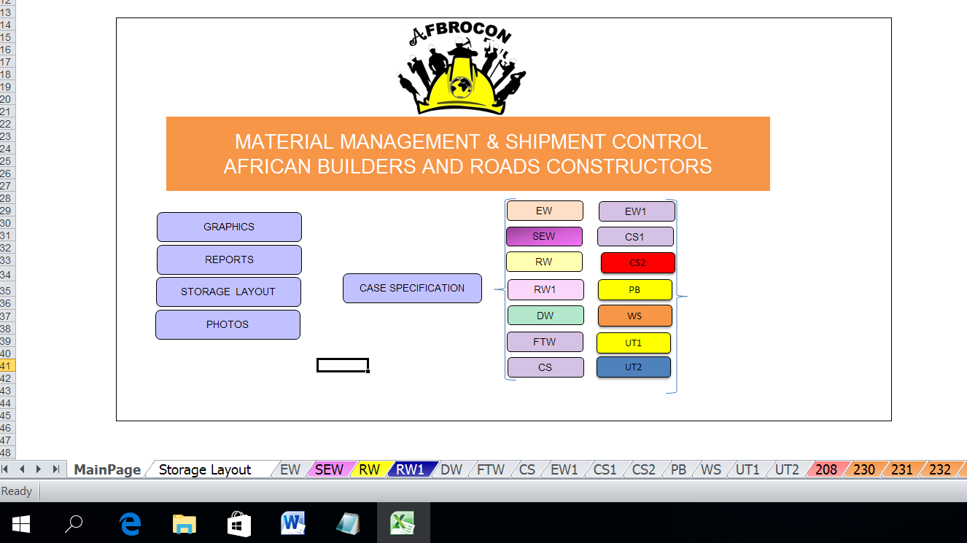

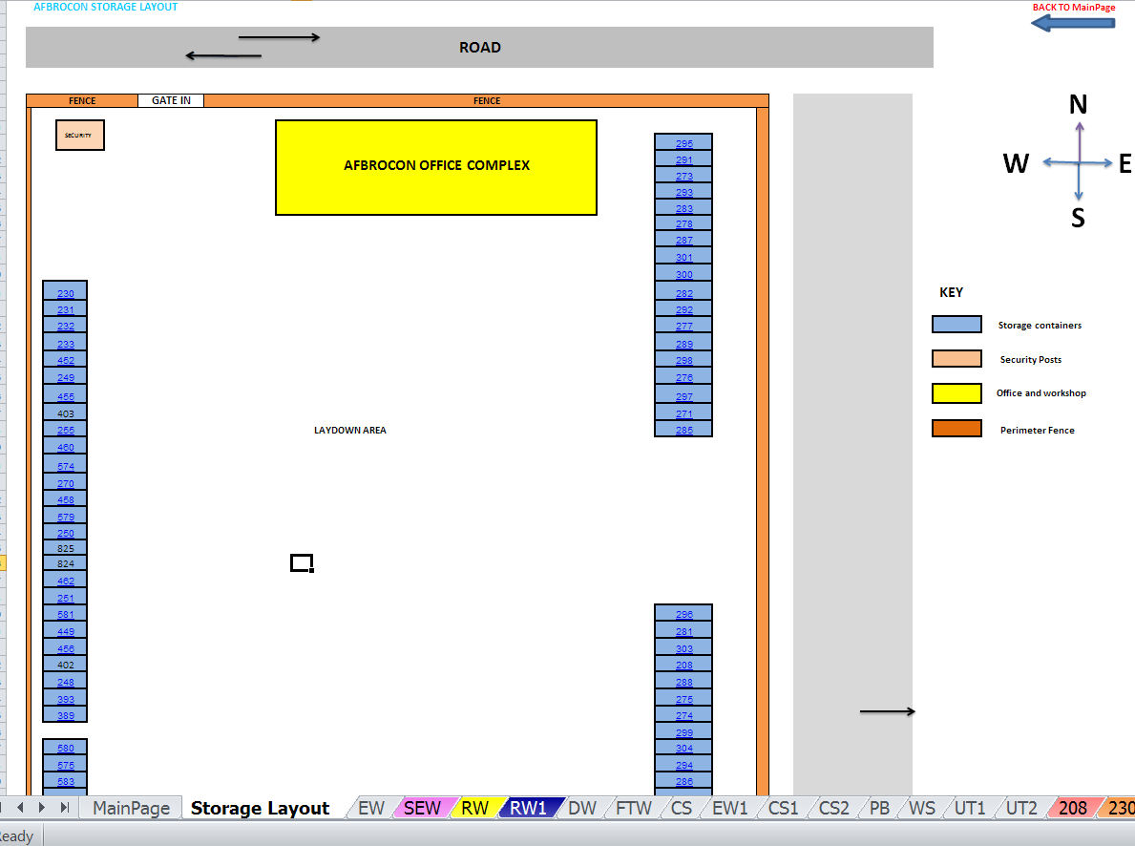

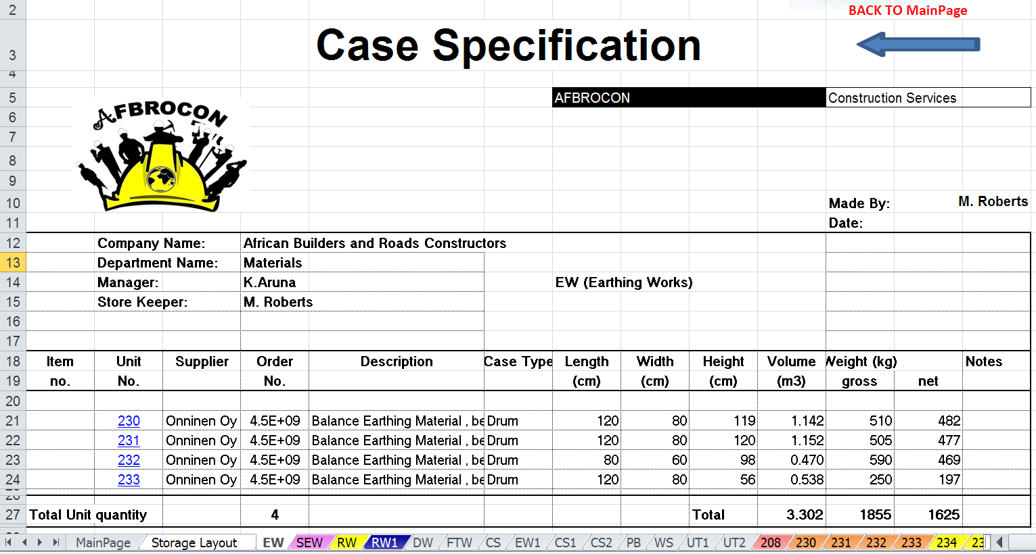

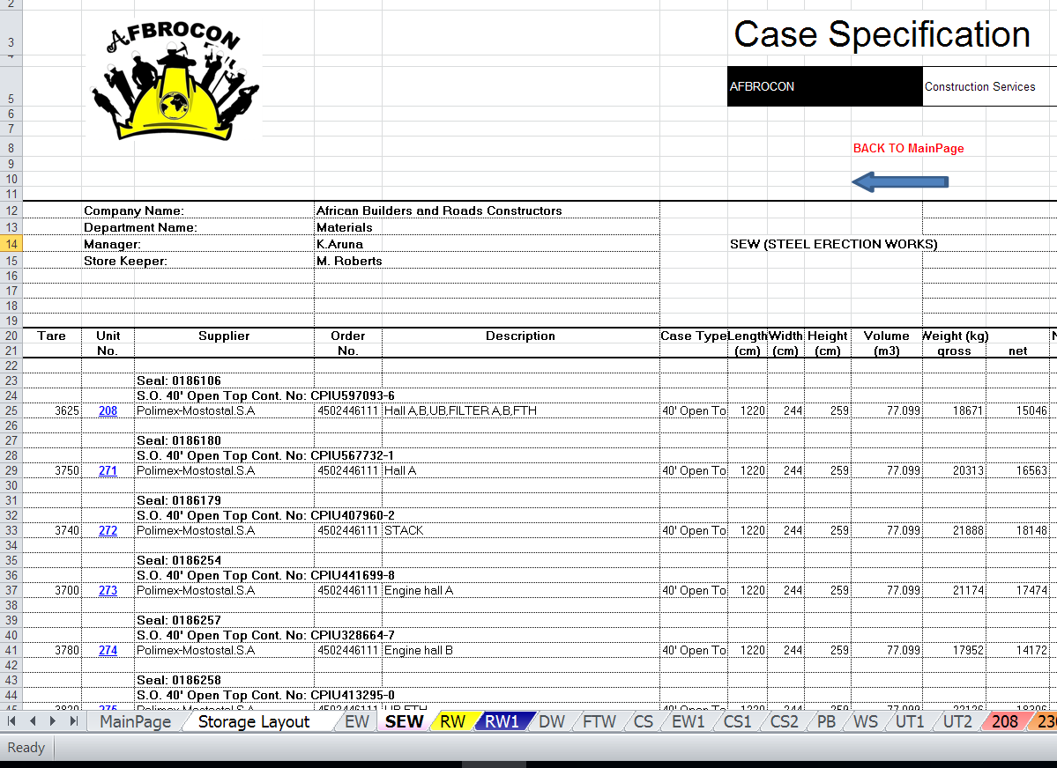

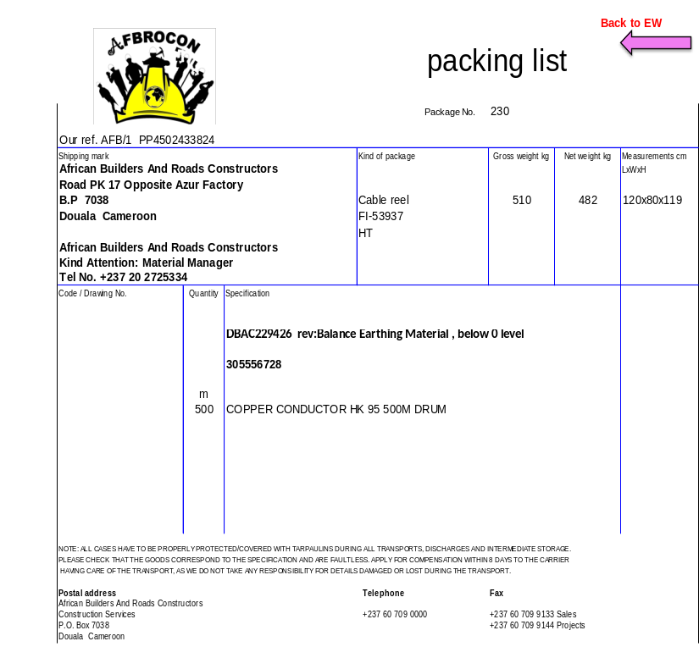

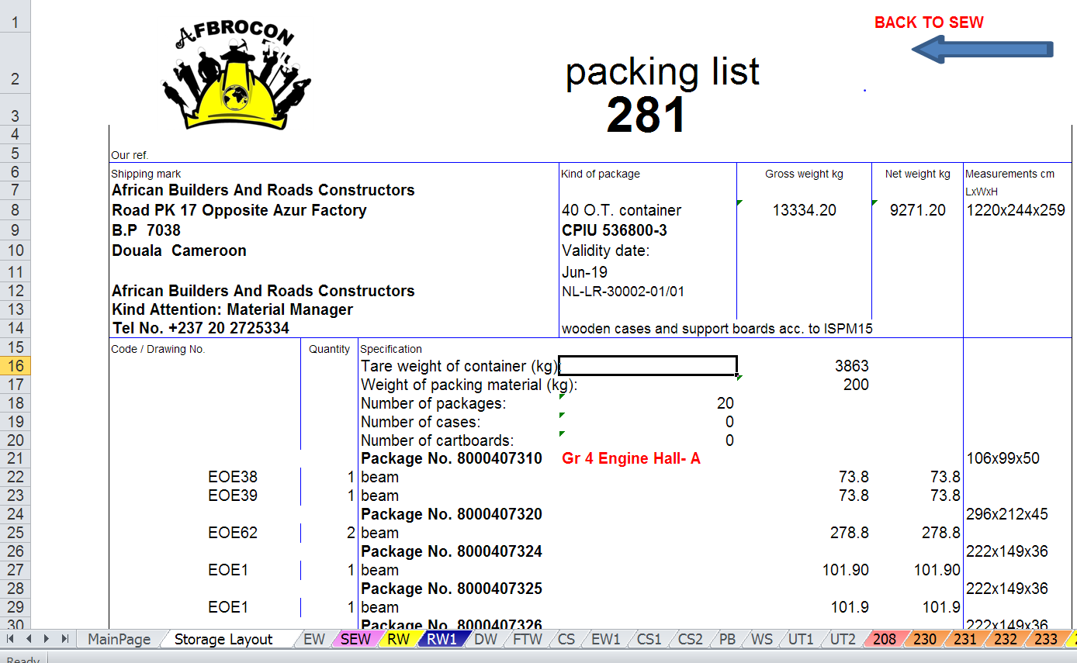

Student Statement:

By submitting this assignment, I confirm that this is my own work.

Student Signature | Eguenu Ola Uwe | Date | 25.05.2017

For Tutor / Assessor Use Only
Total Marks
Marks Obtained
Percentage / Grade

