
Assignment Cover Sheet

Student Name: | Annur Zara Liyana Othman
Student Number: | 1227
Course: | Diploma of Fashion Design
Assignment NO: | 12

Student Statement:

By submitting this assignment, I confirm that this is my own work.

Student Signature | 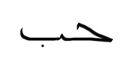 | Date | July 23rd 2014

For Tutor / Assessor Use Only
Total Marks
Marks Obtained
Percentage / Grade

Working With Patterns
Unit 12
Assessment 12
- Multiple Choice Questions. a) The flat pattern method is necessary for the areas like;
ii. Pants or sleeves

b) The draping pattern method helps the designer to;
i. See proportions and lines of the design exactly as they will look three dimensionally on the wearer

c) Pattern grading decides;
ii. How patterns increase or decrease in sizes

2. Define the followings:
a) Dart, grain line, hem line
Dart
Dart is a line that be create for matching the human body curve. In pattern making, darts help shape the flat piece of fabric into a form-fitting one that fits the curves of the human body. Broken stitching lines meet at a point to create the dart. These lines show where to fold the fabric to create dart. It will give the exactly proportion of the fabric when it turn into a garment. It also give the right measurement in how much to spare the fabric when cutting process.
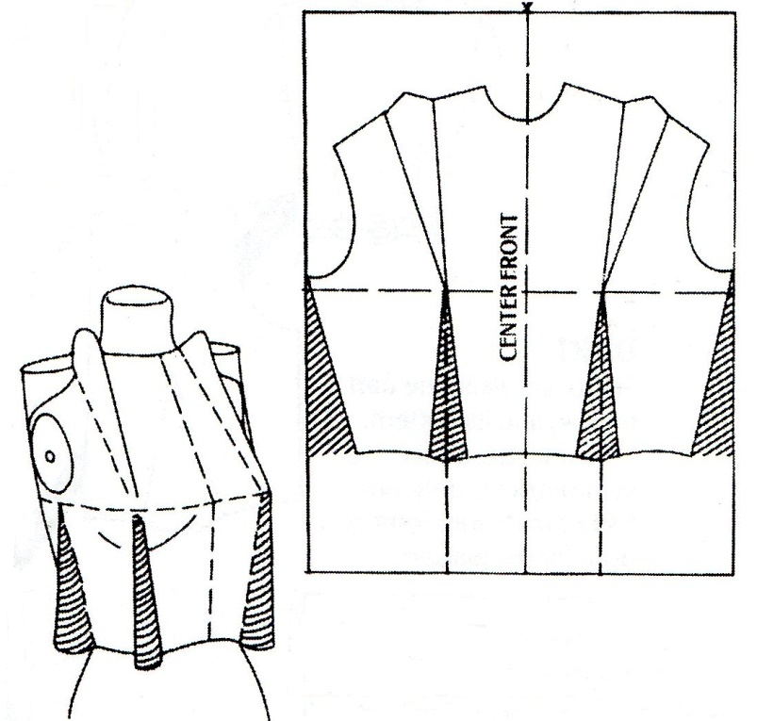
The example of a dart making on a basic bodice pattern

Grain line
Grain lines are a generally unnoticed aspect of the garment that is until they are either used in the wrong way and cause fit problem, or used in interesting ways to mould the fabric in different ways to the body. Sometimes they can also be used to turn a print onto a different angle for interesting visual effect. When fashion designers and pattern makers talk about grain lines they are referring to the way that a pattern is cut out when it is laid out on a piece of fabric. Basically, fabric is woven from thread going in two different directions and it is sometimes easiest to remember that fabric is built on tiny squares of threads which criss-cross each other.
The warp thread runs up and down while the weft thread runs right to left (You can rhyme weft with left to remember which one is which). The reason why these threads are important to grain lines is that they each react in different ways. The warp thread is generally the stronger of the two and is the least likely to stretch out of shape. So for example on the straight front placket of a shirt, you don’t want it to go out of shape so if you align it with the strongest threads then it will hold it’s shape better.
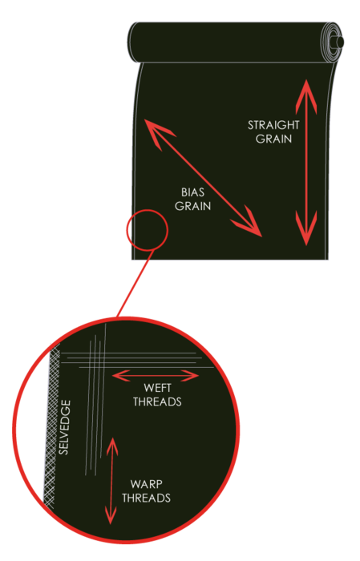
The example showing grain line.

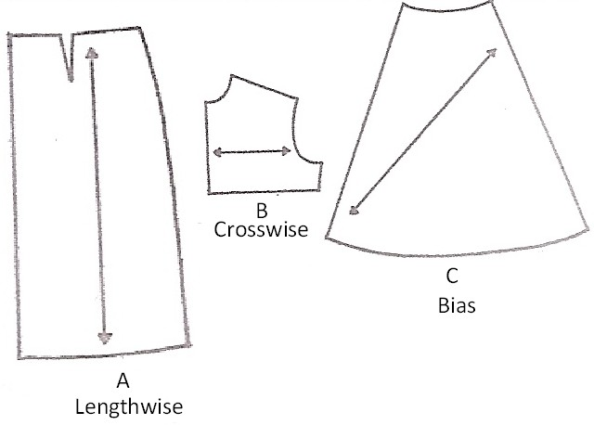
The picture showing grain lines drawn on a fashion pattern
The Hemline
The hemline is a solid line near the lower edge and it indicates where to fold the hem so the garment is the length indicated on the pattern envelope. The hemline is not always drawn in, but the depth may be written along the lower edge cutting line. In other words, Hemlines is the direction on the pattern shows the recommended finished length of the project, which varies from person to person.

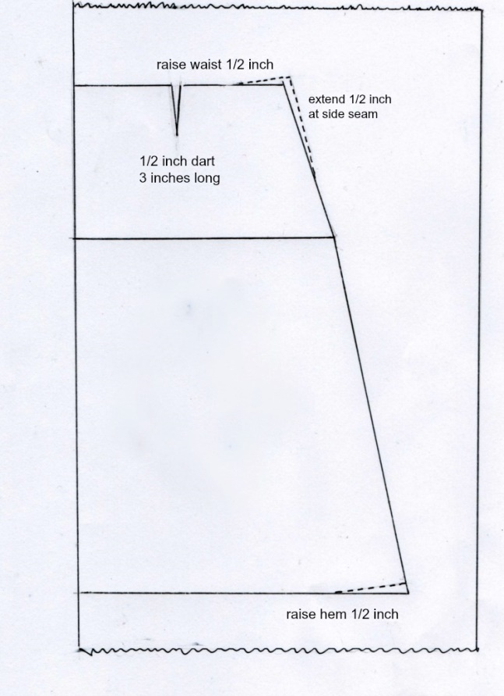
The picture above showing a mark of hem line at the edges of pattern.

3. Define the followings:
a) Selvages, length wise grain, bias
Selvages
Selvages can be defined as the finished edges where the fabric comes off the looms, the selvages are parallel to the lengthwise grain. Often times, the fabric designer and company are printed right along the selvage to making it easier to remember what type of fabric you bought. In most fabric stores, you will find fabric folded in half lengthwise and then wound around a bolt. And then you’ll see rows and rows of bolts of fabric. When the fabric store cuts fabric for you, they will cut you off a piece that is perpendicular to the selvage. So you will will always have a selvage along both sides of your piece of fabric.
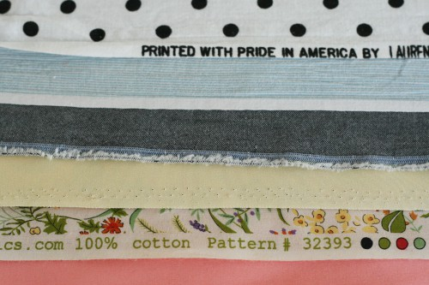
The example of selvages
length wise grain
The grain can be defined as the line runs the length of the fabric, parallel to the selvages. On knit fabrics, the lengthwise grain is usually more stable and less stretchy than the crosswise grain. In other words, grain is the way the fabric is woven or knit together. If we look really closely at the polka dot fabric below, there are little threads that run parallel and perpendicular to the selvage. This is the grain of the fabric.

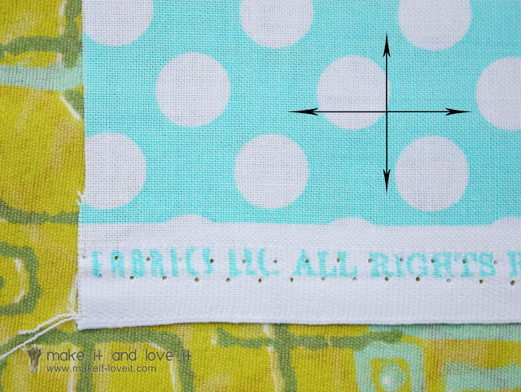

If we cut right along the threads of fabric that are running perpendicular to the selvage, we will get a straight line and will make a good 90 degree angled corner. In fact, sometimes the print of the fabric (like stripes) are printed onto the fabric a little crooked and will not run exactly perpendicular or parallel to the selvage. But if we look closely, the grain still will be the same and we can use that as a guide.

Bias
Bias can be defined as the 45 degrees between the lengthwise and crosswise grains. When you pull a woven fabric on the bias it stretches and is very malleable. This is why bias tape and trims that are cut on the bias can be easily shaped to follow a curved edge. Fabric cut on the bias actually has more give/stretch to it. If we hold a square piece of cotton fabric in our hand and pull along both selvage sides away from each other in your hands, our fabric won’t stretch at all. But if we pull along two opposite corners, or along the bias, the fabric will stretch just a bit.
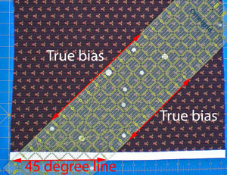
The example of Bias in fabric

4. Explain step by step the following processes:
a) ’placing the pattern pieces on grain’,
Each pattern piece shows a grain line (which can also be the place-on-fold symbol) which is also the lengthwise grain. The grain line allows you to cut the piece on-grain, meaning that the pattern piece lines up with the lengthwise grain of the fabric.
The step
- Place each pattern piece so the grain line arrow runs lengthwise on the fabric. Grain line arrows should run parallel to the selvage edges regardless of the way the fabric has been folded.
- Pin one end of the grain line arrow to hold it
in place.
3. Measure from the pinned end of the arrow to
the fabric selvage edge.
4. Now measure from the other end of the grain-
line arrow to the fabric selvage edge. Make
sure it is the same distance from the selvage
as the end you have already pinned in place.
Adjust the distance if necessary and then pin
the arrow in place.
5. Pin the edges of the pattern piece in place

The lengthwise grain on knits is seen as a rib. Use this rib to place pattern pieces on the straight of grain. Special techniques are used when placing pattern pieces on off-grain fabrics that cannot be straightened. For solid color fabrics or fabrics with an all-over design, lay the fabric so that the selvages are together. Make sure the lengthwise fold lies smoothly. (You will not be able to line up the cut ends of the fabric.) Then measure from the grainline arrows to the selvages as described above. For off-grain fabrics with a stripe, plaid, or obvious horizontal design, ignore the lengthwise grain. Instead, follow the print as much as pos-sible. Cut the pattern pieces out of a single layer of fabric. Match the design of the second piece with the first.
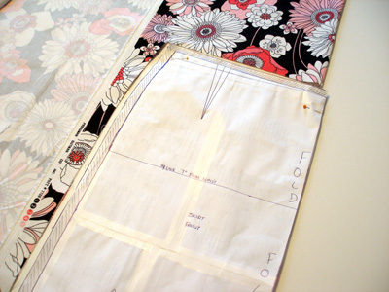

b) ‘Pinning and cutting out the pieces’.

Pinning
1. Pin with care to prevent inaccurate cutting. A cutting error of ⅛inch on each side of a pattern piece can result in a ½inch difference in the final garment.
2. Use only enough pins to hold down the pattern securely. Depending on the fabric and the size of the pattern piece, placing pins about six inches apart is usually enough.
- Place pins completely inside the cutting line.
- Place pins diagonally in corners.
- Use pattern weights instead of pins to hold the pattern in position, if desired. However, be sure to pin grainlines in place first. Position weights, inside the cutting lines, on one pattern piece at a time.
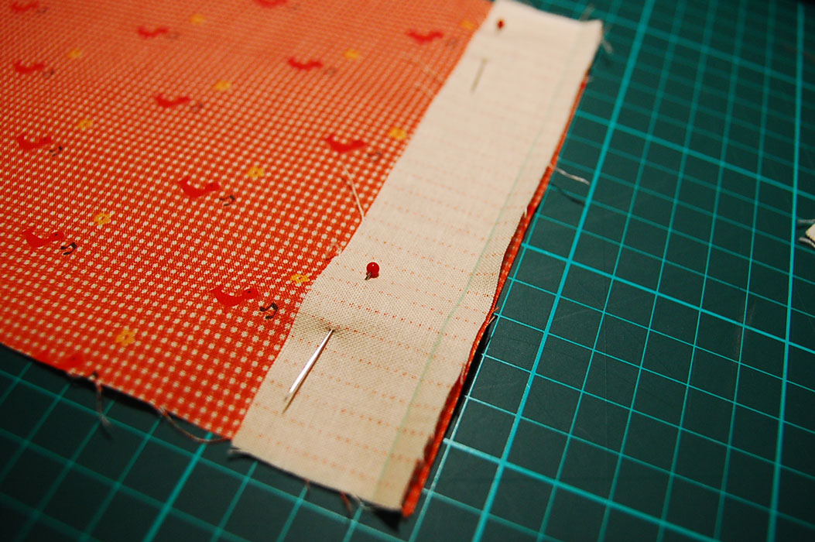
Cutting
- Use sharp shears or a rotary cutter to cut out your pattern pieces. Never use pinking
shears. Pattern pieces cannot be cut out accurately with pinking shears.
- Do not allow the fabric to hang over the edge of the table when you are cutting. This is especially true when working with knits and other stretchy fabrics. The weight of the fabric hanging over the table edge will pull the fabric and result in inaccurate cutting. Also, be careful to leave the fabric resting on the table as you cut. Lifting the fabric will result in inaccurate cutting.
- Cut notches out away from the seam allowance. Cutting notches into the seammallowance will weaken the seam. This will also prevent you from letting the seam out if a looser fit is needed.
- When using a rotary cutter, always be sure to place a protective plastic cutting mat beneath the fabric. Shift the cutting mat under your work as you proceed around the pattern. A metal ruler can be used as a guide for cutting straight edges. When cutting complex shapes, a small rotary wheel is easier to maneuver than larger ones. You will not be able to cut out the notches with a rotary cutter. Instead, cut off the notches and mark them using another technique, such as chalk or washable marking pen.
- Before cutting pattern pieces from a multisize pattern, determine which lines you need to follow. To do this, compare your measurements with those on the envelope size chart. Identify which size you should use for different areas of your body. Use a colored pen to trace along the lines you plan to follow before placing the pattern on the fabric. Taper from the cutting line for one size into the cutting line for another size, as needed. You might also wish to cut out the pattern on the desired size lines before placing it on the fabric.

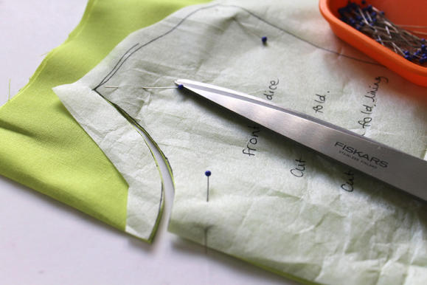

Reference
Information: BOLC unit 12 note, Fashion lecturer of Hongik University, Fashion websites, Sewing websites, Taylors
Images: Google images, sewing websites

