
Assignment Cover Sheet

Student Name: | Blessing Amosun
Student Number: | 1447
Course: | Fashion design
Assignment NO: | 9 complated

Marking Criteria:
We expect the learners to write minimum one well expressed point in three lines against each allocated mark. This means one needs to write 15 lines with 5 well expressed points to get high grades for a 5 marks question.
For high grades use examples and illustrations where appropriate.
Please insert your completed assignment ( in word format) here:

ASSIGNMENT 9
CHOOSING THE RIGHT MATERIAL
1A, Engraved roller printing: is used to for each colour in the pattern, the design is rolled onto the fabric as it passes through the printing machine. When a separate dye paste for each colour is applied to the fabric from a metal roller that is intaglio engraved according to the design. ERP is also Known as the method a heavy copper cylinder roller is engraved with the print design by carving the design into the copper, the copper is soft once the design is engraved the roller is electroplated with chrome for durability this printing technique was developed in late 19th and early 20th century.
1B, Flat bed screen printing: this technique uses a screen spread over a frame, portion of the design to be printed are made of porous nylon that allows the colour to pass through the screen, the areas that are not to be printed are covered or coated with enamel. Colours are poured into the frame she'll and is forced through the nylon by means of a squeegee work back and forth, is also a slow process done by hand it is used by designer makers for complicated fabric or for small runs.
1C, Rotary screen printing: in this method the roller itself is porous in the area to be printed. Dye is forced into the roller cylinder and throughout its porous screen as it roll over the cloth, this method is faster than flat bed screen printing and is continuous leaving no breaks between screens. Is also known uses a cylindrical screen that rotates in a fixed position rather than a flat screen that is raised and lowered over the same print location, rotary presses place the squeegee within the screen. Or is also a technique where colour is pressed though holes on a cylindrical mesh tube onto a substrate to give a printed fabric design.
2, Different between weft knitting and wrap knitting; In weft knitting are made in a wide variety of single and double knits a and generally have more stretch than warp knits, weft knitting is a also a piece of fabric where the stitches run from left to right horizontally across the fabric, it is usually knitted with one piece of yarn and can be made.
2b, warp: In a wrap knitting structure each loop in the horizontal direction is made from different thread like sweater is made by this wrap knitting techniques, multiple Yarns are used and thee loops run vertically warp knits include tricot and reschel
Warp knitting loops are produced to the length of fabric
Weft knitting loops are produced to the width of the fabric
Warp it is elastic to the length.
Weft it is elastic to the width
Warp elasticity of the knitting fabrics is less than weft knitting
Weft electricity of the weft knitting fabrics is higher than warp knitting
Warp it's shrinkage properties is less
Weft it's shrinkage properties is higher than warp knitting fabrics
Warp Yarns are supplied from beam
Weft Yarns are supplied from cone
Warp at least one yarn is required for each needle
Weft any number of needle
Warp creating fabric by this method is suitable to dry wash
Weft hand wash is suitable for weft knitting
Warp any design is done easily
Weft all types of design is complex
Warp is specially suitable for producing coarse fabric
Weft it is suitable for producing think fabric
Activity
1, in my wardrobe how many garment are made from natural fibres: 5 are made of natural fibres
Linen, silk, wool, cotton, cashmere
B, how does the fibre content affect the care of the garments: by wash the cloth if only the cloth was made for stiming only, the cloth content will indicate how the cloth should be wash, bleached, ironing, dry cleaning instructions, tumble drying may be at high or low temperature or may be not to tumble dry, the standard care of each cloths explain the aftercare for products made from natural fibres.
C, examples of plain weave, twill weave, a satin weave
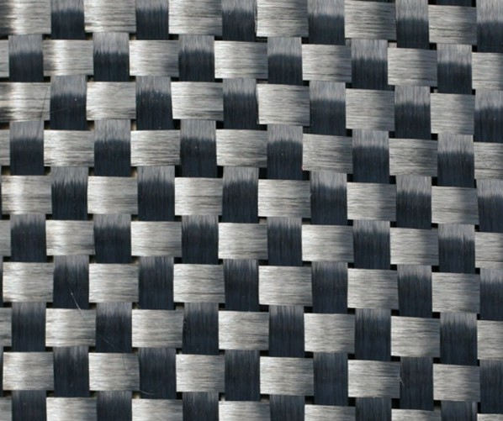
A plain weave
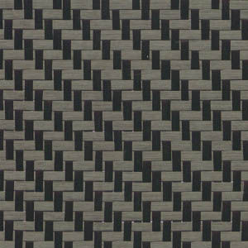
A twill weave
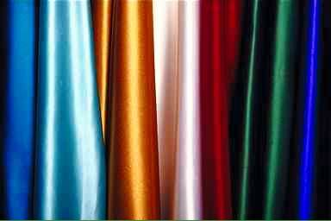
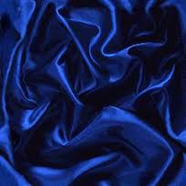
A satin weave

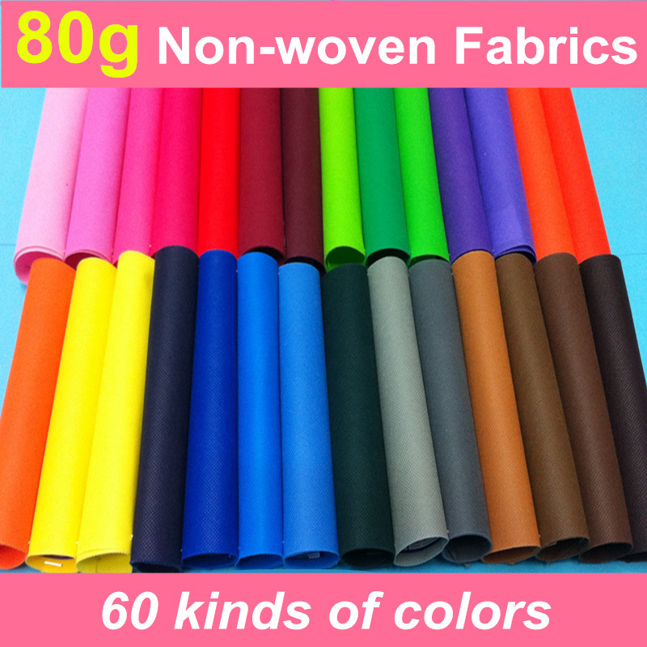
A non woven fabric
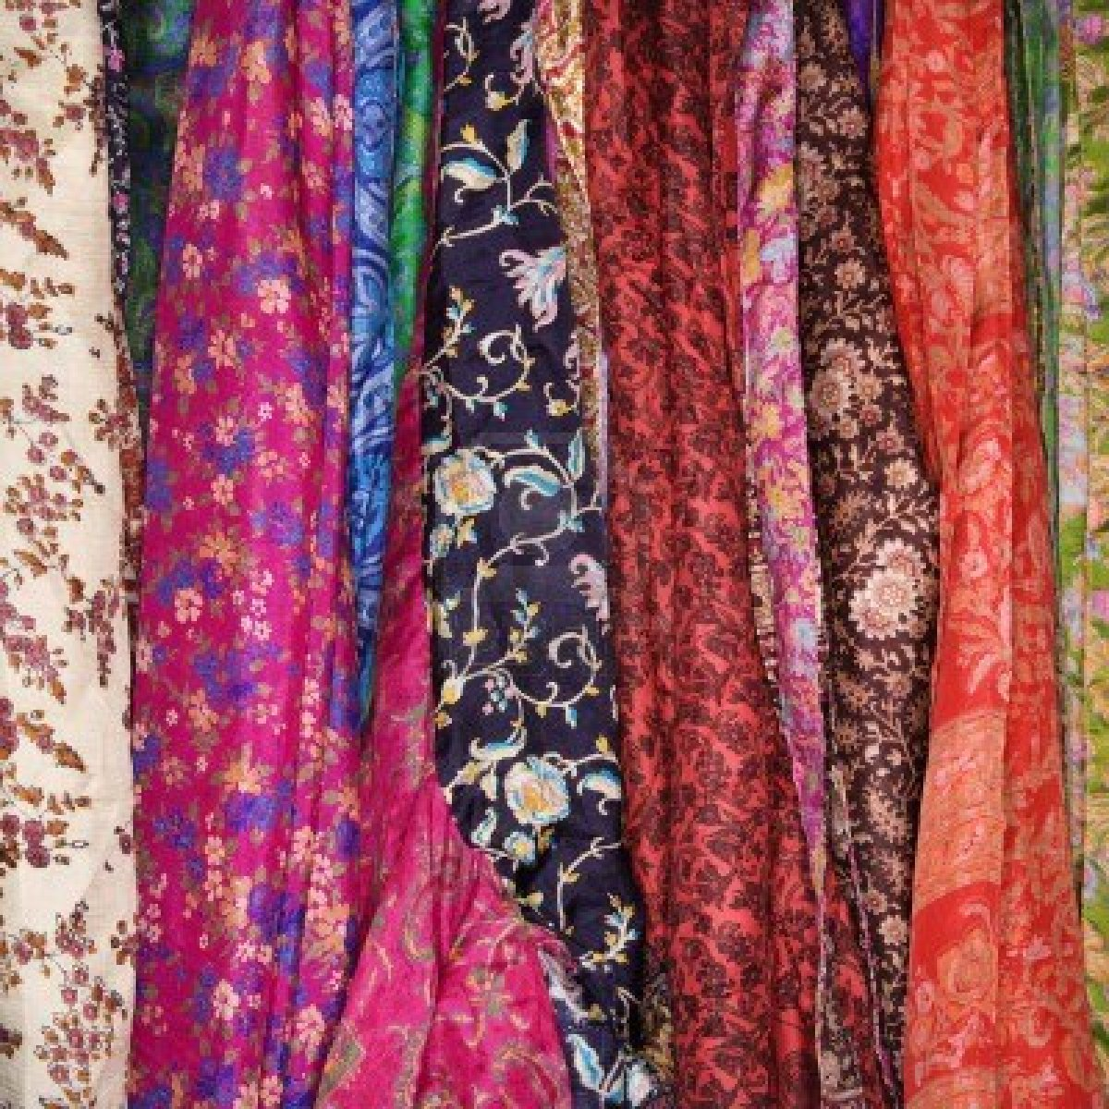

Student Statement:

By submitting this assignment, I confirm that this is my own work.

Student Signature | Blessing Amosun | Date | 19/07/16

For Tutor / Assessor Use Only
Total Marks
Marks Obtained
Percentage / Grade

