
Catherine Richardson
1427
Diploma in Public Relations
Internal Communication
Assessment 9
Page 1
Assignment Cover Sheet

Student Name: | Catherine Jane Richardson
Student Number: | 1427
Course: | Diploma in Public Relations
Assignment NO: | Internal Communication - Assessment 9

Marking Criteria:
We expect the learners to write minimum one well expressed point in three lines against each allocated mark. This means one needs to write 15 lines with 5 well expressed points to get high grades for a 5 marks question.
For high grades use examples and illustrations where appropriate.
Please insert your completed assignment (in word format) here:
1.Give short answers to the following questions: (24)
I. What is internal communication about?
Internal communications, regarding employee communication, has been noted as being central to internal brand-building and integrated communication. While public relations is partly viewed by many as a predominantly externally oriented practice and profession, it now requires the comprehension of internal audiences and recipients as a basis for developing effective external communication strategies (Athal, 2013).
Communication activities and processes within an organisational sphere are also considered as 'internal communications'. Other references to this field may include the more general 'organisational communication', 'corporate communication', 'internal public relations' or the more specific 'employee communication'. While the advocates of each perspective may decipher that one is more fitting than the other, the agreed general concept involves strategic communication activities geared towards an organisation's internal audiences and stakeholders.
Kennan and Hazleton (2006), proposes a theory of internal public relations by viewing 'internal public relations' as a means of improving the relationships and understanding between employees in management roles and those as non-managerial employees or workers.
Catherine Richardson
1427
Diploma in Public Relations
Internal Communication
Assessment 9
Page 2
Internal communications are not only perceived as an indicator of qualitative measures. Watson Wyatt's third Communication ROI study (2007/2008) showed that effective employee communication is a "leading indicator of financial performance." The study did not suggest the correlation between effective communications resulting in better performance; they did indicate that the investment in employee communication is likely to have "higher financial returns."
Internal communication is a new concept, particularly within the realm of public relations. This concept is still evolving, and as such is subject to various interpretations depending on who is attempting to define the field. Organisational communication academics state that organisations are created through conversation while marketing academics refer to employee communication within the context of internal brand building and customer service. The scope of activities under the header of internal communications largely depends on the viewpoint and innovations of the CEO or the most senior communication executive in the organisation. This depends on their experience and vision about communication's value to the business.
Internal communications include public relations activities as well as organisational processes, such as culture change and values development.
Internal communication can also be important to amalgamate the driving force of productivity and the individual’s levels of satisfaction and enjoyment in the workplace (Miller, 1999; Argyris, 1982). As a result, valued employees become true 'ambassadors' because not only are they exposed to the organisational culture and practices and they demonstrate their affinity and interest in the organisation. If an employee becomes unappreciated, they can easily whistle blow at an instant with the aid of the internet. Employees who take pride and value, their organisation, are more likely to promote and defend the reputation of their employing organisations.
Internal communication also leads on to the concept of employee engagement. Employees need to feel a connection with the organisation and their purpose within the organisation (Shaffer 2007). Internal communication acknowledges some degree that employees are included to participate in organizational processes. Internal communication provides a context to organisational values, products and services and the overall culture (McLellan, 2006), or as a tool to inspire their employees and their external stakeholders.
Catherine Richardson
1427
Diploma in Public Relations
Internal Communication
Assessment 9
Page 3
New media technology, along with the geographical dispersion of global employees, has encouraged the development of new internal communications channels. While in-person or face-to-face communication is still the most preferred approach to employee communication (Ward, 2008), this may not always be possible or may not be the most appropriate for the kind of information or message.
Internal Communications is a fast growing major department in organisations. New media technology is providing a faster and more flexible means of gathering, sharing and communicating information between individuals, groups and communities. However, while technology may assist and extend social networks, employee’s still value relationships that are face-to-face where people can connect and interact. These are areas where organisations need to consider when designing strategies for internal communications campaigns.

II. What is the role of internal communication in an organisation?
Internal communication is a supporting function - it makes an organisation work. It creates the bridge that links people and functions within an organisation. Good internal communication creates understanding and helps knowledge sharing.
Without excellent internal communication, organisations grind along inefficiently or stop altogether. There is now a proven link between highly effective organisations and good internal communication (Perrin 2008). There is also a link between engagement, communication and organisational success (Conrad & Poole 2002).
Communication, in particular, internal communication needs careful and precise management if an organisation is expected to function to its full potential (Gray, 1998).
By neglecting internal communication, one creates an environment of grandeur behaviour superseding – regardless of the employee’s role within the organisation or whether their message fits with strategic goals. Enlightened organisations recognise this and build tools and channels to promote and deliver appropriate internal communication (Clampitt, 2005).
Internal communication is about people. It is about how we interact with others and how we react to the information that is received.
The Internal Communication profession – whether small and local or a giant global enterprise should manage the comprehension and knowledge that joins the individuals in the organisation together.
Catherine Richardson
1427
Diploma in Public Relations
Internal Communication
Assessment 9
Page 4
Internal communication is finding its foundations within the corporate culture to facilitate relations and communications within an organisation and the organisation’s actors (Argenti, 2009).
The Institute of Internal Communication is aimed at helping the profession achieve the above.
By providing accreditation programmes, research and networking opportunities for its members, the Institute contributes to further the objectives of internal communication and bring it to the place it deserves to be.
When internal communication is effective, it helps employees understand the organisation's values and gives them the required tools and information they need to do their job brilliantly. Internal communication is the knowledge-base of an excellent organisation.

III. How would you differentiate between the strategic and technical internal communication activities?
Communication is strategic when it is consistent with the organisation vision, values and mission. Strategic positioning regarding competitors is also considered to understand the concept of communication with internal stakeholders. Strategic communication, in general, is defined as the purposeful use of communication by an organisation to fulfill its mission’ (Hallahan et al., 2007). While communication is something that happens in the organisation, organisations that take measures to implement strategies observe the impact regarding the effectiveness of their communications and how it can achieve measurable results. According to Mulhern (2009), advancement with technology has been an important factor in business. Information can be communicated through many diverse channels and media like the internet. Technology has been rapidly growing fast, accelerating communication that allows customers to connect and communicate with others. This makes it easier for all to reach one another in a traditional manner to suit the demand of their needs. ‘These changes mean that marketers are in a far more challenging competitive environment in attempting to fulfil customers wants and needs while simultaneously seeking to develop long-term relationships" ( Mulhern, 2009). Changes in corporate communication help the organisation's communication goals, and the communication channels. A business that communicates with their employees about business and organisational issues will have increased the level of trust between them. In general, strategic communication supports communication from management to the front line. It embraces the organisations’ mission, vision and values. It raises awareness regarding business issues and priorities. It comprises internal credibility by enhancing management communication skills and facilitating employee motivation to engage and achieve goals.
Catherine Richardson
1427
Diploma in Public Relations
Internal Communication
Assessment 9
Page 5
Technical communications are primarily linked to the method of communication in an internal matter which is appropriate according to the requirements (Dacin, 1997). Prime examples are how the Media used to deliver technical communications. These would include internet sources, websites, printed materials, social media sites, meetings, live presentations, e-books and publications, videos, and audio material (Lange, 2010).
Technical communications activities are important throughout many strategic and operational locations of an organization. The planning and executing of integrated technical communications (ITC) strategy becomes increasingly paramount. ITC can be defined as the coordination and integration of all technical communication processes, functions, tools and sources within an organization to transmit information that is relevant to optimizing the users' product experience.
Integrated Technical Communications strategy encompasses six high-level processes: Analysis, Research, Design & Creation, Production & Dissemination, Archival & Disposition and Feedback (TechWriter Today , 2016).
As with most strategies, the goal of the feedback is to produce a better product experience, so the activities that comprise feedback processes fall within the realm of technical communications, even if those performing the activities work in programming, QA, or the help desk.
As modern society relies increasingly on technology for every aspect of life’s activities, technical communications will remain a viable, lively and varied profession and continue to grow in strategic importance.
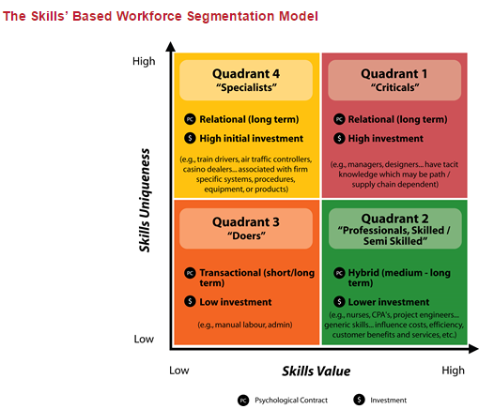
Catherine Richardson
1427
Diploma in Public Relations
Internal Communication
Assessment 9
Page 6
Each of these role types has a different psychological contract such as employer/employee relationship with varying levels of investment in employees. Skills are viewed as methods to improve efficiency and effectiveness of the organisation while adhering to the agency's vision and goals.
Even though skills place a vital role to attain occupational tasks, attitudes, behavior also enhances group classifications. Smith (2012) a business speaker and consultant "ASDA Magic – The 7 principles of building a high-performance culture" also suggested that most organisations classify their workforce in four segments depending on behavior vs. performance:
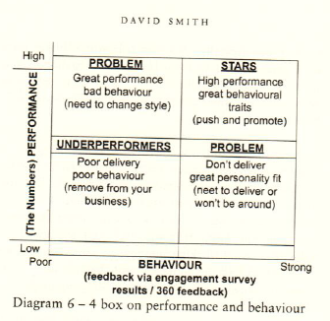
Smith (2012) suggested that for performance-driven organisations they estimated to invest in high performers and to remove the underperformers. Investing in the “STARS” produced motivation and engagement which Smith feels is paramount to see through an organisations’ strategy.
Catherine Richardson
1427
Diploma in Public Relations
Internal Communication
Assessment 9
Page 7
As referred to earlier, dealing with the complexities of people management in the 21st Century workplace requires a more sophisticated and hence differentiated approach. Roles differ in their potential to add value and contribute to business success. Not everyone is equal! Not all employees possess knowledge and skills of equal strategic importance.

V. Outline the basic communication needs of employees in an organisation.
First and foremost, employees require information about them as individuals within the spectrum of their teams and the whole organisation (Bakker, 2010). Once this has been established it is important to identify the general information regarding their organisation. Most organisations give joining inductions to new starters to understand the nature of the business and the concept of the organisation. This also included the organisations vision through a framework or mission statement.
Clarity of roles, such are the tasks and expectations of what needs to be achieved is also given to employees. This is done with discussions and communication on training and development, opportunities and feedback on performances.
Other areas of basic communications are the areas of work practices such as guidelines, policies and procedures and the appropriate manner to communicate these issues throughout the right channels.
Basic communication needs are important for both the employee as well as the organisation. With mutual understanding, the communication practices set the stepping stones with expectations from both perspectives. Organisations are like puzzles, with each piece an individual forming the overall image of the organisation, and how each individual forms part the greater network and organizational structure, culture and purpose.
Effective internal communications are at the heart of achieving business outcomes (Keyes, 2003), and it is something the whole organisation is responsible for. It supports the organisation’s smooth running, successful change programmes, and good leadership on vision, strategy, and values (Smith 2003).
It is also a critical aspect of employee engagement, which in turn promotes better performance, employee retention, and well-being. Employees are more engaged when information flows freely, and they are aware of organisational activities and management decisions that affect their jobs (Smith, Kendall, & Hulin 1969).
Catherine Richardson
1427
Diploma in Public Relations
Internal Communication
Assessment 9
Page 8

VI. Define the term, ‘Ethical Communication’
For employees to effectively comprehend what an organisation considers being ethical practices, it has to be communicated clearly and effectively to employees. Ethical behavior should be communicated on a daily basis to employees and that includes recognizing employees who have acted accordingly. This not only gives praise to those employees doing well, but it also helps to set ethical standards for other employees within the organisation.
Every business and organisation of employment require a written ethics policy (Duska, 2007) that explains what is expected of employees within that given organisation (Turnbull, 2005). Ethical standards are communicated in a manner that the organisation believes the standards reflect fairness and ethics (Elliot, 2005). The policy should also outline the consequences of acting unethically within the small business. This policy should be signed by employees upon their acceptance of employment as well as reviewed and signed on an annual basis (Hanas 2005).
As everyone's understanding of ethics can differ, it is important that the organisation conducts training for all employees so they understand the ethical issues (Jones & Parker 2005). Some employees may see taking business supplies for personal use as unethical whereas they don't believe that taking a business pen home with them is the same. The business should educate the employees about its own ethical standards through hypothetical scenarios and discussion. This can help employees recognize what the business considers to be ethical and unethical.
Management's role in ethical practices for the organisation is to always demonstrate, as role models (Pinnington 2007), ethical behavior in verbal and non-verbal cues. Management needs to reinforce ethical behavior in others with praise while using unethical behavior as a reflective teaching method for other employees. Also, management should realize they are role models for the organisation and must act accordingly and as expected by the organisations vision and culture. If there are expectations for employees to act in a certain manner, management must also act in the same manner and lead by example (Murphy, 2002).
Catherine Richardson
1427
Diploma in Public Relations
Internal Communication
Assessment 9
Page 9
In employee interactions, the use of stories or examples from the newsworthy sources can be used to identify and reiterate the business stance on ethics (Brenkert, 2002). This is a method used to engage employees in the acceptable and ethical manner according to an organisation's values and vision.

2. Describe the various internal communication channels and their role within the organisation. (6)
Today there is an abundance of techniques and technologies used to communicate, both up/down and side-to-side within an organization (Scoble, 2006). Examples are: One-on-one meetings, Staff/team meetings, Emails, Voice mails, Video broadcasts, Intranets, Audio files (usually downloadable audio, but increasingly sent out as podcasts), Staff-to-staff newsletters, Corporate Newsletters, Annual Reports, Quarterly Reports, and Roadshows.
There are three internal communication channels which are highly common; team meetings, emails and the intranet. The three difference methods of communication highlight the purpose of the communication and the benefits of their use.
Team Meetings
Are used to make communication personal and conversationally interactive. It is relevant to the team involved as per those who are invited to attend.
Teams meetings open opportunity for discussion, feedback, questioning and ideas. A good line manager or meeting facilitator can encourage a lively and interactive session. Meeting can help clarify, build understanding and support involvement.
Without saying, the potential downsides are that success depends on the skill of leader. The time commitment for both manager and audience needs to be established, so it does not hinder discussions.
Content overload; having too much to discuss may also limit the attention span of the audience, and other channels are more effective for information delivery when there is much content.
Emails
Emails can reach mass audiences fast. They are cost effective and simple to use, The message can be created to be a controlled and consistent and message. It will reach the recipient directly. Downside to emails is that not everyone may have access. Depending how the message is understood emails may be perceived as impersonal and open to misinterpretation. More often that not emails can result quickly in information overload. Unless you send constant read receipts, you can't tell if messages have been read. Although it might make the sender appear like a paranoid stalker! Emails do not prioritize messages; the sender does that part. In general, emails do not generate dialogue or discussion in a productive way like spoken conversations.
Catherine Richardson
1427
Diploma in Public Relations
Internal Communication
Assessment 9
Page 10
Intranet The intranet is a fast and consistent method for internal communications (Israel, 2006). Possibilities are creative to inform, entertain and portray such messages. It can be used to store information as a reference point and can be utilized as a medium to raise awareness. Some intranet forums engage others with discussions and involvement of ideas. The intranet can be measured for effectiveness by identifying statistics of whom it reaches and who is reading what.
The shortcomings of the intranet are that not everyone may have access to the intranet. The intranet relies on people seeking out the information. Some employees do not have time to read the intranet and depending on security aspects it may be difficult to police sensitive or unethical information.
Successful internal communications focus on a strategic business issue. This focuses the communication goal as required and taking into consideration the organisations vision and culture (Cornelissen, 2004). The language delivery has to be taken into consideration, so the receiver is able to comprehend. Internal communication is only great if the sender can measure the effectiveness and that has a specific outcome. Timely delivery is also important to the receiver is able and will to receive the information with the intention for them to be engaged with the consensus.
According to Lesser (2015), internal communications professionals need to establish that the right message for the right audience and the right channel is paramount if communications are too effective and understood.
This has become more challenging in recent years with new consumer technologies and the choices available to deliver communication.
Some organisations struggle to stay ahead of such challenges, and making haphazard decisions, resulting in confusing communications and confused employees.
Catherine Richardson
1427
Diploma in Public Relations
Internal Communication
Assessment 9
Page 11
The Digital Workplace Group (DWG), developed a framework called the content wheel to help make structured and systematic approaches to content, messaging and news across an organization.
They claim that their framework can help make more informed and intentional decisions about your content, audience and channels. The key is to use opposite colours e.g. Micro vs. Macro
Micro-content refers to abstracts of summaries of headlines. Macro content considers to the full article, policy, report or other content. An example of this is Twitter vs news article. Twitter, with its character limitations per tweet, this challenges the notion that an announcement is only successful if it has a certain number of hits by the numbers of those viewing. Perhaps a well-written headline (or tweet) can get the key message across to most people. Moreover, those who want more details can click through to the full article.
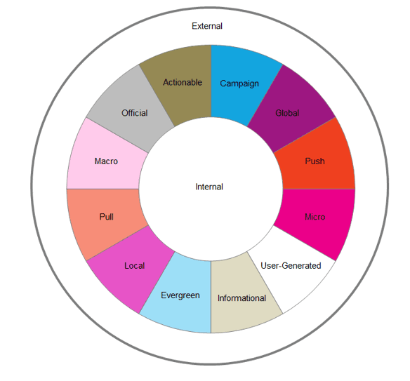
Essentially, building a structured process, picking the right message for the right audience and the right channel assists to communicate effectively within an organisation.
Melcrum – a CEM Company providing consultancy services strategies with internal communication discuss their framework by focusing on five areas of activity within an organisation: Audiences and stakeholders, Infrastructure, Leaders and Managers, Line of sight for business strategy and Research and measurement.
Catherine Richardson
1427
Diploma in Public Relations
Internal Communication
Assessment 9
Page 12
They focus on these areas of activity and not on the roles and responsibilities within an organisation. They suggest that roles and responsibilities vary by organization and successful functions typically focus on five areas of activity as mentioned before.
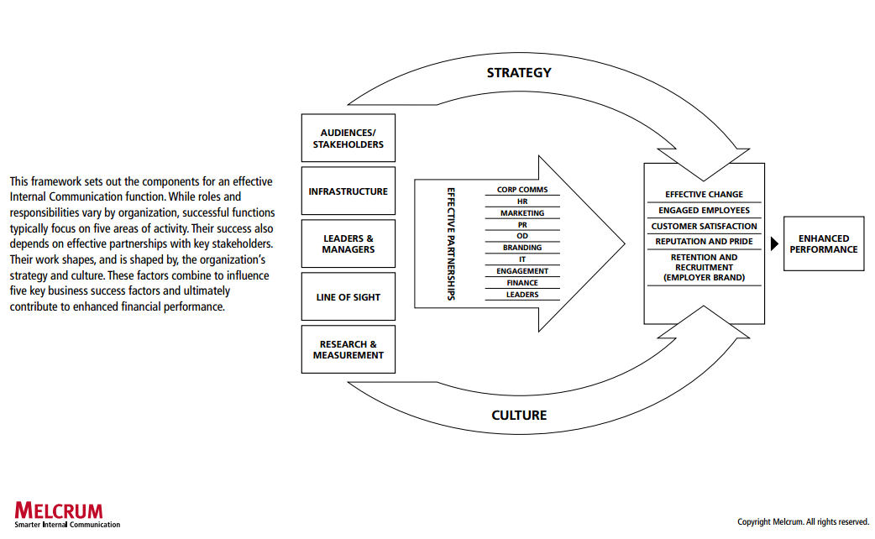
The framework also acknowledges that the organisations' success depends on effective relationships with stakeholders.
The work of Internal Communication shapes, and is shaped by, the organization’s strategy and culture. These factors, in combination influence the five success outcomes: Effective change, Engaged employees, Customer satisfaction, Reputation and pride, and Recruitment and retention. Ultimately, this leads to an improved performance in the organization.
Melcrum perceives internal communication as relations and the cause and effect of organizational activities whereas, The Digital Workplace Group (DWG) primarily look at the message content and the delivery according to the recipient and sender.
Internal communication requires cross-functional collaboration and dialogue by helping to connect people across the organization. It facilitates dialogue and investment to understand and listen to its stakeholders (Balmer, 1998).
The range of channels help to be purposeful according to the requirements of an organisation, from advanced technological communication methods to face-to-face interactions. Duties and responsibilities need to be performed as per organisations objectives and culture.
Any employee in an organization is required to translate the strategy and comprehend what is expected for their part of the organization, their team and themselves individually and that they are aware of what they need to do to achieve it (Weick,1995).
It's important that the strategy is made meaningful to every part of the organization rather than remaining at an abstract, high level. When communicating the strategy, an effective team uses methods that enable employees to discuss, engage with and internalize the strategy (Troy, 1996). Employees understand what it means to them and translate it into everyday actions and behaviors.
An effective Internal Communication function uses measures with good judgment to guide and prioritize communication decisions, strategies, and tactics.
Finally, an effective internal communication function benchmarks with external organizations to identify opportunities for continuous improvement.
Catherine Richardson
1427
Diploma in Public Relations
Internal Communication
Assessment 9
Page 13
Student Statement:

By submitting this assignment, I confirm that this is my own work.

Student Signature | Catherine Jane Richardson | Date | 16th May 2016

For Tutor / Assessor Use Only
Total Marks
Marks Obtained
Percentage / Grade

