
Assignment Cover Sheet

Student Name: | Eniko Surjanne Schuller
Student Number: | 2459
Course: | Diploma in Business Administration
Assignment NO: | 12

Marking Criteria:
We expect the learners to write minimum one well-expressed point in three lines against each allocated mark. This means one needs to write 15 lines with 5 well-expressed points to get high grades for a 5 marks question.
For high grades use examples and illustrations where appropriate.
Risk control is an important action taken by firms that are intended to proactively identify, manage and reduce or eliminate risks using risk prevention and risk reduction methods. It is a technique that utilises findings from risk assessments, which involve identifying potential risk factors in a firm's operations, such as technical and non-technical aspects of the business, financial policies, and other policies that may impact the well-being of the firm.

Risk avoidance is a way to manage risk. Risk avoidance deals with eliminating any exposure of risk that poses a potential loss. The investor who avoids the risk forfeits any potential gains the oil stock may have. On the other hand, the investor who reduces his risk still has potential gains if the stock market goes higher.

The difference between risk avoidance and risk prevention is that when we are using the risk avoidance we decrease the risk at a minimum level by doing preventive actions such as, not driving a car to avoid a car accident or theft, stop smoking to avoid health problems, close money and other assets in a safe. Risk prevention can be used in a potentially huge loss where the risk can not be reduced or transferred. People have to work with risk in mind. This is the only way if there are no other options available.

Risk management has always effect directly to profit as it can minimise costs made by losses, and this will directly increase profits, therefore, it can contribute to business’ goals and objectives to achieve.

The purpose of risk management is to identify potential problems before they occur so that risk-handling activities may be planned and invoked as needed across the life of the product or project to mitigate adverse impacts on achieving objectives.

Risk management is a continuous, forward-looking process that is an important part of the business and technical management processes. Risk management should address issues that could endanger the achievement of critical objectives. A continuous risk management approach is applied to effectively anticipate and mitigate the risks that have a critical impact on the project.

The risk management process can be developed by using a checklist:
Responsible person for carrying out the risk assessment
The scope or focus of the risk assessment
Initiate and complete the process and assessing risk management
Consultation between management members, staff
Findings recording and documentation
Risk assessing and discussing
Risk assessment review

The main benefits of risk management are:
Defining Risk Management: incorporate several disciplines, such as financial risk, liability management or health and safety rules
Financial Considerations: welcome news to your banker and insurance agent
Protecting Resources: reducing leave time injuries, alternatives for machine failures, for example, these will all leads to savings, funds increasing
Business culture: build and support strategic planning will evaluate performance and adapt to changing needs

The risk can be evaluated by using techniques.

Once risks are identified, the next issue is to determine the root causes of what drives the risks.

Risk management circle

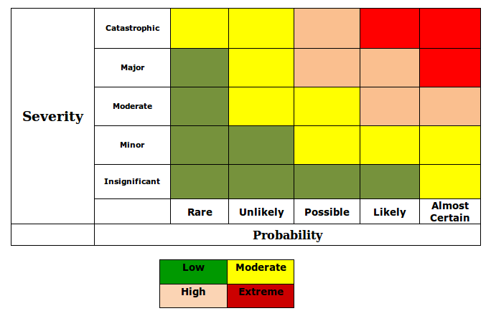

Risk map

Case Study:

William Telford made a mistake when he did not identify the risk of the GFC even after Tameer went bankruptcy as other large businesses also. He could think that through using risk management techniques it will have effects on other business sectors and perhaps he had to change their sector because consultancy is not the best choice when people and businesses have not enough money to afford it. Maybe he could specialise to bankruptcy avoiding consultancy business as target businesses faced with this.

Risk management strategy would help him to find the solution to the GFC caused problems and risks. It was almost certain that every business would affect by the GFC.

Student Statement:
By submitting this assignment, I confirm that this is my own work.

Student Signature |  | Date | 29-Oct-2016
For Tutor / Assessor Use Only
Total Marks
Marks Obtained
Percentage / Grade

