Manufacturing and Delivery Operations in Supply Chain
ASSESSMENT # 3 Total Marks: 30
Total Marks: 30

1. Give short answers for the following questions: (21)
i. What is the ‘facility management’ about?
ii. What is meant by the term ‘milk run deliveries’?
iii. What is meant by the term ‘reverse logistics’?
iv. Deliveries can be made to customers from two sources. What are these?
v. Describe the procedures involved in production scheduling.
vi. Outline the procedures for Affective Order Management.
vii. Outline the benefits of outsourcing supply chain operations.

Project (9)
Take a critical look around you and see if you can see examples of poor logistics. You might find, for example, that a train is cancelled, a bus arrives at the wrong time, a delivery of goods arrives after the promised time, a shop runs out of a product that you want, a town centre is poorly laid out, and so on.
What could you do to improve these operations? Produce your findings in a report.
Responses:
1. Give short answers for the following questions:

A What is the ‘facility management’ about?

Facility administration takes location as an entity and pays attention on how best to make use of the capacity available.
Relationships with partners in the supply chain Facilities Management are increasingly complex as service groups, offering a series of solutions that may appear attractive initially, but the management contract can be fraught with difficulties.
This is carried out by making decisions in the following three areas:
*The role that will be played by each facility
* How the capacity is allocated in each facility
* The allotment of suppliers and markets to each facility

These decisions help define the ways in which the supply chain can alter their operations to meet changing market demands.
B- What is meant by the term ‘milk run deliveries?
These are deliveries that are routed either to bring products from a single source location to multiple receive locations.
Method for mixed loads from different suppliers. Instead of each of several for example 5 suppliers sending a vehicle every week to meet the weekly needs of a customer, one vehicle visits each supplier on a daily basis and picks up deliveries for that customer. This way, while still five vehicle loads are shipped every week, each vehicle load delivers the full daily requirements of the customer from each supplier.
C- What is meant by the term ‘reverse logistics’?
It refers to all operations related to the reuse of products and materials. It is the process of moving goods from their final destination in order to capture value, or activities remanufacturing and reconditioning appropriate disposal. You can also refer to the growing concern and advancing green green supply concepts and practices chain management make it all the more relevant.
* The process includes reverse logistics management and sale of surplus equipment and machines as returning from hardware leasing business. the case of reverse logistics, the resource is at least one step back in the supply chain. For example, products move from the client to the distributor or manufacturer.
D- Deliveries can be made to customers from two sources. What are these?

1-Deliveries are made to customers from two sources:
*Single Product Locations: Locations for a single product are facilities like factories warehouses or where a single product or a thin range of related items are accessible for shipment. These facilities are suitable when there is an expected and high demand levels for the products they offer and where shipments will be made just to customer locations that can obtain the products in large mass amounts.
* Distribution Centres: The distribution centers are facilities where product mass mailings come from individual product placements.
When there is a long distance between suppliers and customers, the use of a distribution center provides for economies of scale in the long-distance transport to carry large quantities of products to a site near the end customers.

E-Describe the procedures involved in production scheduling.
Production scheduling assigns accessible capacity (equipment, facilities and labour to the work that is required to be done.
The production setting up operation is a course of finding the correct balance between a numbers of competing objectives:
* High Utilization Rates: this frequently means long production runs and central ised production and distribution centres. The plan is to create and make advantage from economies of scale.
* Low Inventory Levels: this usually implies short production runs and just-in-time delivery of materials. The thought is to reduce the assets and cash used in inventory.
* High Levels of Customer Service: this often needs high inventory levels or a lot of short production runs. The plan is to offer the customer with fast delivery of products and not to run out of stock in any product.

The calculation for run out time for a product is expressed as:
R = P / D
Where:
R = run out time
P = number of units of product on hand
D = product demand in units for a day or week
The scheduling procedure is a repetitive procedure that starts with a calculation of the run out times for all products their R values. The first production run is then planned for the product with the lowest R value

F- Outline the procedures for Affective Order Management.

*The following are four rules for effective Order Management -
1-Enter the Order Data Once and Only Once: Track the data electronically as close to its original source as possible and do not by hand re enter the data as it progresses through the supply chain. is typically best if the consumers themselves put their orders into an order entry system.
2-Automate the Order Handling: Manual interference should be kept at lowest level for the routing and satisfying routine orders. Computer systems should transmit required data to the suitable locations to complete routine orders.
3-Make Order Status Visible to Customers and Service Agents: Let consumers track their own orders through all the phases right from entry of the order to delivery of their desired products.
4-Integrate Order Management Systems with Other Related Systems to Maintain Data Integrity: Order Entry Systems require product descriptive data and prices of the products, so that the consumer can have a guide while making choices. The systems that preserve this product data must be in touch with order management systems.

G- Outline the benefits of outsourcing supply chain operations.
1-Concentrating on its core business: OEMs and system integrators have realized that the development, production and marketing of products are your strengths; do not perform repair and logistics. Many companies are now looking for external suppliers to provide more efficient and profitable logistics services, ranging from repair parts through inventory management and all facets of the management of the supply chain.

2-Reduce total costs: if a service organization or company decides not to carry out certain tasks that otherwise would be considered as part of their strengths, then these functions, in any practical sense, it can be regarded as unprofitable, the decision to outsource these functions will both identify the actual costs associated with performing these functions and ultimately reducing the actual costs of the processes.

3-Meeting the highest customer expectations: Any organization that outsources critical functions related customers will also be looking for improvements in existing levels of service provided to its customers.

Project
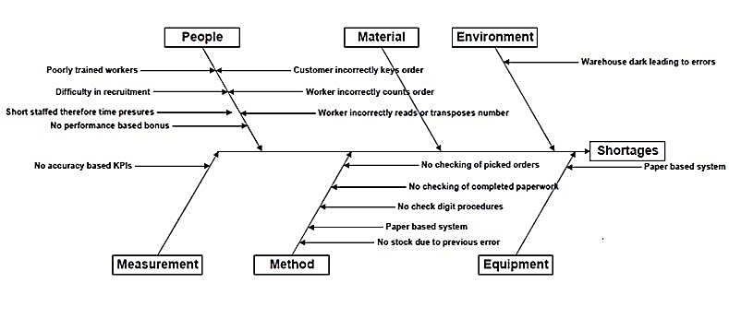

PROJECT: ANALYSIS GARMENT COMPANY

My project is aimed at a clothing company that works in my neighborhood, which detects and visit the following cases and which raises them a solution :: Xx apparel company in my neighborhood which distributes high quality clothing but has several problems that have lead to bottlenecks such as the following:
PROBLEM:
1. In the process of confectionery are carried out making shirts which goes first cutting fabric then sewn and then follow the process, but one day three workers skipped work so that production becomes slow, creating low production and drawbacks to meet orders placed.
SOLUTION:
1. It should train staff in different functions that have to do with the process as such know sewing, cutting, etc. This can replace the missing persons and thus take optimal production.

PROBLEM:
2. The company buys raw material from a supplier and were in agreement that they were going to bring certain day xx. But the vehicle did not come the raw material and could not do any production today.
SOLUTION:
2. It should take into account different providers that can that a supplier cannot bring the raw material. While having several different vendors can solve the supply problem and avoid delays in other processes.
PROBLEM
3. We already have the product ready for distribution at all clothing stores in the country but the only means of transport, it has a large fleet and has technical flaws in their vehicles and cannot ship the product by creating unrest in our customers clothing throughout the country.
SOLUTION: 3.
Should evaluate different transport providers, quality, time, service, vehicle type, quantity available and have different options in case any transport provider is missing.
PROBLEM
4. The sewing machine was handling an employee of the company was damaged and stopped working. The problem is that was the only machine to perform the specific tissue of the company, creating delays in the production process.
SOLUTION:
4. It could have sewing machines in reserve in case one fails or you should have a person with the job of maintenance of machinery and avoid delays in other processes of production and distribution.
PROBLEM
5. The company carries out production in about 5 hours each 200 garments, the problem is that they get complaints from customers of clothing that some products come with serious defects in the garments.
SOLUTION:
5. What would be done is to detail the process more quality to the product leaves in perfect condition and pleasing to the store and the customer.

PROBLEM
6. In the process of the company at the time of the cut fabric is accumulated much so that when you pass the fabric is delayed, and this makes the company lower production output per hour.
SOLUTION:
6. The problem may be with the person who cuts the fabric, can that person be cut very slowly accumulating a lot of material then we could replace the employee with a faster or employ the employee in another function of individual production process.

